Exercises Set 3 – Unit 1 September 16th, 2016
- Ask the user for the values of x, y, r, and h and calculate and display

a) 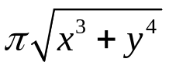

b) 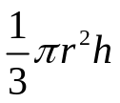
Save as calcEx1.py

- Write an application that ask the user for 3 digit number. It should then display the digit in the hundreds, tens, and ones place respectively.

Example:
Enter a 3-digit number: 348

The hundreds-place digit is: 3
The tens-place digit is: 4
The ones-place digit is: 8
Save as calcEx2.py

- Ask the user for the number of cents less than $1.00 and then display the minimum number of coins necessary to make the change. The change can be made up of quarters, dimes, nickels, and pennies.
For example if money = 83 the program should display:

Money Quarters Dimes Nickels Cents
- 3 0 1 3
Save as calcEx3.py

- Print your timetable using print and %. You should use right and left text alignment.
Save as calcEx4.py
Example 1:
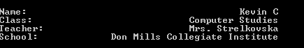
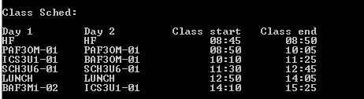
Example 2.
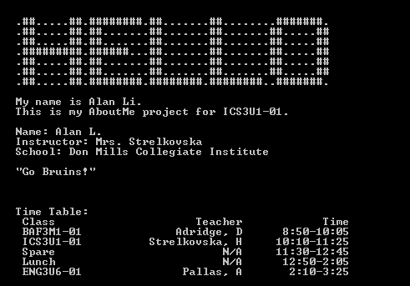
After completing all the Exercises, create a folder named:
LastnameF_CalculationsUnit1 and be ready to drop it off on

