Loop and ASCII Exercises

For the following exercises you will need to generate random characters.
To generate random characters you can use random.choice(string) of chr(random character code)
random.choice(‘AEIOUY’) → generates random letter from the list

x= random.randint(97,99)
chr(x) → generates randomly a,b,or c because 97 it is a code for a, 98 – code for b, and 99 – code for c

- Mr. S is a new teacher. He is behind on his marking. That is why he decided to generate random marks for his interim report instead of evaluating all the assignments. Help him to create a program that generates random letters from A to D for his ICS2O class. He also wants B to have twice as many chances to be assigned as any other letter. Ask how many students in the class and assign a letter for every student randomly. Your output should look similar to:
Example 1 Example 2
How many students are in your class: 5 How many students are in your class: 3
- B 1. C
- B 2. B
- C 3. A
- A
- D Save file as Loops_ASCII_Ex1.py

2(a)Rock Paper Scissors Exercise
For this exercise you have to create a simple rock paper scissors game.
In this exercise the players is prompted for a throw, where r or R corresponds to Rock, p or P to Paper, and s or S to Scissors (alternatively, you can use numbers to represent the throws, i.e. 1 for Rock, 2 for Paper, or 3 for Scissors. You should display the player’s throw.
Example (the user entry is in red):
Enter your throw (r=Rock, p=Paper, s=Scissors): s
Player throws SCISSORS.
OR
Enter your throw (1=Rock, 2=Paper, 3=Scissors): 3
Player throws SCISSORS.
Now that we have the input from the player we have to complete the game. Generate a random number between 1 and 3 (or 0 and 2) for the computer throw. Determine the winner based on the rules of Rock Paper Scissors: Rock dulls Scissors, Scissors cuts Paper, and Paper covers Rock.
Example 1 (the player entry is in red):
Enter your throw (r=Rock, p=Paper, s=Scissors): s
Player throws SCISSORS.
Computer throws PAPER.
You Win!

Example 2 (the player entry is in red):
Enter your throw (r=Rock, p=Paper, s=Scissors): r
Player throws Rock.
Computer throws PAPER.
2(b) Update your Rock Paper Scissors application. Ask the user to enter a throw or some value to exit. If you use chars (r=Rock, p=Paper, s=Scissors) use ‘!’ to exit. If you use numbers (1=Rock, 2=Paper, 3=Scissors) use ‘-1’ to exit. Continue playing till the exit symbol is entered.
Example (the user entry is in red):
Enter your throw (r=Rock, p=Paper, s=Scissors) or ! to exit: s
Player throws SCISSORS.
Computer throws SCISSORS.
It is a tie.
---------------------------------------
Enter your throw (r=Rock, p=Paper, s=Scissors) or ! to exit: p
Player throws PAPER.
Computer throws ROCK.
Player wins.
---------------------------------------
Enter your throw (r=Rock, p=Paper, s=Scissors) or ! to exit: !
Good Bye.

OR
Enter your throw (1=Rock, 2=Paper, 3=Scissors) or -1 to exit: 3
Player throws SCISSORS.
Computer throws SCISSORS.
It is a tie.
---------------------------------------
Enter your throw (1=Rock, 2=Paper, 3=Scissors) or -1 to exit: 2
Player throws PAPER.
Computer throws ROCK.
Player wins.
---------------------------------------
Enter your throw (1=Rock, 2=Paper, 3=Scissors) or -1 to exit: -1
Good Bye.
Save file as Loops_ASCII_Ex2.py

- Write Mind Reader application. Ask the user to follow the instructions.
Choose any 2-digit number. Add together both digits and then subtract the total from your original number. Find the symbol next to that number on the chart and concentrate on it, then press enter to reveal the character. (Wow! It seems to be reading your mind!)
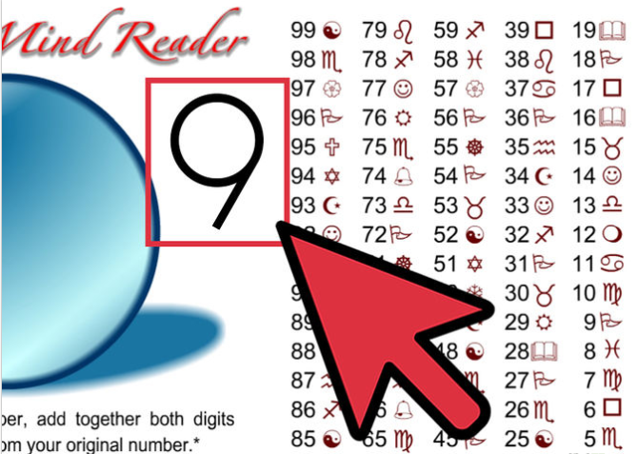

Have fun playing psychic for your friends! Be sure to explain how you did it - after you wow them a few times, of course.

Your application should print instructions, display the table with numbers and symbols that is generated randomly every time you run the application, reveal the symbol after the user press enter and ask the user if they want to continue playing.
Save file as ASCII_Ex3.py

