SPEC/4/COMSC/HP1/ENG/TZ0/XX

SPECIMEN PAPER

COMPUTER SCIENCE

HIGHER LEVEL

PAPER 2011

11.

The temperature (in °C) of a lake was recorded every hour, every day, for one week. As each reading was taken, it was added sequentially to the collection TEMPERATURES, which is stored permanently. At the end of the week this data was read into a two-dimensional array named TEMPWEEK as shown below.

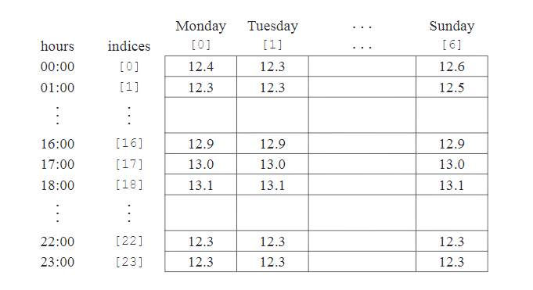 (a) Construct the algorithm that will read the data from the collection into the array. You can use the collection functions TEMPERATURES.getNext() and TEMPERATURES.isEmpty(). [5 marks]

(b) Using the array TEMPWEEK, construct an algorithm to determine and output the minimum temperature for the week. [4 marks]

(c) If the temperature is less than 12.00. °C then the day, time and temperature are also placed in a separate data structure.

(i) Describe a dynamic data structure that might be used to hold this data. You may use a labelled diagram. [3 marks]

(ii) Using this dynamic structure suggest how the number of days when the temperature of the lake was below 12.00. °C can be found.

[3 marks]

Señor Rodriguez is having a new house built and will require local tradesmen to complete a number of tasks. The Gantt chart below shows the tasks involved in the building of the house.

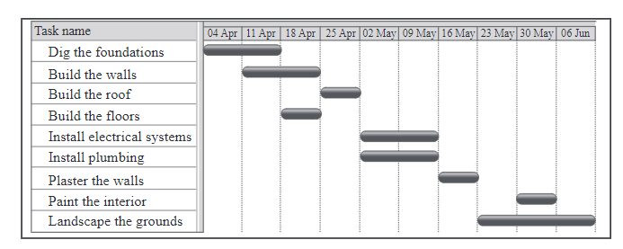

(a) Define the term concurrent processing. [1 mark]

(b) Identify two tasks that are carried out concurrently. [1 mark]

(c) Identify two tasks that are carried out sequentially. [1 mark]

(d) Describe how the idea of abstraction applies to one of the tasks. [2 marks]

(e) Explain one advantage and one disadvantage of carrying out a number of tasks concurrently. [4 marks]

Marking Schema

