**Homework. 2D array/Pseudocode practice.**

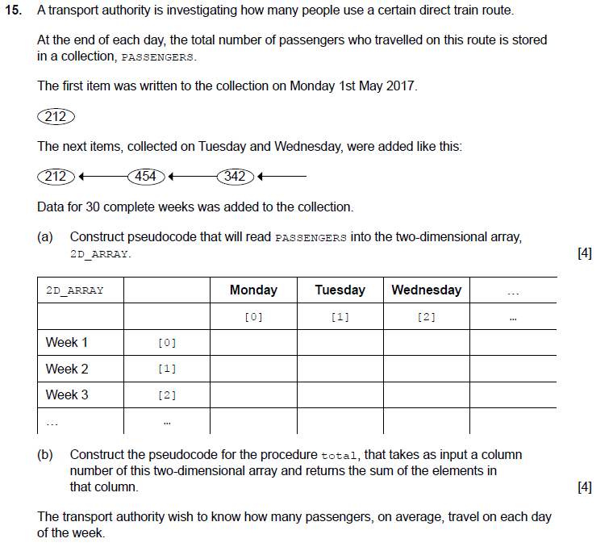

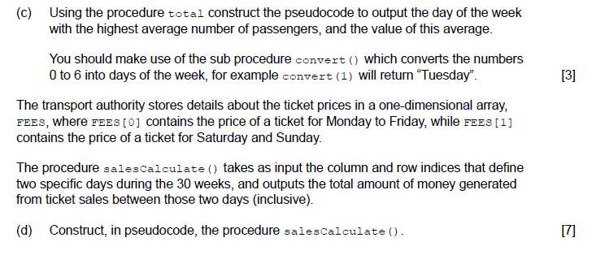

1. The collection MARKS contains the marks of 10 students for 5 exams, starting from students 1 exam 1 mark and ending with student 10 Exam 5 mark.

For example: {98, 68, 65, 73, 67, 77, 77, 88, 78, 90, 53……81};

|  |  |  |  |  |
| --- | --- | --- | --- | --- |
|  | Exam 1 | Exam 2 | ……. | Exam 5 |
| Student 1 | 98 | 68 |  | 67 |
| Student 2 | 77 | 77 |  | 90 |
| ……. | ……. | ……. |  | ……. |
| Student 10 | 88 | 86 |  | 81 |

1. State the total number of marks in the collection. [1]
2. Construct the algorithm to read this data into a 2D array, SCORES, that would allow the mark of a specific student at a specific exam to be accessed directly.[4]
3. Construct the algorithm that will output the Student with the highest average [3]
4. Construct the algorithm that will print the highest mark with indication which students has received this mark at which exam.

Use Pseudocode.