**Add SQLITE driver to ECLIPSE library**

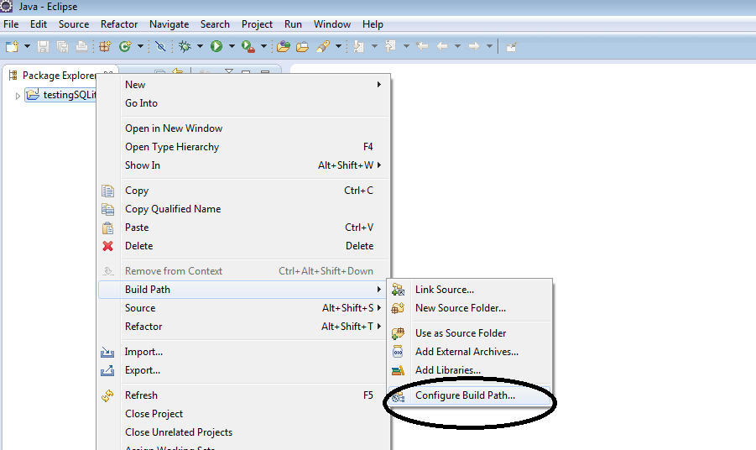Make sure you get the driver from [*https://bitbucket.org/xerial/sqlite-jdbc/downloads*](https://bitbucket.org/xerial/sqlite-jdbc/downloads), then import the driver into your project.

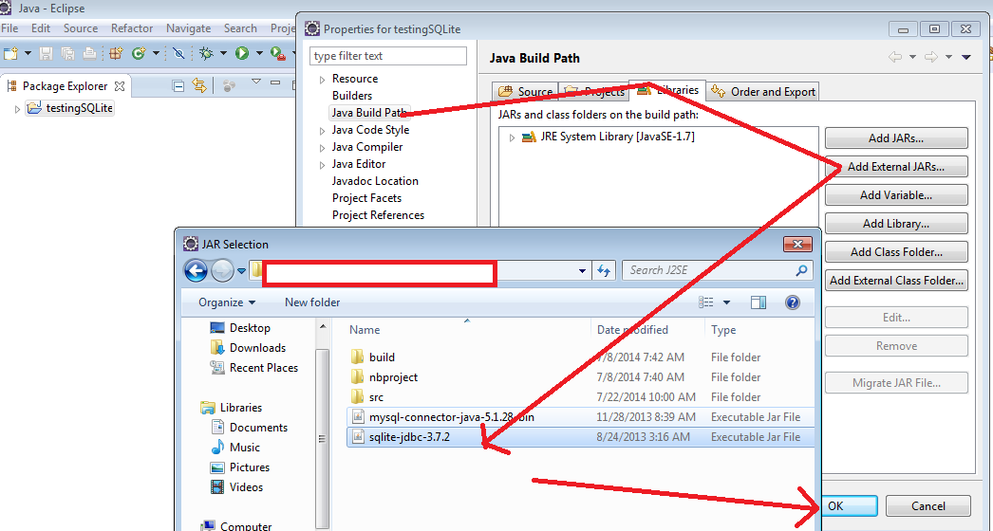

**Add SQLITE driver with .bat execution**

**.bat file**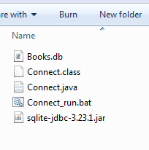

**javac Connect.java**

**pause**

**java -classpath ".;sqlite-jdbc-3.23.1.jar" Connect**

**pause**

Download SQLite Studio to work with SQLite <https://sqlitestudio.pl/index.rvt?act=download>