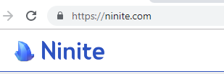

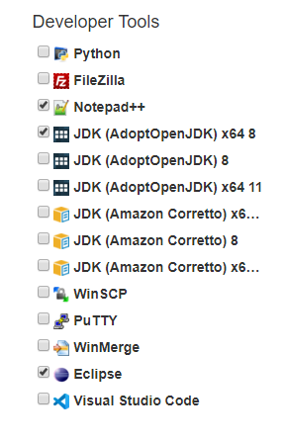

Notepad++

JDK(AdoptOpenJDK) x 64 8

Eclipse

