**Software Installation**

1. Go to:

<https://ninite.com/>

1. Select **Notepad++** , **JDK**, and  **Eclipse** in the Development Tools section

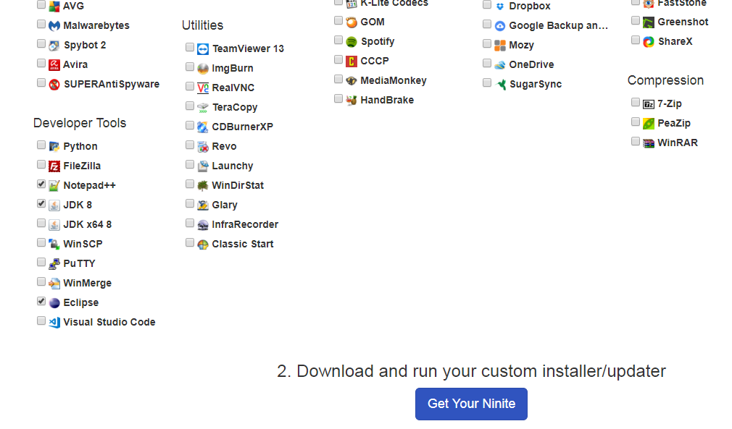

Click on Get Your Ninite button to download installer file. Run the Ninite Eclipse JDK….exe to install the apps.

1. Setup Environment Variables

Windows 10 <https://www.youtube.com/watch?v=_YmuR4aw9pM> till 7:14 min

Windows 7 <https://www.youtube.com/watch?v=FAglfB8h8uU> starting from 1:18 min

Windows 8 <https://www.youtube.com/watch?v=PjYraV5Ndzc>

Linux <https://www.youtube.com/watch?v=FnKHH3YhV7M>

**Homework**: Bring a screen shot of the running java in your computer