Skylar Trendley
PA05 – MITM-Spoof

Kali ARP Spoofing (using Ettercap)
In order to learn about how to conduct an ARP spoof, I used this website as a resource:
https://www.tutorialspoint.com/ethical_hacking/ethical_hacking_arp_poisoning.htm

First, I made sure to check my environment for my ip address to be sure I was connected to another VM as well as the internet.

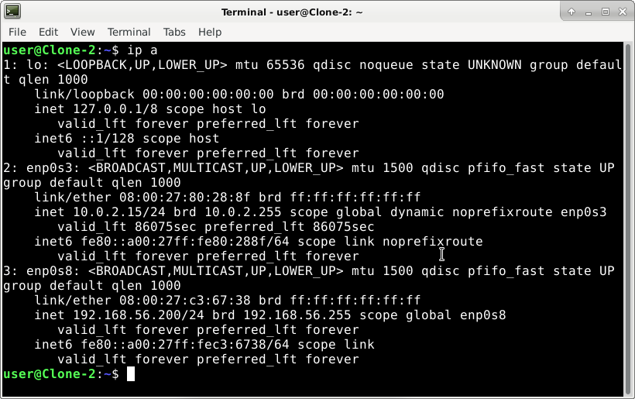
I was using user@Clone-2 as my attacker, and user@Clone-1 as my victim. They are connected on enp0s3 to the internet and enp0s8 as a host-only adapter network. The IP for clone-2 is 192.168.56.200 and the IP for clone-1 is 192.168.56.100.

Next, I was able to add ettercap to my debian 10 environment on clone-2 by running:
“sudo apt-get update”
“sudo apt-get install ettercap”

After installing ettercap, I ran it with sudo permissions and the -G flag to run it as a graphical interface.

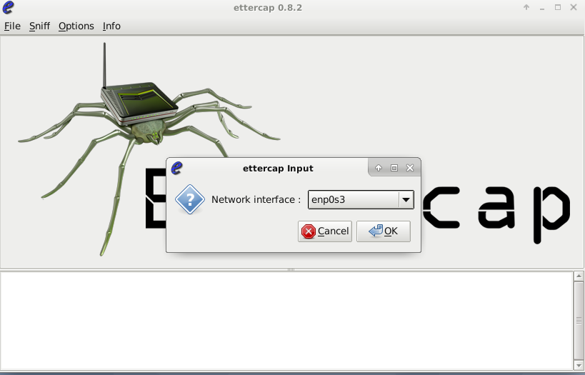
The first thing I was asked was to verify the ettercap input, or which network it was running the attacks on. I specified it under enp0s3 as that is my network adapter connected to the internet.

Next, I went to the Hosts drop down and started scanning for hosts. Three hosts on the network appeared, as shown in the image below. I then added those hosts to the host list to start tracking them.

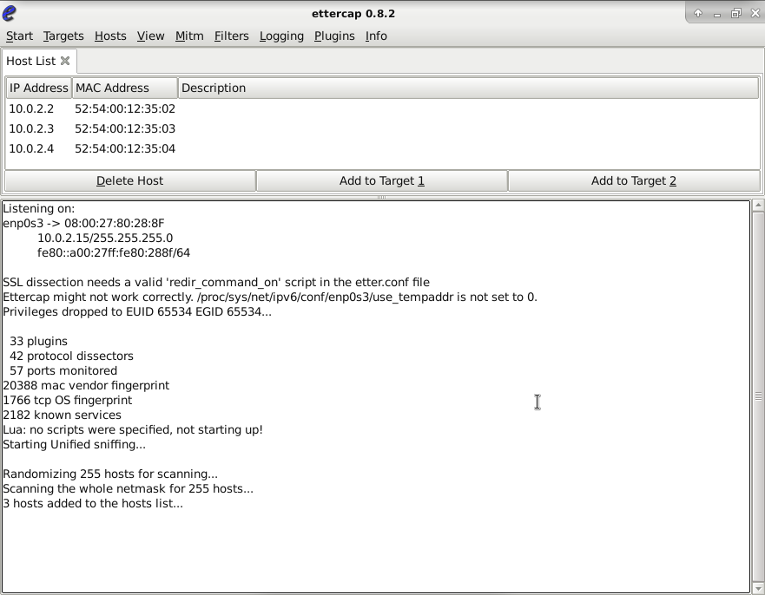

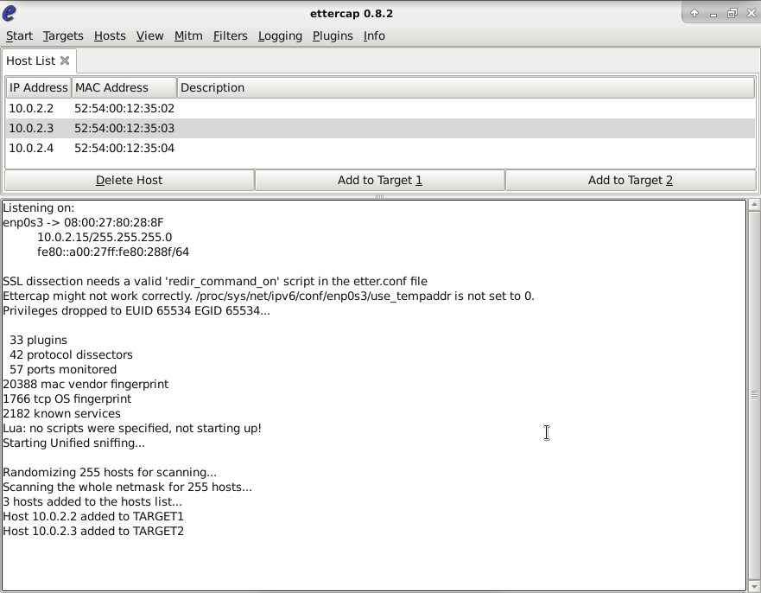
After adding the hosts, I was prompted to set targets for the hosts.

Finally, using the MiTM dropdown, I was able to start an ARP Poisoning attack and specify ettercap to allow for sniffing of remote connections.
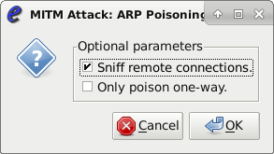

After setting up the ettercap environment, I was able to “start sniffing” on the victims, which looked like this:
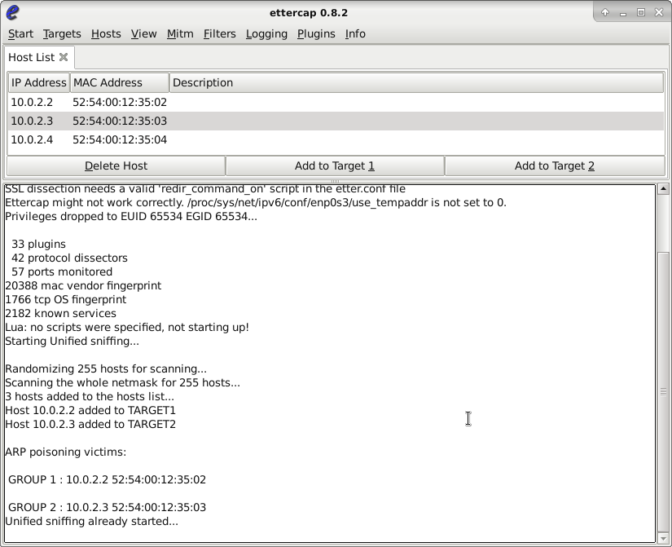
Unfortunately, I wasn’t able to test this as ettercap only captures logins on HTTP websites, and I couldn’t find a website outdated enough that still had an HTTP login available. However, I was able to see what the projected outcome would have been from the previous link (NOTE: Next image is borrowed from that link)

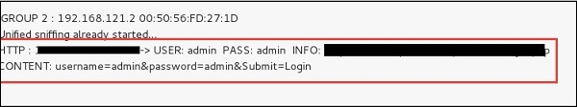

From this example, I can see that the ARP poisoning allowed me to get HTTP credentials by sniffing packets while connected to the same router.

