# CSCI 1120 Test Cases for Assignment 3

WANG, Yue

1. Separately test playerScore
   * 1. Correctly return player1’s points
        + 11111111111100 🡪0
        + 1001010101010 🡪1
        + 31🡪3
     2. Correctly return player2’s points
        + 11111111111100 🡪0
        + 1001010101001 🡪1
        + 13🡪3
2. Separately test updateNetwork with its calling functions
   * 1. Correctly update the string’s status at pos
        + updateNetwork (11111111111100, 1, 1) 🡪11111111111xx
        + updateNetwork(11111111111100, 12, 1)🡪111111111110xx
        + updateNetwork (1111111, 10, 1)🡪 11011xx
        + updateNetwork (1001010101001, 2, 1) 🡪 10101010xx
     2. Correctly update the player’ points for p (5%)
        + updateNetwork (11111111111100, 1, 1)🡪xxxxxxxxxxxx00
        + updateNetwork (10101010, 7, 1)🡪 xxxxxxxxxxxx20
        + updateNetwork (10101010, 7, 2)🡪 xxxxxxxxxxxx11
        + updateNetwork(10001111100, 4, 2) 🡪 xxxxxxxxxxxx02
3. Test the whole game flow
   1. (3; -1,13,3,4; 1; 2; 6; 9; 10; 11; 8; 5;7;12)🡪Player 1wins
      * + 3
          - 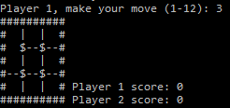
        + -1,13,3,4
          - 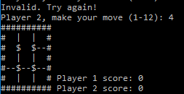
        + 1;2;6
          - 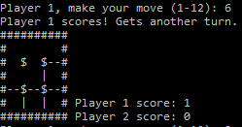
        + 9;10;11;8
          - 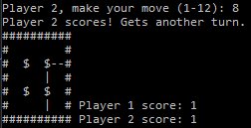
        + 5;7
          - 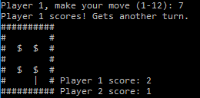
        + 12
          - 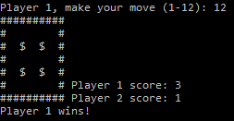
   2. (11; 2; 4; 5; 9; 10; 12; 7; 3; 1; 8; 6)🡪Draw game (when the player1 move 4, he scores two points by this move)
      * + 11; 2; 4; 5; 9; 10; 12;
          - 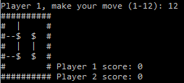
        + 7
          - 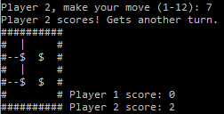
        + 3; 1; 8;
          - 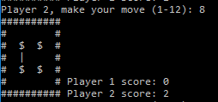
        + 6
          - 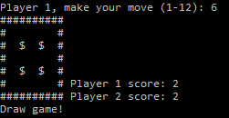
   3. (2; 5; 8; 9; 1; 3; 7; 4; 6; 11; 12; 10)🡪Player 2 wins
      * + 2; 5; 8; 9; 1; 3; 7
          - 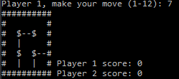
        + 4
          - 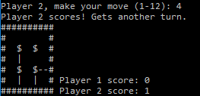
        + 6
          - 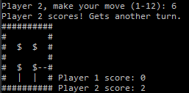
        + 11
          - 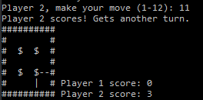
        + 12; 10
          - 