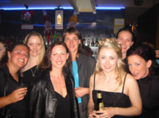
School
What do I miss about school? I miss being with friends everyday. I really don’t believe that you can ever be true friends with anyone you work with. Because really, the quality of your life is at stake. Everyone has to play the political game at some point to gain a promotion, win business or keep their job… And it’s not even so important now. All that’s at stake is how many times you can eat out in a week or whatever, but when you have children, their lives are at stake. What schools will they be able to go to, what medical care can you afford for them? We just weren’t in that type of competition with each other when we were at school and I don’t think you can ever replicate again that context and those day-to-day friendships that it affords. My best friends are still those I made at school.¹
Career
The first five years after school were spent slowly completing my Bachelor of Visual Arts at SCA majoring in Electronic & Temporal Art (film, video, sound and multimedia)². The next five years culminated in working as a documentary producer at ABC Radio National. 2 ½ years there and 2 ½ either side trying to find the job and getting over losing it! I had four full-length docos on air while I was there and was just starting to really find my feet and feel competent and ready to work as a fully-fledged professional when I was retrenched at the height of Jonathon Shier’s reign. I haven’t got back on track yet. Maybe this is a hiatus, or maybe I’m back at square one. The next few months will tell. I still don’t know what I want to ‘do’. I have a lot of conflicting ideas about what constitutes worthwhile work. Finding my career direction is my most pressing concern now. I just need to resolve the spiritual and material world and I’ll be right - a minor detail! On the upside, I run my own communications business, Voca Vista, part time and I’m half way through my Masters – both of these things keep me going.

Love
I married a beautiful man called Matt Ball in 1997 after we met playing in a band together.³ This year we went to Fiji for our fifth anniversary and fell in love with the place.^{4,5} We’d never been so relaxed in our lives – I’ll always remember the humid tropical smell, the heat and the arching palm trees. Mmmmm.

Home
This is where we live – we call it The Bay.⁶ This year we bought the apartment we were renting and are about to renovate. It’s like living on the central coast, but 15 minutes from Sydney CBD. We share the place with ducks, magpies, cockatoos, kookaburras, currawongs, rainbow lorikeets, jumping mullets, wild rabbits, seagulls and possums. Last time I went away I really missed them!

Future
I don’t think I’ve ever been so confused about life, how I want to live, the world, or my place in it . My hope for the future is to be less confused. Perfectly clear would be even better!
Karen Cambrell
1

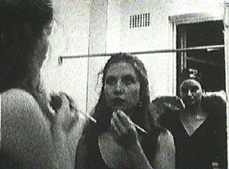
2

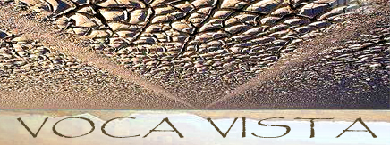

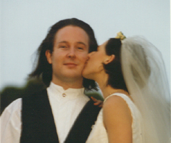
3

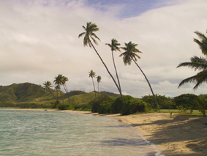
4

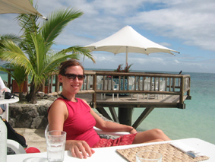
5

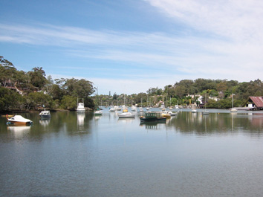
6

