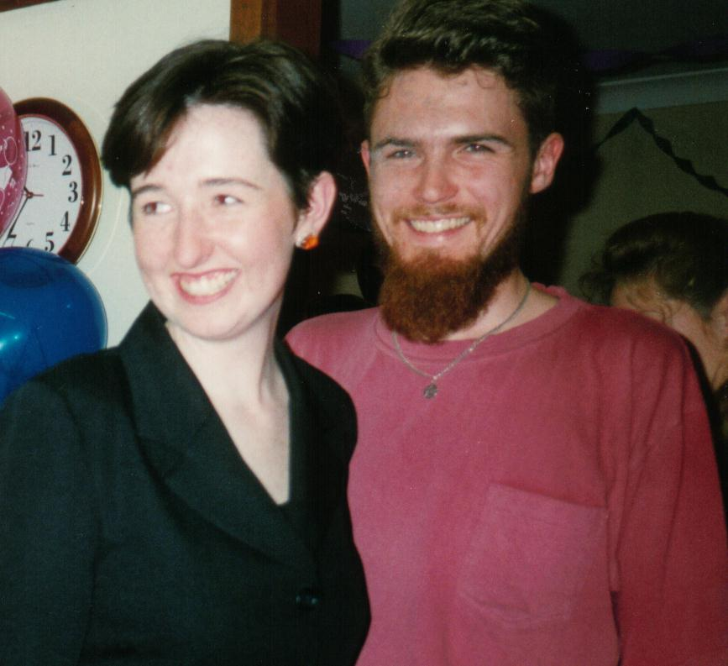
Paul & Rowena: 10 years in a nutshell….

After school Paul & Row went to Sydney Uni (along with half the year!). Paul finished a BA at Sydney Uni with an archaeology major, whilst Row did Arts/Law with a major in Psychology. During that time we also started going out!

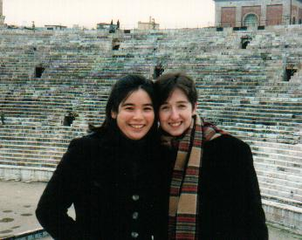
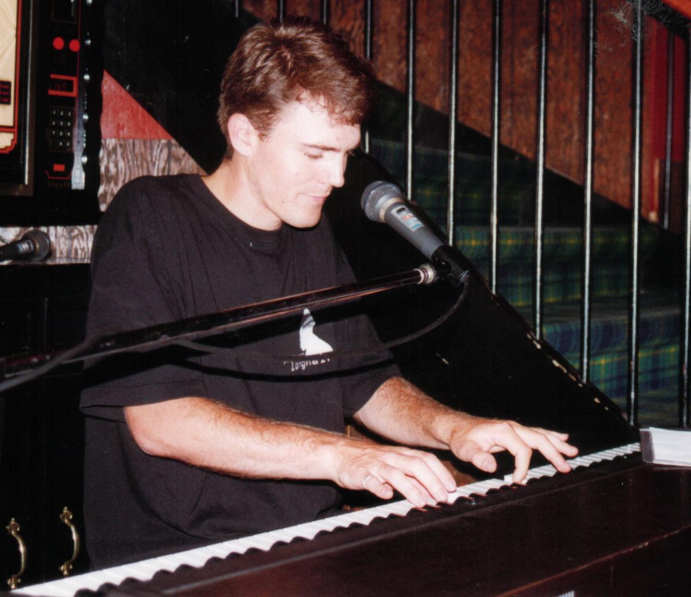
After uni, we headed off on a series of overseas trips which we timed perfectly to avoid being in the same country at the same time. First Row headed off to Europe with Sarah Cheong for a few month’s backpacking. Soon after her return, Paul packed up and headed over to Denmark, where he started studying a Masters in archaeology, and earning a crust playing piano in smoky bars. After a year (completing Psych Honours), Row headed over to Europe, first working in London for 6 months before heading across to Denmark, where we were finally together again!

After a couple of years in Denmark we returned to Oz, both studying and working. In 1999 we headed over to Denmark again, Row for a semester of law and Paul to finish his masters thesis. In late 1999 we returned (this time for good) to Sydney town and rented a place in Marrickville. Soon after Row finished law and started working at Mallesons, a law firm in the city. Paul scratched around for archaeology work and after a few months began work self-employed as a consultant. He also formed the seminal blues band Underbelly (!) and started gigging around Sydney (with Row as trusted roady and groupie).
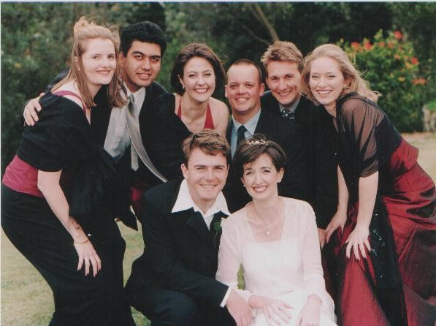
In October 2001 we got hitched and just a few months ago moved into our own place in Arncliffe. Row is still working at Mallesons and teaching English as a volunteer tutor. Paul is working as an archaeological consultant and still gigging with Underbelly. In our spare time we either sleep, go camping or other outdoorsy stuff, and next year we are planning a 6 month trip around Australia.

