**Knowledge Engineering LAB**

**Assignment 4**

**Q1.**

Solu.

A.

SELECT

"A2"."CITY" "CITY",

"A1"."ITEM_NAME" "ITEM NAME",

SUM("A3"."DOLLARS_SOLD") "SUM(DOLLARS_SOLD)"

FROM

"SYSTEM"."SALES" "A3",

"SYSTEM"."LOCATION" "A2",

"SYSTEM"."ITEM" "A1"

GROUP BY

ROLLUP("A2"."CITY",

"A1"."ITEM_NAME");

OUTPUT:

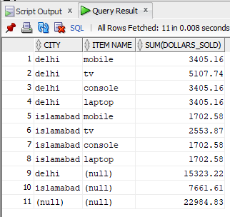

B.

SELECT

"A2"."CITY" "CITY",

SUM("A1"."DOLLARS_SOLD") "SUM(DOLLARS_SOLD)"

FROM

"SYSTEM"."SALES" "A1",

"SYSTEM"."LOCATION" "A2"

GROUP BY "A2"."CITY";

OUTPUT:

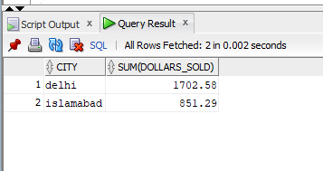

C.

SELECT

"A2"."ITEM_NAME" "ITEM NAME",

SUM("A1"."DOLLARS_SOLD") "SUM(DOLLARS_SOLD)"

FROM

"SYSTEM"."SALES" "A1",

"SYSTEM"."ITEM" "A2"

GROUP BY "A2"."ITEM_NAME";

OUTPUT:

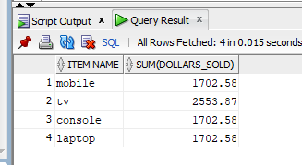

D.

Maximum number of cells in the base cuboid: 3888

E.

Minimum number of cells in the base cuboid: 1

**Q2**

**Solu.**

**Tables and their data**

* Game Table

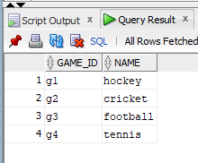

* Location_Game Table

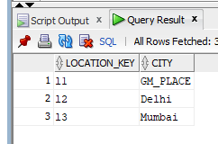

* Date_Game Table

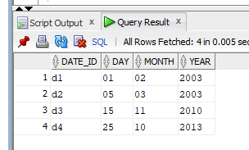

* Sales_Game Table

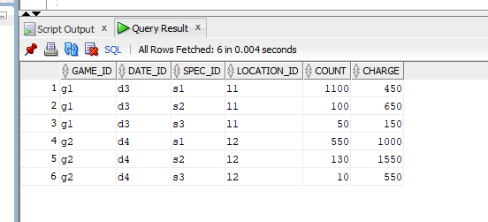

* Spectator Table

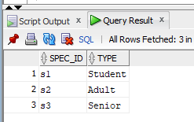

i)

SELECT

SUM("A1".charge*"A1".count)

FROM

"SYSTEM"."SALES_GAME" "A1",

"SYSTEM"."LOCATION_GAME" "A2",

"SYSTEM"."SPECTATOR" "A3",

"SYSTEM"."DATE_GAME" "A4"

WHERE

(

"A2".city='GM_PLACE' and

"A4".year='2010' and

"A3".type='Student'

)

GROUP BY

"A2".city;

**OUTPUT:**

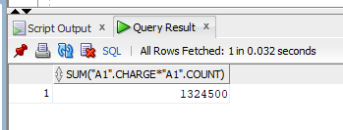

ii)

SELECT

"A1"."DAY" "DAY",

"A1"."MONTH" "MONTH",

"A1"."YEAR" "YEAR",

SUM("A2"."CHARGE" * "A2"."COUNT") "SUM( A2 .CHARGE* A2 .COUNT)"

FROM

"SYSTEM"."SALES_GAME" "A2",

"SYSTEM"."DATE_GAME" "A1"

WHERE

"A2"."DATE_ID" = "A1"."DATE_ID"

GROUP BY

ROLLUP("A1"."DAY",

"A1"."MONTH",

"A1"."YEAR");

**OUTPUT:**

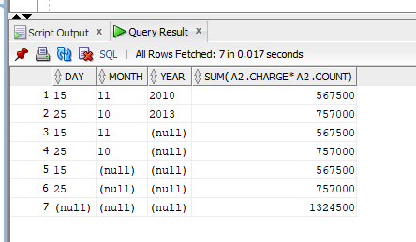

iii)

SELECT

"A1"."TYPE",

AVG("A2"."CHARGE" * "A2"."COUNT")

FROM

"SYSTEM"."SALES_GAME" "A2",

"SYSTEM"."SPECTATOR" "A1"

WHERE

"A1".SPEC_ID="A2".SPEC_ID

GROUP BY

"A1"."TYPE";

**OUTPUT:**

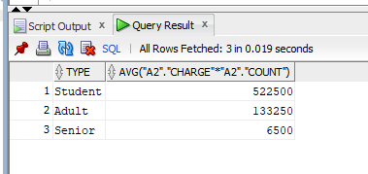

iv)

Snowflake diagram for the above datawarehouse

