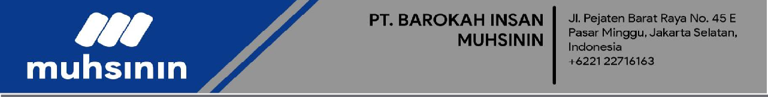

KODE PEMESANAN #: {booking} DATE: {date}

Muhsinin Jakarta INVOICE

|  |  |  |  |
| --- | --- | --- | --- |
|  | **{address}** | **BILL**  **TO** | **{name}** |
|  |  |  |
|  |  |  |
|  | **{phone}** |  |  |
|  |  |  |  |

|  |  |  |
| --- | --- | --- |
| **DESCRIPTION** |  | **AMOUNT** |
|  | |  |
| **{title}** | | **Rp {payment}** |
| **{packet}** | | **Rp {total}** |
|  | |  |
|  | |  |
|  | |  |
|  | |  |
| **Transfer diterima Bank Syariah Indonesia** | |  |
| **No Rek. 8008282080** | |  |
| **an. PT. Barokah Insan Muhsinin** | |  |
|  | **SISA BAYAR** | **Rp {rest}** |
| **TAX** | **Rp -** |
| **DISCOUNT** | **Rp -** |
| **TOTAL BAYAR** | **Rp {payment}** |

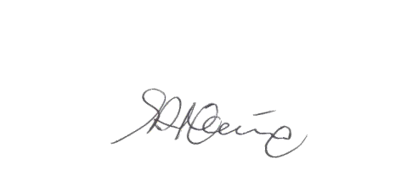

**Make all checks payable to:**

**Muhsinin Travel**