H B n B
Technical Documentation
A blueprint for how the system is built and why

This document brings together the architecture, the data model, and the request flows behind HBnB, written for anyone picking up the project — whether to build a new feature, debug an existing one, or just understand how the pieces fit together.

Holberton School · HBnB Project

Table of Contents
Table of Contents 1
1. Introduction 1
2. High-Level Architecture 1
2.1 The Three Layers 1
2.2 The Facade Pattern 1
3. Business Logic Layer 1
3.1 BaseModel 1
3.2 User 1
3.3 Place 1
3.4 Review 1
3.5 Amenity 1
3.6 Why It's Built This Way 1
4. API Interaction Flow 1
4.1 User Registration 1
4.2 Place Creation 1
4.3 Review Submission 1
4.4 Fetching a List of Places 1
4.5 The Pattern So Far 1
5. Closing Thoughts 1

1. Introduction
HBnB Evolution is a simplified accommodation rental platform inspired by Airbnb. Users can register and manage their own accounts, create and manage place listings, submit reviews, and attach amenities to the places they list.
This document lays out the system architecture behind that platform using a three-layer design — Presentation Layer, Business Logic Layer, and Persistence Layer — built around the Facade pattern, which gives the layers a single, unified way to talk to each other instead of reaching directly into one another's internals. The result is a codebase that stays organized as it grows, easier to maintain, and easier to extend with new features later.
Three sections carry the explanation, each building on the one before it:
- High-Level Architecture — the package diagram showing how the three layers connect, and where the Facade sits between them.
- Business Logic Layer — the entities at the core of the app (User, Place, Review, Amenity), what they hold, and how they relate to each other.
- API Interaction Flow — real API calls traced step by step, showing the layers actually talking to one another.
Think of this as the reference to come back to whenever a design decision is unclear — not a one-time document to read and forget, but something that should evolve alongside the codebase.

2. High-Level Architecture
The diagram below illustrates the main components of HBnB and how data and requests flow between the three layers of the system.
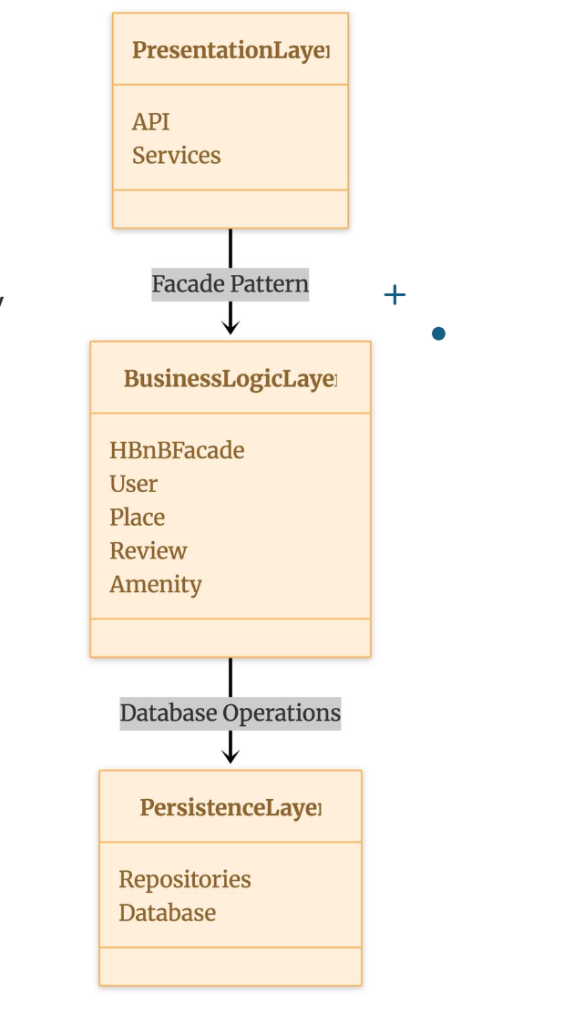
Figure 1 — High-level package diagram

2.1 The Three Layers
- Presentation Layer — exposes the API and its services. It's what clients actually talk to, and its only job is handling requests and responses — not deciding what's valid or how data gets stored.
- Business Logic Layer — built around the HBnBFacade, with the four core entities (User, Place, Review, Amenity) sitting behind it. This is where the real rules live.
- Persistence Layer — handles repositories and the database itself, the part responsible for actually getting data in and out of storage.

2.2 The Facade Pattern
Rather than letting the Presentation Layer reach directly into four different business logic classes, every call passes through the HBnBFacade. The API asks the facade for what it needs, and the facade figures out which entities and database operations are involved — visible in the diagram as the single arrow connecting PresentationLayer down to BusinessLogicLayer.
That one decision pays off in a few ways. The API layer stays simple and doesn't need to change just because something shifts internally — say, a new validation rule on Place, or a different way of linking Amenities. It also makes testing more pleasant: the facade can be swapped out or mocked without dragging the persistence layer along with it.
In the sequence diagrams later in this document, the API participant stands in for this Presentation Layer, and its calls into the model classes represent what would, in the real implementation, be routed through that facade.

3. Business Logic Layer
This is the part of the system that actually models what HBnB is about. Four entities — User, Place, Review, and Amenity — share one parent class, BaseModel, which takes care of identity and lifecycle so none of the four have to repeat that logic themselves. The diagram below is the full picture: every attribute, every method, every relationship.
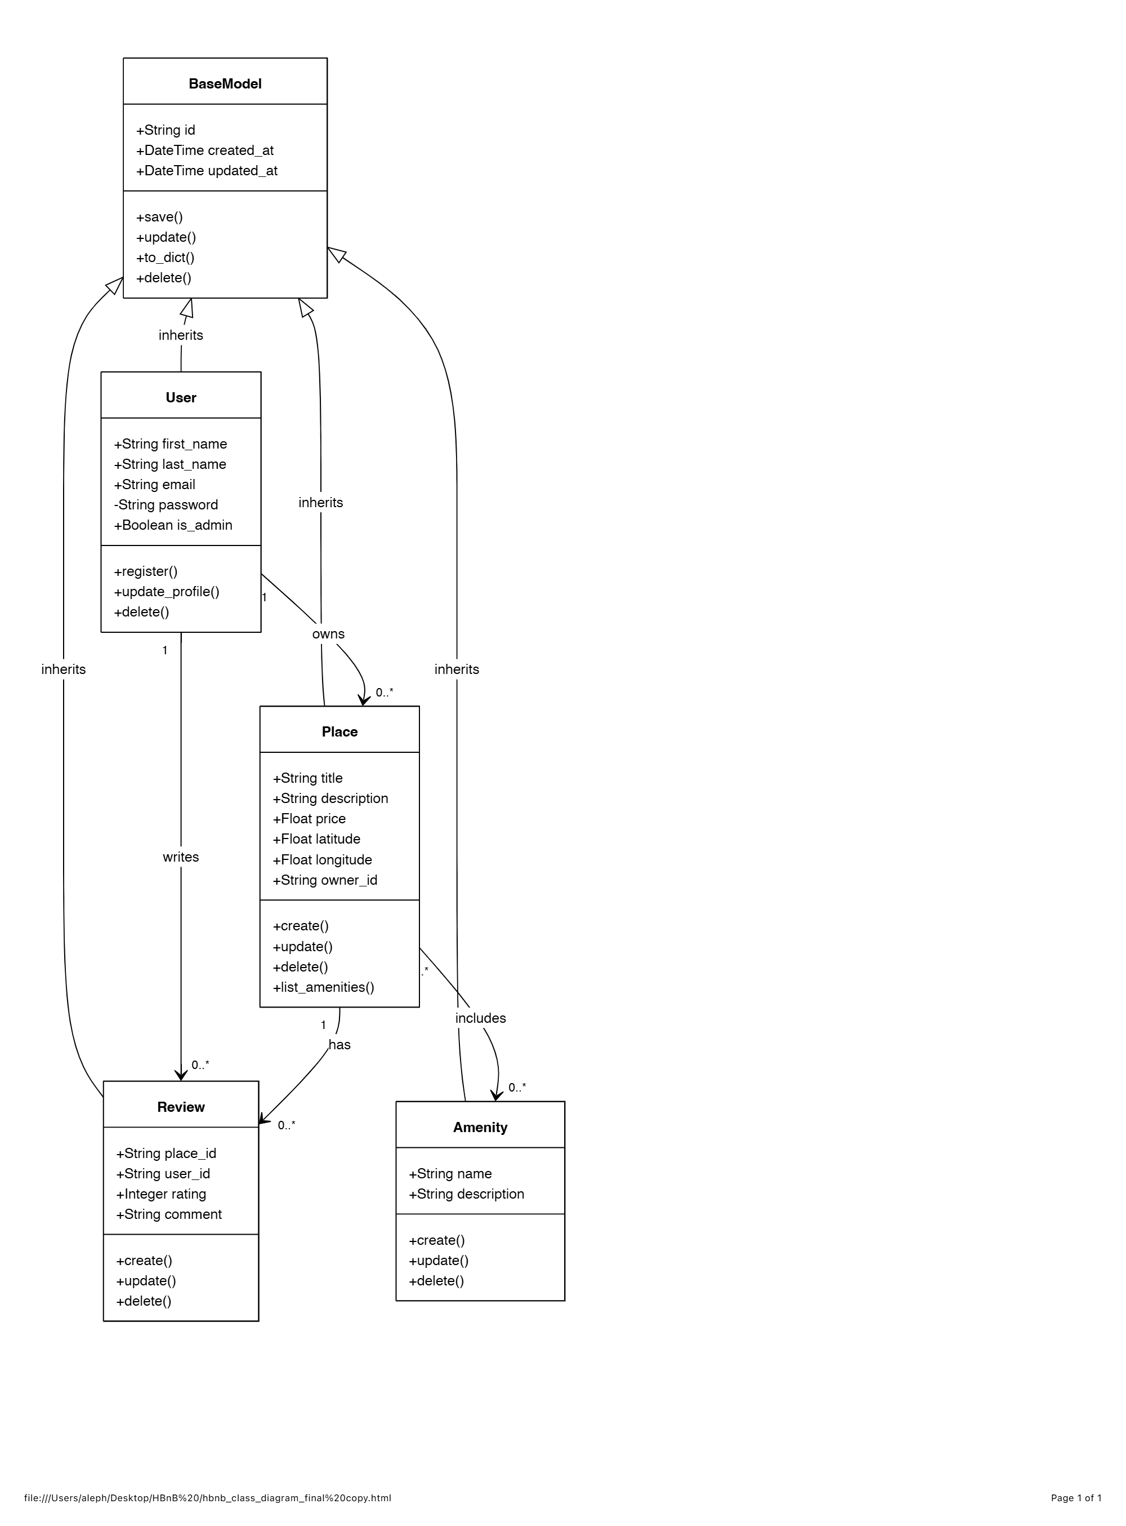
Figure 2 — Business Logic Layer class diagram

3.1 BaseModel
Every entity in the system inherits from BaseModel, which exists purely to avoid repeating the same boilerplate four times over. It's a small class with an outsized job: tracking identity and time.
- Attributes — id (String), created_at (DateTime), updated_at (DateTime).
- Methods — save(), update(), to_dict(), delete(), inherited automatically by User, Place, Review, and Amenity.
Because this lives in one place, every entity gets consistent timestamps and a consistent dictionary representation for free — useful the moment any of this needs to be serialized into a JSON response.

3.2 User
- Attributes — first_name, last_name, email (String), password (String, private), is_admin (Boolean).
- Methods — register(), update_profile(), delete().
The password field is marked private on purpose — that minus sign in the diagram is a reminder that it should never make its way into an API response, only ever be used internally for authentication. A User can own several places and write several reviews, which is exactly what the owns and writes relationships in the diagram capture.

3.3 Place
- Attributes — title, description (String), price (Float), latitude, longitude (Float), owner_id (String).
- Methods — create(), update(), delete(), list_amenities().
Every Place belongs to exactly one User — the owns relationship is one-to-many, one owner with any number of listings. From there, a Place can collect any number of Reviews (has) and list any number of Amenities (includes).

3.4 Review
- Attributes — place_id, user_id (String), rating (Integer), comment (String).
- Methods — create(), update(), delete().
A Review only makes sense in context — it's always tied to a specific Place and written by a specific User, which is why both place_id and user_id sit directly on the entity rather than being implied.

3.5 Amenity
- Attributes — name, description (String).
- Methods — create(), update(), delete().
The simplest entity in the layer — a feature attached to a Place, like Wi-Fi or parking. The includes relationship lets a single Place list as many of these as it needs.

3.6 Why It's Built This Way
Two choices are doing most of the work in this layer. Inheriting from BaseModel means identity and timestamp logic exists exactly once, leaving each entity free to focus only on what makes it unique. And keeping every relationship explicit — owns, writes, has, includes — rather than leaving it implicit in the code, means the shape of the system is visible at a glance: a Place can't exist without an owning User, and removing a User has real, traceable consequences for the Places, Reviews, and Amenities connected to it.

4. API Interaction Flow
Diagrams and class definitions only tell half the story — this section shows the system actually doing something. Four representative API calls are traced end to end, from the moment a client sends a request to the moment data lands in storage and a response makes its way back. Three are fully diagrammed below; the fourth (Fetching a List of Places) is noted and will follow.
Every diagram follows the same rhythm: the User Client sends a request, the API receives it and hands off to the right Business Logic class, that class talks to Storage, and the result travels back up the same path. Solid arrows move forward into the system; dashed arrows are the responses coming back out. The numbers just keep the order honest.

4.1 User Registration
Someone signs up with a first name, last name, email, and password. The API builds a User instance — inheriting its identity and timestamps from BaseModel along the way — and persists it. What comes back to the client is the new profile, password deliberately left out.
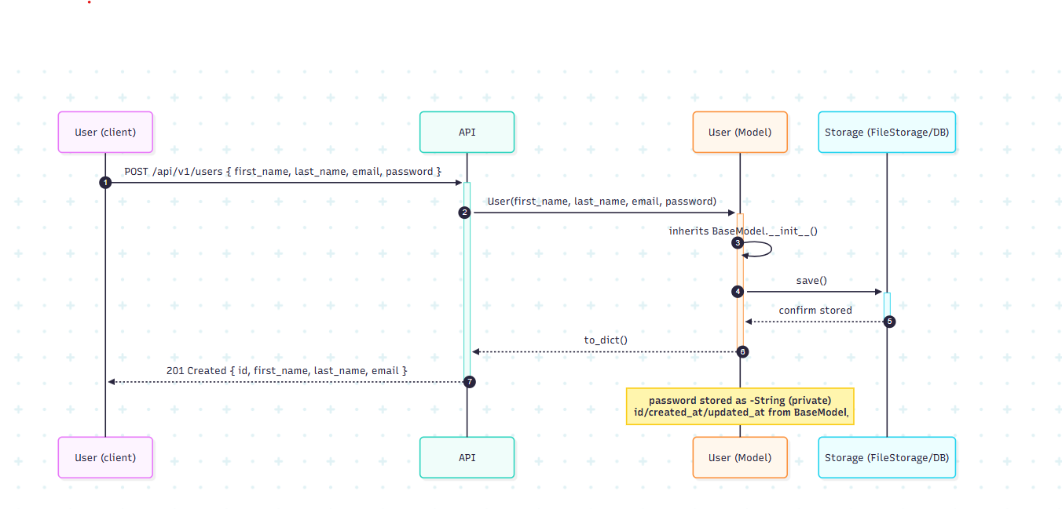
Figure 3 — Sequence diagram for User Registration
Design note
The password never appears in the response. It's stored as a private attribute on the User class, which is the same encapsulation already visible in the class diagram — this flow is just that decision in action.

4.2 Place Creation
A signed-in user submits a new listing. The API constructs a Place tied back to that user through owner_id, saves it, and returns the finished listing. This is the owns relationship from the class diagram playing out directly — every Place is always traceable to exactly one owner.
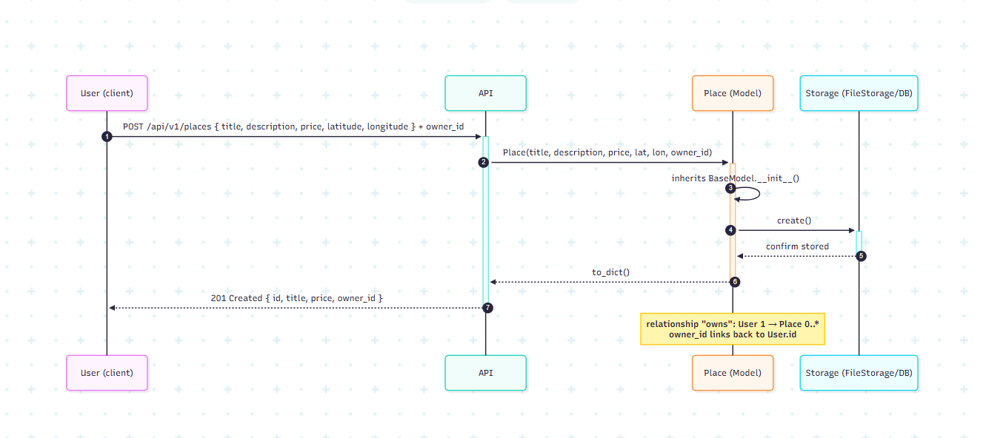
Figure 4 — Sequence diagram for Place Creation
Design note
Validating fields like price, latitude, and longitude happens inside the Place model itself, not in the API layer — that's the Business Logic Layer doing the job it's meant for.

4.3 Review Submission
The most layered flow of the four, because a Review can't stand on its own — before anything is created, the API first checks that the target Place actually exists. Only once that check passes does it build and save the Review, which carries references to both the reviewing User and the reviewed Place.
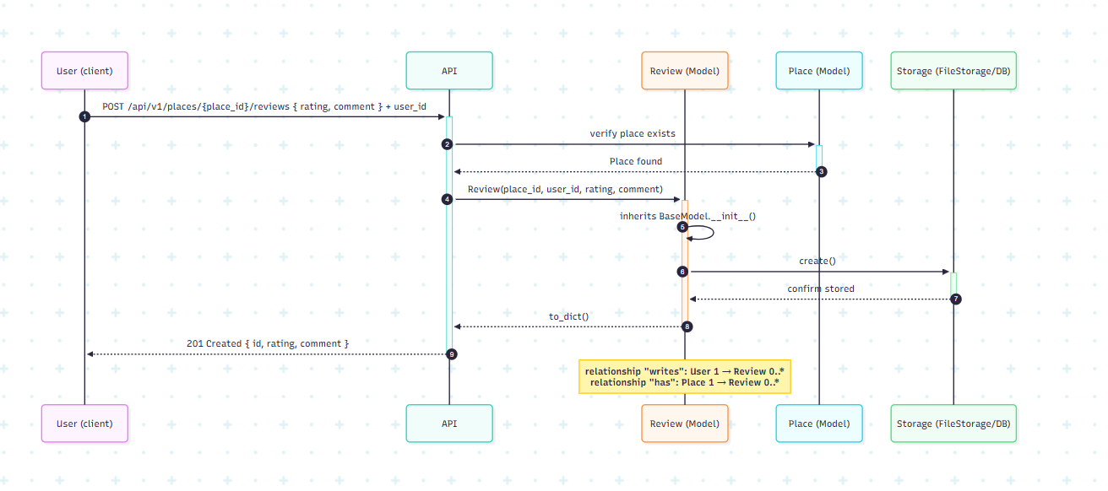
Figure 5 — Sequence diagram for Review Submission
Design note
Both relationships from the class diagram show up explicitly here — writes (User to Review) and has (Place to Review) — as two separate references sitting right on the Review entity.

4.4 Fetching a List of Places
This one's different from the rest — public, read-only, no authentication needed. The client can pass optional filters (a max price, a location), the API hands those to the Place model, which queries Storage and also resolves each place's amenities along the way before the full list goes back.
Pending
The sequence diagram for this flow is being finalized and will be added here once available.

4.5 The Pattern So Far
Look at the three diagrams above side by side and the same shape repeats every time: API receives, delegates to Business Logic, Business Logic talks to Storage, and the result flows back the way it came. That's not a coincidence — it's the layered architecture and the facade pattern from Section 2, showing up consistently because every endpoint in the system was built to follow the same rules.

5. Closing Thoughts
Put together, the three sections of this document cover HBnB from three different distances: the architecture that organizes the whole codebase, the entities that model what the application actually does, and the sequence diagrams that show those entities responding to real requests. Read together, they should be enough to implement a new endpoint, change an existing entity, or just get oriented on the project without having to reverse-engineer any of it from the code alone.
None of this is meant to be frozen in place. As the implementation moves forward, this document should move with it — updated whenever a new entity, relationship, or endpoint changes the picture described here.

