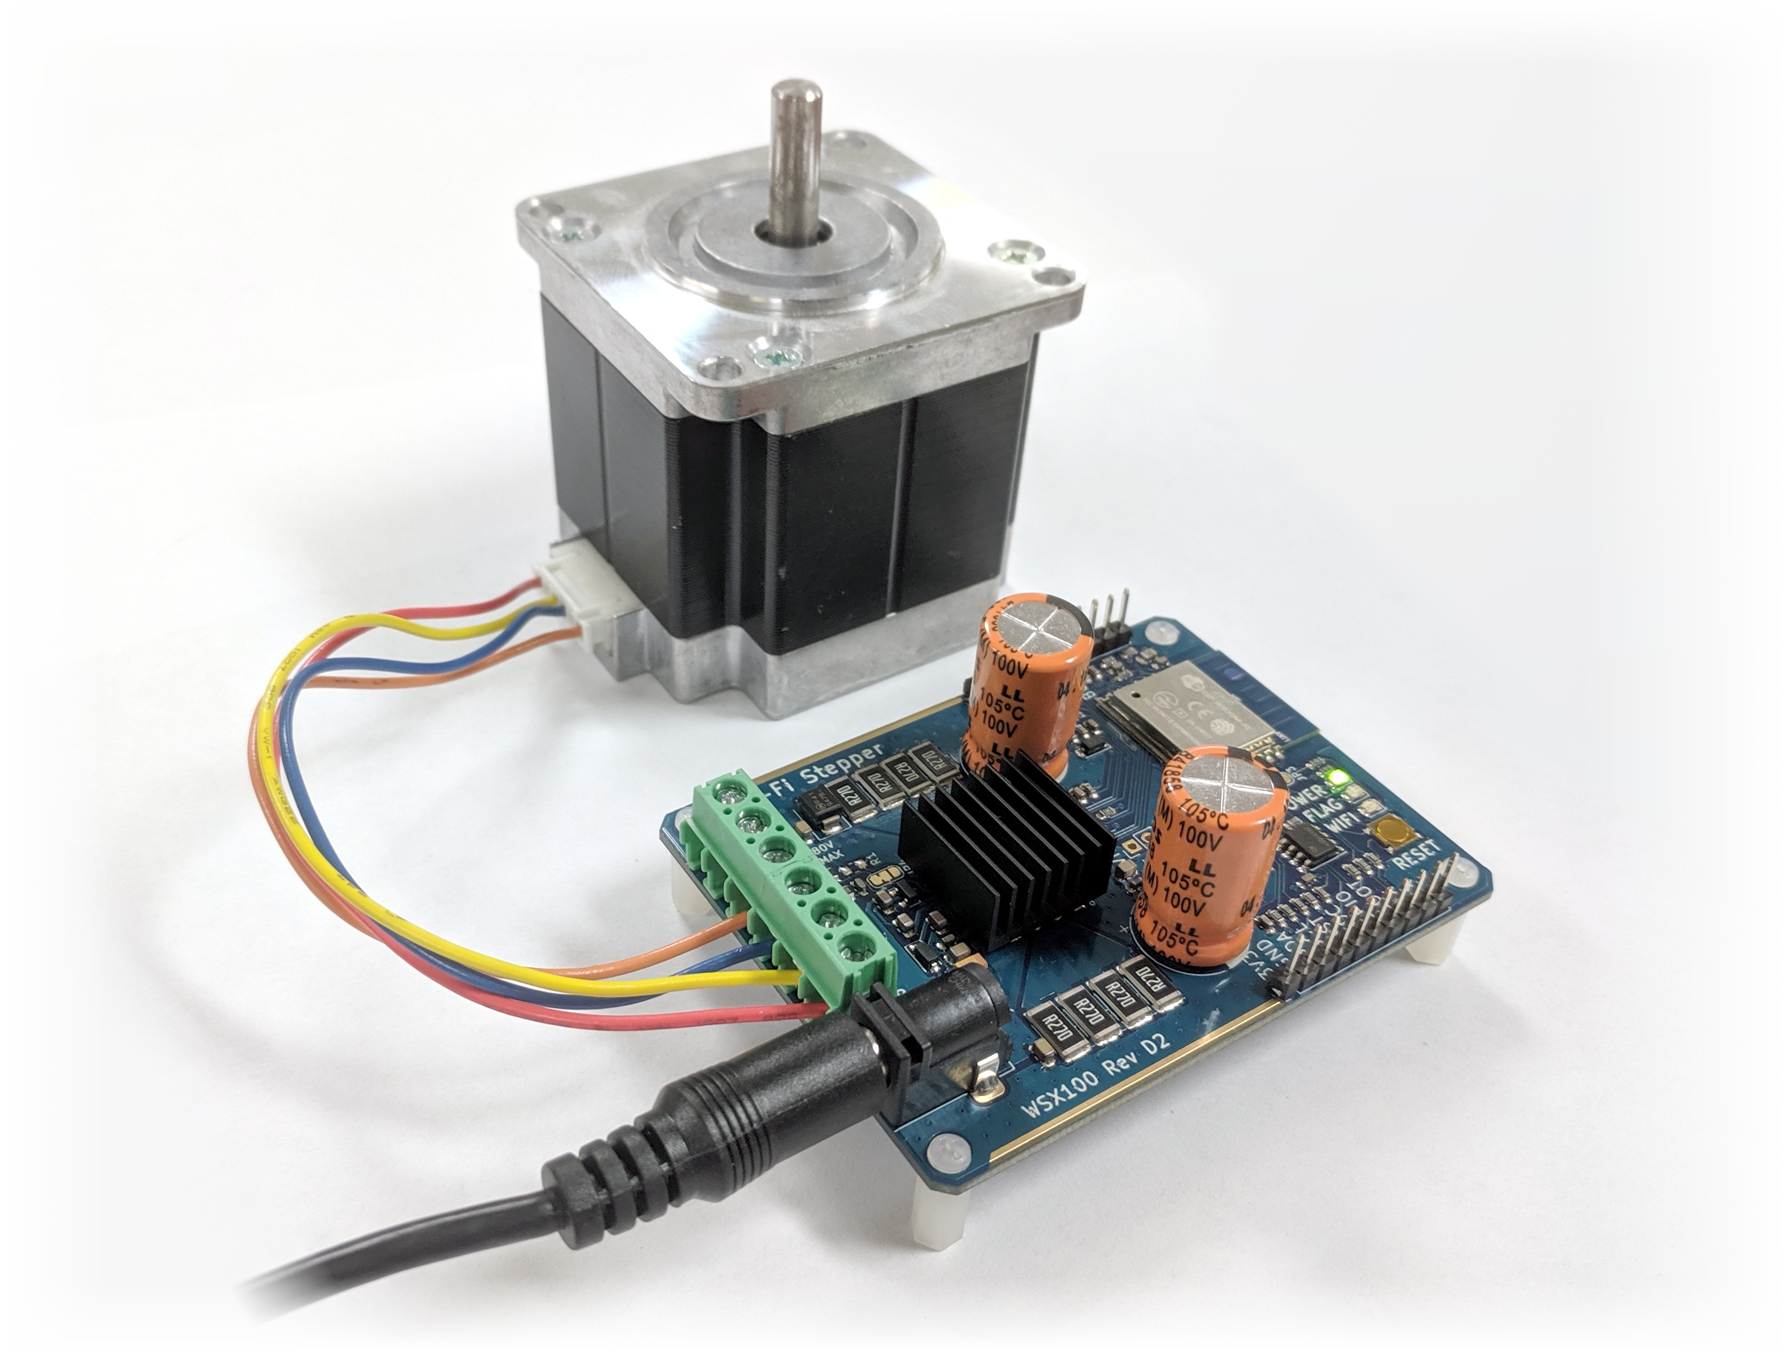

Wi-Fi Stepper WSX100

Quick Start Guide

- Connect Bipolar Stepper Motor
- Bipolar stepper motors have two pairs of wires (four total)
- Determine which pairs are A and B, see reverse
- Connect Power (12V - 80V)
- Use either barrel connector or screw terminals
- For high voltage (greater than 50V), see documentation
- Connect computer to newly-created access point wsx100-ap-XXXXXX
- Open webpage to http://192.168.4.1 (or http://wsx100.local with mDNS)

Finding Stepper Motor Wiring Pairs
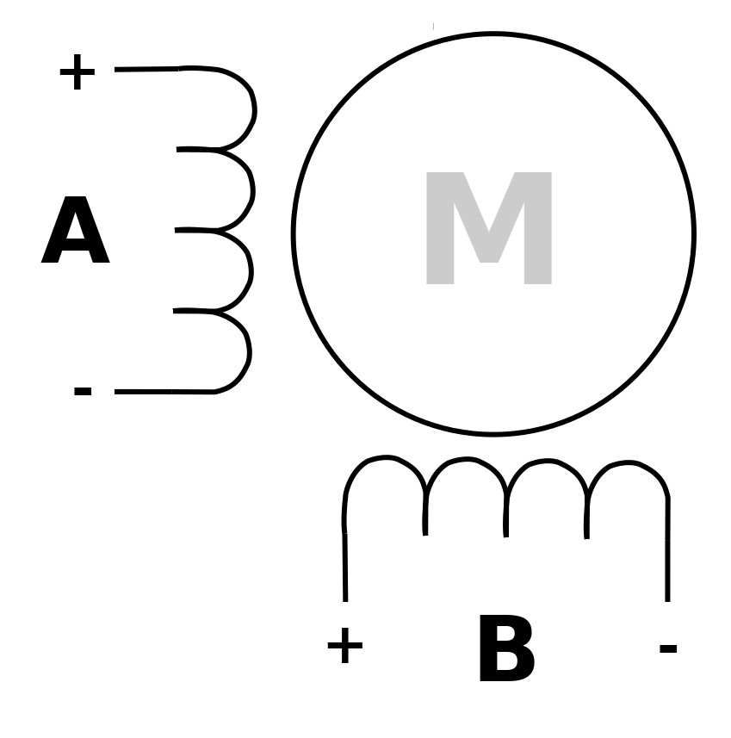
- There is no standard coloring scheme for stepper motor wires
- Use an Ohm Meter to determine which pairs are electrically connected
  - A pair will be less than 10 Ohms
  - The (+) and (-) terminals are arbitrary. If the motor is rotating backwards, swap the (+) and (-) terminals on A or B

Reset to Factory Defaults

- With power disconnected, press and hold Reset Button
- Connect Power while holding Reset Button
- Remain holding Reset Button for 5 Seconds
- Release Reset Button
- The Wi-Fi Stepper will revert to Factory Defaults

