As the crowded and competitive Democratic presidential primary field gradually winnows, Minnesota’s own Sen. Amy Klobuchar has soldiered on partially due to strong support from her home state.

The impact of Minnesota donors on Klobuchar’s campaign manifests in several ways, helping keep her in the presidential mix and setting her apart from her rivals months before either the crucial Iowa Caucus or the Super Tuesday voting deciding who gets the state’s delegates even begins.

Here’s some ways Minnesota has contributed to Klobuchar’s run so far:

Small donor data [suggests some indecision among Minnesota Democrats](http://www.startribune.com/undecided-democrats-spread-small-donations-across-the-presidential-field/559781472/) as two dozen presidential candidates jockeys for position, yet Klobuchar maintains a healthy statewide lead in donations, cash and unique donors statewide, even over Sen. Bernie Sanders who overwhelmingly won the state caucus in 2016.

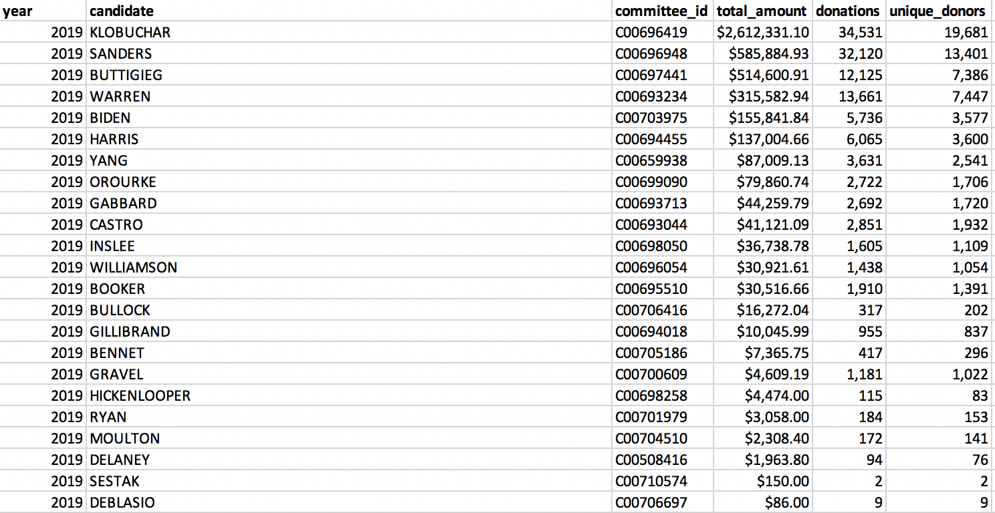

While about a fifth of Klobuchar’s 20,000 unique donors also gave to other candidates, about 80 percent gave exclusively to her campaign.

A combination of early Democratic enthusiasm, the raised profile of ActBlue as a donation tool and Klobuchar’s name in the ring are also likely factors driving Minnesota’s small donor engagement far past 2015’s pace.