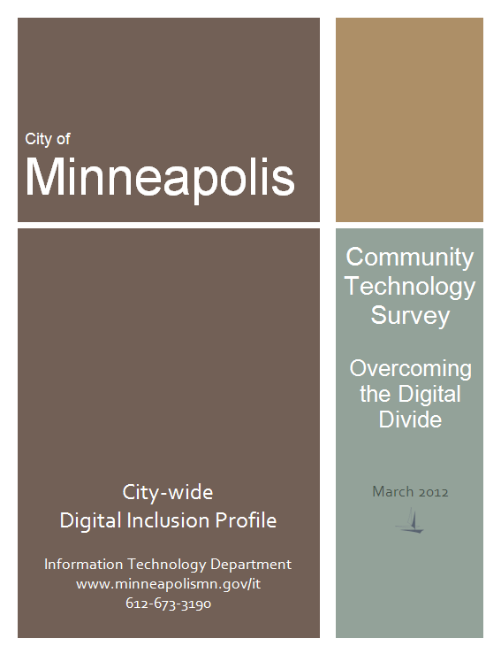

**Introduction and Overview**

Access to computers and the Internet, along with the skills to use these tools is critical as technology becomes more and more a part of our daily lives. The City of Minneapolis IT department conducted the 2012 Community Technology Survey, with the help of a grant from the Minneapolis Foundation Digital Inclusion Fund, to determine the state of the digital divide in Minneapolis. The survey gathered data about residents’ access to and experiences with computers, mobile devices and the Internet.

**Get Involved**

The City is taking on a facilitator role to help digital inclusion stakeholders, community members, and the private sector come together to address the digital divide in Minneapolis. This report is intended to generate ideas and actions to make the most of our community resources in light of the survey results.

**Access to Tools:**  People need affordable and reliable computers and broadband Internet access. Access opens up a world of possibilities and allows full participation in our society.

**Digital Literacy:** Beyond having access to technology, people need to understand digital technologies and how to use them effectively to achieve their educational, economic, civic, and social goals.

**Value:** To embrace the digital society, people must see the benefits to their life. The City is stronger, the more its residents take advantage of computing and the vast sea of knowledge the Internet offers.

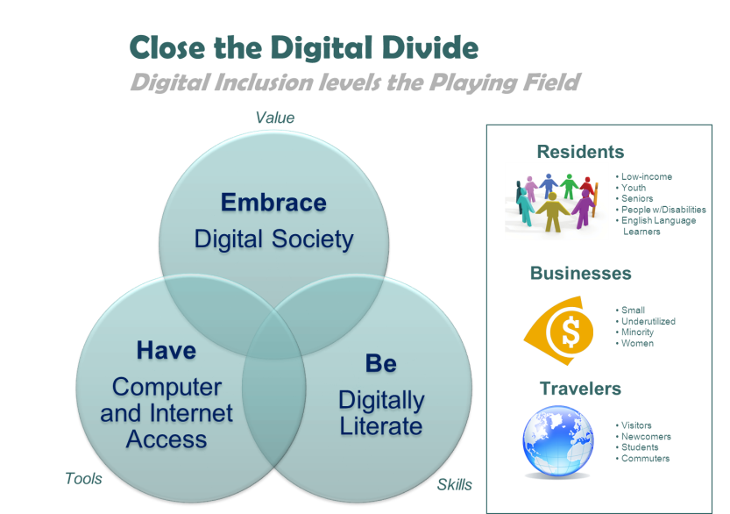 **Priority Principles**

**Why Does It Matter?**

* Job postings/applications have moved online.
* Employers need well-trained workers—most jobs require increasing levels of computer skills—to effectively compete with others around the world.
* Access to technology that promotes the pursuit of productive and creative interests enhances one’s quality of life.
* Education often depends upon Internet access—schools use online tools to communicate with students and families.
* The Internet offers access to the online economy, community and business resources, and social/civic engagement opportunities.
* Health care providers are increasingly using online tools to connect with patients.
* To prosper in today’s information-based world requires access to the world’s knowledge.

**Key Points from the Survey**

* While 82% of City households overall have computers with Internet access, only 57% of Phillips and 65% of Near North residents have access at home. 25% of African Americans reported they don’t have Internet access at home.
* Too many residents do not feel comfortable finding and applying for jobs online.
* Residents are not comfortable attaining education online.
* Residents aged 55 and older are least likely to be computer and Internet users.
* The Internet is not being used often by residents to find community resources, engage in civic activities or communicate with government.
* Residents are not seeking health information online.
* Residents do not feel they know enough to deal with cyber security issues.
* Most residents are not aware of the City’s Wi-Fi network.

**Citywide Results Highlights**  
Survey questions captured Minneapolis residents’ opinions and preferences related to technology, as well as their access to computers and the Internet.



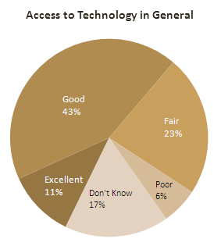Overall, residents thought somewhat favorably of technology in Minneapolis, saw computers and the Internet as important, had a computer and Internet access and accessed the Internet regularly (most commonly via a high-speed connection).

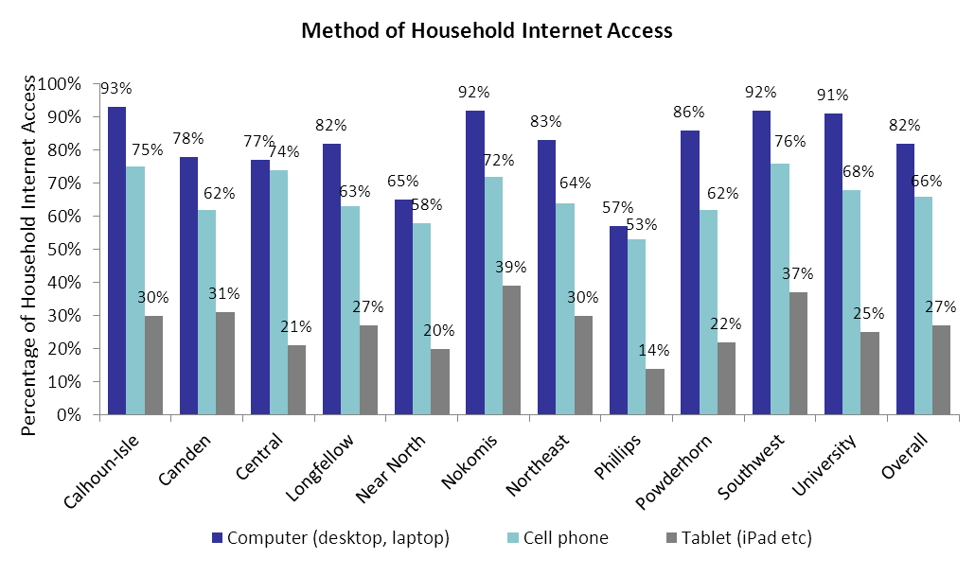Residents generally found help for any computer or Internet issues through a variety of means and participated frequently and comfortably in many basic digital activities, including emailing and using social media. However, meaningful differences were seen across the 11 communities that comprise Minneapolis as well as among different socio-demographic characteristics.

Non-user Profile

User and non-user profiles reveal more information about the digital divide in the city. Forty-seven of the questions on the survey had response categories that related to residents’ use of and comfort with technology; for each of these questions, response categories were divided into those that connoted “use” versus “non-use” and then each respondent’s total count of “non-use” answers was tallied. A respondent with 31 or more non-use responses was considered a “non-user,” 15-30 non-use responses was considered a “mid-level” user and fewer than 15 non-use responses made someone a “high-level” user.

When comparing use levels by community, high-level use was most common in the communities of Calhoun Isles and University while non-users were greatest in Phillips and Camden. 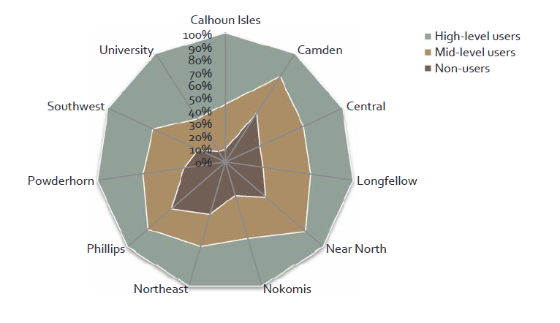

High-level users were more likely to laud the City’s use of technology, while non-users often said they did not know about technology in the city. A similar pattern held true for overall access to technology in the city; non-users felt unfamiliar and mid-level and high-level users gave positive assessments.

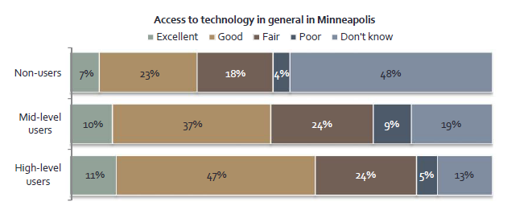

No high-level users described having Internet access at home as unimportant, while the plurality of non-users gave that response.

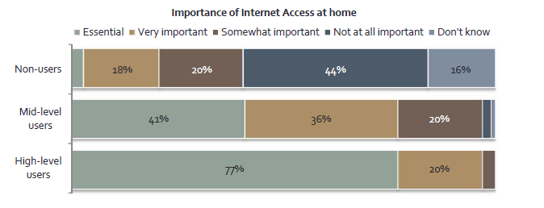

Income differentiated users and non-users; 9 in 10 non-users had household incomes under $50,000 (and 40% were under $10,000), while half of high-level users had incomes over $50,000 (and just 9% were under $10,000).

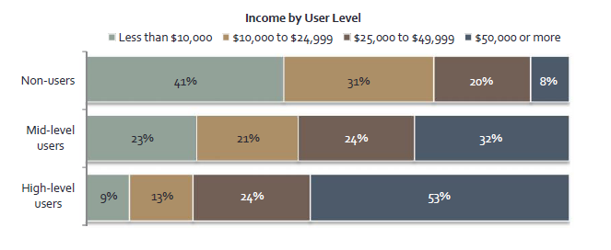

Race and ethnicity varied by user level, primarily in the composition of white and Black/African American residents. High-level users were 72% white and 10% Black or African American, while nonusers were 46% white and 34% Black or African American.

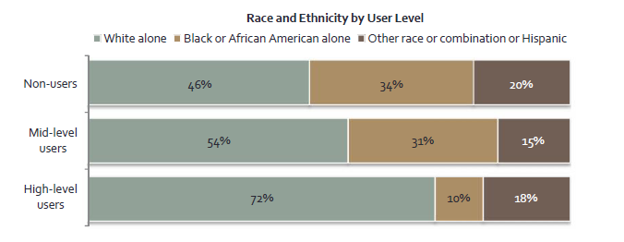

Race and Ethnicity Profiles

With 45% of African Americans not having a computer at home and 25% without Internet access at home, there is no surprise in this group not feeling computers and the Internet as important in their lives. They access the Internet the least and are not comfortable doing most online activities. African Americans seek help with technology at the library the most.

Asian Americans use computers the most at home (they are big users of game consoles with access to the Internet) and access the Internet outdoors the most. They most often take advantage of the Internet for training and education purposes. Asian Americans write and publish information on the Internet the most and create websites, blogs, etc. the most.

Native Americans more often feel no help with technology is available to them. They use social media and share opinions online the most. Native Americans use the Internet the most to find information on community resources/events, engage in civic activities, and look up information, such as in the health and medical field.

Families with Children Profile

Families with children use cell phones and tablet computers more and have the most Internet access at home. They seek entertainment venues and information on community resources and events the most. Families with children are the biggest user of social media. They are the most comfortable using a computer, using social media, job hunting online and using education tutorials.

**Points of Note**

While areas of the City of Minneapolis have digital inclusion gaps, the City needs to facilitate solutions to the following citywide challenges. [1]

**Tools:** Without a Computer and Internet Access, Embracing the Digital Society is Tough

* Overall 18% of households do not have a computer with Internet access at home, which translates into 29,437 households in Minneapolis.
* The majority of residents are not aware of the City’s WiFi network.
* Some areas of the City use dial-up access to the Internet—insufficient bandwidth.
* People primarily rely on their friends and family for help with computer or Internet questions. The next most common support methods include computer/Internet resources, Internet providers, and coworkers. Less frequent users are about four times more likely to go to the library for help than high level users. Libraries are also popular sources of help for unemployed job seekers, disabled respondents and those with less educational attainment. Renters in detached housing units were most likely to report they have no one available to help them.

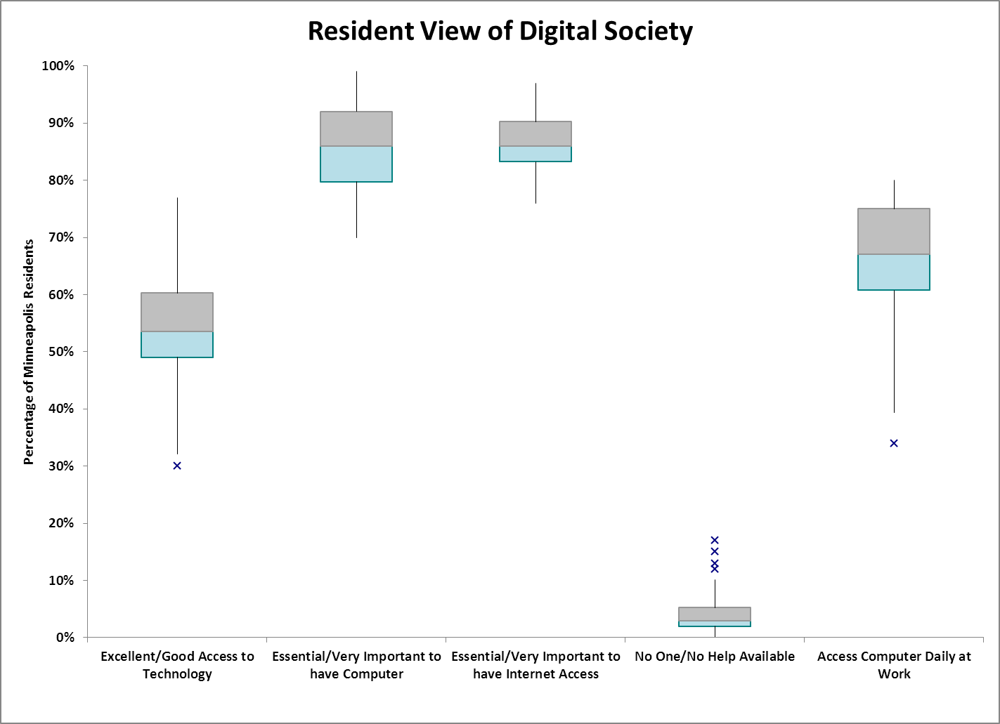

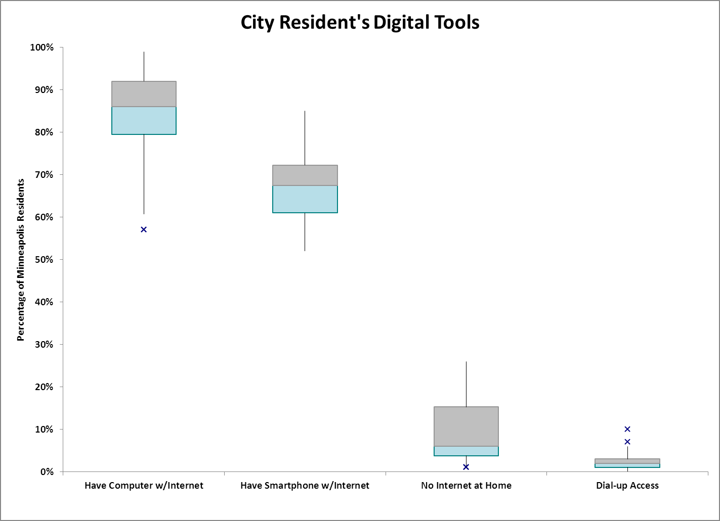

Getting Help

From a list of potential resources to help residents with computer or Internet questions and problems,

“friends or family” was cited most (59% of respondents). Near North residents were more likely than residents in other communities to say that no help was available to them. Phillips and Near North listed the library more often as a resource for help with 19% of Phillips residents and 13% of Near North responding that they get help at the library.

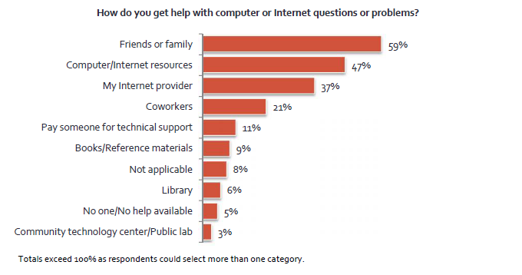

**Skills:** Reading, Writing and Arithmetic Are Now Joined by Digital Literacy

* Residents aged 55 and older are least likely to be computer and Internet users.
* Residents do not feel they know enough to deal with cyber security issues.
* Overall troubleshooting and software installation skills need improvement.
* Residents need skills in using the new online communication and collaboration skills—such as, publishing to the Internet, creating websites, maintaining blogs and even coding their own applications.
* Too many residents do not feel comfortable finding and applying to jobs online.
* Residents are not comfortable attaining education through online means.

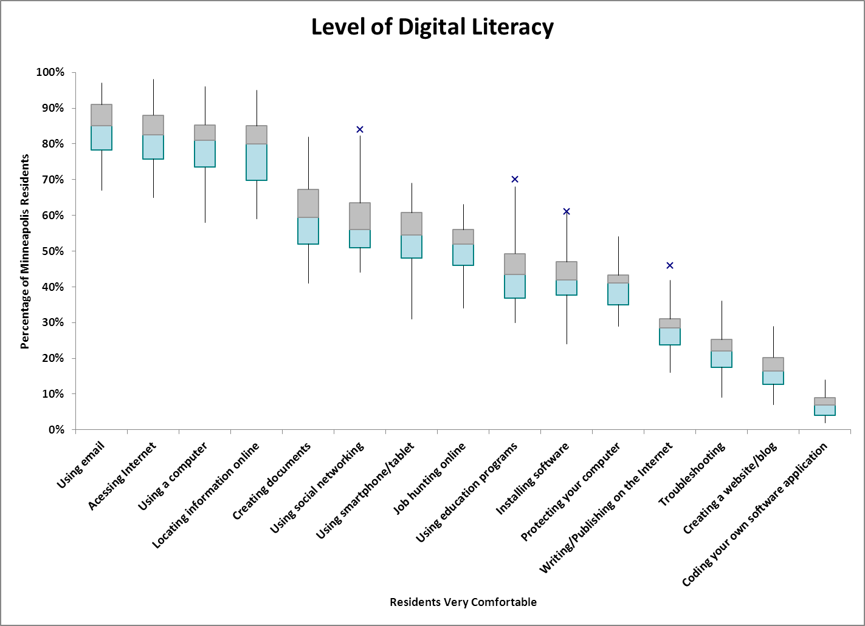

**Defining Digital Literacy:** In general, digital literacy means the ability to locate, evaluate, and use digital information. The digitally literate can efficiently find the information they seek, evaluate that information, and use that information effectively. The ability to recognize what information is needed and when to use it are additional components of digital literacy. Digital literacy also includes the ability to effectively use a range of technologies (such as computers and mobile devices) and Internet-enabled services (such as online publishing and engagement tools, social media, video/digital media tools). Without access, people cannot develop digital literacy; without digital literacy, they cannot gain maximum benefit from online resources. *(from American Library Association and http://www.plinternetsurvey.org/analysis/public-libraries-and-digital-literacy)*

**Value Proposition:** Technology Use Must be Compelling

* Retired and disabled people do not see the importance of computers and the Internet; hence, have the least technology at home and are the least comfortable using technology. They also use dial-up communications the most.
* Economic development through direct selling of goods and services on the Internet and working within the IT industry is not happening.
* The internet is not being used often by residents to find community resources, engage in civic activities or communicate with government.
* Residents overall are not seeking health information online.

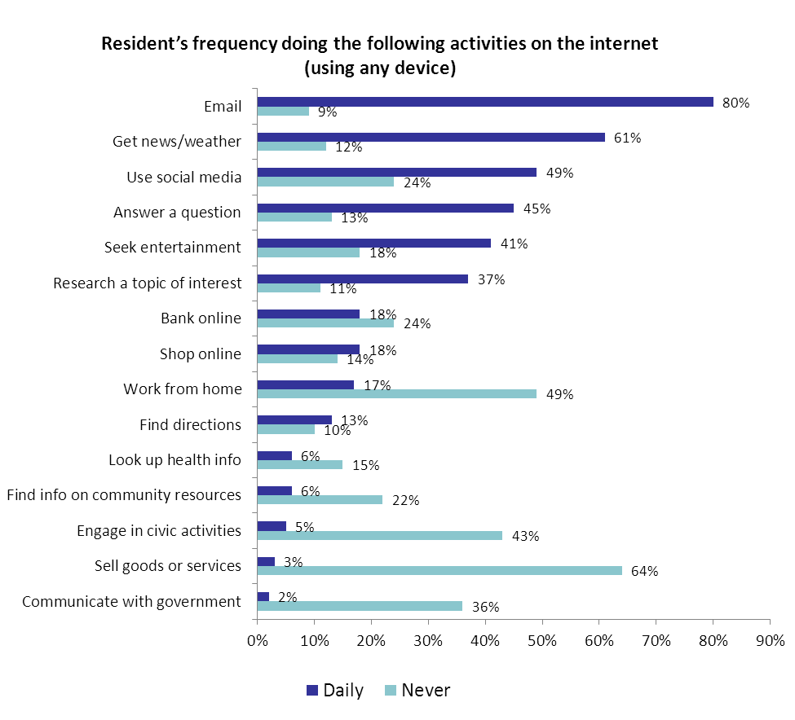

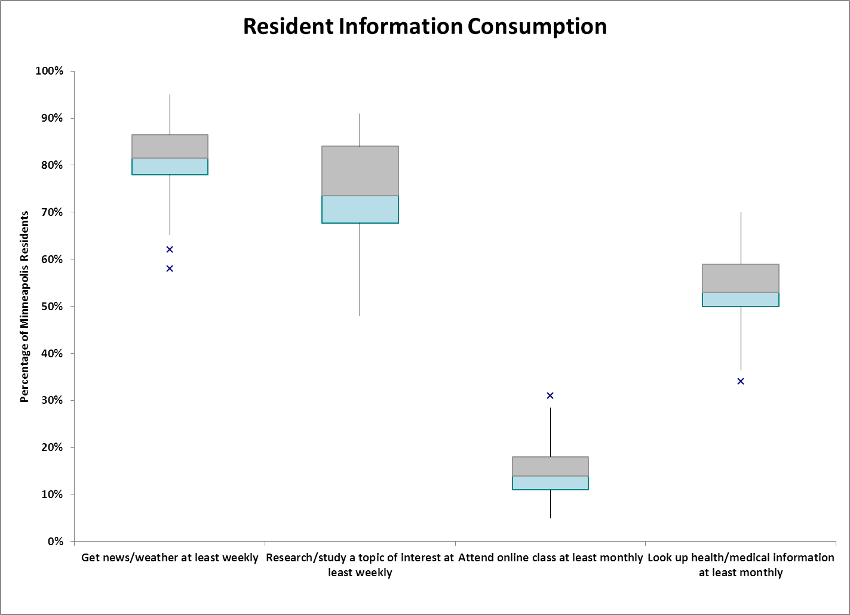

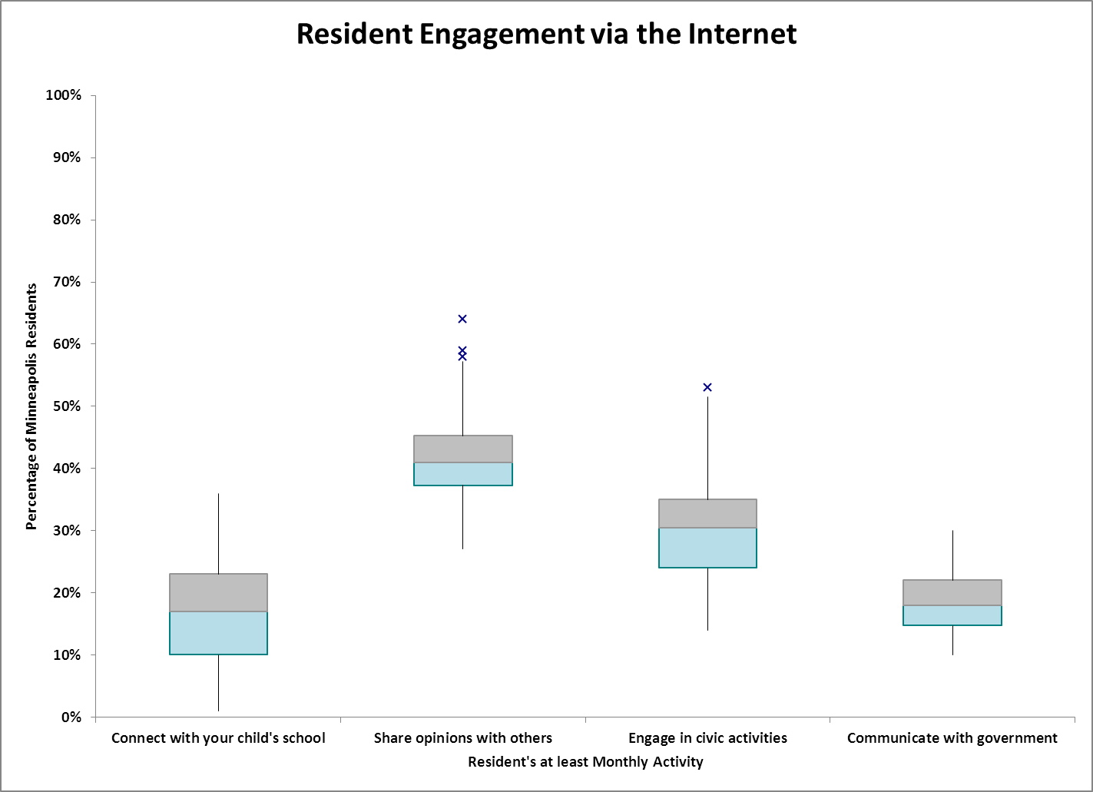

**Appendix: Background and Highlights of Results by Neighborhood Clusters**

**Survey Background**  
The City's IT Vision includes a component for addressing the digital divide in Minneapolis:   
  
*All City residents, institutions and businesses will have the tools, skills and motivation to gain value from the digital society.  Our residents and businesses need to be equipped to effectively compete with others around the world—to be smarter, more creative, more knowledgeable, and more innovative. The City becomes stronger the more its residents take advantage of computing and the vast sea of knowledge the Internet offers, to achieve their educational, economic, civic, and social goals. Leveraging technology is a necessary ingredient of success.*

The purpose of the 2012 Minneapolis Community Technology Survey was to gather data about Minneapolis residents’ access to and experiences with computers, mobile devices and the Internet. The results will inform priorities for the City’s digital inclusion initiatives, and help us engage businesses, neighborhood and community groups, public sector partners, and funders to more effectively address community technology and economic development needs.  In addition, the survey provides a baseline to measure changes in our community over time and our effectiveness at closing the gaps.

The City of Minneapolis IT Department contracted with National Research Center, Inc. to conduct a 2012 survey of residents to inform the City’s efforts to overcome the “digital divide”—the gap between individuals and groups in their access to and use and knowledge of information and communication technologies. Three mailings were sent to a random selection of 800 addresses in each of the 11 communities in the City, a pre-notification postcard and two survey packets, each just under a week apart. The 30% response rate reflects 2,578 completed surveys; the margin of error for comparisons by community is plus or minus nine percentage points. The results were weighted to reflect the 2010 Census profile within each of the 11 communities and the City overall.

The survey data was also aggregated around 32 neighborhood clusters. At the risk of using smaller sample sizes within the neighborhoods clusters, there is value in a more granular neighborhood view of the data to allow community members to see specific opportunities within their geographic area. City residents and their businesses need the tools (i.e. computing device and access to the Internet) to go online, need to be digitally literate to use those tools effectively, and must see value in incorporating computing and the Internet into their daily lives to fully embrace the digital society. Hence, the study analyzed the resident view of the digital society; profiled their digital tools; defined their level of digital literacy; showed their information consumption patterns; and showed their engagement via the Internet.

### Interactive maps show survey results for neighborhood clusters in Minneapolis at <http://bit.ly/KTbjPB>

The map layers show how each neighborhood cluster compares to the results for the city overall by showing if the cluster is in:

* Quartile 1 (Upper quartile, 75th percentile or above, compared to city overall)
* Quartile 2 (50%-74% range)
* Quartile 3 (25%-49% range)
* Quartile 4 (lower quartile, below 25th percentile)

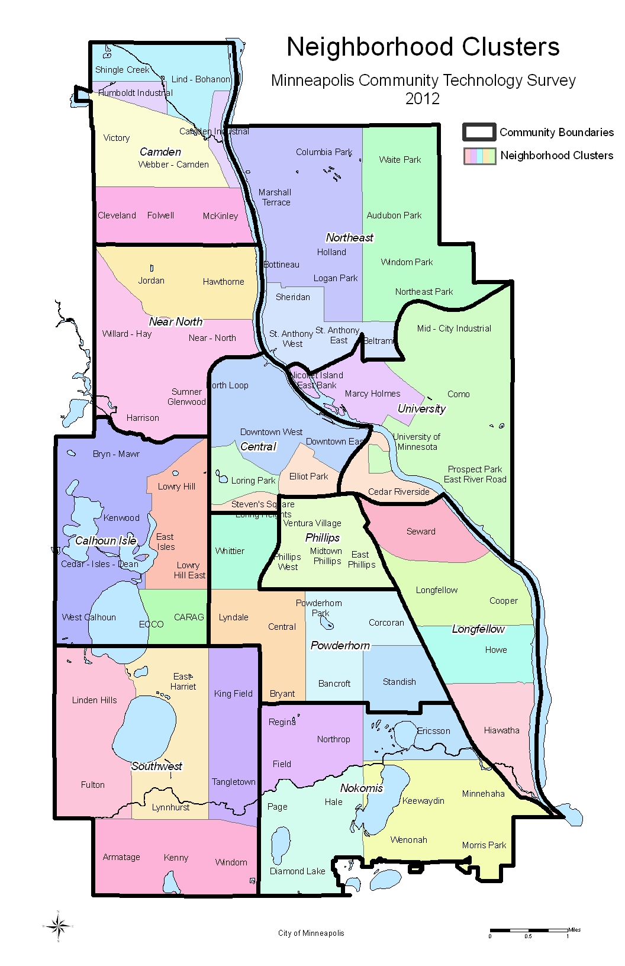

1. The following digital inclusion profiles make use of the technique of [descriptive statistics](http://en.wikipedia.org/wiki/Descriptive_statistics), a **box plot** or **boxplot** (also known as a **box-and-whisker diagram** or **plot**) as a convenient way of graphically depicting groups of numerical data through their [five-number summaries](http://en.wikipedia.org/wiki/Five-number_summary): the smallest observation ([sample minimum](http://en.wikipedia.org/wiki/Sample_minimum)), lower [quartile](http://en.wikipedia.org/wiki/Quartile) (a set of values are the three points that divide the data set into four equal groups) (Q1), [median](http://en.wikipedia.org/wiki/Median) (Q2), upper [quartile](http://en.wikipedia.org/wiki/Quartile) (Q3), and largest observation ([sample maximum](http://en.wikipedia.org/wiki/Sample_maximum)). A boxplot may also indicate which observations, if any, might be considered [outliers](http://en.wikipedia.org/wiki/Outlier) (an observation that is numerically distant from the rest of the [data](http://en.wikipedia.org/wiki/Data_set)). This graphical method for showing the median, quartiles, and extremes of data, points out where the data are spread out and where they are concentrated. The box represents the second and third quartiles, with a central line at the median. Whiskers extend to the smallest and largest points which are not classified as outlier points (which are represented by Xs).

   