Pokémon GO, as most probably know by now, is a worldwide mobile gaming phenomenon with people obsessively hunting their surroundings for Pikachus, Charmanders and more.

But for some players, the journey to “catch ‘em all" is tougher based on where they live.

[Pokémon GO](http://pokemongo.nianticlabs.com/en/) requires players to get outside and move around to find PokéStops, which are checkpoints where players can replenish vital supplies like eggs, potions and Pokéballs – items necessary to collect and maintain a growing stable of digital battle monsters and increase a character’s strength.

These pit stops, though, are found in publicly accessible spaces of local significance, creating heavy concentrations in urban corridors and leaving many players in rural areas and suburban neighborhoods struggling to keep pace.

Players in suburban or rural areas are more likely to see a map in Pokémon GO like the one on the left (from residential Maple Grove), without any PokéStops in sight, while someone in Minneapolis or St. Paul will more likely see a map like the one on the right (from downtown Minneapolis) with a couple dozen PokéStops represented by the blue checkpoints.

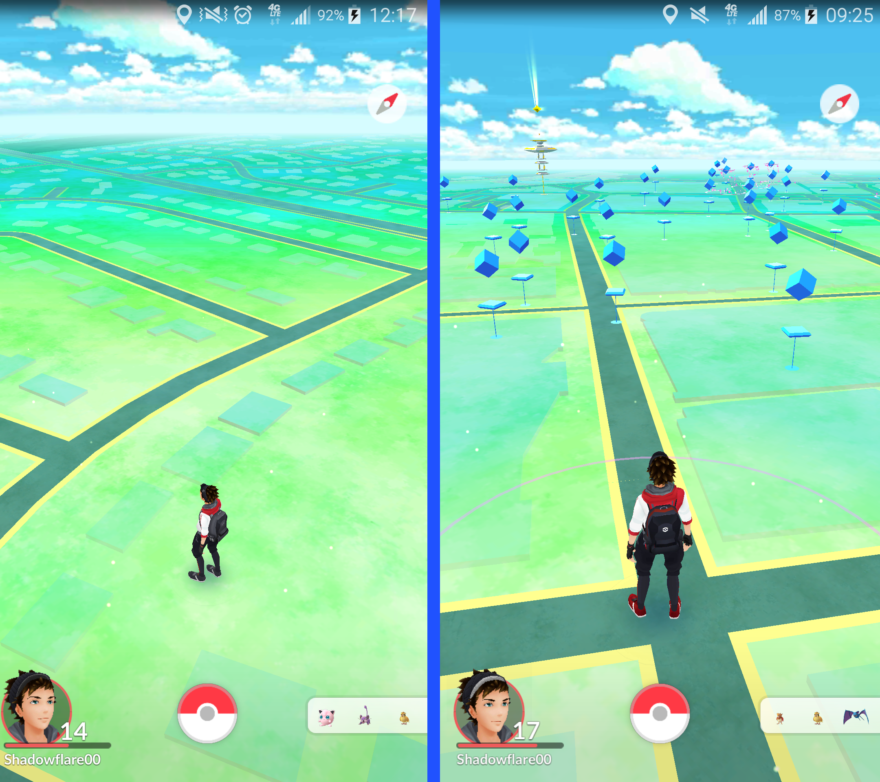

Social media and message boards across the Internet have been flooded with comments from users frustrated by the lack of PokéStops near them.

“Only landmarks near me are the post office and some dilapidated bookstore that looks like it went out of business 10 years ago," said Reddit user [Czsixteen](https://www.reddit.com/r/gaming/comments/4s81ah/when_your_town_is_pokemon_af/d57b77k)last month.

PokéStop and "gym" locations in Pokémon GO are drawn from developer Niantic’s previous augmented reality project, Ingress, a game where players on two opposing teams compete for control of crowd-sourced portals. Ingress launched in 2013, with portals added gradually since then. The portals were repurposed for Pokémon GO.

The game is really built for pedestrians, and perhaps cyclists, with the hatching of new Pokémon eggs tied to how far you walk. Driving and playing Pokémon GO is discouraged by in-game messages and common sense.

Data from the [official Ingress intel map](https://www.ingress.com/intel) reveals a favoritism toward public spaces with landmarks in dense urban corridors – historical markers, statues, museums, old churches, skyscrapers, street art, city parks and the like. Gyms and stops around residential suburban communities are fewer, further between and stretched across landscapes less friendly to walking.

Big public spaces in urban areas are prime Pokémon hunting territory, including the downtown cores of Minneapolis and Saint Paul, Victory Memorial Parkway, the State Fair Grounds in Falcon Heights and elsewhere across the Twin Cities and their first-ring suburbs.

The further out one gets, there are fewer public spaces (more private residential land) and the harder it gets to find these game markers. That, in turn, makes the game more challenging.  In order to catch the Pokémon characters that randomly pop up, a player needs to have supplies -- particularly Pokéballs -- that you can only get by finding a PokéStop, leveling up or by purchasing them through the app.

Some property owners have complained about Pokémon hunters flooding neighborhoods where rare creatures have appeared. And there have been complaints from the Holocaust Museum in Washington, D.C. and other less-than-appropriate locations for video games, as well. Niantic [has reportedly been working to remove PokéStops and gyms from organizations that have filed complaints](http://www.nbcnews.com/tech/video-games/pokemon-go-creators-working-remove-problematic-pokestops-n619856" \t "new).

The ability for players to request new PokéStops [was briefly available some weeks ago](http://kotaku.com/you-can-now-request-new-pokestops-and-gyms-in-pokemon-g-1783669406" \t "new_), but has since disappeared. A Niantic representative said a “huge number" of requests have flooded in for new Pokémon GO stops and gyms, and that the company isn’t in a position to process them until the game completes its global launch.

The map below, a sampling of Ingress portals, gives you an idea of how both Ingress and Pokémon GO players will have far better luck in some parts of the state than others.

Click on any of the buttons at the top to zoom the map to various parts of the state, or use the search box below the map to zoom to your address or city.

Disclaimer: This data is a sampling from Niantic's Ingress intel website. Niantic is not responsible for the content of this map. It is not meant as a gaming guide. The map does not represent every landmark and doesn't necessarily show every PokéStop.

**Data Drop** is a weekly feature that uses data analysis and visualizations to explain, surprise, inform and entertain readers on topics relevant to Minnesotans. Do you have an idea you'd like us to explore?[Contact MaryJo Webster](mailto:MaryJo.Webster@startribune.com)