**Mike Johnson, who leads the University of Minnesota Technology Leadership Institutes master’s program.**

**Director of graduate studies for the Master of Science in Security Technologies**

“The price for convenience, for cool functionality, is your privacy.”

“Data that once seemed innocuous or benign before can really impact a person.”

Users have some control over what they share, so it’s a good idea to do your audit. Even if you think you’re careful or have things turned off, there might be other things still turned on.

“You’re not going to leave your physical possessions unprotected,” he said, and that users need to take a breath before diving in headline and take stock of what they’re trading away or leaving unsecured when they using these services.

“The most important asset you have is your privacy and your identity.”

**Jamie Lee Williams | EFF Staff Attorney**

People can’t really comprehend what they’re giving to these companies.

“Everywhere you go can reveal so much about your life and your patterns,” she said. “It’s some of the most sensitive information people are giving out.”

Feature has been around a few years

It’s mostly on Google-powered devices

Opt-in, though not everyone may realize what that means, were probably prompted at some point during setup

But with all the talk of digital privacy in the news related to Facebook, fake news and how everyone is being tracked, it’s a good reminder that owning a digital device or being a social network pretty much requires a massive sacrifice of personal information privacy

It tracks your distance, elevation, [whether you’re walking, riding or driving and much more](https://qz.com/1183559/if-youre-using-an-android-phone-google-may-be-tracking-every-move-you-make/)

It can be cleared either selectively or all at once

But knowing is half the battle, and how much it tracks isn’t necessarily immediately made clear to users

Chances are pretty good your smartphone, if you have one, is transmitting your location everywhere you go. It knows the name of nearly every pub you crawled, store you shopped in and cinema you sat in.

It’s very likely that data is being transmitted to Google and other tech giants in an effort to better understanding your likes, habits and surroundings.

Sure, generally speaking, people realize technology companies, the government, hackers and untold legions of unseen others are collecting every byte of their digital information.

So those Americans may not be surprised to learn their phone knows everything about them and doesn’t really keep it a secret. My own expectations of privacy in the Information Age are lowkey at best.

**UMN TIL REP QUOTE**

But seeing the data in its entirety might lend a different perspective. When I mapped my Google location data, even I was surprised by its detail.

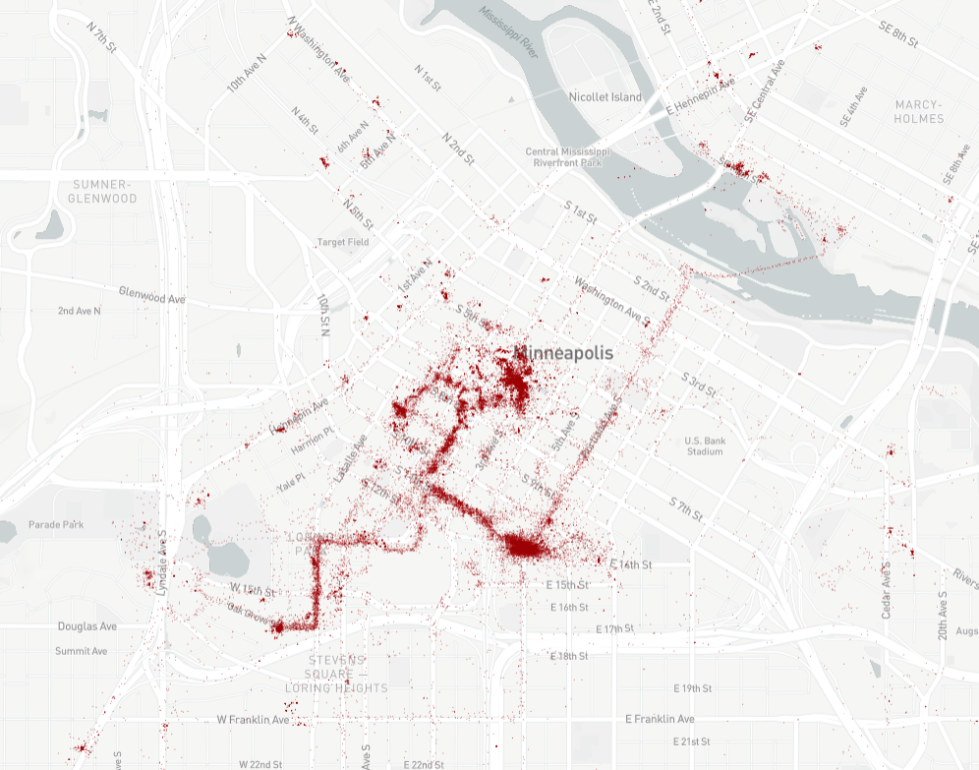

That’s a map representing nearly everywhere I went in Downtown Minneapolis for more than a year – totaling about 400,000 data points, represented by tiny red dots -- meticulously tracked over the lifetime of two different Android-based smartphones.

Here’s a sample of a typical, uneventful day for me on Wednesday, March 14, 2018, as logged by Google Maps:

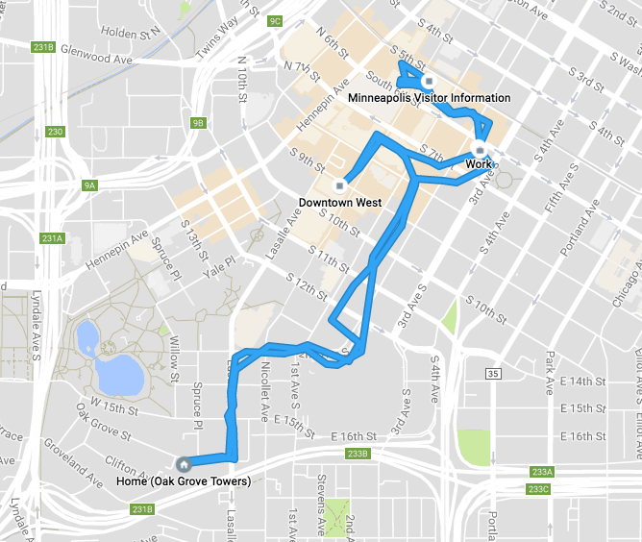

The data is viewable one day a time using Google Maps Timeline, but users can download their entire history using [Google Takeout](https://takeout.google.com/settings/takeout?pli=1). Using some digital magic, I converted the data and mapped all the points spanning 2016 through 2017, granting a more complete look at how much of my life is being transmitted to Google.

**EFF REP QUOTE**

This feature seems to particularly affect phones using Google Maps on the Android operating system, which in 2017 [represented a nearly 90 percent market share](https://www.statista.com/statistics/266136/global-market-share-held-by-smartphone-operating-systems/) among mobile devices. [iPhones have also been tracking user locations](https://www.wired.com/2015/11/how-to-get-rid-of-the-iphone-map-that-tracks-you/) in different ways as well, though seems to send less to Google.

It’s possible to just turn off the phone’s GPS, but that cripples a lot of apps, including the ones we use to not get lost. Instead, the locations feature [can be specifically deactivated](https://support.google.com/accounts/answer/3118687?hl=en).

**GOOGLE QUOTE**

This location data, of course, represents a tiny fraction of the information Google and other tech companies collects about people, which also includes the emails, texts, search history, app usage, relationships, social networks and myriad other bits of data being rounded up and analyzed to better understand their customers’ habits, wants and needs.

**FINAL QUOTE**

**MAP EMBED**

**<strib type="text" data="<style type='text/css'>.dataframe{height:400px;} @media only screen and (min-width: 200px) and (max-width: 767px){.dataframe {height:400px;}}</style><div class='embed'><iframe class='dataframe' src='http://datadrop-dev.startribune.com/20180329-gps_tracking/build' border='0' frameborder='0' scrolling='no' width='100%' height='400'></iframe></div>"></strib>**

**MAP IMAGE**

**<img src=”**[**http://datadrop-dev.startribune.com/20180329-gps_tracking/build/img/compare.png**](http://datadrop-dev.startribune.com/20180329-gps_tracking/build/img/compare.png)**” width=”100%”  />**