**To do list:**

-requesting enrollment by race data for each school going back to at least late 1980s (maybe longer?). Matos

-Test score data. We have data back to 2002 in-house. Webster.

-Open enrollment data by race or at least by district. Matos checking on this (might have it)

-School boundary map files. Webster and Matos looking into

-Teacher turnover data?

-Figure out how to define segregation. How other people have measured it.

--Demographic data on school-age population from Census. Webster

--Free & reduced price lunch data. Webster (might need to put in request for older stuff)

**Discussed at Sept 18 meeting :**

--Need to keep eye on breaking news (NAACP suing districts? Other action?) and be ready to publish as soon as possible

--Want scope to be metro-wide, including suburbs

--Need to show consequences, not just tell people what happened

--Let’s try to get data visualization to reporters as soon as possible so they can explore the data

**Other stories we can get inspired by:**

ProPublica: <https://www.propublica.org/article/segregation-now-full-text>

Tampa Bay- Failure Factories: <http://www.tampabay.com/projects/2015/investigations/pinellas-failure-factories/>

(scroll down to see analysis)

**Analysis as of Oct 2nd:**

This is using an 80% threshold recommended by Myron Orfield. This means that we’ve identified a school as “segregated” if the population is either 80% or more white or 80% or more minority. Previously we had used a 75% threshold and Orfield said that would also be fine to use, but he recommended going a little higher. We found that the trend lines remain the same, but tightening it up does make it a tad more interesting. And it also makes our approach more conservative-- which is what you want to do in a situation like this.

A couple other things to note:

* This only covers elementary schools in the 7 county metro
* All charter schools are in their own group and not included in the other groups, regardless of where they are located

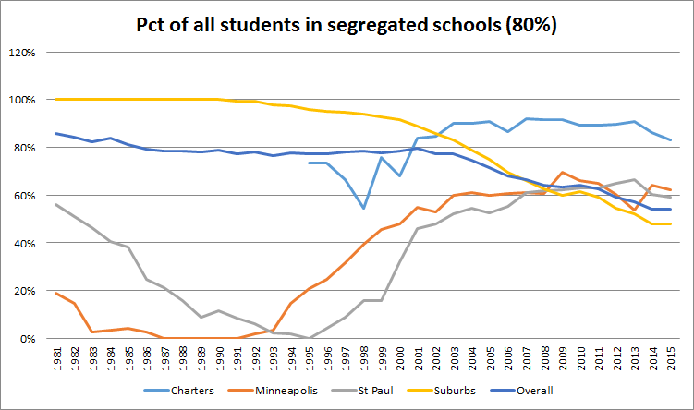

Here’s that same chart, except the suburbs line is split into two lines -- inner ring (inside the 694/494 beltway) and outer ring. (suburbs=7 county metro area)

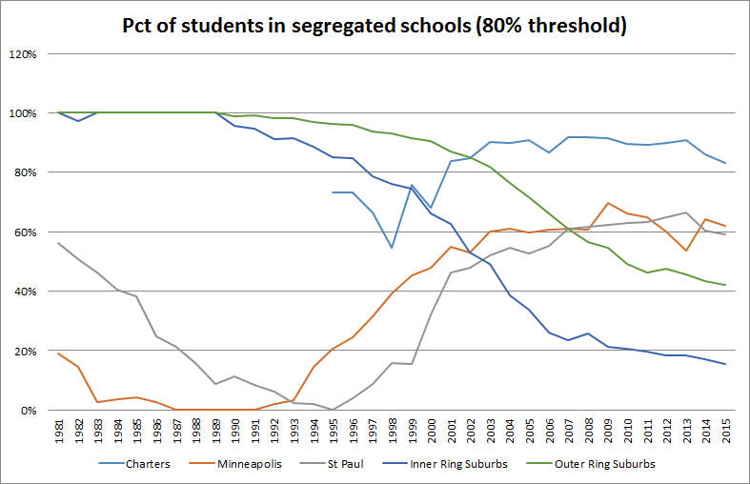

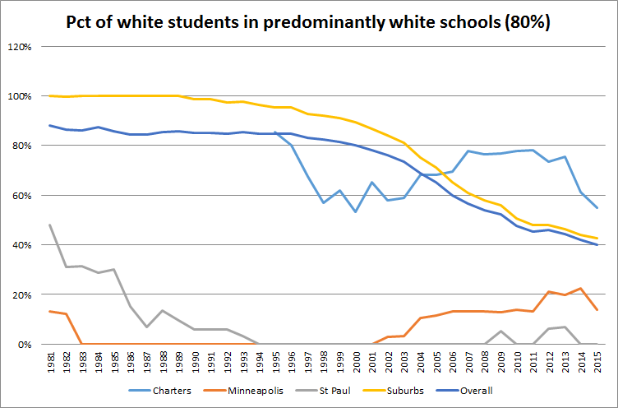

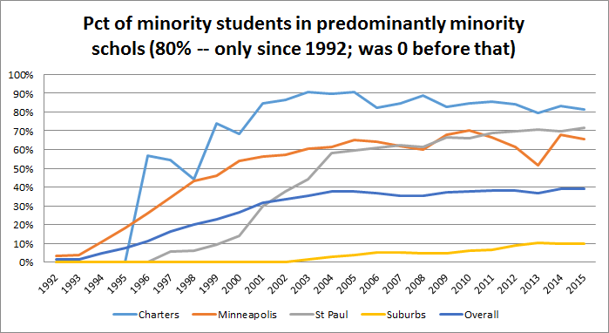

The next two charts provide some overall context to what’s been happening in the schools in terms of diversity change over time:

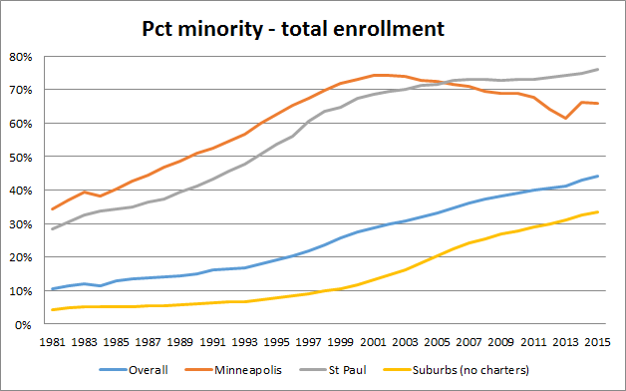

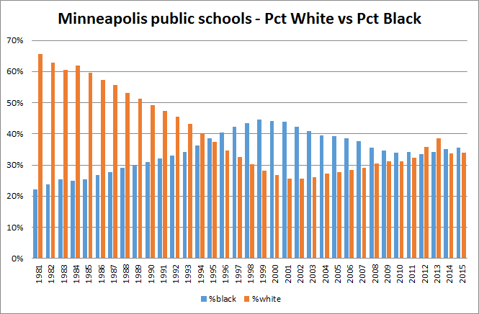

The next charts use Census data to look at the overall population (all ages) based on where they live. Using the same methodology as we did with the schools, I calculated whether census “block groups” were segregated (80% or more white or 80% or more minority) in 1990 and again with the most recent data (which is through 2013) so that we can look at the overall segregation in these communities and how that has changed over time.

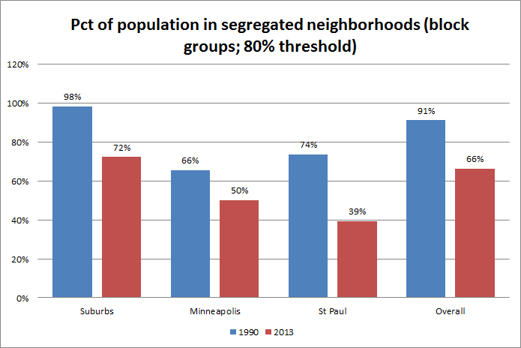

The next two just look at the white population and the first chart is on the population and the second is on the schools – note that Minneapolis white population living in predominantly white has dropped, but that same number for schools has gone up. But also note that Mpls white population is MORE segregated than St Paul

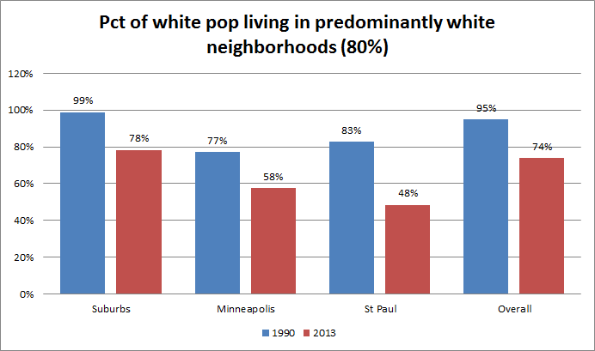

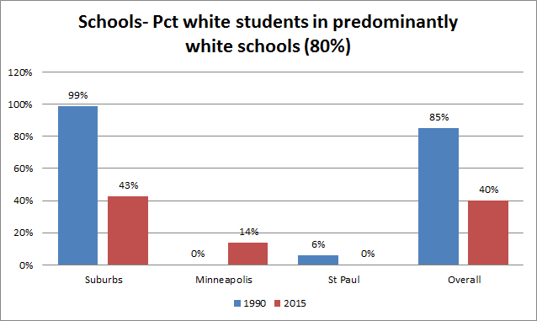

This next chart gets at Eric’s question about the diversity of the school-age population. The ENROLLED student population at Minneapolis Public Schools is more diverse (66%) than the overall school-age population of the city (57%) and the same is true in St. Paul – in fact it’s even more pronounced – and it’s also true among the suburban schools.

This means that a greater share of white students are fleeing to either private schools or charter schools.

With a bit more time and effort I can go back to a previous point in time – 2000 perhaps– and do this same comparison.

For context, about 30% of the ADULT population in Minneapolis is minority; 35% in St Paul and 13% in the suburbs (see below for a separate chart that shows the full population, all ages). So this is also an indicator of what’s coming down the road. Having majority-minority schools – across the board – is in the very near future.

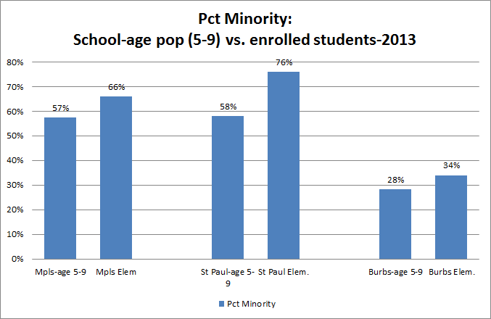

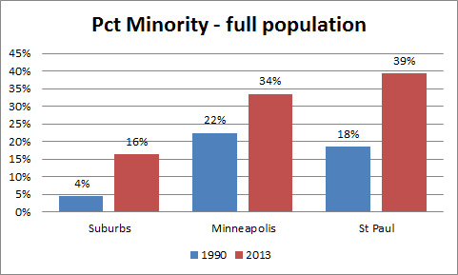

There are 74 schools (out of 441) that are segregated, but located in a neighborhood that is NOT segregated (20 in St Paul; 13 in Minneapolis; rest in suburbs)

166 schools that are diverse, but located in a segregated neighborhood (16 in Minneapolis; 10 in St Paul; rest in suburbs)

Interestingly, the schools located in St. Paul’s most segregated area (Highland Park) are all considered “diverse” by our measure

And North Minneapolis schools are all segregated – not all the neighborhoods meet our 80% threshold, but all are 50% or more minority.

**Charter schools**

Currently – about 58% of students in charter schools are in schools that are predominantly minority (“segregated minority” in the chart) and 19% are in predominantly white schools. In 1996, those figures were 27% and 46%, respectively. And you can see that in the late 1990s, the percentage of kids in a “diverse” charter school reached a peak of about 45% in1998. Now it’s 23% (it was at 9% in 2008)

So bottom line is that more than three-quarters of charter school students are in a segregated school

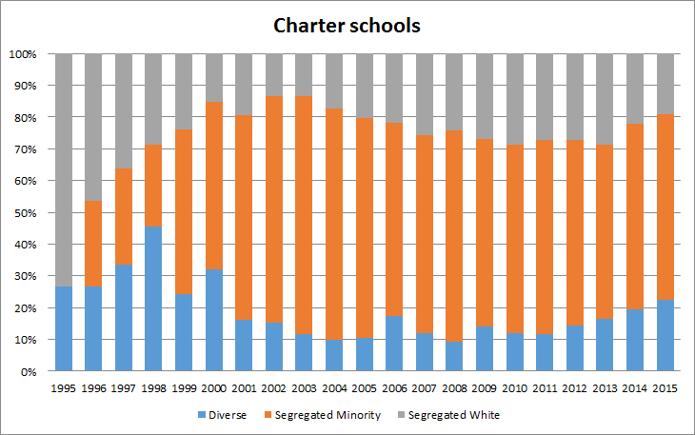

Looks like suburban charter schools have diversified ; St Paul-based charter schools have gotten slightly more segregated; Minneapolis-based charters are mostly unchanged in quite awhile

As you can see, these percentages were all over the road until more recently. But those early years with the big ups and downs had about one-third the number of charters that there are now (see subsequent charts to show change in number of schools and student population)

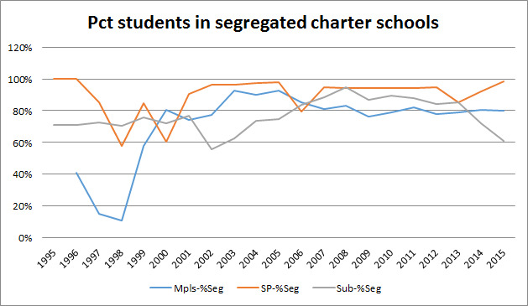

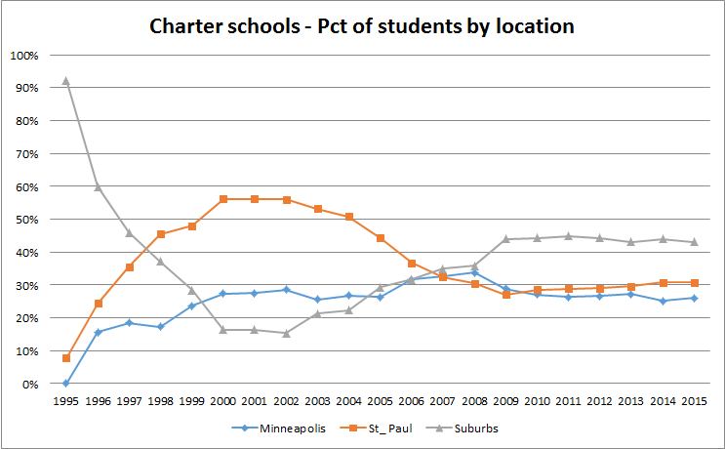

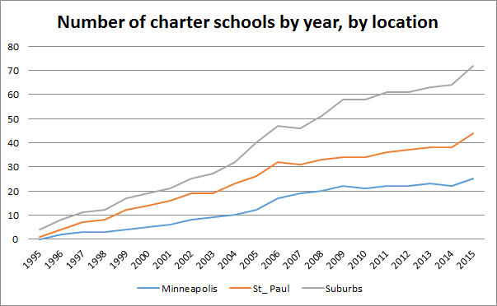

This next chart is the same data as above -- just displayed differently:

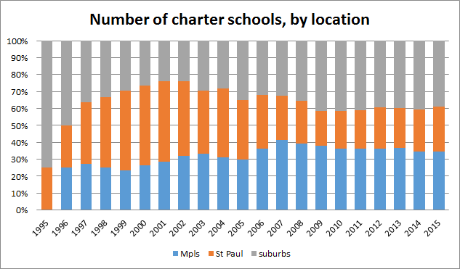

TEST SCORES:

Minority students who attend “segregated white” schools do far better than their peers at other schools – 65% proficient in reading and math (combined), compared to 49% at “diverse” schools and 28% at “segregated minority” schools.

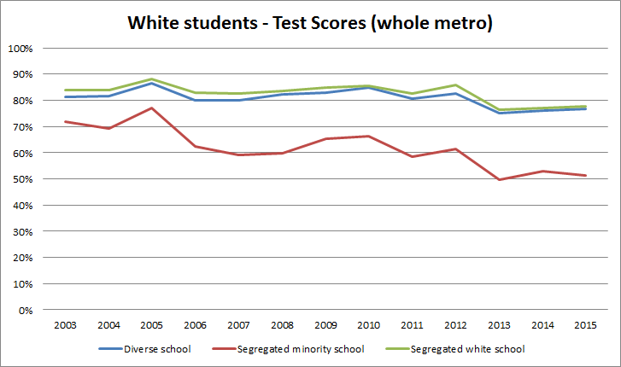

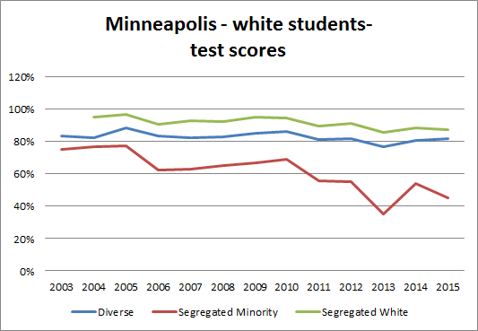

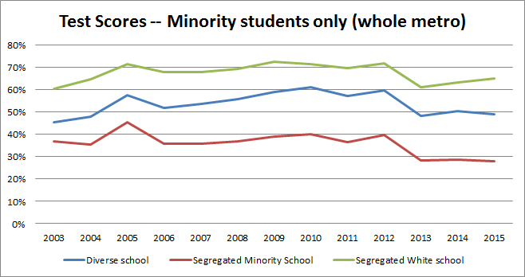

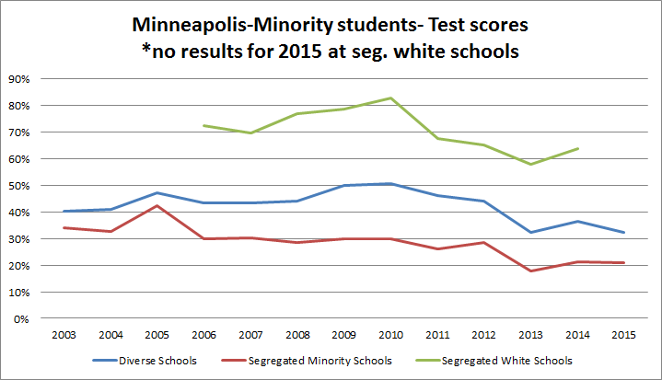

As a comparison point, I ran the same analysis on just the “free and reduced price lunch” kids (regardless of race). You’ll see that it’s very similar to the top (minority) graph, although the scores are lower. at “segregated white” schools, they have 55% proficiency; at diverse schools it’s 44% and at “segregated minority” it’s 27%

This shows just how powerful a factor poverty is and that poor kids are doing better in diverse (and predominantly white) school settings. And it makes me wonder if we should look at “segregation” by socioeconomic status and see how it compares? We’d need free and reduced price lunch data. MDE has it on their website going back to 1997-98, but each year is in a separate file.

