Last year, more than $8.4 million was paid out in response to claims or lawsuits regarding law enforcement misconduct in Minnesota. Only one other year in the past decade has been higher and that’s solely due to a $3.6 million payout stemming from the Metro Gang Strike Force lawsuit.

Between 2007 and 2017, about $60.8 million was paid out statewide on 933 claims or lawsuits, encompassing 191 agencies.

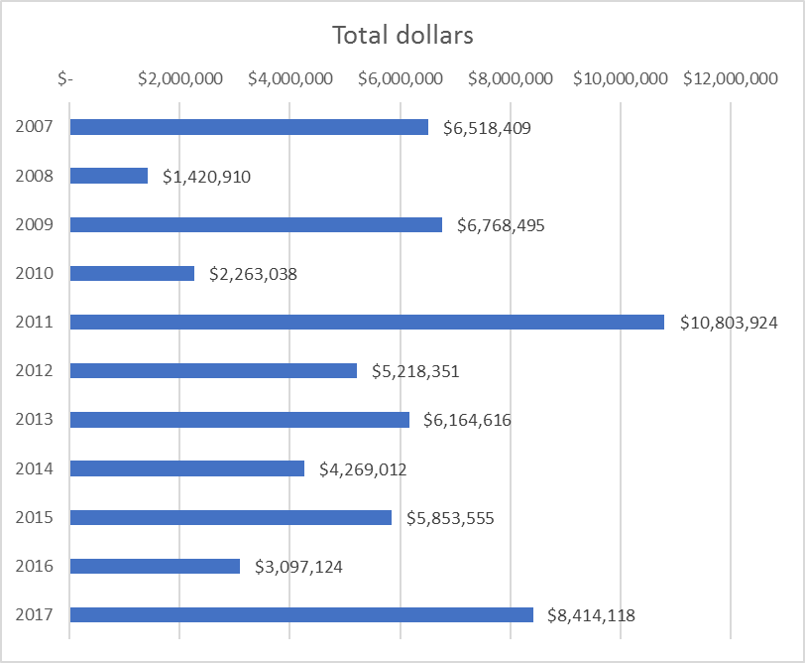

Here’s another way to look at it, showing Minneapolis makes up a large share each year:

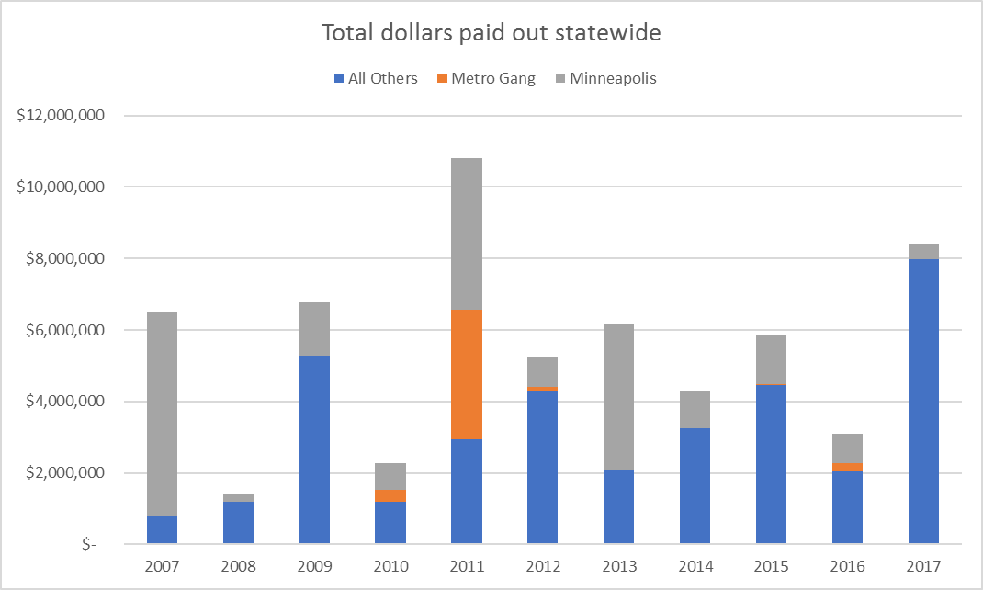

In the chart below you can more easily see how the big payouts - $1 million or more – tend to skew the yearly totals. Last year there were 3 big payouts totaling nearly $6.5 million. Without those three cases, last year would’ve been among the lowest in the past decade.

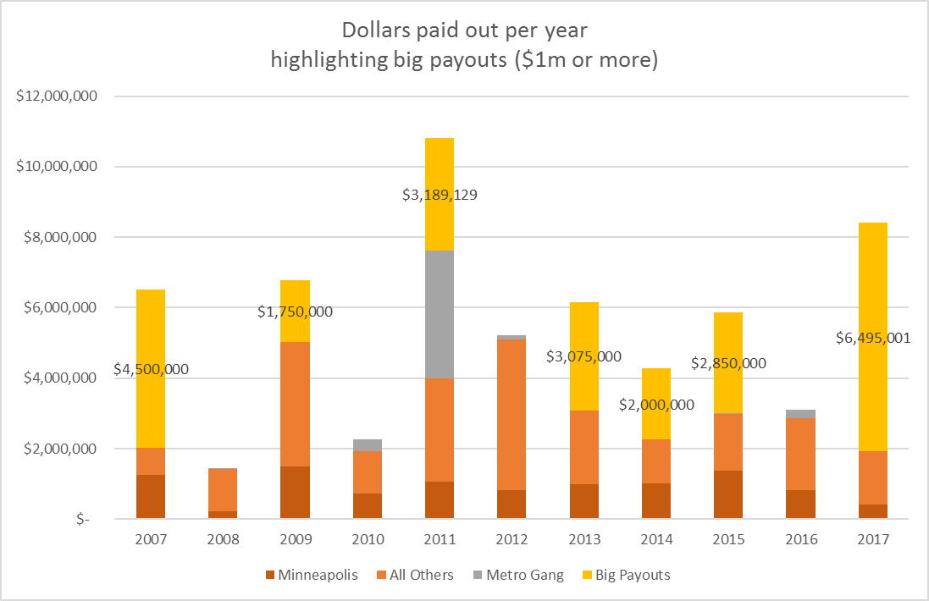

The number of payouts each year has been higher in recent years than a decade ago. Last year there were 109 statewide. Only 2015 (with 112 payouts) and 2012 (with 110) were higher.

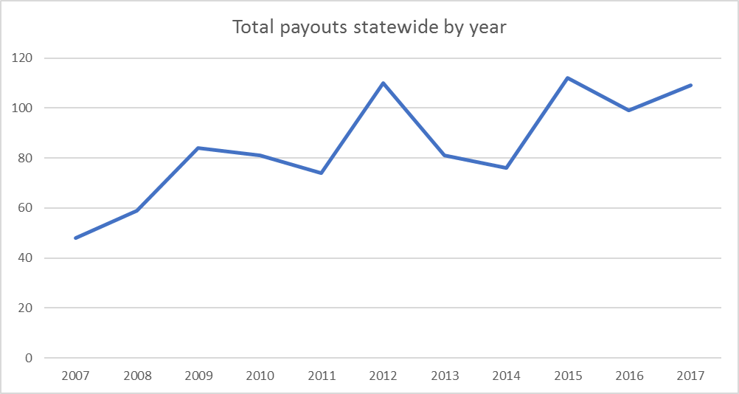

Minneapolis accounts for 21% of all payouts and 35% of the dollars paid out between 2007 and 2017.

That’s 195 payments, totaling nearly $21 million.

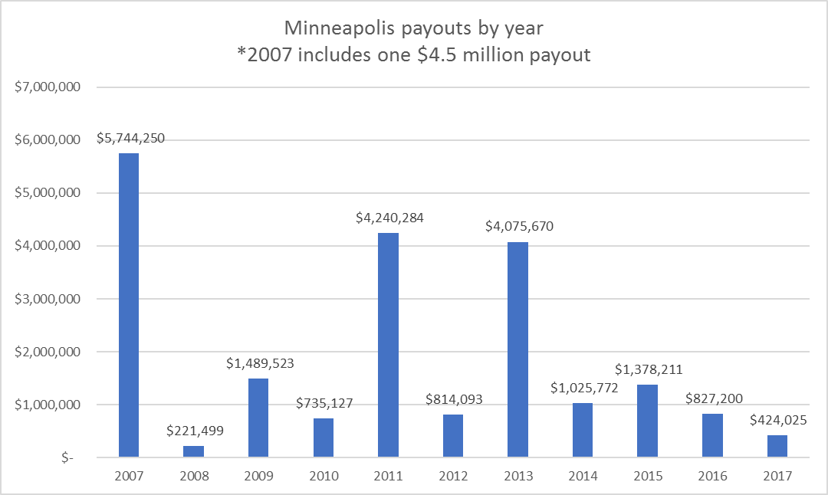

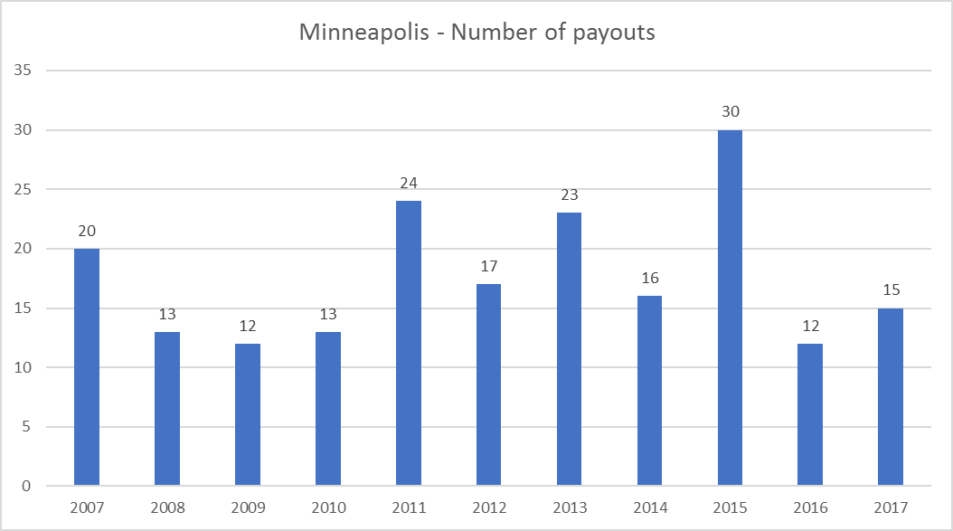

There have been 11 payouts of $1 million or more, including the Philando Castile payout and two others that account for why last year was such a high year.

|  |  |  |  |
| --- | --- | --- | --- |
| Payouts of $1 million or more |  |  |  |
|  |  |  |  |
| Minneapolis PD | Duy Ngo | $4,500,000 | 2007 |
| Metro Gang Strike Force | Dagoberto Rodriguez | $3,625,000 | 2011 |
| Minneapolis PD | Larry Smith | $3,075,000 | 2013 |
| **St Anthony PD** | **Philando Castile** | **$2,995,000** | **2017** |
| Brooklyn Park PD | SHOUA YANG | $2,850,000 | 2015 |
| Minneapolis PD | Dominic Felder (Katie Felder) | $2,189,129 | 2011 |
| **St Paul PD** | **Frank Baker** | **$2,000,000** | **2017** |
| Koochiching SO | Kathryn Schneider | $2,000,000 | 2014 |
| Meeker SO | Gail Simpson class action | $1,750,000 | 2009 |
| **Chaska PD** | **Dawn Pfister** | **$1,500,001** | **2017** |
| Minneapolis PD | Rickia Russell | $1,000,000 | 2011 |

1. The biggest awards in last decade totaled $27 million.
2. Three, totaling $6.5, occurred in 2017
3. In all but three, the victims and families were represented by Bob Bennett’s law firm, with two of the three by Bennett himself, including Philando Castile, killed by a St. Anthony cop, Frank Baker, who was kicked by a St. Paul policeman and bitten by a police dog, and Dawn Pfister, shot and killed by a Chaska police officer in Eden Prairie after a high-speed chase in which her boyfriend was the driver.
4. Bennett or his firm represented seven of the top cases of the decade. Bennett was last profiled in the Star Tribune in 2005 by Dave Peterson. Ruben Rosario did an extensive interview of him in the summer of 2017 after the Castile settlement.
5. 4 of the top awards were Minneapolis police incidents.

Agencies with the most payouts over the past decade:

|  |  |  |
| --- | --- | --- |
| AGENCY | CLAIMS | TOTAL PAID OUT |
| Minneapolis PD | 195 | $ 20,975,654 |
| St Paul PD | 68 | $ 5,052,061 |
| Bloomington PD | 38 | $ 756,740 |
| Rochester PD | 37 | $ 98,172 |
| Brooklyn Park PD | 35 | $ 3,319,708 |
| Metro Gang Strike Force | 29 | $ 4,320,388 |
| Ramsey SO | 25 | $ 991,250 |
| Eagan PD | 20 | $ 147,932 |
| Woodbury PD | 20 | $ 75,513 |
| Moorhead PD | 11 | $ 24,884 |
| Blaine PD | 11 | $ 265,190 |

We looked at law enforcement agency totals between 2007 and 2017 as a per capita rate. Among agencies that serve 15,000 or more people, Mille Lacs Sheriff’s, Minneapolis, Brooklyn Park, Bloomington and New Brighton PD top the list in terms of number of payouts per 10,000 people.

|  |  |  |  |  |
| --- | --- | --- | --- | --- |
| AGENCY | CLAIMS | TOTAL PAID OUT | POP SERVED | Claims per 10k |
| Mille Lacs SO | 9 | $ 1,005,000 | 16631 | 5.4 |
| Minneapolis PD | 195 | $ 20,975,654 | 413479 | 4.7 |
| Brooklyn Park PD | 35 | $ 3,319,708 | 79433 | 4.4 |
| Bloomington PD | 38 | $ 756,740 | 87158 | 4.4 |
| New Brighton PD | 9 | $ 13,332 | 22463 | 4.0 |
| Anoka PD | 6 | $ 22,733 | 17306 | 3.5 |

Mille Lacs rises to the top largely due to 1 incident in May 2012 involving officer Aaron Heuer and 6 people who filed claims or lawsuits (we don’t know which). Each were each paid $10,000.

St Paul has a fairly low rate – 2 claims per 10,000 people. It has had 68 payouts since 2007, totaling more than $5 million.

**Notes:**

We requested details on each payout from all the big cities or counties that are self-insured, plus the insurance funds that represent cities and counties on behalf of the League of Minnesota Cities and the Minnesota Counties Insurance Trust. (the Philando Castile payment came out of the League of Minnesota Cities Insurance Trust).  This is as close as we can get to saying this represents ALL such cases in Minnesota; it’s slightly possible there is a city here or there that isn’t in one of these big groups and self-insures. But we know we have all of the big cities and big counties covered.

This analysis includes payouts made in cases involving jailers at county jails.

We included payouts related to the drivers license fiasco a few years ago.

We asked agencies to provide us data on payouts related to police misconduct, but because most of them didn’t provide details on the cases, its hard for us to check to ensure that each agency complied with that.

Not all of the agencies provided the name(s) of the officers involved in the incident or details such as date of incident or any description.