**Analysis of police use-of-force rates in Minneapolis**

Full dataviz: <http://datadrop-dev.startribune.com/20180225-police_force/build/>

The rate at which Minneapolis police use force on suspects has dropped by about 50 percent since 2008, according to Star Tribune analysis of data from the City of Minneapolis.

Measuring the rate of incidents per 10,000 police calls where an officer used bodily force, tasers, mace, firearms or other physical means of subduing a suspect reveals those actions becoming rarer over the past decade.

This trend emerges from the data despite rates of violent crime and property crime in Minneapolis that are either flat or very slightly declining, and an overall rise in police calls of 18 percent between 2008 and the end of 2017.

The data also provides a snapshot of what police use-of-force typically looks like in Minneapolis: about 70 percent involved police using bodily force like head or arm locks on a suspect, more than half of incidents didn't involve a 911 call and about two-thirds of suspects were black. Suspects commonly tended to be approached by police for suspicious behavior and often attempted to resist by tensing or fleeing.

Neighborhoods in Downtown and the North Side had the highest rates of officer use-of-force incidents per 10,000 police calls.

The number of times police used a taser in a year dropped almost 70 percent over the time period, while use of bodily force fell about 40 percent, which seem to be two of the most significant drivers behind falling use-of-force rates.

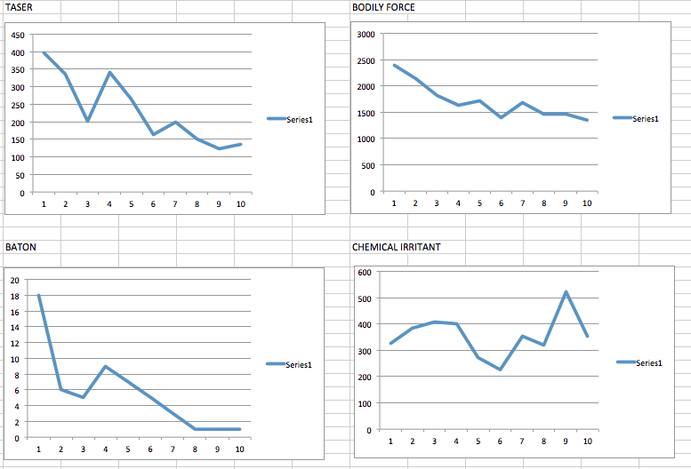

The percentage of suspects being injured when police apply force dropped about 10 points, from about 34 percent in 2013 to 24 percent in 2017.

How often police use force doesn’t seem to be affected in any obvious way by major events like the shooting deaths of Jamar Clark or Philando Castile.

Police use force more often in January, perhaps because of New Year’s Eve celebrations getting out of hand, though that’s not entirely clear at this point.

Data analysis/explanation still needed:

* A “why” explaining these trends (gotta sit down with MPD)
* MPD arrest rates spanning 2008 through 2017 to figure if declining arrests are parallel/connected to declining use-of-force rates

**Online charts and embeds**

TREND

<http://datadrop-dev.startribune.com/20180225-police_force/build?chart=trend>

<strib type="text" data="<style type='text/css'>.dataframe1{height:450px;} @media only screen and (min-width: 200px) and (max-width: 767px){.dataframe1 {height:430px;}}</style><div class='embed'><iframe class='dataframe1' src='http://datadrop-dev.startribune.com/20180225-police_force/build?chart=trend' border='0' frameborder='0' scrolling='no' width='100%' height='450'></iframe></div>"></strib>

ARRESTS

<http://datadrop-dev.startribune.com/20180225-police_force/build?chart=arrests>

<strib type="text" data="<style type='text/css'>.dataframe2{height:450px;} @media only screen and (min-width: 200px) and (max-width: 767px){.dataframe2 {height:430px;}}</style><div class='embed'><iframe class='dataframe2' src='http://datadrop-dev.startribune.com/20180225-police_force/build/?chart=arrests' border='0' frameborder='0' scrolling='no' width='100%' height='450'></iframe></div>"></strib>

INJURIES

<http://datadrop-dev.startribune.com/20180225-police_force/build?chart=injuries>

<strib type="text" data="<style type='text/css'>.dataframe3{height:450px;} @media only screen and (min-width: 200px) and (max-width: 767px){.dataframe3 {height:430px;}}</style><div class='embed'><iframe class='dataframe3' src='http://datadrop-dev.startribune.com/20180225-police_force/build?chart=injuries' border='0' frameborder='0' scrolling='no' width='100%' height='450'></iframe></div>"></strib>

CRIME

<http://datadrop-dev.startribune.com/20180225-police_force/build?chart=crime>

<strib type="text" data="<style type='text/css'>.dataframe4{height:450px;} @media only screen and (min-width: 200px) and (max-width: 767px){.dataframe4 {height:430px;}}</style><div class='embed'><iframe class='dataframe4' src='http://datadrop-dev.startribune.com/20180225-police_force/build?chart=crime' border='0' frameborder='0' scrolling='no' width='100%' height='450'></iframe></div>"></strib>

MONTHS

<http://datadrop-dev.startribune.com/20180225-police_force/build?chart=months>

<strib type="text" data="<style type='text/css'>.dataframe5{height:450px;} @media only screen and (min-width: 200px) and (max-width: 767px){.dataframe5 {height:430px;}}</style><div class='embed'><iframe class='dataframe5' src='http://datadrop-dev.startribune.com/20180225-police_force/build?chart=months' border='0' frameborder='0' scrolling='no' width='100%' height='450'></iframe></div>"></strib>

TYPE

<http://datadrop-dev.startribune.com/20180225-police_force/build?chart=type>

<strib type="text" data="<style type='text/css'>.dataframe6{height:450px;} @media only screen and (min-width: 200px) and (max-width: 767px){.dataframe6 {height:430px;}}</style><div class='embed'><iframe class='dataframe6' src='http://datadrop-dev.startribune.com/20180225-police_force/build?chart=type' border='0' frameborder='0' scrolling='no' width='100%' height='450'></iframe></div>"></strib>

WHEN

<http://datadrop-dev.startribune.com/20180225-police_force/build/?chart=when>

<strib type="text" data="<style type='text/css'>.dataframe7{height:530px;} @media only screen and (min-width: 200px) and (max-width: 767px){.dataframe7 {height:500px;}}</style><div class='embed'><iframe class='dataframe7' src='http://datadrop-dev.startribune.com/20180225-police_force/build/?chart=when' border='0' frameborder='0' scrolling='no' width='100%' height='530'></iframe></div>"></strib>

CITY

<http://datadrop-dev.startribune.com/20180225-police_force/build?chart=city>

<strib type="text" data="<style type='text/css'>.dataframe8{height:610px;} @media only screen and (min-width: 200px) and (max-width: 767px){.dataframe8 {height:510px;}}</style><div class='embed'><iframe class='dataframe8' src='http://datadrop-dev.startribune.com/20180225-police_force/build?chart=city' border='0' frameborder='0' scrolling='no' width='100%' height='610'></iframe></div>"></strib>