I requested some very basic data from Minneapolis parks (total trees removed, ash trees removed, total trees planted) for the years 2010-2018. I ran the numbers for 2013-2017, since they started counting trees lost in storms in 2013 and didn't provide total tree removals for 2018. All the numbers are in the forwarded emails below.

Here's what I found:

Total trees removed: 41782

Ash trees removed: 21985 (about 53 percent of total)

Total trees planted: 40479

So, Minneapolis is not replacing trees at the rate it's losing them, and the bulk of the problem is EAB. I'm guessing the same is true in St. Paul.

2010 = 4995

2011 = 5444

2012 = 4508

2013 = 6368

2014 = 8442

2015 = 9942

2016 = 8560

2017 = 8470

2018 = TBD

These include all trees removed, including those removed due to storm damage. (Note: storm damage counts begin in 2013.)

Ash trees removed / 30,092

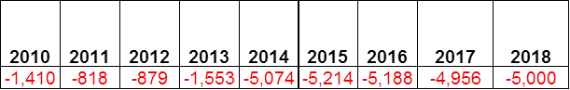

New Trees Planted / 65,397

mb60956:Users:hargaja:Dropbox:construct:STRIBLAB:queue:enterprise:20180805-ash:build:data:_raw:mpls1.png

Note:  Trees planted replaced ash as well as other trees lost.  That’s why the planted number is higher than the ash losses.