• More than 10,000 EAB-infested ash trees were removed in St. Paul from 2010 through 2017

• While more than 20,000 trees were planted in St. Paul from 2010 to 2017, only about 5,500 of those trees were using funds labeled as EAB, EAB-DNR or  SR-EAB. If there are other funding designations used for EAB replacements, that would be nice to know about.

• Your source had mentioned in her message that the city’s removal/planting ratio is about 1:1 but it’s not clear whether or not the data is bearing that out unless we’re counting plantings from other funds. Knowing how to interpret the funds used for plantings will be important and will affect the data analysis.

• Using just the EAB-designated funds from the data, it appears that EAB-related plantings have slowed down while removals have picked up over time:  
  
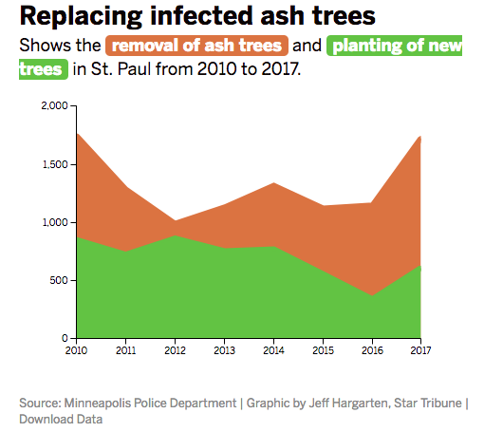

• Here’s a sample of what the map of removals versus plantings looks like:

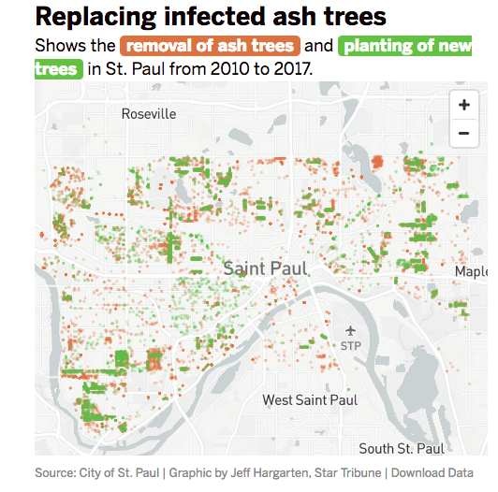

I'm happy to answer any further questions to the best of my ability. Thanks!

-Jeff