Hyper-V NAT + DHCP Isolation Lab Setup

Overview
This document outlines the steps taken to create a secure and isolated virtual lab environment using Hyper-V with NAT networking and DHCP isolation. The setup allows virtual machines (VMs) to access the internet via NAT, receive IP configuration from a domain controller (not the host or router), and remain completely isolated from the physical network.

Step 1: Create Virtual Switch
1. Open Hyper-V Manager and go to Virtual Switch Manager.
2. Create a New Virtual Network Switch and select 'Internal network'.
3. Name the switch (e.g., 'ExSwitch') and click OK.
This switch is used to isolate the virtual network from the physical network while still allowing internet access via NAT configured on the host.
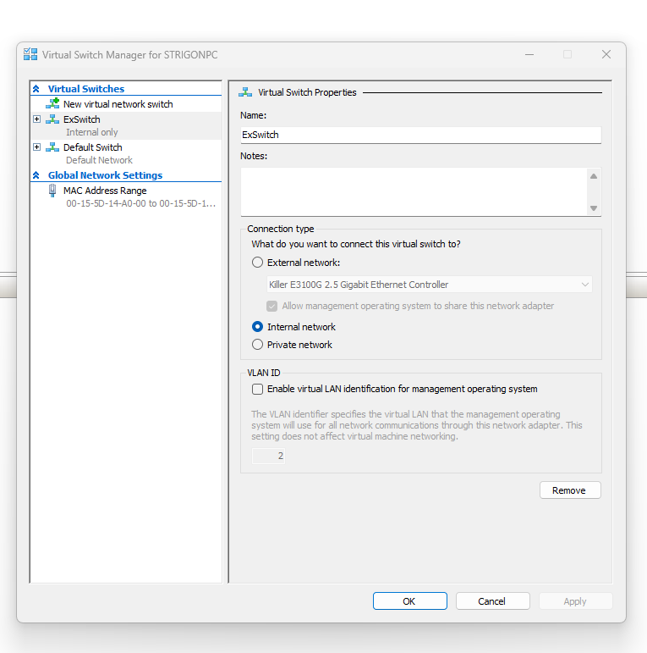
Figure 1: Hyper-V Internal Virtual Switch Configuration (ExSwitch)

Step 2: Configure NAT on Host
Run the following PowerShell commands as Administrator on the host machine to assign an IP address and configure NAT:
New-NetIPAddress -IPAddress 192.168.100.1 -PrefixLength 24 -InterfaceAlias "vEthernet (ExSwitch)"
New-NetNat -Name NATNetwork -InternalIPInterfaceAddressPrefix 192.168.100.0/24

Step 3: Setup DHCP & DNS on Domain Controller (DC1)
1. Assign a static IP to DC1 (e.g., 192.168.100.10).
2. Install and configure the DHCP role on DC1.
3. Create a DHCP scope with:
- IP range: 192.168.100.50 – 192.168.100.200
- Gateway: 192.168.100.1
- DNS: 192.168.100.10 (DC1)
4. Ensure only DC1 gives out IPs by disabling DHCP on other VMs or routers.

Step 4: Join Client VMs to Domain
Configure client VMs to receive IP settings via DHCP and join the domain (e.g., 'stellar.local'). This confirms successful network and DNS setup.

