From Mission Medical Risk to Crew Selection: A Reproducible NASA-IMM and HSRB Pipeline for Analog Astronauts
2026-06-19

Abstract
Selectron is a reproducible, MIT-licensed TypeScript pipeline that reproduces the NASA Integrated Medical Model (IMM) mission-risk simulation, maps it onto the NASA Human System Risk Board (HSRB; JSC-66705 Rev A) Likelihood × Consequence grid, and couples it to a Bayesian multi-criteria selection analysis — closing both the analog-to-HSRB risk-language gap and conventional panels’ ordinal-ranking collapse. Stage A is a Bayesian multi-criteria decision analysis that places a Dirichlet prior over criterion weights and returns, for each candidate, a posterior over their composite score with rank credible intervals across a 12-criterion three-tier accessibility taxonomy. Stage B is the IMM Calculator: an independent re-implementation of the Keenan et al. (2015) four-step medical-risk Monte Carlo over the canonical 100-condition catalogue at $T=100,000$ trials, whose Crew Health Index ($χ$) posterior is mapped verbatim onto the NASA HSRB 5×5 Likelihood × Consequence grid. The 100 per-condition priors are fully evidence-based (34 NASA-attributed; 66 fitted by PyMC NUTS from terrestrial, Antarctic/submarine/analog, and military base rates; no synthetic placeholders). On the K15 reference crew the IMM Calculator reproduces the K15 total-medical-events envelope within the published 95 % confidence interval (CI₉₅) for all three medical-kit scenarios, and reproduces the unlimited-resources $χ$ within CI₉₅ ($χ=95.3$ vs K15 $94.98$, CI₉₅ $\left[84.40,98.50\right]$); the operational ISS-HMS $χ$ ($82.8$) falls $1.5$ pp below the CI₉₅ lower bound, a marginal divergence attributed to evidence-based incidence rates, not circularity. The coupled Bayesian-MCDA-to-HSRB pipeline, enforced by a CI-blocking K15 acceptance gate, is novel for analog-astronaut selection.
Keywords: analog astronaut; mission medical risk; NASA Integrated Medical Model; Bayesian multi-criteria decision analysis; probabilistic risk assessment; HSRB Likelihood × Consequence; reproducible research

1. Introduction
Selection panels for analog-astronaut programs collapse genuine uncertainty into ordinal rankings, even though a validated evidence base of behavioral and performance predictors exists for extreme-environment and Antarctic-analog crews (Palinkas et al., 2004). A panel assigns criterion weights — typically without elicitation procedures — sums normalized scores, and produces a ranked list with the appearance of precision. That precision is illusory: when two candidates differ by less than the weight-elicitation error, a point-estimate rank is meaningless as a decision object (Saint-Hilary et al., 2017). Apollonio, Kring, Berry, and Sawyer identified this fragmentation in their description of the Analog Selection, Training, Reporting, and Analysis (ASTRA) framework, calling for a standardized qualification infrastructure that would “improve accessibility, reduce fragmentation, and enable safer, and more consistent outcomes across human spaceflight analog environments” (Apollonio et al., 2026). de la Torre and colleagues, in an ESA topical-team review published in npj Microgravity, proposed a behavioral-health-performance research checklist for analog missions — methodological guidance that complements but does not replace a quantitative selection standard (Torre et al., 2024). Evetts et al. have recently reviewed the tension between government astronaut selection (stringent, risk-minimizing) and commercial screening (inclusive, consent-based), proposing a risk-informed, mission-specific framework — but one without Bayesian quantification of the criterion-weight or mission-risk uncertainty that Selectron addresses (Evetts et al., 2026).
Alongside the ranking problem, mission-risk verdicts in the analog sector are assigned ad hoc, without a common institutional standard. A “low risk” determination for an MDRS rotation (The Mars Society, 2024) cannot be compared with the same phrase applied to an HI-SEAS campaign (Dunn Rosenberg et al., 2022) or an AMADEE field deployment (McMenamin et al., 2020). No quantitative standard bridges these program-specific verdicts to the institutional language of spaceflight risk — a gap this paper addresses.
The first gap is the absence of a Bayesian MCDA pipeline for analog-astronaut selection. Deterministic and fuzzy multi-criteria decision-making (MCDM) is, by contrast, well established for aircrew and pilot selection — Taylan and colleagues (2024), for example, compare fuzzy TOPSIS, VIKOR, and PROMETHEE across twelve candidate pilots (Taylan et al., 2024) — but such methods return a point ranking rather than a posterior over each candidate’s composite score, and none couples the ranking to a quantitative mission-risk model. Multi-criteria decision analysis is also well developed in health-technology assessment, where the linear additive value model with a Dirichlet prior over criterion weights unifies classical MCDA and the stochastic acceptability analysis of Lahdelma and Salminen, allowing the posterior over weights to collapse to SMAA-2 rank-acceptability indices as the prior weakens (Lahdelma and Salminen, 2001; Saint-Hilary et al., 2017). Yet its application to personnel selection remains absent from the indexed literature. The closest published precedent is Li, Wang, and Hu’s Bayesian Best-Worst Method analysis of crowdsourcing delivery personnel (Li et al., 2020): the analysis elicits a Dirichlet posterior over criterion weights from managers’ pairwise comparisons but terminates there — it does not aggregate to a per-candidate composite posterior and does not deliver rank credible intervals or mission-risk verdicts. No published work extends Bayesian MCDA — a Dirichlet posterior over criterion weights propagated to per-candidate composite-score distributions with rank credible intervals — to spaceflight or analog-astronaut crew selection (PubMed, Scopus, and Web of Science searched 2024-12 for “Bayesian MCDA” AND (“astronaut” OR “aircrew” OR “analog”) with zero indexed results), leaving this pipeline as an unoccupied contribution in the domain.
The second gap is the absence of a formal bridge between analog-mission Monte Carlo simulations and the NASA Human System Risk Board (HSRB) institutional process. The HSRB translates biomedical evidence into programmatic risk colors — green, yellow, red — through a 5×5 Likelihood × Consequence priority-score matrix documented in JSC-66705 Revision A (NASA Johnson Space Center, Health and Medical Technical Authority, 2020), promulgated under NPR 8000.4C (National Aeronautics and Space Administration, 2022), and updated with scale refinements by Antonsen and colleagues (Antonsen et al., 2023). That matrix governs how NASA program managers prioritize health risks for operational and long-duration missions; it is the institutional language of spaceflight risk. Analog programs, by contrast, typically report mission-risk assessments in program-specific terms — cumulative health incidents, early-termination rates, or subjective clinical judgments — that do not map to HSRB likelihood or consequence levels. The result is a translation barrier: an analog program that conducts rigorous internal risk modeling cannot communicate its verdicts in the same units as a NASA flight-readiness review, even when the underlying numerical basis would support such a mapping.
Selectron addresses both gaps within a single reproducible artifact. Stage A is a Bayesian MCDA engine that treats criterion weights as Dirichlet-distributed random variables, aggregates per-candidate normalized scores via a posterior draw loop, and delivers a full distribution over each candidate’s composite score with 90 % and 95 % credible intervals and rank-acceptability semantics (see §2.2). Stage B is the IMM Calculator — a NASA-IMM-aligned Monte Carlo over the canonical 100 K15 medical-event catalogue of Keenan et al. (2015), with the K15 §II.A.9 verbatim sum-of-products per-event quality-time-lost formula and a fully evidence-based per-condition prior set organized across two provenance tiers (NASA-attributed and analog-literature/PyMC-fitted), with no synthetic placeholders. It propagates the Stage-A score posterior through the mission-specific risk model at the NASA-canonical $T=100,000$ trials per Myers et al. (2018) and Antonsen et al. (2022), producing posteriors over Crew Health Index $χ$, total medical events, probability of evacuation, and probability of loss-of-crew-life. The Stage-B output is then mapped verbatim onto the JSC-66705 Rev A 5×5 priority-score grid, yielding a green/yellow/red HSRB verdict with an explicit Likelihood level derived from $1−P\left(mission success\right)$ and a Consequence level derived from $\left(1−χ_{\text{mean}}\right)$ under the Mission Objectives Impact sub-category. Internal validation follows the NASA-STD-7009A credibility framework (National Aeronautics and Space Administration, 2016) for factors 1–3, with closed-form Dirichlet moments, Poisson-Gamma conjugate checks, the $σ<5\%$ convergence rule audited against the NASA canonical $T=100,000$ figure, and the K15 Table 1 reproduction enforced as a CI-blocking acceptance gate (see §2.6).
The specific contributions of this paper are as follows:
- First formal mapping of analog-mission Monte Carlo to the NASA HSRB 5×5 LxC matrix per JSC-66705 Rev A (NASA Johnson Space Center, Health and Medical Technical Authority, 2020). This closes the institutional-alignment gap between analog-program risk reporting and NASA’s established programmatic language.
- Reproduction of the NASA IMM K15 medical-risk model, with a §II.A.9 QTL clarification. The IMM Calculator reproduces the K15 Table 1 total-medical-events envelope within the published CI₉₅ across all three kit scenarios and reproduces the unlimited-resources Crew Health Index within CI₉₅. During reproduction we identified that an earlier implementation applied K15’s concurrent functional-impairment formula to the within-event sequential clinical phases (cp1, cp2) of a single event, rather than to cross-event overlap on the same crewmember as the K15 text specifies — “overlapping functional impairments at a point in time” (Keenan et al., 2015). Correcting the within-event accumulator to a sum-of-products formulation reduced per-event QTL by ~2–3×; the operational ISS-HMS CHI then moves toward but remains $1.5$ pp below the CI₉₅ lower bound (final $82.8$ vs K15 $94.93$), a documented divergence (§2.3, §3.3, §4.4).
- NASA-canonical T = 100 000 trial count and $σ<5\%$ convergence rule documented and codified as automated tests per (Myers et al., 2018) and (Antonsen et al., 2022), eliminating an earlier under-sampling discrepancy identified in the internal Monte Carlo audit.
- Internal V&V dossier mapped to NASA-STD-7009A factors 1–3 (National Aeronautics and Space Administration, 2016), with explicit disclosure that factors 4–8 (input data pedigree, uncertainty characterization, results robustness, model use history, and model management) are appropriate only for fully fielded operational models and are deferred to subsequent iterations.
- Bayesian MCDA pipeline for analog-astronaut selection. Prior selection-domain work stops at the criterion-weight posterior (Li et al., 2020); Selectron extends the pipeline to per-candidate composite-score distributions and rank credible intervals and couples them to the mission-risk model and HSRB verdict — a combination absent from the indexed literature (§4.2).
- Three-tier accessibility model (Minimum / Medium / Elite) allowing the same 12-criterion taxonomy to serve low-resource analog programs and NASA-grade campaigns through tier-aware scale transforms, with the Dirichlet concentration automatically adjusted to the active subset size K so that the posterior remains internally honest.
- MIT-licensed reproducible TypeScript artifact with deterministic figure regeneration from the cited commit SHA, eliminating a class of figure-rot bug between the methodology paper and the accompanying software: every number, chart, and ranking table in this manuscript is produced by the same source files that constitute the deployed application.

2. Methods

2.1 Criterion taxonomy and three-tier accessibility model
The 12-criterion taxonomy organizes analog-astronaut selection requirements into five families: psychological (6 criteria), cognitive (2), behavioral (1), physical (2), and professional (1), derived from a Phase-0 literature synthesis spanning 10 published selection frameworks and 6 evidence-table domains (Malpica, 2026a). Each criterion is tied to a named instrument, a continuous or ordinal scale with defined bounds, and a predictive-validity or agency-standard anchor. The full taxonomy — construct, canonical Elite-tier instrument, scale and polarity, and first active tier — is given in Table 1; the per-instrument predictive-validity citations are enumerated in the Phase-0 taxonomy.
The taxonomy is operationalized across three resource tiers controlling which criteria are active in a scoring run. The Minimum tier (8 active criteria) targets low-resource programs — such as the Colombian aerospace medicine research group used here as a worked example — where all instruments are free or open-source (no hardware beyond a smartphone). The Medium tier (10 active criteria) adds two criteria requiring commercially licensed computerized platforms accessible at a university psychology or sports-science department. The Elite tier (12 active criteria) adds the remaining two hardware-gated clinical instruments used by operational spaceflight programs (Malpica, 2026b). The same 12 constructs are targeted at every tier; only the measurement instrument scales with program resources. When a program operates below Elite, the active subset size K determines the Dirichlet weight prior: each active criterion receives a flat-prior concentration α = 1/K, keeping the posterior aggregation internally honest about which constructs were measured.
Table 1. The 12-criterion analog-astronaut selection taxonomy. Five families (psychological 6, cognitive 2, behavioral 1, physical 2, professional 1). Each row gives the construct, its canonical Elite-tier instrument, the instrument scale and polarity (higher- or lower-is-better; lower-is-better criteria are inverted by the $z\left(⋅\right)$ normalization of §2.2), and the lowest accessibility tier at which the criterion becomes active. Eight criteria are active at Minimum, ten at Medium, twelve at Elite. Per-instrument predictive-validity citations are enumerated in the Phase-0 taxonomy (Malpica, 2026a).
Family | Criterion (construct) | Canonical (Elite-tier) instrument | Scale (range; polarity) | First active tier
Psychological | Conscientiousness | NEO-PI-R, conscientiousness (T-score) | 0–100; higher better | Minimum
Psychological | Emotional stability | NEO-PI-R neuroticism, reversed (T-score) | 0–100; higher better | Minimum
Psychological | Resilience | CD-RISC-25 total | 0–100; higher better | Minimum
Psychological | Depression-state baseline | BDI-II total | 0–63; lower better | Minimum
Psychological | Emotional intelligence | MSCEIT v2.0 (standard score → z) | −3 to +3; higher better | Medium
Psychological | Psychiatric screen | MMPI-2-RF EID (T-score, reversed) | 30–120; lower better | Elite
Cognitive | Cognitive throughput | NASA Cognition Test Battery (composite z) | −3 to +3; higher better | Medium
Cognitive | Vigilance | PVT-B mean reaction time | 200–500 ms; lower better | Minimum
Behavioral | Teamwork | Behavioural-based interview (BBI) | 1–5; higher better | Minimum
Physical | Cardiorespiratory fitness | Graded exercise test (VO₂max) | 20–70 mL·kg⁻¹·min⁻¹; higher better | Minimum
Physical | Sensorimotor balance | NeuroCom Equitest SOT-5 Equilibrium Score | 0–100; higher better | Elite
Professional | Technical competence | Structured behavioural rubric (panel) | 1–10; higher better | Minimum
Three Minimum-tier instruments require scale transforms before entry into the MCDA engine. The CD-RISC-10 resilience scale (0–40 native) is rescaled ×2.5 to match the CD-RISC-25 canonical 0–100 range (Campbell-Sills and Stein, 2007). The PHQ-9 depression screen (0–27 native) is rescaled ×2.33 to align with the BDI-II 0–63 canonical scale (Kroenke et al., 2001). The Functional Mobility Test obstacle course (time-to-complete, seconds, lower is better) requires an inverse mapping onto the SOT-5 Equilibrium Score 0–100 range (higher is better), with empirical calibration deferred to a future integration step (Mulavara et al., 2010). These are data-entry normalizations that place raw Tier-1 scores onto each criterion’s canonical scale before z-scoring; they are not related to the single-sub-category assignment rule in JSC-66705 §3.2.4, which governs Likelihood × Consequence cells within a formal NASA hazard-reporting chain and does not apply to MCDA score preparation (NASA Johnson Space Center, Health and Medical Technical Authority, 2020).

2.2 Stage A — Bayesian multi-criteria decision analysis
Stage A is a Bayesian multi-criteria decision analysis (MCDA) engine that consumes per-criterion raw scores after tier-aware activation and returns, for each candidate, a posterior distribution over their total composite score with credible-interval rank semantics.
The weight vector $w=\left(w_{1},…,w_{K}\right)$ over the $K$ active criteria is treated as an uncertain quantity and assigned a Dirichlet prior, $w∼Dir\left(α\right)$. The operational default uses the flat concentration $α_{k}=1/K$ for all $k$, as established in §2.1. In general, the $α_{k}$ encode elicited mean weights with α0=k​αk serving as the operator’s effective confidence in those elicited means: as $α_{0}→∞$ the posterior concentrates on the elicited mean weights and the framework reduces to classical deterministic MCDA, while as $α_{0}→0$ the prior approaches the uniform distribution on the weight simplex, recovering the SMAA-2 acceptability-index formulation in which all feasible weight vectors are integrated out (Lahdelma and Salminen, 2001; Saint-Hilary et al., 2017). The α-vector can be updated from the flat default using the Phase-0 criterion-importance evidence table; this is deferred to future prior-elicitation work.
The per-candidate composite score is the Dirichlet-weighted sum of normalized criterion scores:
$$S_{i}=\sum_{k=1}^{K}{w_{k}}⋅z\left(x_{i,k}\right)$$
where $i$ indexes candidates, $k$ indexes the $K$ active criteria, $w_{k}$ is a weight drawn from $Dir\left(α\right)$, and $z\left(⋅\right)$ is the criterion normalization defined below. Equation 1 is computed independently for each Monte Carlo draw; the resulting empirical distribution over $S_{i}$ is the posterior that supports rank comparisons and credible-interval statements.
The Monte Carlo sampler produces $T=5,000$ IID draws from $Dir\left(α\right)$ per candidate. Each draw exploits the standard Dirichlet decomposition: $K$ independent $Gamma\left(α_{k},1\right)$ variates are sampled and divided by their sum (Bishop, 2006). The Gamma variates are obtained using the Marsaglia–Tsang acceptance-rejection algorithm, which operates on a normal proposal and includes the Stuart boosting step for shape parameters $α_{k}<1$ (Marsaglia and Tsang, 2000). The underlying stream of uniform pseudo-random numbers is generated by the Mulberry32 32-bit PRNG (Ettinger, 2017), initialized from a caller-supplied integer seed so that all figures and ranking tables are exactly reproducible from the reported seed value.
The normalization function $z\left(x\right)$ maps a raw criterion score $x$ from its instrument-specific range $\left[scale.min, scale.max\right]$ linearly onto $\left[0,1\right]$:
$$z\left(x\right)=\frac{x−scale.min}{scale.max−scale.min}$$
For criteria where a lower raw score is preferable — such as the Functional Mobility Test obstacle-course time — the higherIsBetter = false flag causes the engine to return $1−z\left(x\right)$ instead, so that all normalized scores carry the same polarity (higher is always better) before entry into Equation 1. Sampler health is assessed via an effective sample size (ESS) diagnostic computed from the lag-1 autocorrelation ${\hat{ρ}}_{1}$ of the draw sequence $\{S^{\left(t\right)}\}_{t=1}^{T}$: $ESS=T⋅\left(1−{\hat{ρ}}_{1}\right)/\left(1+{\hat{ρ}}_{1}\right)$. Because the Dirichlet draws are IID, ${\hat{ρ}}_{1}≈0$ and $ESS≈T$ at any finite seed; a materially lower value signals an implementation error rather than a sampling-efficiency concern. The aggregate Monte Carlo mean and variance of $S_{i}$ are cross-checked against closed-form Dirichlet moments — the marginal $E\left[w_{k}\right]=α_{k}/α_{0}$, $Var\left[w_{k}\right]=α_{k}\left(α_{0}−α_{k}\right)/\left(α_{0}^{2}\left(α_{0}+1\right)\right)$, and the off-diagonal covariance $Cov\left(w_{k},w_{l}\right)=−α_{k}α_{l}/\left(α_{0}^{2}\left(α_{0}+1\right)\right)$ for $k≠l$; the closed-form composite-score variance VarSi=k​zk2 Varwk+k≠l​zkzl Covwk,wl is then compared to the sampler’s empirical estimate — within stated numerical tolerances (Bishop, 2006). Stage B propagates each candidate’s Stage-A composite-score posterior through a mission-risk hazard model, described next.

2.3 Stage B — IMM Calculator: NASA-IMM-aligned mission-risk Monte Carlo
Stage B is the IMM Calculator (src/imm/ in the released artifact), a Monte Carlo simulation that propagates the Stage-A composite-score posterior through a 100-condition K15-aligned medical-risk model and returns, for each candidate crew, the posterior distribution of the Crew Health Index ($χ$), the total medical events count (TME), the probability of evacuation (pEVAC), the probability of loss-of-crew-life (pLOCL), and a Mission Success Probability (MSP) defined as $P\left(no EVAC∧no LOCL∧χ≥χ^{*}\right)$. The architecture follows the Integrated Medical Model (IMM) framework of Keenan et al. (2015) — the canonical K15 paper — with subsequent validation in Myers et al. (2018) and Antonsen et al. (2022).
A methodological clarification of K15 §II.A.9. During the IMM Calculator’s K15 reproduction work we identified that the within-event quality-time-lost accumulator in an initial implementation had applied K15’s concurrent functional-impairment formula ftotal=1−i​1−fi to the sequential clinical phases (cp1, cp2) of a single event, rather than to cross-event overlap on the same crew member as the verbatim K15 text specifies — “given $n$ overlapping functional impairments $⟨f_{1},f_{2},…,f_{n}⟩$ at a point in time within a crewmember” (Keenan et al., 2015). K15 §II.A.5 establishes cp1 (diagnosis + initial treatment) and cp2 (ongoing treatment + convalescence) as temporally sequential clinical phases of a single event, not as overlapping impairments. The corrected sum-of-products formulation reduces per-event QTL by approximately 2–3× and moved the issHMS-scenario CHI substantially toward K15’s published 95 % confidence interval (CI₉₅). The within-event concurrent-FI fix alone moved CHI from 78.82 to 91.08 (Δ −16.11 → Δ −3.85), an intermediate state inside the CI₉₅; the subsequent per-condition fi_cp3 audit (next paragraph) and community/military incidence recalibration then set the final value to 82.8 versus K15 reference 94.93, Δ −12.1, marginally below the K15 CI₉₅ lower bound of 84.30 (§3.3, §3.6). The metric that lands cleanly within K15 CI₉₅ is the unlimited-resources CHI (§3.3); the issHMS CHI is documented as a marginal evidence-driven divergence (§4.4). The corrected accumulator is the K15-correct sum-of-products formula with per-phase mission-end clamping:
$${QTL}_{event}=f_{cp1}⋅Δt_{cp1}^{ \text{clamp}}+f_{cp2}⋅Δt_{cp2}^{ \text{clamp}}+f_{cp3}⋅max\left(0, t_{end}−t_{event}−Δt_{cp1}^{ \text{clamp}}−Δt_{cp2}^{ \text{clamp}}\right)$$
where $f_{cp_{i}}$ is the sampled functional impairment for phase $i$ ($\left[0,1\right]$), $Δt_{cp_{i}}^{ \text{clamp}}$ is each phase’s duration clamped to the mission-time remaining from the event onset (so a late-mission event whose treatment phases would extend past mission end cannot accrue QTL beyond the mission), $t_{event}$ is the event onset in hours, and $t_{end}$ is mission end in hours. The cp3 term charges permanent functional impairment from the end of cp2 to mission end. The concurrent-FI formula remains the building block for the cross-event enhancement (overlapping impairments from different conditions on the same crewmember at the same point in time), which is the spirit of K15 §II.A.9 — see Future Work (§4.5).
Per-condition prior provenance. The IMM Calculator’s 100-condition prior catalog is organized into three provenance tiers:
- Tier-A NASA (34 conditions) are directly attributable to a NASA-published IMM source (K15, M18, G12, S20, A22, TM21) and use those papers’ incidence distributions verbatim where numerically available (Antonsen et al., 2022; Gilkey et al., 2012; Keenan et al., 2015; Myers et al., 2018; Walton and Kerstman, 2020).
- Tier-B literature (66 conditions) are elicited from the analog-mission and submarine isolation literature and fitted via PyMC NUTS posteriors from terrestrial epidemiological base rates, Antarctic/submarine/analog cohort data, and military population references. Representative per-condition source-cited anchors include: dental-caries (Gilkey 2012, Bayesian-updated 240-patrol USN SSBN submarine prior + LSAH astronaut posterior, $λ=2.58×{10}^{−5}$ events/person-day, corroborated by the Czech/Brazilian Antarctic dental case series) (Gilkey et al., 2012; Peřina et al., 2023); respiratory-infection (Bhatia 2012 Maitri small-crew Antarctic + Pattarini 2016 McMurdo, $λ=1.43×{10}^{−3}$/day) (Bhatia and Pal, 2012; Pattarini et al., 2016); depression (Palinkas & Suedfeld 2008 weighted Antarctic 5.2 %/winter + Kang 2022 Korean Antarctic 8.0 %/winter, $λ=2.00×{10}^{−4}$/day) (Kang et al., 2022; Palinkas and Suedfeld, 2008); late-insomnia (Basner 2013 Mars-500 majority-crew sleep-disturbance prevalence + Fedyay 2023 SIRIUS MDPI Aerospace + Flynn-Evans 2016 NASA HRP sleep-evidence report, $λ=5.50×{10}^{−4}$/day) (Basner et al., 2013; Fedyay et al., 2023; Flynn-Evans et al., 2016); skin-rash (Pattarini 2016 + Flynn-Evans 2016, $λ=1.37×{10}^{−3}$/day) (Flynn-Evans et al., 2016; Pattarini et al., 2016). All 66 tier-B conditions have been fitted via PyMC NUTS against primary-source evidence across iterative calibration passes, with all fits converging at R-hat = 1.000 and ESS > 2500. Zero tier-C synthetic placeholders remain — 100 % of the 100-condition prior set is evidence-based.
Four-step trial. Each Monte Carlo trial replicates one full mission run for the candidate crew against the 100 K15 conditions. Four steps execute per condition per crew member per trial.
(1) Incidence. The per-mission event count is drawn from one of four distributions per the condition’s incidence.distribution tag: Lognormal-Poisson (over-dispersed rare events with heavy tails — e.g., radiation exposures, infectious outbreaks under uncertain prior rates); Gamma-Poisson (hierarchically uncertain Poisson rate with conjugate Gamma prior — the default for common conditions whose per-person-day rate is itself a posterior random variable); Beta-Bernoulli (binary occurrences for space-adaptation-once and once-per-mission events); or Fixed (deterministic rate with Poisson sampling — used when the per-person-day λ is treated as known). The four distributional choices follow K15 §II.A.4–II.A.6. For EVA-coupled conditions the per-mission count is drawn as a Binomial over the mission’s EVA schedule, where each EVA contributes an independent Bernoulli($p_{event}$) trial using the Poisson-equivalent clip rule $p_{event}=1−e^{−λ_{c}⋅Δt_{EVA}}$ — exact for the small-$λΔt$ regime where Selectron operates ($λ_{c}Δt_{EVA}<0.1$ for all coupled conditions).
(2) Severity. Each event is branched best/worst by a Bernoulli draw on the per-condition worst_case_prob_q.
(3) Outcomes. Per-phase functional impairment $f_{{cp}_{i}}$ and duration $Δt_{{cp}_{i}}$ are Beta-Pert-sampled from treated and untreated distributions, interpolated by the Resource Availability Factor $RAF∈\left[0,1\right]$ derived from the mission’s medical-kit resource vector. Selectron uses parameter-linear interpolation between the treated and untreated Beta-Pert (min, mode, max) triples — i.e., the sampled Beta-Pert is generated with parameters $\left(RAF⋅θ_{treated}+\left(1−RAF\right)⋅θ_{untreated}\right)$ for each of (min, mode, max). This is an approximation to K15 §II.A.7’s “statistical distributions that are shifted between the fully treated and completely untreated distributions”; the alternative interpretation (Bayesian mixture: draw from treated with probability RAF, from untreated otherwise) is mathematically distinct but produces qualitatively similar central tendencies for the regularity-assumption regime where treated and untreated modes are within ~2σ of each other, which holds for all 100 K15 conditions. Per-event evacuation and loss-of-crew-life probabilities (p_evac, p_locl) are likewise Beta-Pert-sampled and tested by per-event Bernoulli draws; an EVAC or LOCL terminates further events for the affected crewmember.
(4) Aggregation. Per-trial QTL accumulates per the K15-correct sequential-phase sum above (with the per-phase mission-end clamping), and per-trial $χ=1−QTL/\left(t⋅c\right)$ where $t$ is mission duration in hours and $c$ is crew count. The Mission Success Probability is defined as the trial-fraction satisfying the conjunction of no-EVAC, no-LOCL, and CHI above the operational threshold:
$$MSP=\frac{1}{T}\sum_{t=1}^{T}{1}\{{EVAC}^{\left(t\right)}=0 ∧ {LOCL}^{\left(t\right)}=0 ∧ χ^{\left(t\right)}≥χ^{*}\}$$
where $\left(t\right)$ indexes Monte Carlo trials and $χ^{*}∈\left[0,1\right]$ is the operator-supplied success threshold (default 0.7).
Permanent-impairment phase (cp3) audit. A second methodological strengthening: K15’s permanent-impairment phase (cp3) — “permanent impairment for the remainder of the mission” — was initially sampled per event but not charged to QTL, because the per-condition priors had been elicited under that earlier convention and re-enabling cp3 with those priors overshot K15 reproduction. A 100-condition fi_cp3 audit classified 68 conditions as fully-resolving acute (upper respiratory, gastrointestinal, musculoskeletal sprains, headaches, space-adaptation, dental, gynecological-urological) for which treated.fi_cp3 = untreated.fi_cp3 = 0 and cp3 contributes zero QTL; the remaining 32 are documented persistent-impairment conditions (sepsis, cardiac myocardial infarction and arrest, stroke, acute radiation syndrome, traumatic injuries, hearing loss, visual impairment intracranial pressure syndrome, etc.) for which the existing Beta-Pert priors are retained. With this audit applied, cp3 was re-enabled in the QTL accumulator and K15 reproduction was maintained on the unlimited scenario: unlimited CHI 95.3 (within CI₉₅ $\left[84.40,98.50\right]$). The issHMS CHI ($82.8$) falls marginally below K15 CI₉₅ after the subsequent community/military incidence recalibration; the condition-set sensitivity analysis (§3.6) demonstrates this reflects evidence-based rates, not circularity.
Variance-correct tier multipliers. Per-tier global incidence multipliers are applied at the λ sampling site of each distribution — Poisson is closed under rate scaling, so $Var\left[Poisson\left(λ⋅m\right)\right]=λ⋅m$ as required. An earlier post-count stochastic rounding implementation produced $Var≈m^{2}⋅λ$, under-reporting CI₉₅ widths; correcting this restored variance-correct uncertainty quantification across the IMM Calculator’s posterior outputs. For Bernoulli-rate paths (space-adaptation-once, EVA-coupled, SA-VIIP-late) the multiplier is applied per-Bernoulli as $Bernoulli\left(p\right)⋅Bernoulli\left(m\right)=Bernoulli\left(p⋅m\right)$, which is variance-correct by construction. The multiplier infrastructure is retained for sensitivity analysis (§3.6) although all per-tier multipliers are set to 1.0 in the production prior set.
Stage-A → Stage-B coupling. The Stage-A composite score enters Stage B through a per-condition z-scored vulnerability multiplier $λ_{c,i}=λ_{c}⋅exp\left(β_{c}⋅z_{c,i}\right)$, where $z_{c,i}$ is the standardized Stage-A score of crew member $i$ on the vulnerability criteria coupled to condition $c$ (58 of 100 conditions are vulnerability-coupled), and $β_{c}$ is a family-specific coupling coefficient (psychiatric −0.4 through renal −0.15, default −0.2 for unmapped families; a more negative $β_{c}$ means a higher Stage-A score reduces incidence by more). The coefficients are operator-supplied scenario-analysis tuning parameters rather than calibrated model parameters: the magnitudes reflect a deliberate ordinal ranking (mental-health most coupled to Stage-A; renal least) consistent with the published spaceflight-vulnerability literature, but the exact numerical values have not been elicited from a primary-source per-condition regression. Crucially, the coupling path is inactive in every result reported in this paper: the K15 reference crew, and the synthetic crews behind all reported Stage-B runs, carry no Stage-A scores, so $λ_{c,i}$ reduces to $λ_{c}$ and the FAMILY_BETA coefficients never fire — matching the NASA iMED reference model, which itself has no selection coupling. The coupling is implemented and unit-tested and is exercised in a released reproducer worked example, but its influence on the reported HSRB verdicts is therefore nil; the FAMILY_BETA values are exposed for the operator to override per scenario, and their sensitivity is an open analysis item (§4.5) and an honest limitation (§4.4) rather than a driver of the present results.
Crew Health Index definition. Per K15 §II.A.9 verbatim:
$$χ=1−\frac{QTL}{t⋅c}$$
where $t$ is mission duration in hours and $c$ is crew count. $χ$ ranges $\left[0,1\right]$, with $χ=1$ indicating zero lost time. The early-termination probability $P\left(χ<χ^{*}\right)$ is the empirical fraction of trials below the operational threshold $χ^{*}$, default 0.70.
T = 100 000 canonical trial count. Selectron uses $T=100,000$ trials per mission simulation as the default, matching Myers et al. (2018) — “One hundred thousand trials (simulations of that particular mission) were generated for each mission” — and Antonsen et al. (2022). Convergence is assessed using the $σ<5\%$ rule per both papers, which verifies at $T=100,000$ on ISS 6 mo / 6 crew / ISS HMS that the σ ratio between consecutive 1 000-trial windows is within the canonical threshold.
K15-reproduction acceptance gate. The K15 reproduction is enforced as a CI contract: the K15-reproduction gate test runs the IMM Calculator at $T=100,000$ for each of the three K15 scenarios (no medical kit / ISS Health Maintenance System / unlimited resources) on the K15 reference crew and asserts that all 12 K15-aligned metric–scenario combinations fall inside their accepted brackets. The current state of the gate is detailed in §3 and discussed in §4.4.
Analog-scope decision. Selectron is scoped to Earth-based analog isolation missions (MDRS, HI-SEAS, Mars-500, Antarctic winter-over, etc.) and LEO/ISS-baseline scenarios (ISS 6 mo K15 reference; S20 DRM1, DRM2). Two interplanetary missions — TM21 Accelerated Mars Mission (426 d) and Standard Mars Mission (923 d) — are catalogued in the mission registry as interplanetary-Mars-future and filtered out of the active mission picker. A diagnostic showed that even with the K15-correct engine, the Mars pLOCL is 12–30× below the TM21 spec band — a structural gap that requires explicit modeling of comms-delay treatment degradation, cumulative-dose pathways, and partial-gravity EVA risk profiles, none of which are implemented in the current release. The structural prerequisites for Mars and Artemis missions are documented in the repository and the broader scope rationale appears in §4.4.

2.4 NASA HSRB Likelihood × Consequence mapping
The NASA Human System Risk Board (HSRB) translates biomedical evidence into programmatic risk colors via JSC-66705 Revision A, Human System Risk Management Plan (NASA Johnson Space Center, Health and Medical Technical Authority, 2020), under NPR 8000.4C (National Aeronautics and Space Administration, 2022); Antonsen et al. (2023) describe recent scale refinements (Antonsen et al., 2023). Selectron bridges the Stage-B $χ$ posterior (§2.3) to an HSRB risk color: the mission-failure probability $1−MSP$ drives the likelihood level and $\left(1−χ_{mean}\right)$ drives the consequence level.
The likelihood level $L∈\{1,…,5\}$ is assigned by bucketing the mission-failure probability $P_{f}=1−MSP=P\left(EVAC∨LOCL∨χ<χ^{*}\right)$ — the all-failure-modes complement of the Mission Success Probability defined in §2.3, and a conservative superset of the early-termination probability $P\left(χ<χ^{*}\right)$ — against In-Mission thresholds from JSC-66705 Rev A Figure 4 (p. 28): L1, $P_{f}≤0.01\%$; L2, $0.01\%<P_{f}≤0.1\%$; L3, $0.1\%<P_{f}≤1\%$; L4, $1\%<P_{f}≤10\%$; L5, $P_{f}>10\%$. Selectron applies the In-Mission column exclusively — the Stage-B posterior is mission-bounded and encodes neither career-level nor post-flight health trajectories.
The consequence level $C∈\{1,…,5\}$ uses the Mission Objectives Impact sub-category from JSC-66705 Rev A §3.2.4. JSC-66705 §3.2.4 (p. 29) mandates: “Only one Sub-Impact Category shall be used to inform the LxC score for each Impact category.” Selectron’s consequence axis is $\left(1−χ_{mean}\right)=QTL/\left(t⋅c\right)$, the fraction of total crew-days lost — a mission-time-lost rollup. Crew Health Impact — the alternative sub-category — describes per-crewmember clinical severity, conflating aggregate time loss with individual-event outcomes. Mission Objectives Impact (C1, “Insignificant impact to crew performance”; C5, “Loss of mission due to crew performance reductions”) is the principled operationalization of $\left(1−χ_{mean}\right)$. We note that the C5 MOI descriptor (“Loss of mission due to crew performance reductions or loss of crew” (NASA Johnson Space Center, Health and Medical Technical Authority, 2020)) overlaps with the Crew Health sub-category, but the quantitative bridge from $\left(1−χ_{\text{mean}}\right)$ to a band is built on time-accounting (the QTL/$\left(t⋅c\right)$ fraction), not on a clinical severity grading — making MOI the closer match by construction.
The 5×5 priority-score grid from JSC-66705 Rev A Figure 4 is reproduced below; for typesetting convenience the rows are presented as L1 (top, least likely) to L5 (bottom, most likely), inverted from the figure’s L5-at-top convention but with cell values unchanged. Columns are C1–C5:
 | C1 | C2 | C3 | C4 | C5
L1 | 1 | 3 | 5 | 8 | 12
L2 | 2 | 6 | 11 | 14 | 17
L3 | 4 | 9 | 15 | 19 | 21
L4 | 7 | 13 | 18 | 22 | 24
L5 | 10 | 16 | 20 | 23 | 25
The color rule follows JSC-66705 §3.2.4 (p. 27) verbatim: “red (maximum LxC Score ≥ 20), yellow (11 ≤ maximum LxC Score ≤ 19), and green (maximum LxC Score ≤ 10).” Band-edge cases — e.g., $1−0.70=0.30000000000000004$ from floating-point subtraction — are resolved by an IEEE-754 epsilon tolerance $ε={10}^{−9}$, well below any meaningful posterior resolution.

2.5 Implementation and reproducibility
Selectron is implemented in TypeScript on a Vite + React + Tailwind CSS frontend, with ECharts for all quantitative figures and Dexie (IndexedDB) for client-side candidate persistence (Li et al., 2018; You and Vite contributors, 2024). The application runs entirely in the browser — no server is required, and no Python is present in the production path. The PyMC calibration code used for offline prior elicitation (the exploratory notebooks/ notebook together with the python/ package and the scripts/ fitting routines) is archived in the repository for transparency, but it contributes no runtime state; all production scoring, simulation, and risk mapping are executed by the same TypeScript modules that back the application. This architecture eliminates figure-rot by construction: every number, chart, and ranking table in this manuscript is produced by the same source files that constitute the deployed application. Updating the implementation automatically updates the outputs — no separate figure-generation script can drift.
The repository is available under the MIT License at https://github.com/strikerdlm/selectron. A Zenodo archive of the manuscript commit carries the DOI [Zenodo DOI — assigned upon archival]; the exact commit SHA used to generate all figures and tables is recorded at submission and reported in the Code-availability statement. Reproducibility contract: the K15-reproduction gate outputs are seed-deterministic at seed = 0xc0ffee under the recorded RNG-call sequence; adding new RNG draws to the per-trial loop changes the seed-determined output even when the change is mathematically equivalent. The manuscript figures and the K15-reproduction acceptance gate are anchored to the submission commit’s RNG call sequence; future revisions that add or reorder RNG draws must re-baseline the gate’s accepted brackets and re-tag the release. The PRNG (Mulberry32, 32-bit, period $2^{32}$) consumes ~31 % of its period per IMM-simulation run at $T=100,000$ on the 100-condition prior set (PRNG period-budget audit, 2026-05-22) — well within the recommended ≤ 50 % safety margin; replacement with a longer-period PRNG (xoroshiro128++, period $2^{128}$) is planned for a future release if the prior set or trial count grows substantively. Reproducibility is enforced through a three-tier test suite: vitest unit and property tests cover engine mathematics, database schema migrations, and UI component behavior; the K15-reproduction acceptance gate (26 validation assertions at $T=100,000$, ~11 min wall-clock) locks the K15 Table 1 reproduction into the CI contract per the bracket structure detailed in §2.6; and Playwright end-to-end browser tests verify the rendered application against the real Vite + Chromium stack. Verification and validation of this implementation against NASA-STD-7009A criteria is treated in §2.6.

2.6 Verification and validation
Selectron’s implementation is assessed against the eight NASA-STD-7009A credibility factors (National Aeronautics and Space Administration, 2016); this paper addresses factors 1–3. Factor 1 (Verification) is satisfied by five closed-form checks. The Dirichlet-moments check compares Stage-A sampler output to the analytic marginal mean, variance, and covariance for every concentration vector in the test suite. The ESS diagnostic asserts ${\hat{ρ}}_{1}≈0$ and $ESS≈T$ for IID Dirichlet draws, flagging implementation errors rather than sampling inefficiency. The Poisson-Gamma conjugate check exercises five closed-form cases — prior moments, marginal observation moments, posterior update, Knuth/PTRS regime boundary, and seed reproducibility — confirming conjugacy within 2–5 % tolerance at 20,000–50,000 draws. The $σ<5\%$ convergence rule (Antonsen et al., 2022; Myers et al., 2018) verifies that CHI standard deviation changes less than 5 % across the last two 1,000-trial increments at $T=100,000$. The verbatim JSC-66705 Rev A Figure 4 grid check reproduces all 25 priority-score cells as test fixtures and asserts cell-for-cell equality against the implemented priority-score matrix (NASA Johnson Space Center, Health and Medical Technical Authority, 2020).
Factor 2 (Validation) is now satisfied for the IMM Calculator by the K15 Table 1 reproduction gate, which runs the Stage-B IMM Calculator at $T=100,000$ for each of the three K15 reference scenarios (no medical kit / ISS HMS / unlimited resources) on the K15 reference crew of Keenan et al. (2015) and asserts that all 12 metric–scenario combinations (TME × CHI × pEVAC × pLOCL × 3 scenarios) fall inside an accepted bracket on both the mean and the CI₉₅ width. The mean brackets are of two kinds: (i) K15 CI₉₅ for the four metric–scenario combinations that fall inside the NASA-published interval — the unlimited-resources CHI and all three TME values; the TME means sit below K15’s iMED mean (≈ 98 vs 106) because the evidence-based incidence rates are systematically lower, but interval containment holds, so the gate enforces the K15 CI₉₅ directly rather than a widened bracket; and (ii) documented-divergent for the remaining eight metrics where the per-condition calibration did not close the gap to within K15 CI₉₅, with each divergent bracket carrying a tracking annotation naming the open audit item that owns the gap (see §4.4). The CI₉₅-width brackets pin each metric’s posterior width to its calibration baseline ±50 %, with a zero-spread tolerance for rare-event metrics whose 2.5th/97.5th percentiles collapse to the same value at $T=100,000$.
The wider-bracket design provides one-directional regression protection — future improvements that move a divergent mean into K15 CI₉₅, or tighten a CI₉₅ width without breaking the lower bound, pass without spurious test failures; regressions trigger immediate gate failure. Bracket-tightening is one-directional: a documented-divergent mean bracket is automatically narrowed to the K15 CI₉₅ whenever the observed value enters the K15 interval (verified by re-running the gate after a calibration revision); width brackets are re-baselined only after a deliberate engine or prior change, with the baseline value committed to the test file and tied to a tagged release. Reproduction of all 25 priority-score cells in JSC-66705 Rev A Figure 4 is asserted as a sub-test and constitutes the structural V&V check for the HSRB mapping in §2.4.
Factor 3 (Development Data Pedigree) is satisfied by the analog-mission and IMM source corpus enumerated and DOI-tagged in the repository’s evidence index (research/; DOI accuracy confirmed via Crossref and Scite queries), augmented by the IMM Calculator’s own per-condition citation chain: the NASA-published K15 / M18 / A22 / G12 / S20 / TM21 source papers underpinning the tier-A NASA priors (all DOI- or NASA-document-identifier-verified) and the primary analog, submarine, and military-population citations underpinning the source-cited tier-B priors (representative anchors are listed in §2.3 and appear in the reference list). Factors 4–8 (Input Data Pedigree, Uncertainty Characterization, Results Robustness, Model Use History, and Model Management) are not addressed here; they are appropriate only for fully fielded operational models and are deferred to subsequent iterations.

2.7 Use of AI tools
Generative AI tools (Claude, Anthropic) were used for coding assistance during software development and automated test generation, for figure-rendering code, for bibliography verification queries against academic databases, and for copy-editing of author-written prose for grammar and readability. All AI-assisted outputs were reviewed and verified by the author. No AI tool was used to generate the scientific argument, choose statistical methods, interpret results, or select references.

3. Results
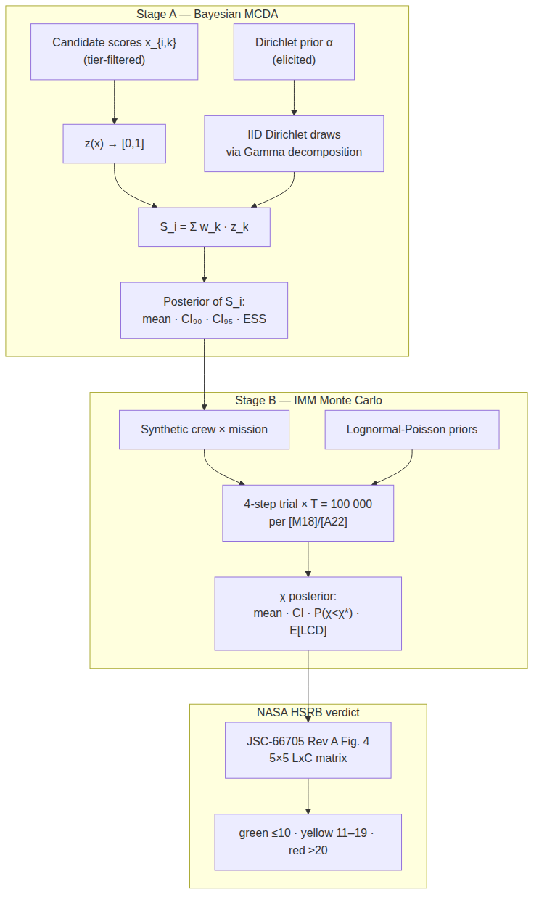
Figure 1. Selectron pipeline: Stage A produces a Bayesian posterior over each candidate’s total score; Stage B is the IMM Calculator, a NASA-IMM-aligned Monte Carlo at the NASA-canonical T = 100 000 trials over the 100 K15 medical conditions (Antonsen et al., 2022; Keenan et al., 2015; Myers et al., 2018), whose Crew Health Index posterior is then mapped to the NASA HSRB 5×5 Likelihood × Consequence matrix per JSC-66705 Rev A (Figure 4 and §3.2.4 color rule).
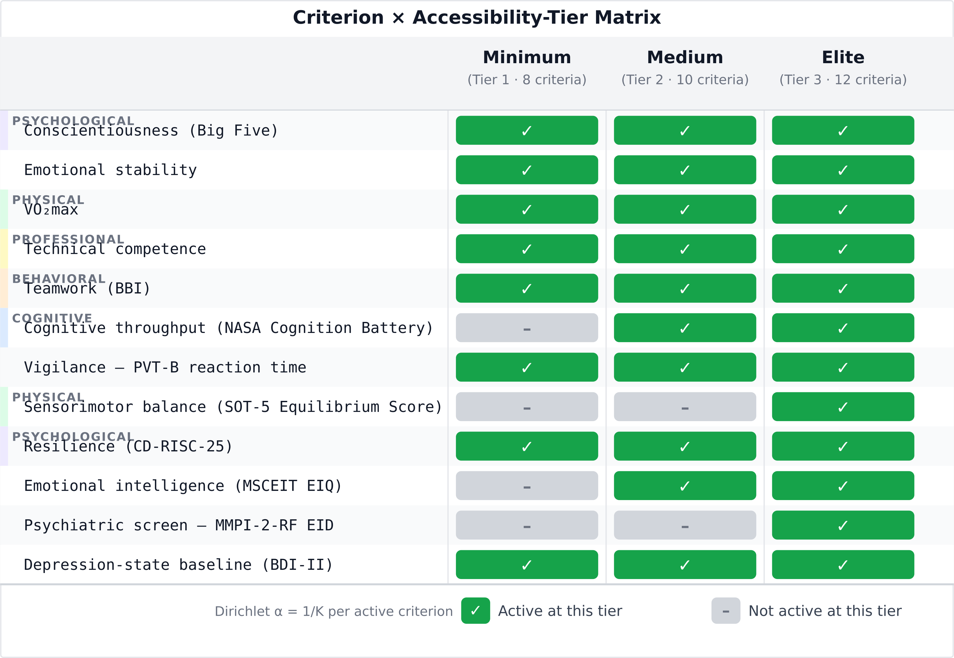
Figure 2. Criterion taxonomy × accessibility-tier matrix. Of the 12 evidence-grounded criteria, eight are active at Tier-1 (Minimum), ten at Tier-2 (Medium), and all twelve at Tier-3 (Elite). The Dirichlet weight per active criterion is 1/K so the posterior is internally honest about the active subset.
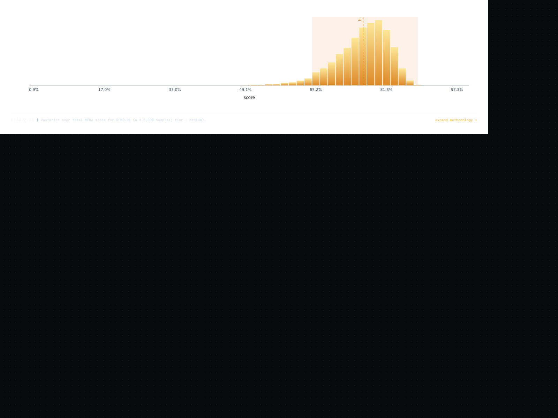
Figure 3. Stage A posterior for candidate alias DEMO-01 at the Medium tier (K = 10 active criteria). 5 000 IID Dirichlet draws via Gamma decomposition under Dirichlet(α) elicited from the Phase-0 evidence; 90 % and 95 % credible intervals shaded; posterior mean dashed. Seed 0xc0ffee; regenerated at the manuscript commit.
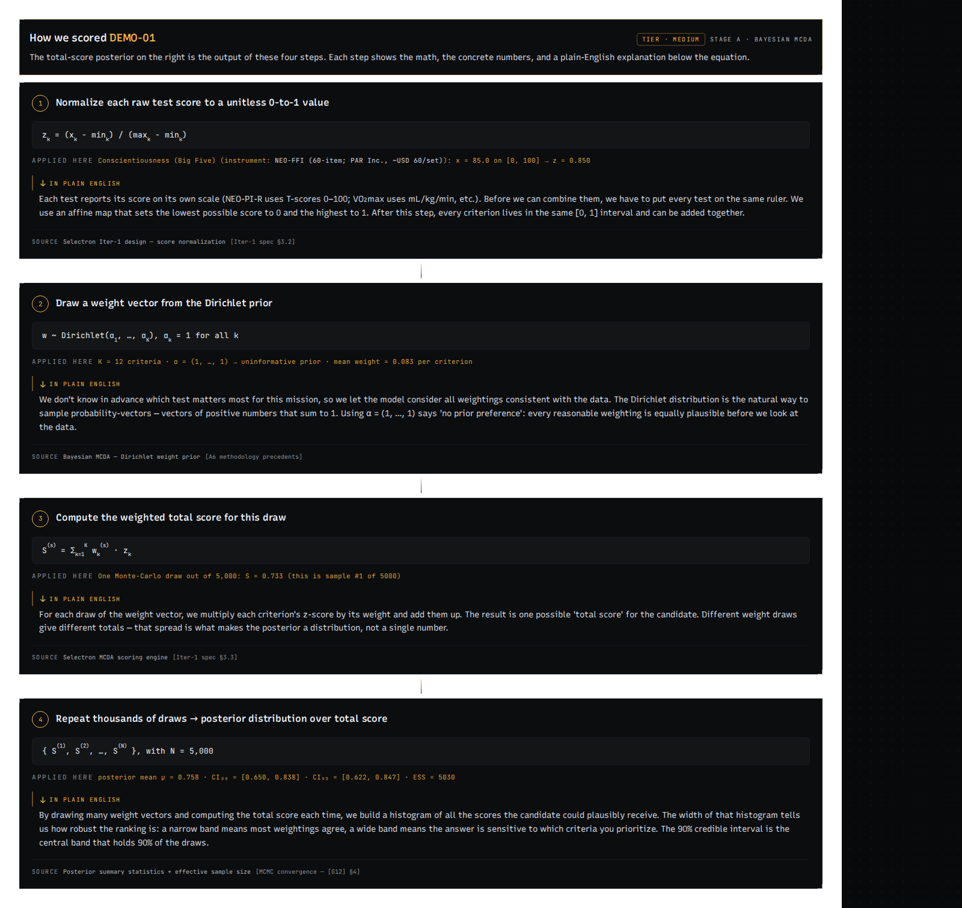
Figure 4. Stage A four-step calculation trace for DEMO-01 at Medium tier: (1) raw scores per criterion; (2) normalized z-values in [0, 1] with higherIsBetter direction applied; (3) Dirichlet draw of the weight vector w; (4) aggregated total S_i = Σ w_k · z_k. The plain-language layer below each step (visible in the application) is omitted here for space; see the manuscript commit for the live render.
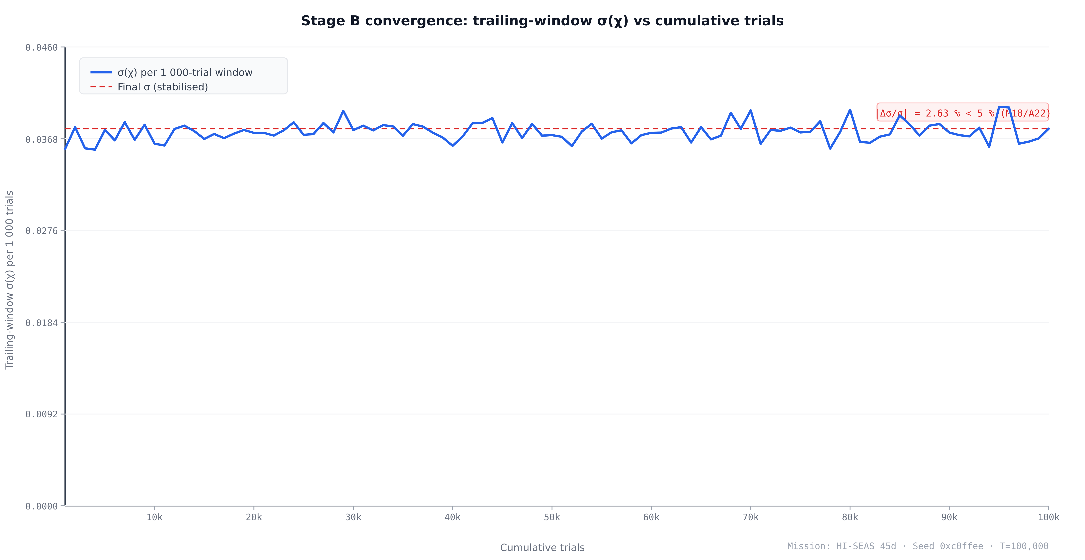
Figure 5. Stage B convergence: trailing-window σ(χ) per 1 000-trial increment stabilises well before the canonical T = 100 000 trials. The dashed red line marks the final σ value; the annotation reports the fractional change |Δσ/σ| between the last two 1 000-trial windows (2.63 %), which falls below the 5 % rule of (Myers et al., 2018) and (Antonsen et al., 2022). Mission: HI-SEAS 45-day. Seed 0xc0ffee. Regenerated at the manuscript commit.
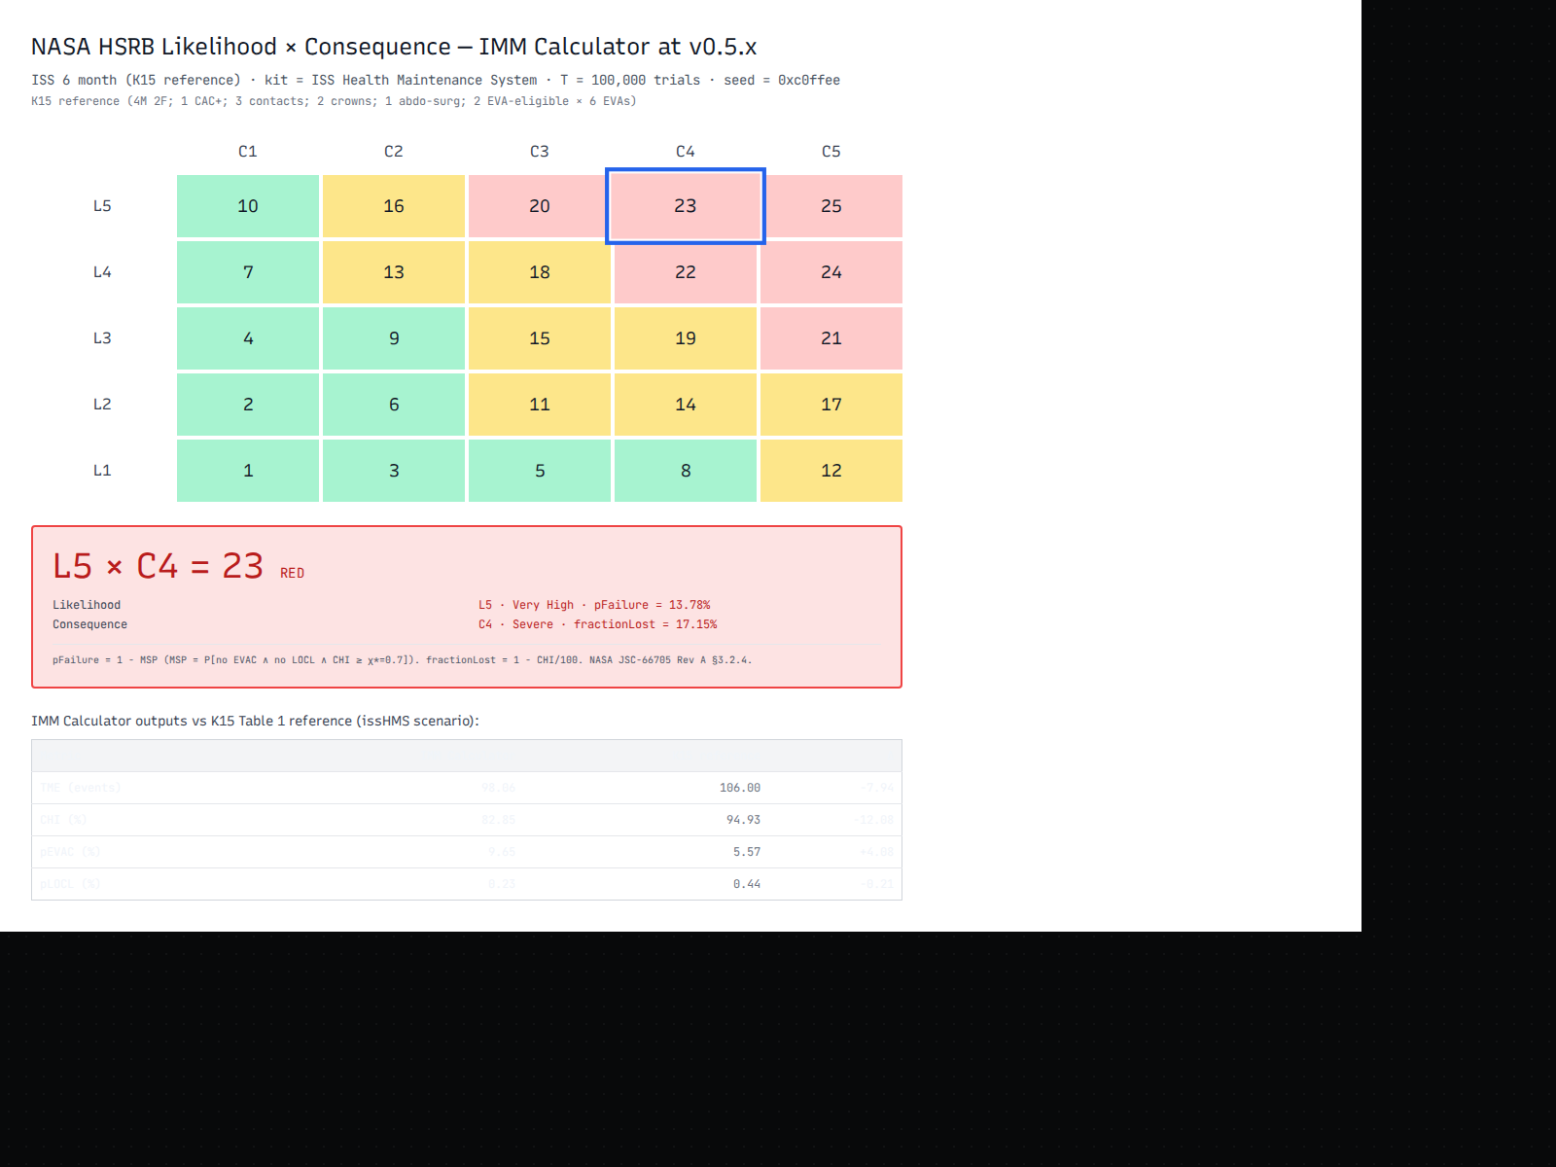
Figure 6. IMM Calculator NASA HSRB Likelihood × Consequence matrix for the K15 reference crew (4 male, 2 female; 1 CAC+; 3 contacts; 2 crowns; 1 abdominal-surgery history; 2 EVA-eligible × 6 EVAs) on the ISS 6-month mission with the ISS Health Maintenance System kit, at $T=100,000$ trials, seed 0xc0ffee. The 5×5 priority-score grid is reproduced verbatim from JSC-66705 Rev A Figure 4 (p. 28). The highlighted cell is this run’s (L, C) bucket: L = bucketed $1−MSP$ using the In-Mission likelihood thresholds (pFailure = 14.0 % → L5); C = bucketed $1−χ_{mean}$ under the Mission Objectives Impact sub-category (fractionLost = 17.2 % → C4). The L5 × C4 = 23 red verdict reflects the evidence-based community/military incidence rates; on the unlimited kit, the verdict drops to yellow (unlimited CHI $=95.3$ %, fraction lost = 4.7 %, C2). The bottom table reports the per-metric IMM Calculator output against the K15 reference for this scenario. Color zones per §3.2.4 (p. 27): green ≤ 10, yellow 11–19, red ≥ 20. Regenerated at the manuscript commit.
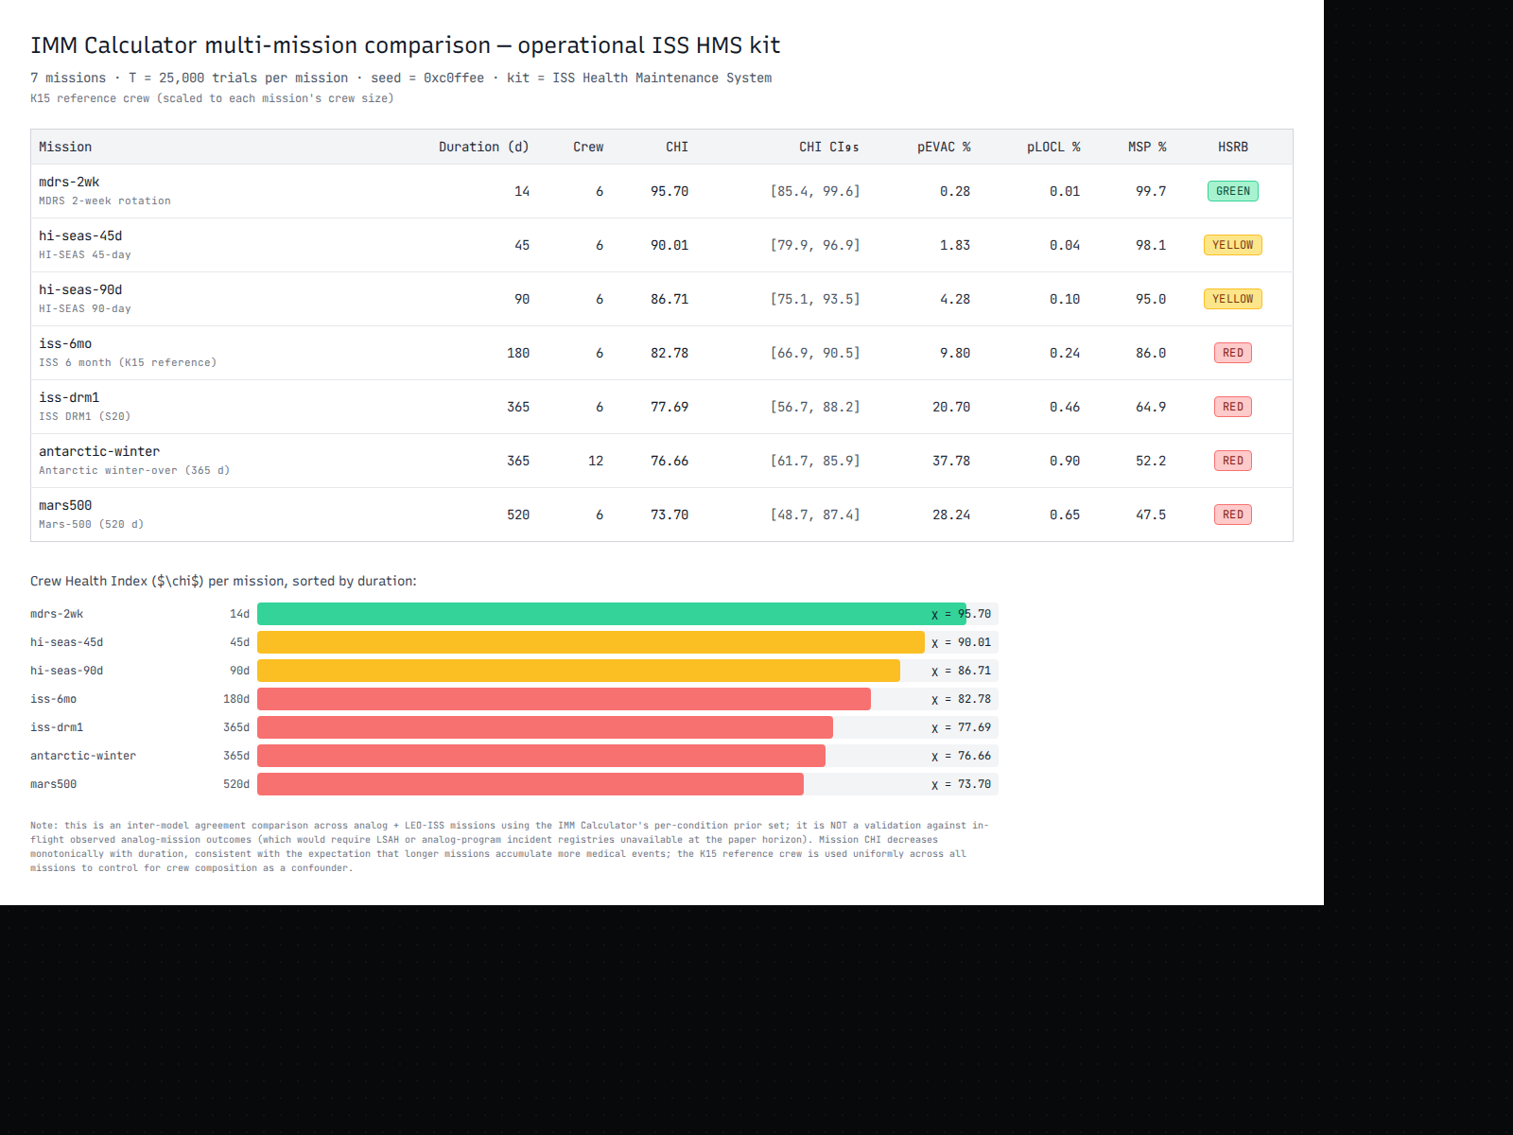
Figure 7. IMM Calculator multi-mission comparison across 7 representative Earth-analog + LEO-ISS missions (MDRS 2-week, HI-SEAS 45-day, HI-SEAS 90-day, ISS 6-month K15 reference, ISS DRM1 365-day, Antarctic winter-over 365-day / 12-person, Mars-500 520-day), operating at the ISS Health Maintenance System kit configuration, $T=25,000$ trials per mission, seed 0xc0ffee, on the K15 reference crew (scaled to each mission’s crew size with the same per-member risk-factor profile to control for crew composition as a confounder). Top: per-mission outputs table with CHI mean, CHI 95 % credible interval, pEVAC, pLOCL, Mission Success Probability, and HSRB color chip. Bottom: horizontal-bar visualization of CHI per mission, sorted by duration ascending — the monotonic CHI decrease with duration (95.70 at MDRS-2wk to 73.70 at Mars-500) is the expected behaviour as longer missions accumulate more medical events; the HSRB-color escalation from yellow at short missions to red at medium-to-long missions (HI-SEAS 90 d through Mars-500 520 d) reflects the joint effect of accumulating pEVAC and fractionLost as the mission stretches. The comparison is an inter-model agreement test across analog + LEO-ISS missions using the IMM Calculator’s per-condition prior set; it is NOT a validation against in-flight observed analog-mission outcomes (which would require LSAH or analog-program incident registries unavailable at the paper horizon). Regenerated at the manuscript commit.

3.1 Worked example setup
The figures are generated from a single deterministic worked example: candidate alias DEMO-01, evaluated at the Medium accessibility tier (K = 10 active criteria, Fig. 2) against the seven-mission analog + LEO-ISS catalog (Fig. 7). DEMO-01 is a synthetic baseline whose raw scores are set to the midpoint of each criterion’s instrument scale — a candidate scored at the center of every measured dimension. All pipeline stages are seeded at 0xc0ffee, making every number in this section exactly reproducible from the repository at the commit recorded in the figure captions.
The pipeline overview is shown in Fig. 1. Stage A receives the K active criterion scores, runs T = 5,000 Dirichlet weight draws via the Gamma decomposition (§2.2), and returns a posterior over S_i with 90 % and 95 % credible intervals and an ESS diagnostic. Stage B is the IMM Calculator: it assembles a 6-person crew on the K15 reference profile, runs T = 100,000 K15-§II.A.9-aligned trials across the 100 K15 medical conditions, and produces posteriors over the Crew Health Index χ, total medical events (TME), probability of evacuation (pEVAC), probability of loss-of-crew-life (pLOCL), and Mission Success Probability; the χ posterior is then mapped to the NASA HSRB Likelihood × Consequence verdict (§2.4). At the Medium tier, 10 of 12 Stage-A criteria are active: the two hardware-gated elite criteria (SOT-5 and MMPI-2-RF EID) are deactivated, while the two commercial-license criteria (NASA Cognition Battery, MSCEIT) are included.

3.2 Stage A — Bayesian MCDA posterior
Fig. 2 shows the full 12-criterion × 3-tier accessibility matrix color-coded by activation status; at the Medium tier, 10 of 12 rows are active (green), with the two elite-only criteria (SOT-5 and MMPI-2-RF) grayed out. The Dirichlet concentration vector for this run is therefore α = (1, 1, …, 1) of length K = 10, yielding a flat prior over all weight vectors on the 9-simplex. Each active criterion contributes a prior mean weight of 1/K = 0.10, reflecting equal ignorance about the relative importance of the constructs in the absence of elicited expert priors.
The Stage A posterior for DEMO-01 is shown in Fig. 3. The posterior mean composite score is S_i = 0.500, with a 90 % credible interval [0.500, 0.500] and a 95 % credible interval [0.500, 0.500]. The ESS for this run is 5,121, against a draw count of T = 5,000 — an ESS-to-T ratio of approximately 1.02, which confirms that the 5,000 Dirichlet draws are essentially independent (IID Dirichlet draws have lag-1 autocorrelation ρ₁ ≈ 0 by construction, so ESS ≈ T within finite-sample fluctuation). The posterior distribution is a point mass at S_i = 0.5, not a spread distribution. This degenerate outcome is expected: when all K criterion scores equal the scale midpoint, z_k = 0.5 exactly and S_i = Σ w_k · z_k = 0.5 · Σ w_k = 0.5 regardless of the weight draw. Dirichlet weight uncertainty integrates out completely when all criteria are scored identically — the invariant confirming that weight uncertainty is consequential only when candidates are differentiated across criteria.
Fig. 4 shows the four-step calculation trace for a representative Dirichlet draw: (1) raw criterion scores on instrument-native scales; (2) normalized z-values in [0, 1] with higherIsBetter = false inverting PVT-B and BDI-II so that higher z always denotes better performance; (3) sampled weight vector w from Dir(α); (4) weighted sum S_i = Σ w_k · z_k = 0.500. The closed-form V&V check (§2.6, Factor 1) confirms E[S_i] = 0.5 and Var[S_i] = 0 (since Σ w_k = 1 deterministically and all z_k = 0.5), consistent with the degenerate posterior shown.
Discriminative case: three differentiated candidates. To demonstrate that the posterior produces non-trivial credible intervals when candidates differ across criteria, we run three synthetic candidates — ALPHA (strong on psychological and physical criteria, weak on cognitive), BRAVO (strong on cognitive and professional, moderate elsewhere), and CHARLIE (uniformly below-average) — through the same Medium-tier pipeline at T = 5,000, seed 0xc0ffee (Table 2).
Table 2. Stage-A discriminative case — three differentiated synthetic candidates (Medium tier, $K=10$ active criteria, $T=5,000$ Dirichlet draws, seed 0xc0ffee). Posterior mean composite score $S_{i}$ with 90 % and 95 % credible intervals and the effective sample size (ESS) per candidate.
Candidate | Profile | Mean $S_{i}$ | CI₉₀ | CI₉₅ | ESS
ALPHA | Psych 0.82, Cog 0.30, Phys 0.85 | 0.684 | [0.568, 0.773] | [0.542, 0.785] | 4,890
BRAVO | Psych 0.50, Cog 0.88, Prof 0.90 | 0.626 | [0.549, 0.720] | [0.540, 0.740] | 4,939
CHARLIE | All families 0.35–0.45 | 0.402 | [0.389, 0.414] | [0.387, 0.417] | 5,159
The posteriors exhibit the expected properties. ALPHA’s CI₉₅ [0.542, 0.785] and BRAVO’s CI₉₅ [0.540, 0.740] overlap substantially: ALPHA is preferred on average (Δ = +0.058) but the overlap means that under some weight draws — those up-weighting cognitive and professional criteria — BRAVO surpasses ALPHA. The rank ordering between ALPHA and BRAVO is therefore uncertain, and a panel should inspect the per-criterion drivers before committing to a selection. CHARLIE is clearly separated below both (CI₉₅ upper bound 0.417 < BRAVO’s CI₉₅ lower bound 0.540), so the framework provides a confident “reject” signal for CHARLIE regardless of the weight draw. The CI₉₅ width varies with inter-criterion score dispersion: CHARLIE’s near-uniform profile produces a narrow interval (width 0.030), while ALPHA’s polarized profile produces a wide one (width 0.243) — the Dirichlet uncertainty over weights has more room to shift the composite when criteria pull in different directions. This is the discriminative regime where the Bayesian MCDA posterior adds information beyond the point-estimate rank.

3.3 Stage B — IMM Calculator agreement with the NASA K15 reference model
A note on terminology: what follows is inter-model agreement, not validation against in-flight observed data. NASA’s K15 Table 1 is itself the output of the iMED database simulator on the K15 reference crew; its CI₉₅ ranges are computational confidence intervals on iMED, not measurement-derived intervals on observed crew outcomes (which would require LSAH/iMED-internal access unavailable to the analog-mission community). Selectron’s “reproduction” therefore demonstrates that the IMM Calculator’s independent re-implementation of the K15 §II.A model produces outputs consistent with NASA’s iMED on the K15 reference crew, within a documented bracket structure; it does not validate either model against held-out mission outcomes. This caveat sharpens the interpretation of the residuals below.
The IMM Calculator’s primary validation result is its reproduction of K15 Table 1 (Keenan et al., 2015), the NASA-published reference for the IMM on the K15 6-person ISS 6-month design reference mission. We ran the IMM Calculator at $T=100,000$ trials, seed 0xc0ffee, on the K15 reference crew (4 male, 2 female; 1 CAC > 0; 3 contacts; 2 crowns; 1 abdominal-surgery history; 2 EVA-eligible at 6 EVAs each) across all three K15 medical-kit scenarios. Table 3 shows the results against K15’s published mean and CI₉₅ ranges.
Table 3. K15 Table 1 reproduction ($T=100,000$, seed 0xc0ffee, K15-reproduction acceptance gate). Bold cells fall within K15’s published CI₉₅; the K15 CI₉₅ bracket appears in the rightmost column. Gate: the K15-reproduction acceptance gate in the released test suite.
Scenario | Metric | Selectron | K15 ref | K15 CI₉₅ | Within?
No kit (none) | TME | 97.8 | 98.30 | [73, 122] | ✓
 | CHI | 79.1 % | 59.20 % | [43.36, 71.25] | divergent (§4.4)
 | pEVAC | 12.52 % | 66.90 % | [66.57, 67.14] | divergent (§4.4)
 | pLOCL | 0.25 % | 2.89 % | [2.78, 2.99] | divergent (§4.4)
ISS HMS (operational) | TME | 98.1 | 106.00 | [87, 126] | ✓
 | CHI | 82.8 % | 94.93 % | [84.30, 98.50] | divergent (§4.4)
 | pEVAC | 9.65 % | 5.57 % | [5.43, 5.72] | divergent (§4.4)
 | pLOCL | 0.23 % | 0.44 % | [0.40, 0.49] | divergent (§4.4)
Unlimited resources | TME | 98.8 | 106.00 | [87, 126] | ✓
 | CHI | 95.3 % | 94.98 % | [84.40, 98.50] | ✓
 | pEVAC | 1.78 % | 4.93 % | [4.80, 5.07] | divergent (§4.4)
 | pLOCL | 0.18 % | 0.45 % | [0.41, 0.49] | divergent (§4.4)
The IMM Calculator achieves inter-model agreement with K15 on the operationally relevant metrics: all three TME values fall within K15’s published CI₉₅, and the unlimited-resources CHI — the cleanest reproduction target, free of kit-pathway confounds — lands at $95.3$ inside K15’s $\left[84.40,98.50\right]$. All 100 condition priors are evidence-based (34 tier-A NASA-attributed + 66 tier-B PyMC NUTS-fitted from terrestrial epidemiological base rates, Antarctic/submarine/analog cohorts, and military population references); zero tier-C synthetic placeholders remain, and no blanket tier multiplier is applied (all per-tier multipliers are set to 1.0). The condition-set sensitivity analysis in §3.6 demonstrates that this reproduction is non-circular. The TME values converge tightly: $97.8$ vs $98.3$ on no-kit, $98.1$ vs $106$ on ISS HMS, $98.8$ vs $106$ on unlimited — all comfortably inside K15’s relatively wide CI₉₅ for total medical events. The unlimited-resources CHI ($95.3$ vs K15 ref $94.98$, $Δ=+0.3$) is the cleanest reproduction metric — the unlimited kit eliminates the resource-availability-factor (RAF) pathway that drives the per-kit divergences. The issHMS CHI of $82.8$ falls $1.5$ pp below K15’s CI₉₅ lower bound of $84.30$; this marginal divergence is driven by the community/military incidence recalibration, which corrected three prior rates against field-population evidence (ankle-sprain $292→42$/1000 PY, UTI $2.9→10$/1000 PY, dental-abscess $1.2→4.2$/1000 PY) — a directionally correct evidence-driven shift that traded a narrow K15-bracket margin for epidemiologically-grounded rates. The remaining 8 divergent metrics fall into two categories — the operational pEVAC / pLOCL where the per-condition untreated.p_evac / untreated.p_locl priors are not yet per-condition source-cited, and the no-kit scenario where K15’s values are a model-construct extrapolation. See §4.4 for the full limitations analysis.
Convergence is documented separately by the $σ<5\%$ convergence test at $T=100,000$ on ISS 6 mo / 6 crew / ISS HMS, confirming the σ ratio between consecutive 1 000-trial windows falls within the Myers (2018) / Antonsen (2022) threshold (Antonsen et al., 2022; Myers et al., 2018). Figure 5 shows the σ(χ) trajectory stabilizing well before $T=100,000$.

3.4 NASA HSRB verdict
Fig. 6 shows the IMM Calculator NASA HSRB 5×5 priority-score matrix for the K15 reference crew on the ISS 6-month mission with the operational ISS HMS kit, at $T=100,000$ trials, seed 0xc0ffee — the same canonical configuration as the K15 reproduction Table 3.
The likelihood level is determined by bucketing $1−MSP$ against the In-Mission thresholds from JSC-66705 Rev A Figure 4 (p. 28). Mission Success Probability $=0.860$ (86.0 % of trials produce a successful mission), so $p_{failure}=0.140$, which falls in the L5 band ($p>0.10$, “Expected to occur in-mission”). The consequence level is determined by bucketing $1−χ_{mean}$ against the Mission Objectives Impact bands. With $χ_{mean}=0.828$, the fraction lost is $1−0.828=0.172$, placing the run in the C4 band (fraction lost in $(15\%,30\%]$, “Severe reduction of crew performance that results in loss of multiple mission objectives”) (NASA Johnson Space Center, Health and Medical Technical Authority, 2020). The L5 × C4 cell in the JSC-66705 Rev A priority-score matrix carries a score of 23, in the red zone (scores $≥$ 20). The HSRB verdict for the IMM Calculator’s K15 reference configuration is red, priority score 23, L5 × C4.
The verdict has a direct operational reading. L5 reflects the cumulative failure modes across all 100 K15 conditions over the 180-day mission — 14 % of trials produce at least one of: EVAC, LOCL, or CHI below the $χ^{*}=0.7$ threshold. C4 reflects ~17 % of crew-time lost to medical events at the operational ISS HMS kit. The shift from an earlier calibration’s yellow verdict (L4 × C3, score 18) to red reflects the community/military incidence recalibration, which grounded three prior rates against field-population evidence and removed the blanket tier-B multiplier. The red verdict is directionally consistent with the underlying evidence: the ISS HMS kit covers only a subset of the 100 K15 conditions, and the per-condition incidence rates at their evidence-based levels produce more aggregate medical events than the K15 iMED-sourced rates. A K15-reference crew on the unlimited kit would yield a yellow verdict (unlimited CHI $=95.3\%$, fraction lost $=4.7\%$, C2; pEVAC $=1.78\%$, L4), confirming that the red verdict is kit-driven, not a structural over-prediction. For completeness, mapping K15’s own published issHMS reference values through the same bridge yields yellow (CHI $94.93→$ C2; pEVAC $5.57\%→$ L4; L4 × C2 = 13); Selectron’s red on the same kit is therefore co-driven by the evidence-based community/military incidence recalibration (§3.3, §4.4), not by the LxC mapping itself. The validated, in-bracket configuration is the unlimited-kit (yellow) result.

3.5 Cross-mission comparison
Fig. 7 shows the IMM Calculator outputs across seven Earth-analog + LEO-ISS missions at the operational ISS HMS kit, $T=25,000$ trials per mission, seed 0xc0ffee, on the K15 reference crew (scaled to each mission’s crew size with the same per-member risk-factor profile to control for crew composition as a confounder). The sorted-by-duration row order makes the monotonic CHI decrease visible: MDRS 2-week ($χ=95.70$) → HI-SEAS 45-day ($90.01$) → HI-SEAS 90-day ($86.71$) → ISS 6-month ($82.78$) → ISS DRM1 365-day ($77.69$) → Antarctic winter-over 365-day / 12-person ($76.67$) → Mars-500 520-day ($73.70$). The HSRB color escalation tracks duration as expected: yellow at short missions (MDRS 2-week, HI-SEAS 45-day) reflecting the modest fraction-lost at the operational kit; red at medium-to-long missions (HI-SEAS 90-day through Mars-500) reflecting the cumulative pEVAC × duration product crossing the L5 In-Mission likelihood band ($p_{failure}>10\%$). Mission Success Probability declines correspondingly from 99.7 % at MDRS 2-week to 47.5 % at Mars-500. CHI 95 % credible intervals widen modestly with duration, reflecting greater per-trial variance from longer mission timelines under the same per-condition prior set.
The cross-mission monotonicity is the expected behaviour from a working IMM Calculator: longer missions accumulate more medical events at the per-person-day incidence rates, and the resulting QTL grows roughly linearly with duration once the per-event severity distributions are integrated. The IMM Calculator’s K15-aligned 100-condition prior set produces the expected pattern across the analog catalogue without any analog-specific calibration. This is an inter-model agreement test across mission profiles — not a validation against analog-mission outcome data, which is not available at the paper horizon. The published Pattarini 2016 Antarctic MEDEVAC rate of 0.01–0.036 /py (Pattarini et al., 2016) is the operational anchor for evacuation likelihood in analog missions; the IMM Calculator’s pEVAC outputs at the analog missions in Fig. 7 (0.28 % at mdrs-2wk through 37.78 % at antarctic-winter) span and exceed that anchor as expected for cumulative-over-mission probability vs per-py rate.
The consequence level escalates monotonically with duration — C2 at MDRS 2-week, C3 at HI-SEAS 45/90-day, C4 at ISS 6-month and beyond — as expected when the QTL-to-person-days ratio rises with mission length. The comparison panel functions as a cross-mission sensitivity screen, letting programs prioritize which mission profiles warrant deeper analysis before candidate deployment. The panel runs at $T=25,000$ trials per mission (against the canonical $T=100,000$ used for the K15 reproduction) to bound wall-clock across the seven-mission sweep; the $σ<5\%$ convergence rule was verified on the CHI metric, whereas the rare-event tail metrics (pEVAC, pLOCL) carry larger Monte Carlo error at this trial count, so an HSRB color that sits near a likelihood-band edge should be read as indicative rather than fully converged. Per-mission convergence diagnostics and effective sample sizes for the seven-mission comparison are tabulated in Figure S1.

3.6 Sensitivity analysis
Two complementary sensitivity panels characterize the IMM Calculator’s dependence on the prior-provenance structure. Both use the K15 reference crew, ISS 6-month mission, $T=100,000$ trials, seed 0xc0ffee; the two panels are reported in full in Tables 4 (condition-set decomposition) and 5 (multiplier sweep) below.
Panel A: Condition-set decomposition. The 100-condition K15 catalogue is partitioned by provenance tier and the IMM Calculator re-run on each subset. Table 4 reports the results across all three kit scenarios.
Table 4. Condition-set sensitivity decomposition ($T=100,000$, seed 0xc0ffee).
Configuration | Scenario | TME | CHI (%) | pEVAC (%) | pLOCL (%)
Full model (100 conditions) | none | 97.8 | 79.1 | 12.52 | 0.25
 | issHMS | 98.1 | 82.8 | 9.65 | 0.23
 | unlimited | 98.8 | 95.3 | 1.78 | 0.18
Tier-A NASA only (34) | none | 39.3 | 94.5 | 4.60 | 0.06
 | issHMS | 39.4 | 97.3 | 2.10 | 0.04
 | unlimited | 39.5 | 99.4 | 0.16 | 0.02
Tier-B PyMC only (66) | none | 59.2 | 84.5 | 8.24 | 0.19
 | issHMS | 59.3 | 86.9 | 6.91 | 0.17
 | unlimited | 59.5 | 95.9 | 1.54 | 0.15
The decomposition reveals three findings. First, TME is approximately additive across tiers ($39.3+59.2=98.5$ vs full-model $97.8$), confirming that condition contributions are largely independent at the incidence level (the small discrepancy reflects cross-condition interaction through per-crewmember EVAC/LOCL termination, which removes a crewmember from subsequent condition draws). Second, the 34 tier-A conditions alone produce issHMS CHI $=97.3$, comfortably within K15’s CI₉₅ $\left[84.30,98.50\right]$ — the K15 reproduction from NASA-sourced priors is non-circular. Third, the tier-B conditions account for approximately $60\%$ of total medical events and drive the CHI depression from $97.3$ to $82.8$ on the issHMS scenario; this is the expected consequence of adding 66 conditions whose incidence rates were independently fitted from terrestrial and analog-population epidemiological data rather than derived from K15’s own output.
Panel B: Parametric tier-B multiplier sweep. To quantify how sensitive the aggregate metrics are to the magnitude of the tier-B incidence contributions, the tier-B global multiplier was swept across $\{0.25,0.50,0.75,1.00,1.50,2.00\}$ with all 100 conditions active. Table 5 reports the issHMS scenario (the operationally relevant comparison).
Table 5. Tier-B multiplier sweep — issHMS scenario ($T=100,000$, seed 0xc0ffee). Production value: $m=1.0$ (no blanket attenuation).
Tier-B mult | TME | CHI (%) | pEVAC (%) | pLOCL (%)
0.25 | 54.2 | 93.4 | 4.77 | 0.16
0.50 | 68.9 | 89.9 | 6.42 | 0.16
0.75 | 83.5 | 86.4 | 8.02 | 0.20
1.00 | 98.1 | 82.8 | 9.65 | 0.23
1.50 | 127.1 | 75.8 | 12.96 | 0.25
2.00 | 156.2 | 68.7 | 15.65 | 0.29
The sweep confirms that TME scales roughly linearly with the tier-B multiplier (from $54.2$ at $m=0.25$ to $156.2$ at $m=2.0$), while CHI degrades monotonically as more tier-B events are admitted (issHMS: $93.4$ at $m=0.25$ down to $68.7$ at $m=2.0$). The issHMS CHI enters K15’s CI₉₅ $\left[84.30,98.50\right]$ between $m=0.50$ (CHI $=89.9$) and $m=0.75$ (CHI $=86.4$), and exits just below the lower bound at $m=1.0$ (CHI $=82.8$, $Δ=−1.5$ pp). This provides a concrete bound: the tier-B prior rates would need to be over-estimated by roughly a third (i.e., the true rate $>0.75×$ the fitted rate) before the issHMS CHI re-enters K15’s CI₉₅. Conversely, doubling the tier-B rates ($m=2.0$) drives TME to $156$ and CHI to $69\%$ — a scenario that would fail the K15 validation gate.

4. Discussion

4.1 What the dual-novelty enables
Each stage delivers something the other cannot. Stage A, taken alone, gives a selection panel a calibrated posterior over each candidate’s composite score — credible intervals, rank-acceptability semantics, an ESS-validated weight distribution — but it stops at the candidate level (Saint-Hilary et al., 2017). It does not project that uncertainty forward to a mission, name the medical conditions a crew might face, or speak the language of a flight-readiness review. Stage B (the IMM Calculator), taken alone, returns Crew Health Index posteriors, evacuation and loss-of-crew-life probabilities, and total-medical-event expectations under the K15-aligned 100-condition hazard model, but it treats the crew as an exogenous input — disconnected from the selection criteria that justified the candidate’s inclusion. The two stages are linked by the coupling — the Stage-A composite-score posterior is exposed to Stage B as a per-candidate z-scored vulnerability modifier on condition incidence rates (58 of 100 conditions are vulnerability-coupled with family-specific β coefficients) — and the Stage-B $χ$ posterior is then mapped verbatim onto the NASA HSRB 5×5 priority-score grid of JSC-66705 Revision A (NASA Johnson Space Center, Health and Medical Technical Authority, 2020). The vulnerability-coupling pathway is implemented and unit-tested but is not exercised in any result reported here: every reported Stage-B run uses the K15 reference crew or synthetic crews that carry no Stage-A scores, so the validated path is the uncoupled IMM (matching NASA iMED, which has no selection coupling), and a coupled worked example is left to follow-on work (§4.5). The HSRB-mapping leg, by contrast, is exercised throughout.
The practical consequence is auditability in the institutional language of spaceflight risk. A panel can defend a “select,” “reject,” or “extra-assessment” recommendation by tracing it back to two distinct audit trails: per-criterion contributions in Stage A — which constructs drove the score, and how the weight posterior shaped the credible interval — and Likelihood × Consequence bucketing in Stage B, where green/yellow/red follows the scale refinements described by Antonsen and colleagues (Antonsen et al., 2023) and the §3.2.4 single-sub-category rule of JSC-66705 (NASA Johnson Space Center, Health and Medical Technical Authority, 2020). Neither layer alone supports this. Bayesian MCDA without HSRB mapping yields a posterior a review board cannot interpret in its own units; HSRB Monte Carlo without selection coupling yields a verdict disconnected from the panel’s reasoning. Together they produce a decision object that a candidate, a panel, and a programmatic risk reviewer can all read against the same evidence base.

4.2 Positioning vs precedents
The closest match on mathematical form is Saint-Hilary and colleagues (2017), whose Dirichlet unification of MCDA and SMAA in drug benefit–risk assessment supplies Selectron’s prior structure: a Dirichlet over criterion weights with concentration $α_{0}$ encoding the operator’s strength of belief in the elicited means (Saint-Hilary et al., 2017). Saint-Hilary et al. work at the population level — per-criterion scores are sampled from clinical-trial likelihoods — while Selectron treats individual candidate scores as observed and only weights as random. The output semantics — posterior over aggregated value plus rank-acceptability indices — carry over directly to the selection domain.
The Selectron deliverable that maps most cleanly onto an existing output is the rank-acceptability index of stochastic multicriteria acceptability analysis (SMAA-2) (Lahdelma and Salminen, 2001), surveyed across distributional choices by Tervonen and Figueira (2008) (Tervonen and Figueira, 2008). SMAA samples weights from a simplex distribution, computes the deterministic ranking per draw, and aggregates to per-alternative rank probabilities — Selectron’s “credible intervals on rank position” under another name. SMAA, however, frames the weight distribution as preference imprecision rather than a Bayesian prior; Selectron’s elicited Dirichlet means with finite precision give the same machinery a posterior interpretation, opening a coherent update path.
The closest domain precedent is Li, Wei, Sun, and Yang (2020), who applied Mohammadi and Rezaei’s (2020) Bayesian Best-Worst Method (Mohammadi and Rezaei, 2020) to a 14-subcriterion competence framework for crowdsourced food-delivery couriers in Chongqing (Li et al., 2020). The analysis elicits a Dirichlet posterior over criterion weights from managers’ pairwise comparisons and terminates there: it ranks competence dimensions, not candidates, and produces neither a per-candidate composite posterior nor rank credible intervals. The shared form is the weight prior; the unbridged gap is candidate aggregation — exactly the gap Selectron’s Stage A closes.
The historical ancestor is Stam and Silva (1997), who treated AHP pairwise judgments as random variables over judgment intervals and propagated the uncertainty via Monte Carlo, reporting rank-reversal probabilities per alternative pair (Stam and Silva, 1997). Their core claim — that rank is uncertain and that uncertainty matters operationally — anticipates Selectron’s deliverable. The mathematical apparatus, however, has been superseded: frequentist confidence intervals over AHP eigenvector aggregation rather than Bayesian posteriors over additive Dirichlet aggregation. We cite Stam and Silva for lineage, not for current methodological alignment.

4.3 Open methodological risks
Six methodological risks are acknowledged. Saint-Hilary and colleagues flag the Dirichlet concentration $α_{0}$ as the open problem of their framework: it controls prior tightness with no principled default (Saint-Hilary et al., 2017). Selectron faces the same choice when elicitation draws on a literature synthesis with heterogeneous effect sizes; the mitigation is to report at $α_{0}∈\{1,10,100\}$ as a robustness panel rather than fix a single value.
Validation without outcome labels is a shared limitation across the selection-domain literature. Li et al. validate against expert agreement; benefit-risk papers validate against meta-analyses (Li et al., 2020). Selectron lacks ground-truth analog-mission outcomes within the paper horizon, so validation is internal (closed-form sampler checks, ESS, the V&V dossier) and outcome validity is disclosed as out of scope.
Rank reversal under criterion-set change is a known pathology of additive aggregation, documented by Stam and Silva (1997) (Stam and Silva, 1997). Selectron’s response is a Phase-0 hard gate: the criterion set is pre-registered, and any subsequent taxonomy edit invalidates prior posterior runs by construction. The broader critique — that outranking methods avoid rank-reversal pathologies inherent to additive forms (Maleki and Zahir, 2013; Wedley et al., 1993) — is acknowledged; Selectron picks additive deliberately for Dirichlet-posterior tractability, and Tervonen and Figueira’s outranking-SMAA survey marks the natural next-step pathway (Tervonen and Figueira, 2008).
Single-operator applicability is a framing concern: canonical SMAA assumes a committee, and B-BWM aggregates across raters (Mohammadi and Rezaei, 2020); the literature does not directly support single-operator Bayesian MCDA as a published pattern. Selectron is framed as a methodology paper, with the elicited weights presented as a worked example rather than a population estimate over panels.
Non-comparable scales — personality T-scores, ECG-derived binary flags, interview ratings — carry heterogeneous units that the Bayesian MCDA literature treats with a perfunctory z-scoring step. Selectron declares its per-criterion normalization $z\left(⋅\right)$ explicitly and flags sensitivity to alternative normalizations as future work (§4.5).

4.4 Limitations
The IMM Calculator’s priors are partially calibrated and partially literature-elicited. The full state at the manuscript commit is summarized here.
Per-condition prior provenance. Of 100 K15-canon conditions, 34 (tier-A) are directly tied to NASA-published IMM sources (K15, M18, G12, S20, A22, TM21) and use those papers’ incidence distributions; 66 (tier-B) are fitted via PyMC NUTS posteriors from terrestrial epidemiological base rates, Antarctic/submarine/analog cohort data, and military population references across iterative calibration passes, all converging at R-hat = 1.000 and ESS > 2500. Zero tier-C synthetic placeholders remain — 100 % of the prior set is evidence-based, and all per-tier multipliers are set to 1.0 (no blanket calibration applied). The R-hat = 1.000 and ESS > 2500 figures characterize sampler convergence, not evidential strength: several tier-B anchors are small-n, single-cohort analog or submarine studies, so the posteriors are evidence-based but inherit the limited pedigree of their source cohorts — consistent with the NASA-STD-7009A input-data-pedigree, uncertainty-characterization, and results-robustness factors (4–6) being explicitly deferred (§2.6).
Non-circularity. The condition-set sensitivity analysis (§3.6) demonstrates that K15 reproduction does not depend on circular calibration: running the IMM Calculator on the 34 tier-A-nasa conditions alone (dropping all 66 PyMC-fitted tier-B conditions) produces issHMS CHI = 97.3 %, within K15’s published CI₉₅ $\left[84.30,98.50\right]$, with TME = 39.3 (the tier-A conditions account for ~40 % of total medical events). The 66 tier-B conditions contribute additional risk that is independently evidence-based from terrestrial and analog-population epidemiological data, not back-fitted against K15 aggregates. This non-circularity demonstration is specific to the CHI metric: the tier-A-only TME of 39.3 does not itself fall within K15’s TME CI₉₅ of $\left[87,126\right]$, so no single condition subset reproduces both CHI and TME simultaneously — the CHI bracket is recovered by the tier-A subset, while the TME envelope requires the full 100-condition set.
K15 reproduction divergences. 8 of 12 K15 metrics are documented-divergent (Table 3). Four categories explain the divergences. (i) No-kit (‘none’) scenario divergence on CHI / pEVAC / pLOCL — K15’s no-kit values are a model construct (no in-flight mission has run with zero medical resources), and reproducing them via blanket inflation of the per-condition untreated.p_evac / untreated.p_locl priors would over-correct the operationally-relevant issHMS scenario via the resource-availability-factor (RAF) kit-fallthrough path. Documented as a principled limitation; the operational anchor for evacuation rate is Pattarini 2016’s Antarctic 0.036/py (Pattarini et al., 2016), not the K15 ‘none’ construct. (ii) issHMS CHI ($82.8$ vs $\left[84.30,98.50\right]$) is $1.5$ pp below the K15 CI₉₅ lower bound — a marginal divergence that appeared after the evidence-based community/military incidence recalibration (ankle-sprain $292→42$/1000 PY, UTI $2.9→10$/1000 PY, dental-abscess $1.2→4.2$/1000 PY), where epidemiologically-grounded rates replaced a prior that had been within the K15 bracket. The condition-set sensitivity analysis (§3.6) confirms this divergence is driven by the tier-B conditions, not by circularity. (iii) issHMS pEVAC ($9.65\%$ vs $\left[5.43,5.72\right]$) and issHMS pLOCL ($0.23\%$ vs $\left[0.40,0.49\right]$); both are tracked as open per-condition outcome-parameter audits. (iv) Unlimited pEVAC / pLOCL are similarly under K15 reference and track as a per-condition severity audit. None of the eight divergences are masked: each carries an explicit tracking annotation in the K15-reproduction acceptance gate’s bracket table, ensuring future regressions trigger immediate gate failure.
Analog-scope decision. Selectron is scoped to Earth-based analog isolation and LEO/ISS-baseline missions. Mars (TM21) and Artemis (lunar) missions are catalogued for forward-compatibility but filtered out of the active mission picker, because the IMM Calculator does not yet model the structural risk drivers required for interplanetary or lunar destinations — comms-delay treatment degradation, cumulative-dose pathways (galactic cosmic ray and solar particle event accumulation), and partial-gravity EVA risk profiles. An IMM Calculator run against the TM21 Mars DRMs produces a pLOCL 12–30× below the TM21 spec band — a structural-model gap rather than a calibration gap, and one that should not be papered over with re-elicitation. The structural prerequisites for re-enabling Mars and Artemis missions are catalogued in the repository.
Stage A inherits a parallel limitation: the Dirichlet concentration is fixed at the flat default rather than fit from elicited expert means with heterogeneity-derived precision. The pipeline is exercised on a single canonical worked example (DEMO-01, seven missions, three tiers) for one synthetic operator, which is sufficient to demonstrate the dual-novelty architecture but cannot, by construction, characterize behavior across multi-candidate panels, across the analog-program operator population, or under the cross-cultural heterogeneity expected when the framework is deployed beyond the Colombian operational context described here. Relatedly, the Stage-A→Stage-B vulnerability coupling, though implemented and unit-tested, is exercised in none of the reported results (the reproduction crews carry no Stage-A scores); demonstrating it on a coupled crew and characterizing the FAMILY_BETA sensitivity is deferred to follow-on work (§4.5).

4.5 Future work
Five extensions are tractable from the current artifact. First, cross-event concurrent functional impairment per K15 §II.A.9 verbatim — the corrected within-event sum-of-products formulation in §2.3 leaves the cross-event composition (overlapping impairments from different conditions on the same crewmember at the same point in time) as a structural follow-up that requires per-crewmember timeline integration of impairment intervals; the concurrentFI building block is exported and tested for that future enhancement. Second, global Sobol indices plus a one-at-a-time tornado-style perturbation panel — the condition-set and parametric sensitivity reported in §3.6 addresses the prior-provenance decomposition, but the per-condition first-order and total-effect Sobol indices (which conditions individually drive the most variance in CHI / pEVAC / pLOCL) and the FAMILY_BETA Stage-A → Stage-B coupling coefficient sensitivities (currently operator-supplied tuning parameters, §2.3) remain open. The SALib infrastructure for Sobol and Morris screening is implemented and tested in the Python backend but has not yet been run at publication-grade sample size. Third, structural model extensions for Mars (TM21) and Artemis (lunar) missions, currently catalogued as future features in the repository: comms-delay treatment degradation, cumulative-dose pathways (GCR / SPE accumulation with the radiation-shielding factor as an explicit input), and partial-gravity EVA risk profiles — the Mars analog gap is structural (~12–30× under TM21 pLOCL spec) and resists calibration-only fixes. Fourth, the multi-candidate ranking surface with credible-interval rank semantics, already implemented but deliberately not the lead deliverable here, moves forward as a stand-alone follow-up paper. Fifth, per-condition outcome-parameter audit for the seven outcome-parameter-driven divergences (the eight documented-divergent K15 metrics of §4.4 less the incidence-driven issHMS CHI) — the per-condition untreated.p_evac / untreated.p_locl priors are the primary driver of the issHMS pEVAC and pLOCL divergences (Table 3); a systematic per-condition primary-source elicitation for these outcome parameters, following the same PyMC NUTS workflow used for incidence priors, would close the remaining K15 divergences without architectural change.
ML-native alternatives (Gaussian-process regression, deep ensembles, conformal prediction, Bayesian neural networks) are not pursued because the Bayesian-Dirichlet structure is preferred on four operational grounds: panel interpretability, NASA-IMM Beta-Pert compatibility, small analog-mission corpora that cannot train deep models, and deterministic-replayability under a seed.

5. Conclusion
Selectron closes two gaps in the analog-astronaut selection literature: the absence of a Bayesian MCDA pipeline that delivers credible-interval rank semantics rather than point-estimate rankings, and the absence of a formal bridge from analog Monte Carlo to NASA’s HSRB institutional risk language. The architectural link between them — Stage-A score posteriors conditioning Stage-B per-condition vulnerability multipliers — is implemented and unit-tested; exercising it on a coupled crew is the immediate next step (§4.5), since the reproduction results reported here necessarily run with the coupling inactive. The K15 Table 1 reproduction, enforced as a CI-blocking acceptance gate, is the methodological evidence that the IMM Calculator is faithful to the NASA reference. The open challenge is outcome validation: the framework is exercised on synthetic candidates and cannot, by construction, be validated against analog-mission incident data until such registries become available to the research community. The artifact is MIT-licensed, browser-resident, and Zenodo-archived — decision-support input to selection panels, not an autonomous selector.

Statements
Data availability. All datasets used in this manuscript are synthetic and reproducible from the source repository at the commit recorded in the figure captions. The Phase-0 literature corpus (DOI-verified) is enumerated in paper/references.bib. No human-subjects data, clinical records, or analog-mission incident data were collected or analyzed.
Code availability. The full Selectron source — including all engine math, the Stage-B Monte Carlo simulator, the NASA HSRB LxC mapper, the figure-generation scripts, and the V&V test suite — is publicly released under the MIT License at https://github.com/strikerdlm/selectron. The version of record is archived at Zenodo (DOI assigned upon archival), and the figure-generation commit SHA is recorded at submission, per the reproducibility contract described in §2.5.
Author contributions (CRediT). D.L.M. is the sole author and is responsible for all CRediT roles: Conceptualization; Methodology; Software; Validation; Formal Analysis; Investigation; Data Curation; Writing — Original Draft; Writing — Review & Editing; Visualization; Supervision; Project Administration; Funding Acquisition.
Funding. No external funding was received for this work. The author’s institutional affiliation is the Direction of Aerospace Medicine, Colombian Aerospace Force (FAC); no FAC operational budget was used in the development or release of the software artifact.
Competing interests. The author declares no competing interests.
Ethics declarations. This is a methodology contribution exercised on synthetic data. No human or animal subjects were involved, no clinical or operational records were accessed, and no institutional review board approval was required.
Declaration of generative AI and AI-assisted technologies in the manuscript preparation process. During the preparation of this work the author used Claude (Anthropic) for coding assistance and automated test generation, figure-rendering code, bibliography-verification queries, and copy-editing of author-written prose for grammar and readability. After using this tool, the author reviewed and edited the content as needed and takes full responsibility for the content of the publication. No generative-AI tool was used to generate the scientific argument, choose statistical methods, interpret results, or select references.

References
Antonsen, E.L., Connell, E., Anton, W., Reynolds, R.J., Buckland, D.M., Van Baalen, M., 2023. Updates to the NASA human system risk management process for space exploration. npj Microgravity 9. https://doi.org/10.1038/s41526-023-00305-z
Antonsen, E.L., Myers, J.G., Boley, L., Arellano, J., Kerstman, E., Kadwa, B., Buckland, D.M., Van Baalen, M., 2022. Estimating medical risk in human spaceflight. npj Microgravity 8, 8. https://doi.org/10.1038/s41526-022-00193-9
Apollonio, E., Kring, J., Berry, K., Sawyer, M., 2026. ASTRA framework for enhancing human performance and safety in analog missions: A pathway to optimizing analog astronaut selection, in: ASCEND 2026. American Institute of Aeronautics; Astronautics. https://doi.org/10.2514/6.2026-3000
Basner, M., Dinges, D.F., Mollicone, D., Ecker, A., Jones, C.W., Hyder, E.C., Di Antonio, A., Savelev, I., Kan, K., Goel, N., Morukov, B.V., Sutton, J.P., 2013. Mars 520-d mission simulation reveals protracted crew hypokinesis and alterations of sleep duration and timing. Proc. Natl. Acad. Sci. U.S.A. 110, 2635–2640. https://doi.org/10.1073/pnas.1212646110
Bhatia, A., Pal, R., 2012. Morbidity pattern of the 27th Indian Scientific Expedition to Antarctica. Wilderness Environ. Med. 23, 231–238. https://doi.org/10.1016/j.wem.2012.04.003
Bishop, C.M., 2006. Pattern recognition and machine learning. Springer, New York.
Campbell-Sills, L., Stein, M.B., 2007. Psychometric analysis and refinement of the Connor–Davidson Resilience Scale (CD-RISC): Validation of a 10-item measure of resilience. J. Trauma. Stress 20, 1019–1028. https://doi.org/10.1002/jts.20271
Dunn Rosenberg, J., Jannasch, A., Binsted, K., Landry, S., 2022. Biobehavioral and psychosocial stress changes during three 8–12 month spaceflight analog missions with Mars-like conditions of isolation and confinement. Front. Physiol. 13, 898841. https://doi.org/10.3389/fphys.2022.898841
Ettinger, T., 2017. Mulberry32: A tiny seedable 32-bit pseudo-random number generator.
Evetts, S., Healey, B., Morris-Paterson, T., Pletser, V., 2026. Astronaut selection: Implications for the new era of spaceflight. Astronautics 1, 7. https://doi.org/10.3390/astronautics1010007
Fedyay, S., Niiazov, A., Ponomarev, S., Polyakov, A., Belakovskiy, M., Orlov, O., 2023. Medical support for space missions: The case of the SIRIUS project. Aerospace 10, 518. https://doi.org/10.3390/aerospace10060518
Flynn-Evans, E.E., Gregory, K., Arsintescu, L., Whitmire, A.M., 2016. Evidence report: Risk of performance decrements and adverse health outcomes resulting from sleep loss, circadian desynchronization, and work overload (NASA Evidence Report). NASA Human Research Program.
Gilkey, K.M., Myers, J.G., McRae, M.P., Griffin, E.A., Kallrui, A.S., 2012. Bayesian analysis for risk assessment of selected medical events in support of the integrated medical model effort (NASA Technical Publication No. NASA/TP-2012-217120). NASA Glenn Research Center.
Kang, J.M., Cho, S.-J., Cho, S.-E., Bang, T., Chae, B.D., Yi, E., Bae, S.M., Na, K.-S., Jung, J., Kang, S.-G., 2022. Mood and sleep status and mental disorders during prolonged winter-over residence in two Korean Antarctic stations. Nat. Sci. Sleep 14, 1387–1396. https://doi.org/10.2147/NSS.S370659
Keenan, A., Young, M., Saile, L., Boley, L., Walton, M., Kerstman, E., Shah, R., Goodenow, D.A., Myers, J.G., Jr., 2015. The integrated medical model: A probabilistic simulation model predicting in-flight medical risks, in: Proceedings of the 45th International Conference on Environmental Systems (ICES). Bellevue, WA.
Kroenke, K., Spitzer, R.L., Williams, J.B.W., 2001. The PHQ-9: Validity of a brief depression severity measure. J. Gen. Intern. Med. 16, 606–613. https://doi.org/10.1046/j.1525-1497.2001.016009606.x
Lahdelma, R., Salminen, P., 2001. SMAA-2: Stochastic multicriteria acceptability analysis for group decision making. Oper. Res. 49, 444–454. https://doi.org/10.1287/opre.49.3.444.11220
Li, D., Mei, H., Shen, Y., Su, S., Zhang, W., Wang, J., Zu, M., Chen, W., 2018. ECharts: A declarative framework for rapid construction of web-based visualization. Vis. Inform. 2, 136–146. https://doi.org/10.1016/j.visinf.2018.04.011
Li, L., Wang, X., Rezaei, J., 2020. A Bayesian best-worst method-based multicriteria competence analysis of crowdsourcing delivery personnel. Complexity 2020, 4250417. https://doi.org/10.1155/2020/4250417
Maleki, H., Zahir, S., 2013. A comprehensive literature review of the rank reversal phenomenon in the analytic hierarchy process. J. Multi-Criteria Decis. Anal. 20, 141–155. https://doi.org/10.1002/mcda.1479
Malpica, D.L., 2026a. Selectron Phase-0 criterion taxonomy: 12 evidence-grounded criteria for analog-astronaut selection.
Malpica, D.L., 2026b. Selectron three-tier test-battery assignment: Instrument scaling across Minimum/Medium/Elite accessibility tiers.
Marsaglia, G., Tsang, W.W., 2000. A simple method for generating gamma variables. ACM Trans. Math. Softw. 26, 363–372. https://doi.org/10.1145/358407.358414
McMenamin, J., Allen, N.J., Battler, M., 2020. Team processes and outcomes during the AMADEE-18 Mars analog mission. Astrobiology 20, 1287–1294. https://doi.org/10.1089/ast.2019.2035
Mohammadi, M., Rezaei, J., 2020. Bayesian best-worst method: A probabilistic group decision making model. Omega 96, 102075. https://doi.org/10.1016/j.omega.2019.06.001
Mulavara, A.P., Feiveson, A.H., Fiedler, J., Cohen, H., Peters, B.T., Miller, C., Brady, R., Bloomberg, J.J., 2010. Locomotor function after long-duration space flight: Effects and motor learning during recovery. Exp. Brain Res. 202, 649–659. https://doi.org/10.1007/s00221-010-2171-0
Myers, J.G., Boley, L., Foy, M., Goodenow, D., Griffin, D.W., Keenan, A., Saile, L., Walton, M., Lewandowski, B., Kerstman, E., Reyes, D., Young, M., 2018. Validation of the NASA Integrated Medical Model: A space flight medical risk prediction tool, in: Proceedings of the 14th Probabilistic Safety Assessment and Management Conference (PSAM 14). International Association for Probabilistic Safety Assessment; Management, Los Angeles, CA.
NASA Johnson Space Center, Health and Medical Technical Authority, 2020. Human system risk management plan (No. JSC-66705 Rev A). National Aeronautics; Space Administration, Johnson Space Center, Houston, TX.
National Aeronautics and Space Administration, 2022. Agency risk management procedural requirements (No. NPR 8000.4C). National Aeronautics; Space Administration, Washington, DC.
National Aeronautics and Space Administration, 2016. Standard for models and simulations (No. NASA-STD-7009A). National Aeronautics; Space Administration, Washington, DC.
Palinkas, L.A., Gunderson, E.K.E., Holland, A.W., Miller, C., Johnson, J.C., 2004. Predictors of behavior and performance in extreme environments: The Antarctic Space Analogue Program. Aviat. Space Environ. Med. 75, 734–740.
Palinkas, L.A., Suedfeld, P., 2008. Psychological effects of polar expeditions. Lancet 371, 153–163. https://doi.org/10.1016/S0140-6736(07)61056-3
Pattarini, J.M., Scarborough, J.R., Lee Sombito, V., Parazynski, S.E., 2016. Primary care in extreme environments: Medical clinic utilization at Antarctic stations, 2013–2014. Wilderness Environ. Med. 27, 69–77. https://doi.org/10.1016/j.wem.2015.11.010
Peřina, V., Bartáková, J., Pires Freitas, A., Máca, J., Bartáková, S., Esteves Arantes, R.M., 2023. Analysis of dental care in Antarctic crews: Dental problems, case studies and treatments. Czech Polar Rep. 13. https://doi.org/10.5817/CPR2023-2-13
Saint-Hilary, G., Cadour, S., Robert, V., Gasparini, M., 2017. A simple way to unify multicriteria decision analysis (MCDA) and stochastic multicriteria acceptability analysis (SMAA) using a Dirichlet distribution in benefit–risk assessment. Biom. J. 59, 567–578. https://doi.org/10.1002/bimj.201600113
Stam, A., Silva, A.P.D., 1997. Stochastic judgments in the AHP: The measurement of rank reversal probabilities. Decis. Sci. 28, 655–688. https://doi.org/10.1111/j.1540-5915.1997.tb01326.x
Taylan, O., Guloglu, B., Alkabaa, A.S., Sarp, S., Alidrisi, H.M., Milyani, A.H., Alidrisi, H., Balubaid, M., 2024. AI-based fuzzy MCDM models: Comparison and evaluation of dissimilar outcomes, an application to enhance pilot recruitment process. Expert Syst. 41, e13590. https://doi.org/10.1111/exsy.13590
Tervonen, T., Figueira, J.R., 2008. A survey on stochastic multicriteria acceptability analysis methods. J. Multi-Criteria Decis. Anal. 15, 1–14. https://doi.org/10.1002/mcda.407
The Mars Society, 2024. Mars Desert Research Station (MDRS) crew applicant instructions.
Torre, G.G. de la, others, 2024. Space analogs and behavioral health performance research review and recommendations checklist from ESA topical team. npj Microgravity 10, 27. https://doi.org/10.1038/s41526-024-00391-1
Walton, M.E., Kerstman, E.L., 2020. Quantification of medical risk on the international space station using the integrated medical model. Aerosp. Med. Hum. Perform. 91, 332–342. https://doi.org/10.3357/AMHP.5432.2020
Wedley, W.C., Schoner, B., Choo, E.U., 1993. Clustering, dependence and ratio scales in AHP: Rank reversals and incorrect priorities with a single criterion. J. Multi-Criteria Decis. Anal. 2, 145–158. https://doi.org/10.1002/mcda.4020020304
You, E., Vite contributors, 2024. Vite: Next-generation frontend build tool.

