Image Morphology

**Task #1: Effect of binary opening and closing**

Consider the following signatures. First, apply binary erosion and dilation. Later, apply binary opening and closing and analyze the difference with respect to erosion and dilation. You may use appropriate functions available in various Python packages.



**Task #2: Application**

Can you segment the foreground (Urdu characters) in the following image from its background (lines and other background)? Consider using proper binarization methods in conjunction with various morphological operations. Does your algorithm face any particular difficult areas while segmenting? Again, use of built-in functions is allowed. Note: Binarization threshold may result in ‘holes’ in the foreground which might be filled with some morphological operations.

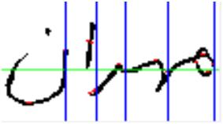

Please make sure that you submit the following contents:-

A document containing code and screenshots of output images or a python notebook.