**Sentinels**

A Sentinel is an actor which is associated with a source/flow/sink. The sinks come with actors such as Camera Actor etc.

Within the ActorSourceTest sourceMethod,

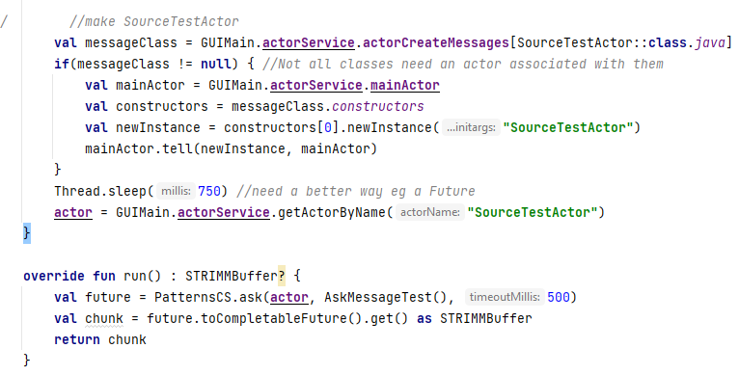

In the init() a SourceTestActor is made. The run function will be called regularly and the result is that the AskMessageTest will be sent to the actor, it will process it and return it – it will be carrying the sample.

This could be an image from a microscope or data from a microcontroller etc.

This can be seen in the SourceTestActor:

The same approach us used for the Flow sentinel. The sentinel will only return when it has processed the request. This could be looking up something in a database – and therefore resulted in changes in experimentStream to account for this, in particular using completableFutures.