Lab report for physics

------------------------------------------------------------------------------------------------------------ Experiment: Moment of Inertia

2018/4/8

Team member: Shuheng Mo 1718532

Yimian Liu 1717608

Lab instructor: Zou

This is the report for experiment: Moment of Inertia which was conducted on 29th March.

Catalogue

1.Intruoduction.......................................................................3

2. Experimental Setup and procedure 6

3. Results and Discussion 7

4. Conclusion 9

4.1 Objective Conclusion 11

4.2 Limitations and Errors 12

4.3 Research in future 12

# Introduction

Moment of inertia was the ratio of the angular momentum of a system to its angular velocity around a rotation axis. In this report, a standardised disk will be used to measure the moment of inertia Idisk.

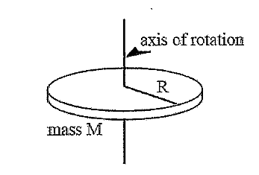

Figure 1

The disc is showed in Figure 1. It included a metal disc with the diameter R and mass M. For ideal outcome, the mass of the string which regarded as the axis of rotation is ignorable. Students were asked to use three-pendulum method to measure the exact moment of inertia of concrete body. By twisting the disk for a particular angle and release it, the disc maintains a rotating condition. Moment of inertia can be defined as the Equation [1]:

$I=\sum_{i}{m_{i}r_{i}^{2}}$ [1]

The mass of part i is defined as mi and τi is the distance from part i to axis.

Simplified Equation [2] was given to calculate the disc’s moment of inertia:

$I_{disk}=\frac{1}{2}MR^{2}$ [2]

Another form of moment of inertia was explained as Equation [3]:

$I_{0}=\frac{M_{0}gRr}{4π^{2}H}T_{0}^{2}$ [3]

Similarly, an object weighs M1 was located on the disc and its centre mass is on axle of rotation axis, then Equation [4] and Equation [5] expressed the moment of inertia of object M1:

$I_{1}=\frac{\left(M_{0}+M_{1}\right)gRr}{4π^{2}H}T_{1}^{2}$ [4]

$I_{M1}=I_{1}-I_{0}$ [5]

Knowing the moment of inertia I for an object of mass M2 where an axis through its centre of mass, then the moment of inertia of any axis parallel to this particular axis is equation below.

$I^{'}=I+M_{2}d^{2}$ [6]

Additionally, if place two metal cylinders on disc, with mass 2M2 and measure period of oscillation T2 using laser sensor so the moment of inertia with two cylinders and the disc.

$I_{2}=\frac{\left(M_{0}+2M_{2}\right)gRr}{4π^{2}H}T_{2}^{2}$ [7]

The moment of inertia of the cylinder where the axis through the mass.

$I_{M2}=\frac{1}{2}(I_{2}-I_{0})$ [8]

the moment of inertia of cylinder about all axes parallel to axis through center of mass.

$I_{M2}^{'}=\frac{1}{2}M_{2}r_{cylinder}^{2}+M_{2}d^{2}$ [9]

Some details were showed below in Figure 2 and Figure 3.

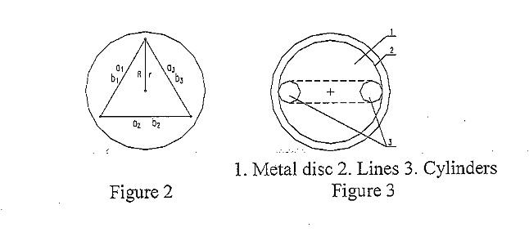

**Objectives**: There were four main objectives in this experiment.

1) To know the principles and three-pendulum method.

2) To measure the moment of inertia of a body whose axis is the symmetric axis by using three-pendulum.

3) To excavate relation between the mass of a substance and its moment of inertia.

4) To exam the feasibility of parallel axis theorem of the moment of inertia.

# Experimental Setup and Procedure:

**Equipment:**

1. Three-wire pendulum system
2. Starting disc
3. Suspending disc
4. Metal ring
5. Two metal cylinders
6. A Hall Effect sensor
7. A MS-1 Millisecond timer
8. A Ф6x2 steel magnet

This experiment was processed from 4pm to 6pm on March 29th, 2018.

**There were five steps to conduct the experiment.**

1. Level both upper (starting) disc and the lower (suspending) disc.
2. Re-locate the hall sensor to ensure it 10mm directly away from small steel magnet below the disc and stimulus the red LED on timer respond to the substances and press “reset” button every time before period measurement.
3. Figure out the value of radius of both upper and lower disc and use Vernier caliper to measure diameter D1 of lower disc. Secondly, measure distance H between upper and lower disc and mass M0 of the lower disc. Lastly, when measuring period T0 of the lower disc, the twisted angle should be less than 5° and the record the time for 20 oscillations.
4. To measure the moment of inertia I1 of the lower disc with the ring, set T2 the period of oscillation for lower disc with the ring. Then use the Vernier caliper to measure Din and Dout.
5. Exam the feasibility of parallel axis theorem. Place two cylinders as Figure 3 revealed.

# Results and Discussion

After the three-wire pendulum and the hall sensor had been properly adjusted, several significant data collected was shown in the following paragraphs.

1. **The result of STEP 3: Measure the I0 of the lower disc.**

For the purpose of calculating I0, the period of one oscillation with nothing on the lower discs had been tested for times and the results had been presented in Figure 1.

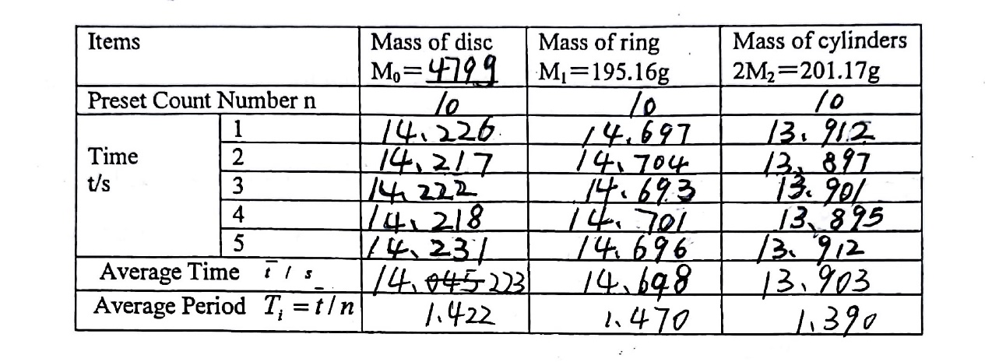

Figure 4

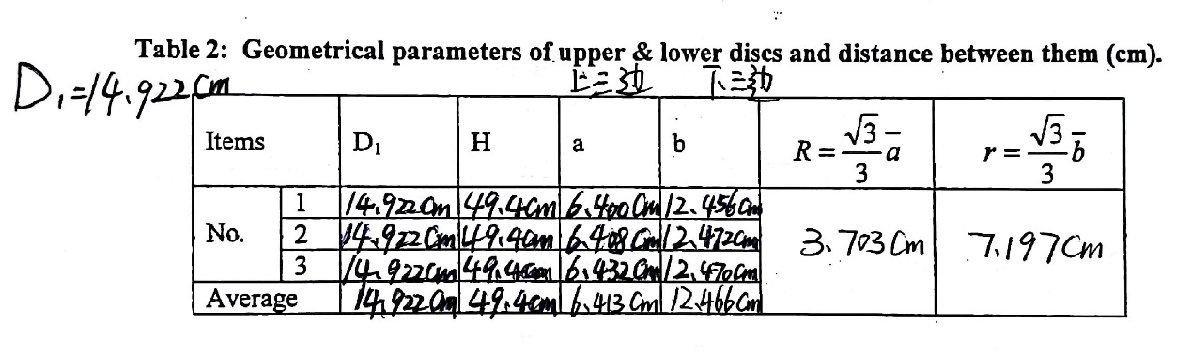As it showed in Figure 4, the average period of single disc was 1.442 seconds.

Figure 5

In this table, the detailed data that could describe several necessary factors such the upper radius R, the lower radius r and the distance between the two discs H had been ideally recorded.

According to equation [3], the moment of inertia of lower disc I0 can be scientifically calculated and was output with the value of 1.297E-3 under the circumstance that the acceleration of gravity g was 9.8.

1. **The result of STEP 4: Measuring I1 of the lower disc with the ring**

In accordance with the experimental records in Figure 4, it could be confirmed that the average period with the ring was 1.470 seconds.

With Equation [4], I1 can be obtained as 1.951E-3.

1. **The result of STEP 5: Verifying the parallel axis theorem.**

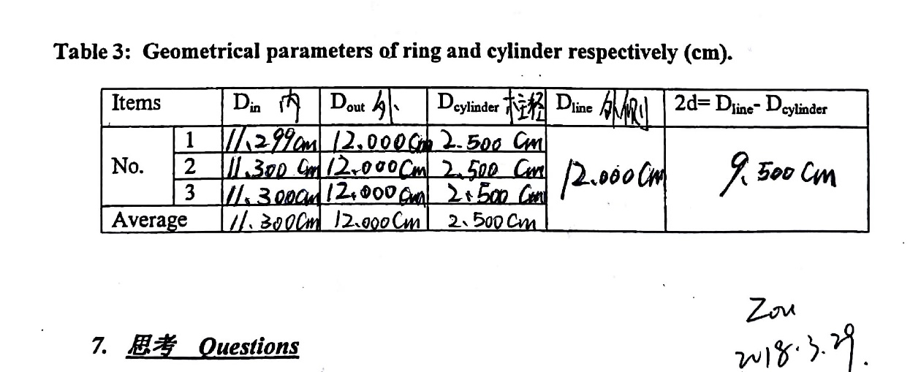For the convenience of proving the theory, several objective values concerning the cylinder and its position had been measured for considerable times with a Vernier calliper. The particular data could be figured in the table below.

Figure 6

By solving Equation [3], Equation [7] and Equation [8] simultaneously, the moment of inertia of the cylinder IM2 thus can be experimentally expressed as 2.315E-4.

Furthermore, according to Equation [9], IM2 can be computed theoretically with the parallel axis theorem (Equation [6]) and the result was 2.348E-4, which was proximately similar with experiment value with an error of 1.4%, thus the parallel axis theorem was verified.

**Discussion for STEP 3:**

Utilizing the records of the lower disc, the moment of inertia of it can also be explained with Equation [2] as 1.333E-3 theoretically. This was quietly similar with 1.297E-3 with an error of 2.8% thus mediately verified Equation [2].

**Discussion for STEP 4:**

From Equation [1], it can be easily conducted with the tool of integral that the mathematic expression of moment of inertia of an arbitrary ring with its centre as its axis.

$I_{ring}=MR^{2}$ [10]

With Equation [10], the moment of inertia of ring can be theoretically computed and output with the value of 6.622E-4.

On the basis that the experiment result of the moment of inertia of the mental ring and the disc with a value of 1.951E-3, the actual can be calculated through Equation [5] and shown as 6.540E-4. This could confirm Equation [10] within an error of 1.2%.

**Final discussion:**

By analysing these data and equations, it can be concluded that the moment of inertia of the disk, ring and cylinder are directly proportional since their mathematic expressions were all in direct proportion, which had been verified with data collected.

# Conclusion

## Objective Conclusion

To conclude, three parts had been effectively conducted in this experiment. The first part was that the moment of inertia of several objectives such as disc, ring and cylinder had been accurately measured. Then, the mathematic expressions of disc, ring and cylinder were also conducted and confirmed with experiment data within error of 3%. Furthermore, the parallel axis theorem had been perfectly verified within an error of 1.4%.

## Limitations and Errors

When measuring the period of oscillation, it had been noticed that the data recorded could be highly affected by air current which may be caused by passing people thus the results were not so stable as expected. In addition, unavoidable random waggle was also a considerable source conducting error.

## Research in future

Based on this experiment, it is suggested that future study should focus on several more accurate experiment method to reverify these conclusions.