String builders inc.

Education Funding Corporation

Requirements Specifications Document

Version 1.0

09/09/2020

# Revision History

|  |  |  |  |
| --- | --- | --- | --- |
| **Date** | **Revision** | **Description** | **Author** |
| 09/09/2020 | 1.1 | Initial Requirements | Ngozi Somah |
| 09/12/2020 | 1.2 | Includes feedback from discussions with the customer and price adjustment | Ngozi Somah |

# Table of Contents

Revision History 2

Table of Contents 3

1 Introduction 3

1.1 Purpose of this Document 3

1.2 Project Background 3

1.3 Project Cost 3

1.4 Project Scope 3

2 Business Rules 8

# Introduction

## Purpose of this Document

This document describes the overall requirements for a solution to replace a Software as a Service (SaaS) for tracking and managing Income Share Agreements.

## Project Background

Coin Education Services Center (CESC) based in Atlanta is requesting StringBuilder Inc., to build a system that maintains its Income Share Agreement between CESC and their students.

## Project Cost



## Project Scope

The system shall be web based. CESC will host the system on Microsoft Azure.

The system will include the following basic capabilities:

* Admin
  + Dashboard, which is a snapshot of components such as:
    - Active Contracts: the number of active contracts
    - In payment status contracts ONLY: Show total dollar amount of upcoming monthly payments
    - Total Collected: Show the total dollar amount that has actually been collected
    - Delinquent Accounts: Show the number of accounts that are late or delinquent
    - Delinquent Active Accounts: Show the total dollar number of accounts that are late or delinquent
    - Future Payouts: Show the total dollar amount of contracts that are NOT in payment status
  + Contracts Tab (List of All of the Contracts)
    - Show a list of all of the contracts. The column headers are as follows:
      * Name
      * Email
      * Contract ID
      * Product Name
      * Date Accepted
      * Completion Date
      * Est. Completion Date
      * Max. Delinquency Age
  + Payments Tab
    - Show a list of contracts that are in payment status. The column headers are as follows:
      * Contract ID
      * Name
      * Status
      * Scheduled Date
      * Income
      * Amount
      * Complete Date
      * Product
  + Communication Tab
    - List all communications between students and CESC
    - Headers will be as follow:
      * Status
      * Date
      * Message Type
      * Medium
      * Read Status
  + Products Tab
    - Shows a list of all products being offered by CESC
    - Headers
      * Product
      * Application Link
      * Income %
      * Duration
      * Cap
      * Min Income
    - New Product Button (See Print Screen for layout and functionality)
      * A screenshot of a cell phone

        Description automatically generated
      * “I already know my ISA terms” Button
        + A screenshot of a cell phone

          Description automatically generated
        + A screenshot of a cell phone

          Description automatically generated
        + Product Details How do you get to this page? TBD

* Student
  + Registration Page (see screen shot)

* + - Create an account Page (see screen shot)

* + - * A screenshot of a cell phone

        Description automatically generated
      * 
  + Student Dashbord
    - Headers
      * Payment status
        + Students not in payment term will show “In School”
        + Students in payment tern will show “In Payment Term”
      * In Payment Term
        + Payment due date
        + Payment amount
        + Payment history
        + Show if payment was successful or not

# Business Rules

| Owner | Description |
| --- | --- |
| Admin | Copy generated link and email it to student. Link will route to registration page. |
| Student | Click link, first view is info with ISA information. Students will clearly see that this is an income share agreement, the program name they’re signing up for, the income percentage, payment term, payment cap and minimum income. This will also show an income payment estimator where they can use the slider to get an idea of what their monthly payments will be. |
| Student | Next Student will Create Account |
| Student | Late payments: a student has fifteen (15) days **starting at midnight on the day after the payment due date** to make the payment. All late payments are assessed a $150 late fee. If they fail to make a payment within the fifteen (15) day period, their ability to make future payments is locked until their account is resolved. |
| Student | The student’s contact information will be locked. I do NOT want them to be able to modify the information on the dashboard. |
| Student | I want students to have the ability to upload their offer letter, set the name of their employer, salary and start date. Once that information is set, I do not want them to be able to change it without admin approval. |
| Admin | SSN Verifications will be provided via an application programming interface (API).  The Verification API will verify that the number holder’s SSN, name, and date of birth matches or does not match the data in the Social Security Administration’s records.  Please see link for infor below:  [View Document to Access Social Security Number](https://www.ssa.gov/dataexchange/eCBSV/documents/eCBSV_webpage_content.pdf) |

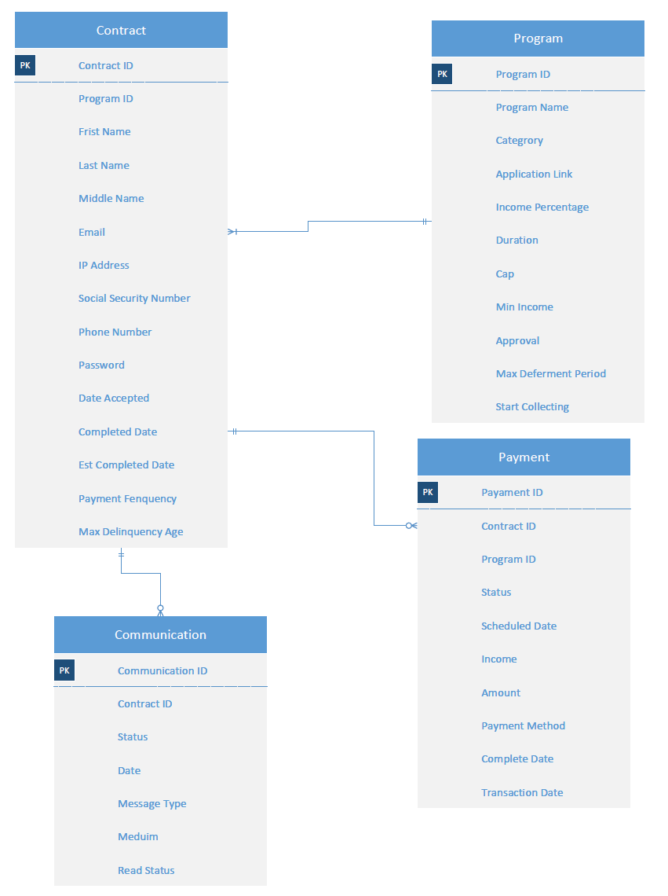

Database schema to show the organization of data according to Education Funding Corporation data model. This design determines what data will be stored and how they are related.

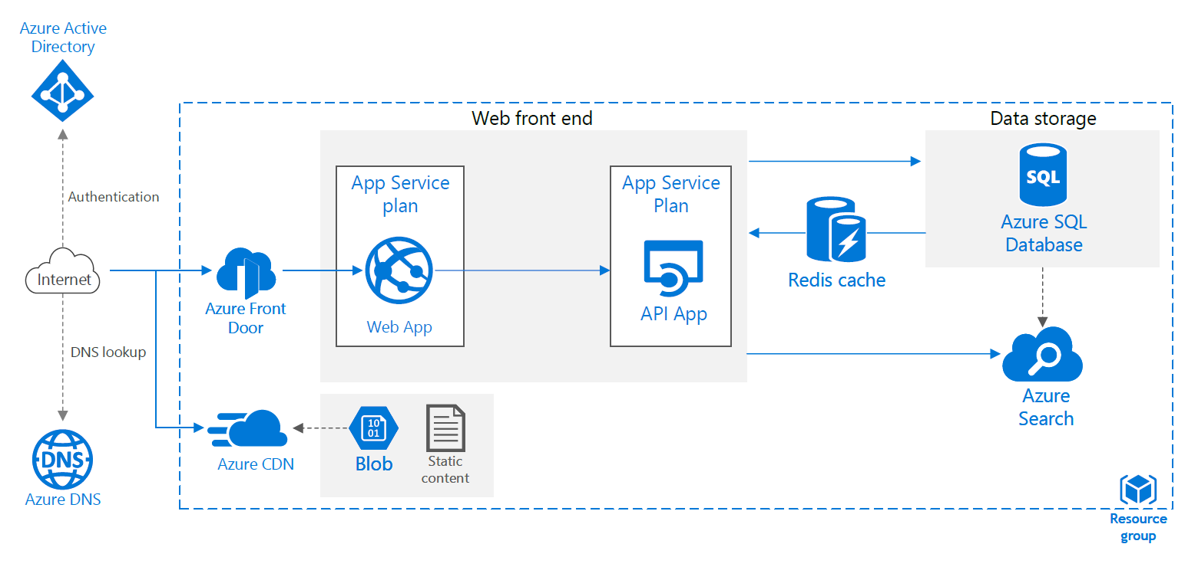

Education Funding Corporation portal will use Azure App Services for hosting and deployment. This diagram includes the following:

* Resource group - a logical container for the portal resources
* App Service app - a fully managed platform for creating and deploying the application
* App Service plan - provides the managed virtual machines (VMs) that host the application
* Azure SQL Database - a relational database-as-a-service for the application data storage
* Logical server - the logical server hosts the database
* Azure Storage - Azure storage account with a blob container to store diagnostic logs atifacts such as the ISAs
* Azure Active Directory (Azure AD) - provider for authentication
* Azure DNS - a hosting service for DNS domains, providing name resolution using Microsoft Azure infrastructure
* Azure Search -   search-as-a-service cloud solution that utilizes APIs and tools for adding a rich search experience over private, heterogeneous content in web, mobile, and enterprise applications
* API App -  offers secure and flexible development, easy deployment including continuous delivery
* Azure Front Door - define, manage, and monitor the global routing for the portal web traffic by optimizing for best performance and quick global failover for high availability
* Azure Content Delivery Network (CDN) - global CDN solution for delivering high-bandwidth content