* **Interface**: How can I change embedded logo? Is there a relative path I can go to or single form I can edit? I need to do this for demo on Thursday

Comment:  
in future I can create “user friendly” interface to change logo. But right now  
Step1: Open UI in “developer mode” (you should be registered as developer in application. If not – just hold Shift and click on database file  
Step2. Find “tblAttachments”   
Step3. See instruction below => Upload new logo into the database.  
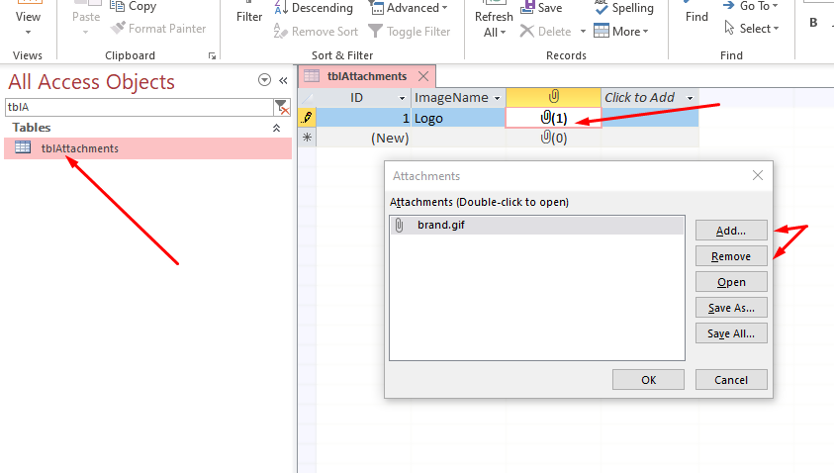

Step4. Open folder with your UI. Find subfolder “Files/Images”.. Remove all files from this folder.  
//===============================================================