**FOUNDATIONS OF INFERENTIAL STATISTICS – DEMO NOTES**

**Descriptive statistics for two categories**

1. Create a PivotTable from the raw data.
2. Group create two PivotTables, each displaying the variable you want to measure in the Values, the ID variable in the Rows, and the category in the Filter:

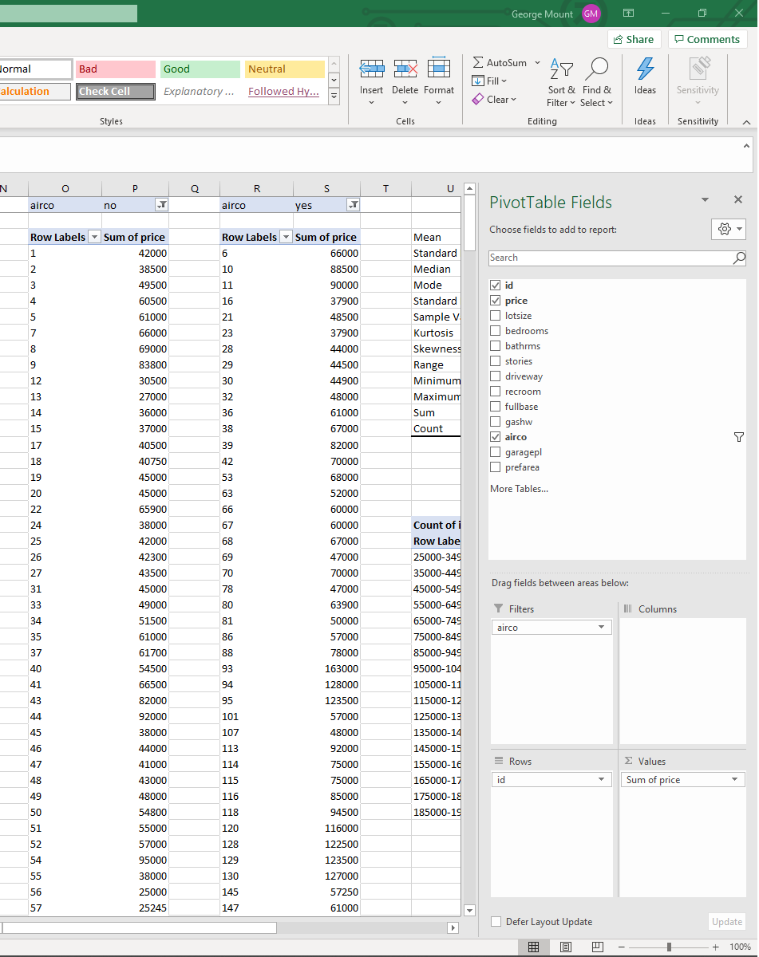

1. Remove the Grand Totals for the PivotTables by clicking inside the PivotTable, selecting Design from the home ribbon, then in the Layout group, under Grand Totals, select Off for Rows and Columns.

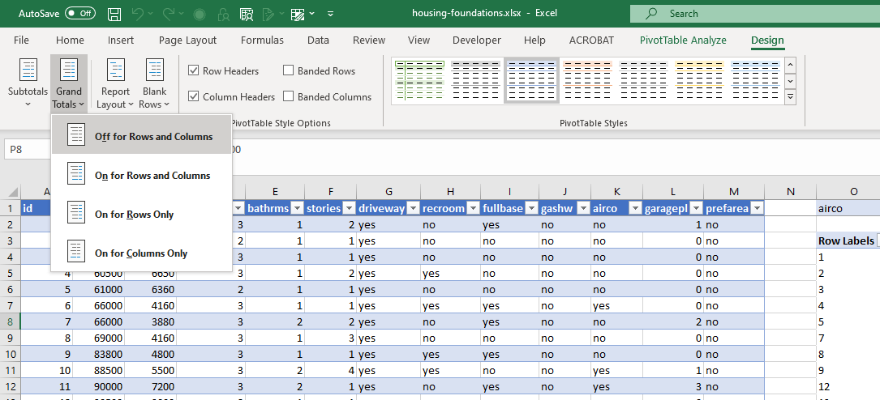

1. Run the descriptives for each category using the Analysis ToolPak. See demo notes from Section 1 for a refresher.

**Plot a histogram for two categories**

1. Create another PivotTable.
2. Place the two categories along the Columns, the continuous variable of interest down the Rows, and the Count of the ID variable in the Values.
3. Right-click the Rows area and select Group.

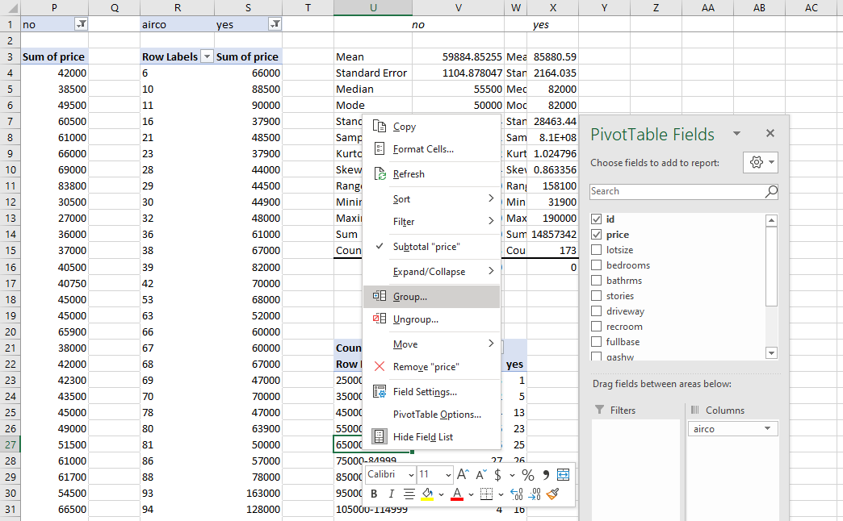

1. Go to Insert on the home ribbon and select a 2-D Column chart.

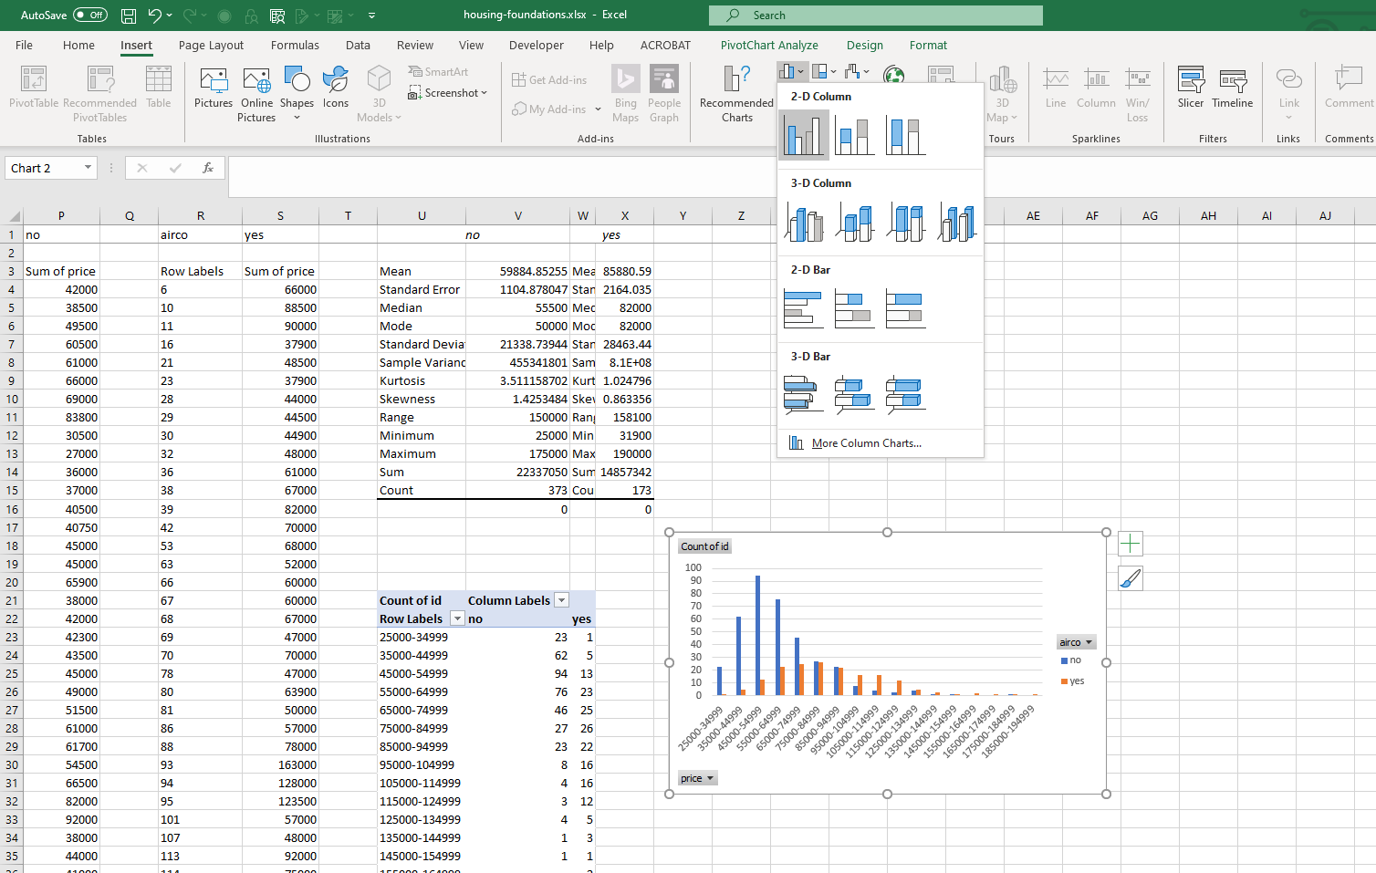

1. Right-click on any of the bars in the resulting bar chart. Select Format Data Series.