Demo 1: Auditable data cleaning with Power Query
Prompt 1: “Here is a table called EquitySnapshot. Review it for any potential data quality issues.
Identify anything that looks inconsistent, unclear, or potentially incorrect.
Do not fix anything yet. Just describe what you notice.”
Prompt 2: “Based on your observations, outline a short step-by-step cleaning plan I could apply in Power Query.”
Prompt 3 (Paste in Power Query M code):
“Review the steps I’ve applied so far and suggest improvements to cleanliness, clarity, and structure.
Don’t change the logic. Only make the transformations clearer.”

Demo 2: Monte Carlo simulation with Python & Copilot

Prompt 1: “Run a simple Monte Carlo simulation of future stock prices.
Please do the following:
1. Load the EquitySnapshot table.
2. For each ticker, take its current Price.
3. Create 1,000 simulated future prices by multiplying the current Price by
random returns drawn from a normal distribution with:
• average return = 1.01
• standard deviation = 0.05
4. For each ticker, calculate the average of the 1,000 simulated prices.
5. Return the final results as a clean, easy-to-read table with two columns:
Ticker | Average Simulated Price
sorted from highest to lowest average price.
Then create a simple bar chart showing each ticker and its average simulated price.
Make the chart clear and labeled so someone can understand it at a glance.”

Demo 3: Agentic reasoning & analysis with Analyst Agent
Prompt 1: “Using EquitySnapshotPlus, identify the stocks with the highest and lowest P/E ratio and create a bar chart comparing all P/E values.”
Prompt 2: “Write a short executive summary describing sector valuation differences using this dataset.”

Demo 4: Automated workflows with Office Scripts & Power Automate
No prompts, flow is built internally.
This Office Script appends a new log entry to the Logs worksheet by finding the first empty row and writing the current date in column A and the text "Model checked" in column B, whether the sheet is empty or already contains data.
https://make.powerautomate.com/environments/Default-9156fa70-f64b-4017-bd91-bad3cd147457/flows/6b90a442-9a2e-451d-af21-5092d2207248/details
A copy of the workbook is saved in the specified location and with the specified name, and a note is posted to the relevant Teams channel.
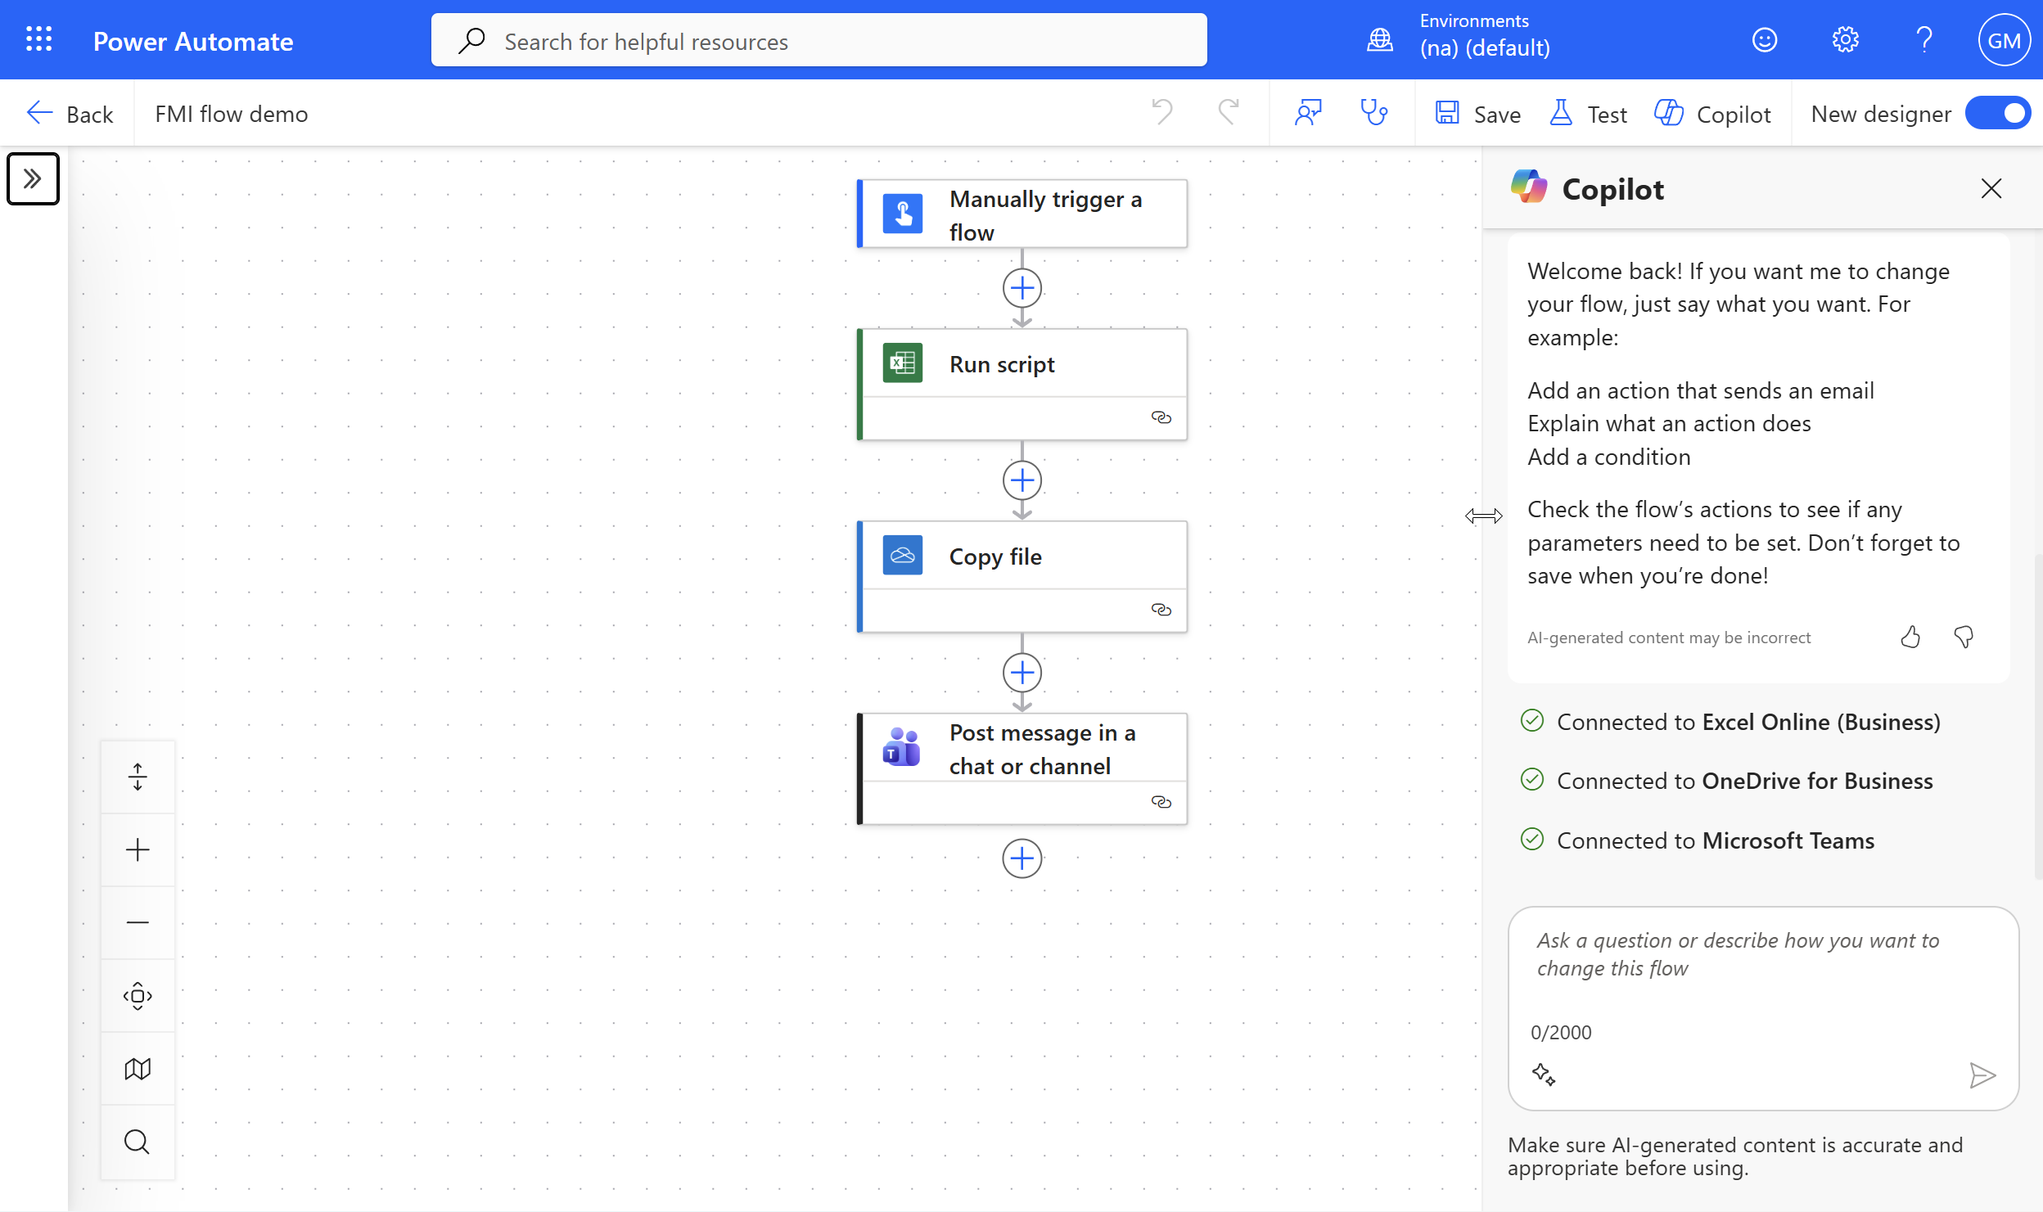

Demo 5: AI-assisted workflows with Agent Mode
Prompt 1: “Using EquitySnapshotPlus, create two sheets:
1. ‘Snapshot’ with a written summary of sector valuations.
2. ‘Chart’ with a visualization comparing P/E across tickers.
Don’t modify the source dataset.”

