Contents
Data Cleaning with Power Query 1
First Steps with Copilot in Excel 5
Table Formatting with Copilot 7
Calculated Columns 8
Summary Charts and Tables 8
Exercises: Analyzing the “Bad Drivers” Dataset 9

Data Cleaning with Power Query
Worksheet: quarterly-claims
Let’s try to answer a few basic questions about this dataset using Analyze Data (Data > Analyze Data). Analyze Data is a simple version of Copilot that answers quick questions and builds fast analyses. For example, we might ask:
- “What are the total claims paid out?”
- “What are all the claims for Q1 where David Lee is the agent?”
The problem is that the shape of the dataset makes it hard for Analyze Data to get things right. ClaimsQ1 through Q4 should really be one column of claims, Agent Info contains both an ID and a name, and the Customer Name column has blanks that should be filled so records group correctly.
These are the kinds of tasks that Power Query is designed for. You can launch it from Data > Get Data > From Table/Range. Power Query records each transformation you make so you can repeat or adjust the process later.
First fill the blank values under Customer Name. Select the column, go to Fill > Fill Down, and the missing values are copied from the rows above. Now every record has a complete customer name.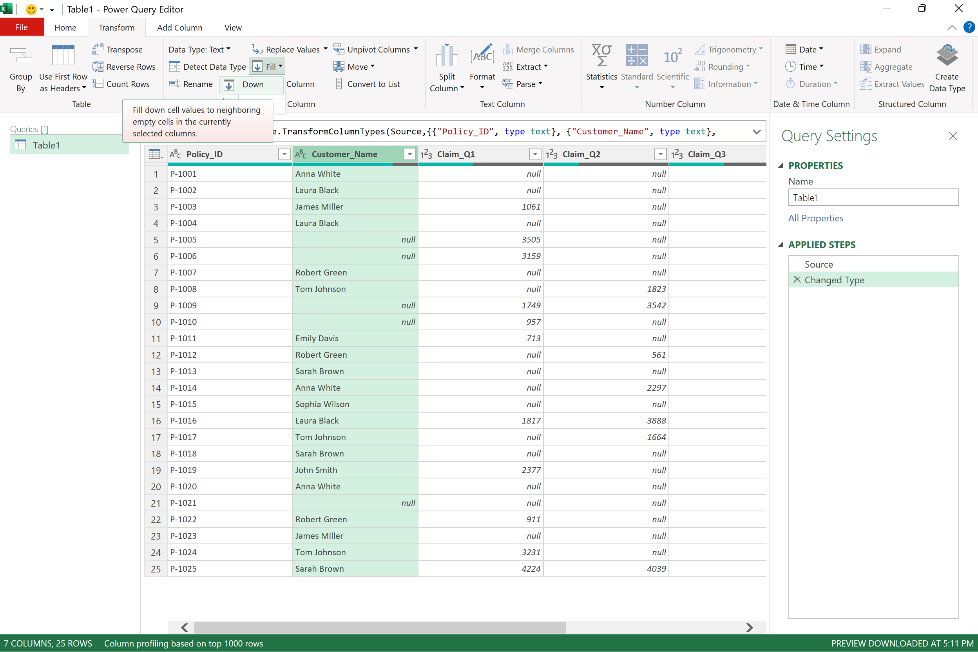

Next, move the Agent Info column next to Customer Name to make the data easier to follow. Split this column at the dash using Split Column > By Delimiter. This gives you two columns, one for Agent ID and one for Agent Name. Rename the headers by double clicking and typing the new names.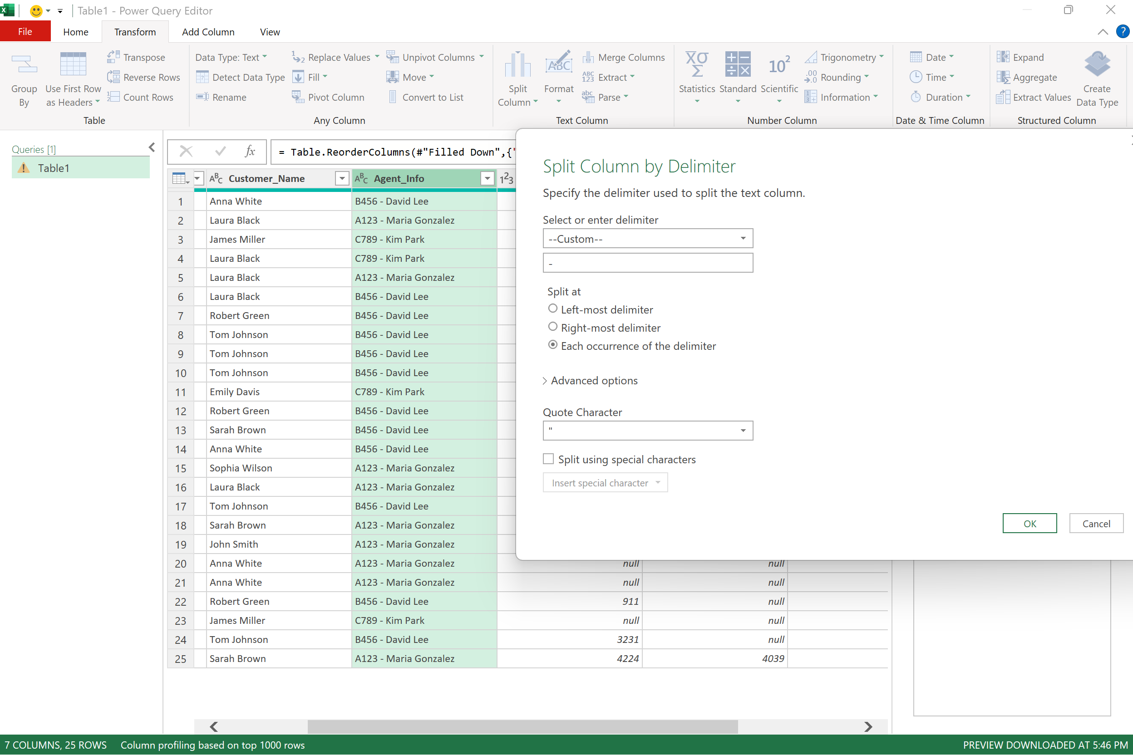

Now unpivot the quarterly claims data. Select everything from Policy_ID to Agent Name, right click, and choose Unpivot Other Columns. The ClaimsQ1 through Q4 fields are turned into two new columns, one called Attribute and one called Value. Rename them Quarter and Claims.

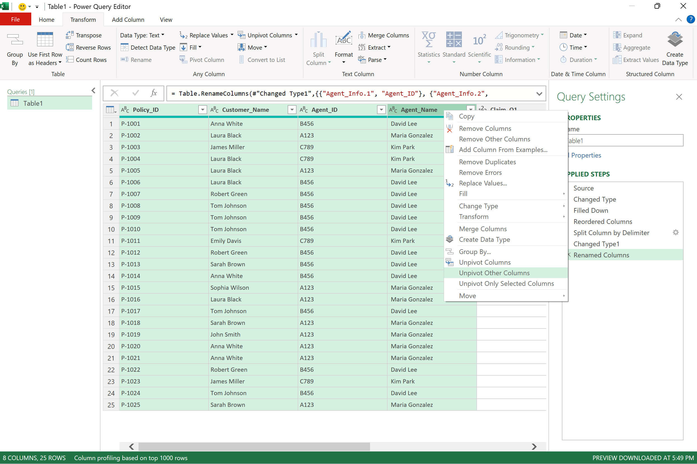
If you only want the last two characters of the quarter label, go to Extract > Last Characters and keep the final two.
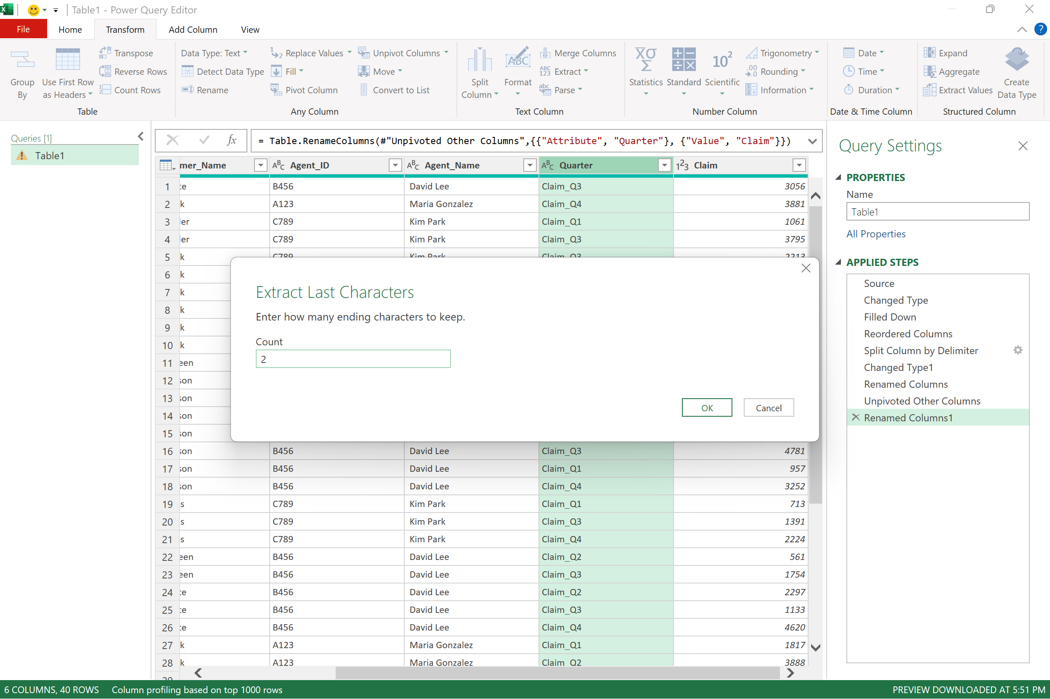

When the data looks ready, go to Home > Close & Load to send the cleaned version back into Excel. It helps to give the query a clear name like claims before you close.

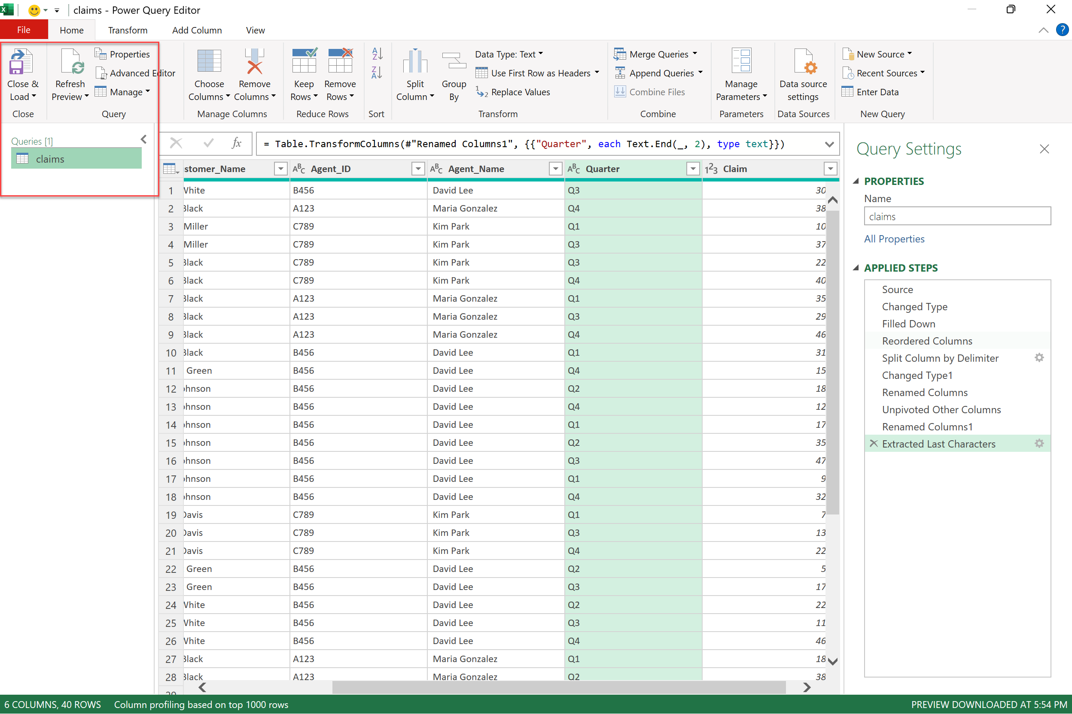

What questions do you have?

First Steps with Copilot in Excel
Next we’ll explore a more complex, real-world dataset. Before launching Copilot, it’s helpful to convert the raw data into an Excel Table (Ctrl + T or Insert > Table). While not strictly necessary, Copilot usually gives clearer results when working with structured tables.
We’ll assign the name fraud to this table using the Name Manager on the Formulas tab. Be aware that formulas written with structured references behave differently from traditional A1 references.

Task | Structured Reference (Table: fraud) | Traditional Reference (A1 style)
Sum the Total Claim Amount column | =SUM(fraud[total_claim_amount]) | =SUM(AH2:AH1000)
Average Policy Annual Premium | =AVERAGE(fraud[policy_annual_premium]) | =AVERAGE(H2:H1000)
First value in Age column | =INDEX(fraud[age],1) | =C2
Reference entire table | =fraud[#All] | =A1:AP1000
Reference only column headers | =fraud[#Headers] | =A1:AP1
Current row’s Injury Claim value | =[@injury_claim] | =AF2

Keep in mind that your workbook must be saved in OneDrive or SharePoint for Copilot to work. Once it’s there, click the Copilot button on the Home tab of the ribbon.
Because you’re on the Pro version of Copilot, you’ll notice there are actually two flavors of Copilot: Chat, which is free, and App Skills, which is part of the paid plan. So what’s the difference?

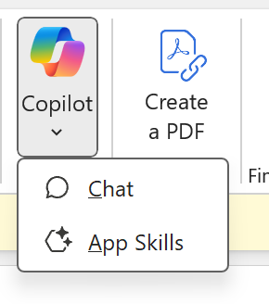
Copilot Chat is the high-level Microsoft 365 Copilot experience inside Excel. It’s conversational and best when you want explanations, guidance, or high-level help. Think of it as the layer you talk to when you’re trying to understand how something works or want advice.
App Skills are the task-driven tools that act directly on your workbook. They write formulas, build PivotTables, clean data, and generate charts. They’re called skills because they directly perform Excel tasks on your behalf.
In short: Chat talks to you, while Skills do the work. Microsoft is continuing to update and refine these capabilities—this is what’s available for now.
For practice, we’ll skip Copilot’s canned use cases and instead provide our own prompts, grouped into three areas: formatting, calculated columns, and data visuals/summaries.

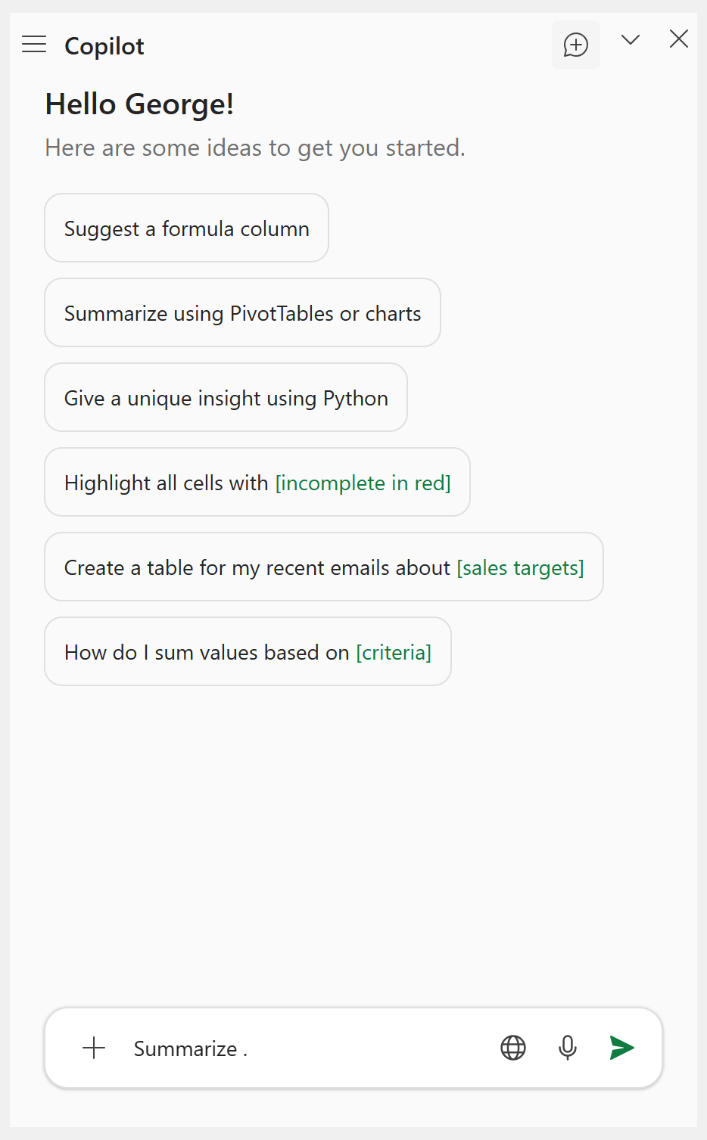

Table Formatting with Copilot

Now that our data is loaded into Copilot, make sure you’re in App Skills and let’s begin with table formatting. With Copilot, you can format entire columns, apply conditional formatting, and more. One limitation: Copilot often struggles to undo changes once they’re applied. That’s why it’s still important to know the Excel basics—you’re the main pilot, Copilot is just the assistant.
Here are some prompts we’ll try:
- “Convert the ‘policy_bind_date’ and ‘incident_date’ columns into standardized date formats.”
- “Apply conditional formatting to the ‘total_claim_amount’ column: red above $10,000, yellow between $5,000 and $10,000, green below $5,000.”
For extra credit, try writing a prompt to highlight the entire row based on a condition… something that takes a lot more effort in plain Excel!

Calculated Columns
Now let’s look at getting help with calculated columns. Copilot generally does a solid job making judgment calls on which formulas to write, and it will even insert and explain them for you.
You can also lean on Copilot for help with individual functions, though if you’re looking for higher-level guidance, this may be a good time to switch over to Copilot Chat.
Either way, it’s best to have your data in a well-labeled table with clear column names. This makes it easier for Copilot to understand your intent and return the right formulas.
Here are some prompts to try:
- "Categorize claims into 'High', 'Medium', or 'Low' severity based on 'total_claim_amount'."
- “Create a new calculated column 'policy_tenure_days' showing the number of days between 'policy_bind_date' and 'incident_date' to measure how long customers held their policy before filing a claim.”
We’ll also look at using Copilot Chat to get higher-level guidance on writing and debugging our formulas and functions.

Summary Charts and Tables

Finally, let’s look at creating some data summaries. Copilot often prefers to return results in PivotTables…and sometimes it’s best to just ask for one directly.
Keep in mind that Copilot’s accuracy with summaries isn’t always consistent. You may need to rerun prompts or step in with your own Excel knowledge. If you get stuck, switch to Copilot Chat and phrase your request more hypothetically (for example, “How would someone do X in Excel?”) instead of asking App Skills to perform the task outright. Copilot App Skills can also help with this, although its abilities are more limited.
Here are some prompts to try:
- “What is the average policy annual premium by state? Summarize using a PivotTable.”
- “What is the average policy_annual_premium?”
- “Summarize the total claims by incident_severity using a PivotTable and visualize with a bar chart.”
- “Visualize claims frequency by the hour of the day using a histogram.”

Exercises: Analyzing the “Bad Drivers” Dataset

To practice your Copilot skills, see if you can answer the following questions using Copilot:

- Highlight states with high insurance premiums using conditional formatting on the ins_premium column.
- Classify states as “High Risk” or “Low Risk” based on the ins_losses column.
- Build a PivotTable of ins_premium and ins_losses by abbrev and list the five states with the highest premiums. (Hint: Copilot will not be able to sort and take the top 5 for you, but you can use Copilot for instructional guidance!)
- Create a scatter plot of ins_premium (x-axis) vs. ins_losses (y-axis) to show their relationship. (Hint: Copilot may try to use Python to create this scatterplot. If you prefer an Excel chart, be specific but there may be trade-offs!)
- Plot a histogram of the alcohol column to show the distribution of alcohol-related accidents.

Here are some possible prompts to use to answer these questions if you get stuck:

- "Apply conditional formatting to the ins_premium column so values above 1200 are red, between 900 and 1200 are yellow, and below 900 are green."
- "Add a calculated column risk_category that shows 'High Risk' if ins_losses > 150, otherwise 'Low Risk'."
- "Insert a PivotTable with ins_premium and ins_losses by state, sort by ins_premium descending, and show the top 5."
  - Follow-up: “How do I filter the top 5 values in a PivotTable?”
- "Create a scatter plot with ins_premium on the x-axis and ins_losses on the y-axis, with state abbreviations as labels.” (Note: Python is generally stronger for customizations like labels, but it may take extra prompting to get the output just right… and that can become a skill barrier you may not want to take on.)
- "Create a histogram of the alcohol column showing the distribution across states."

