***Advancing into Analytics*: Getting Started in R**

1. **Download R and RStudio**

* Go to <https://www.r-project.org>
* Click on “download R”   
  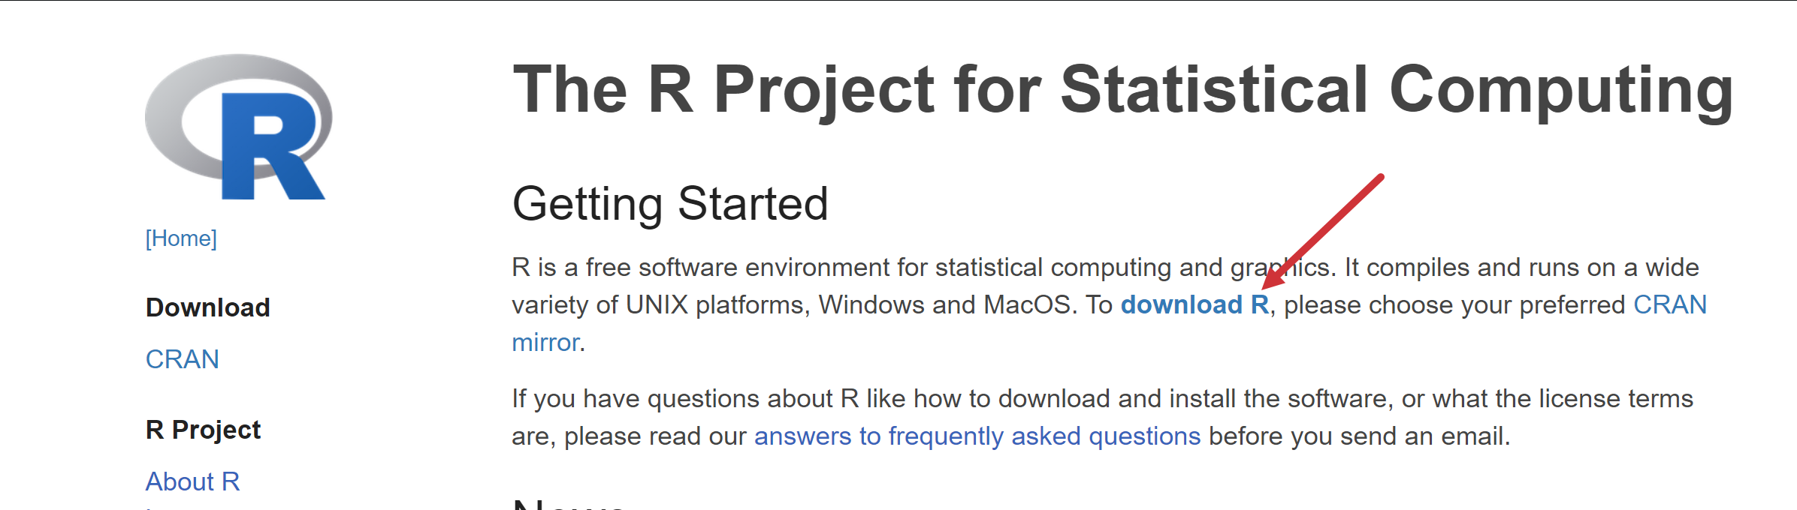
* Choose a location near you from the list of mirrors; I will choose [Case Western Reserve University](https://cran.case.edu).
* Click “Download R for Windows”   
  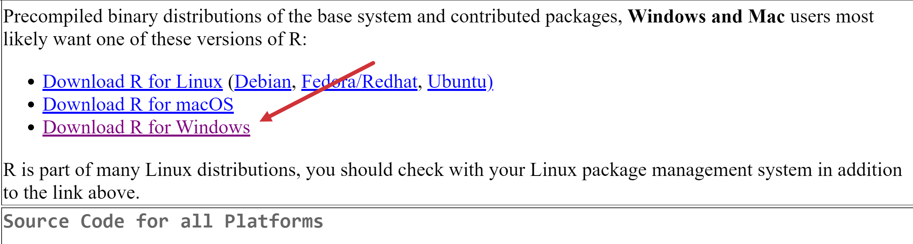
* Click “base” or “install R for the first time” (same link)  
  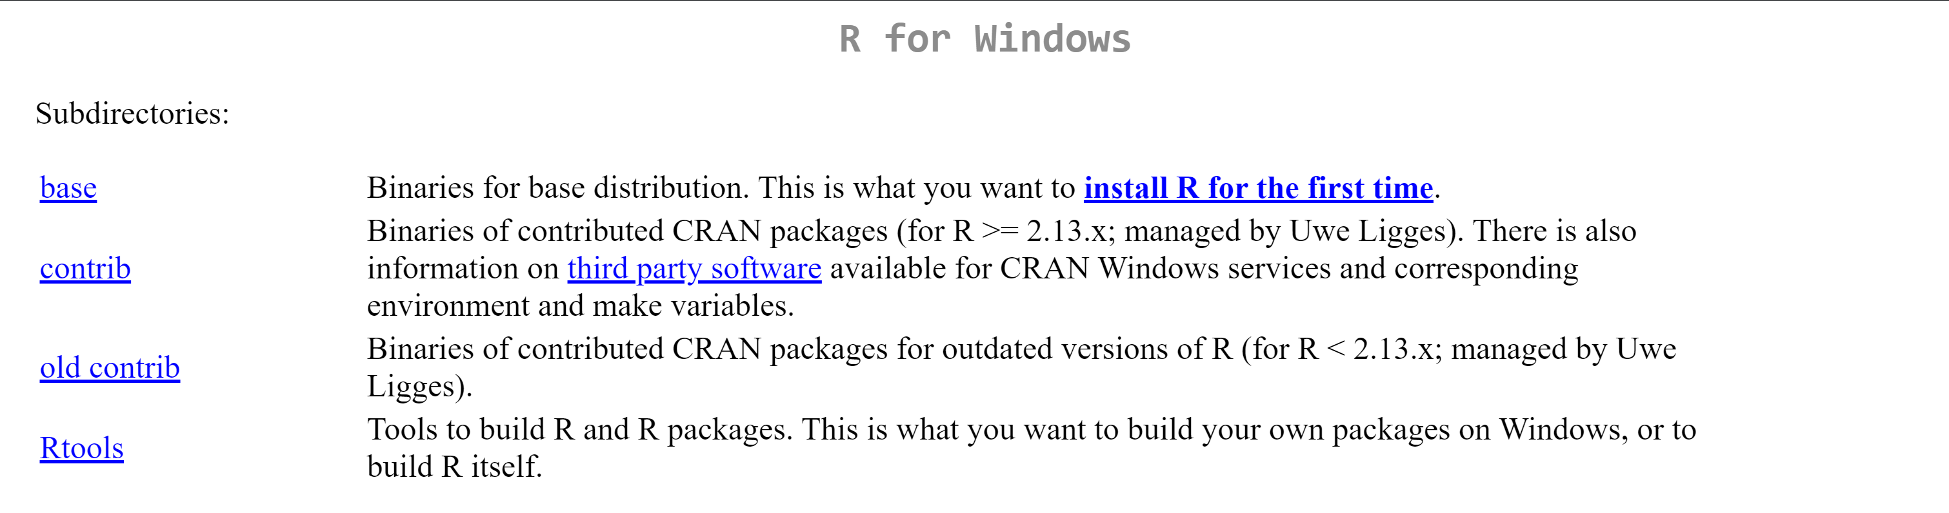
* Click “Download R for Windows” (version number will vary based on when you do this)
* Complete the installation

**R has been downloaded!** Now to RStudio…

* Go to <https://www.rstudio.com>
* Click “Download”  
  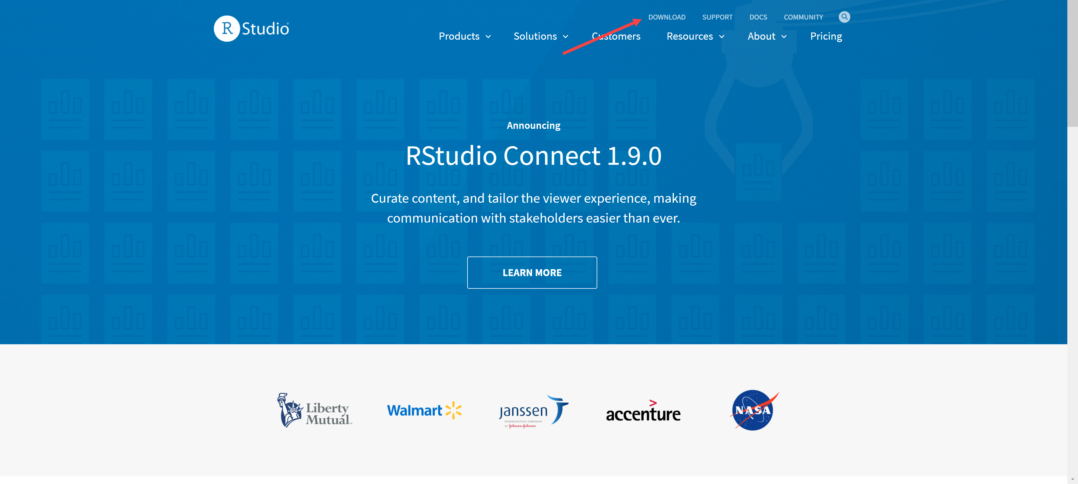
* Click “Download” on RStudio Desktop  
  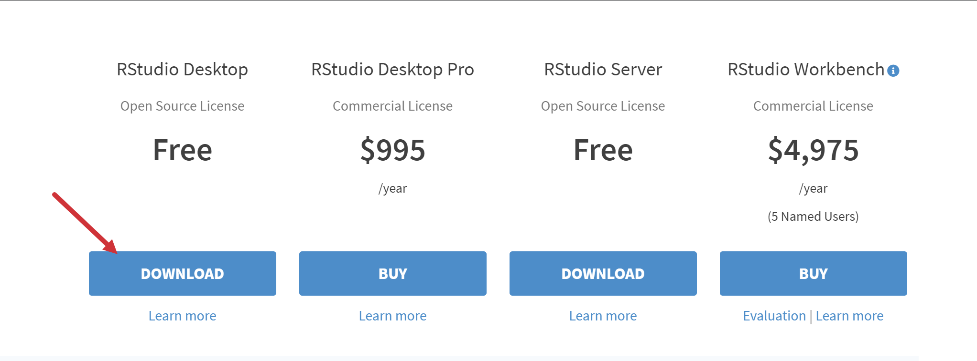
* Click “Download RStudio for Windows”
* Complete installation