**Data profiling and visualization**

1. Find your invite. I emailed it to you.  
   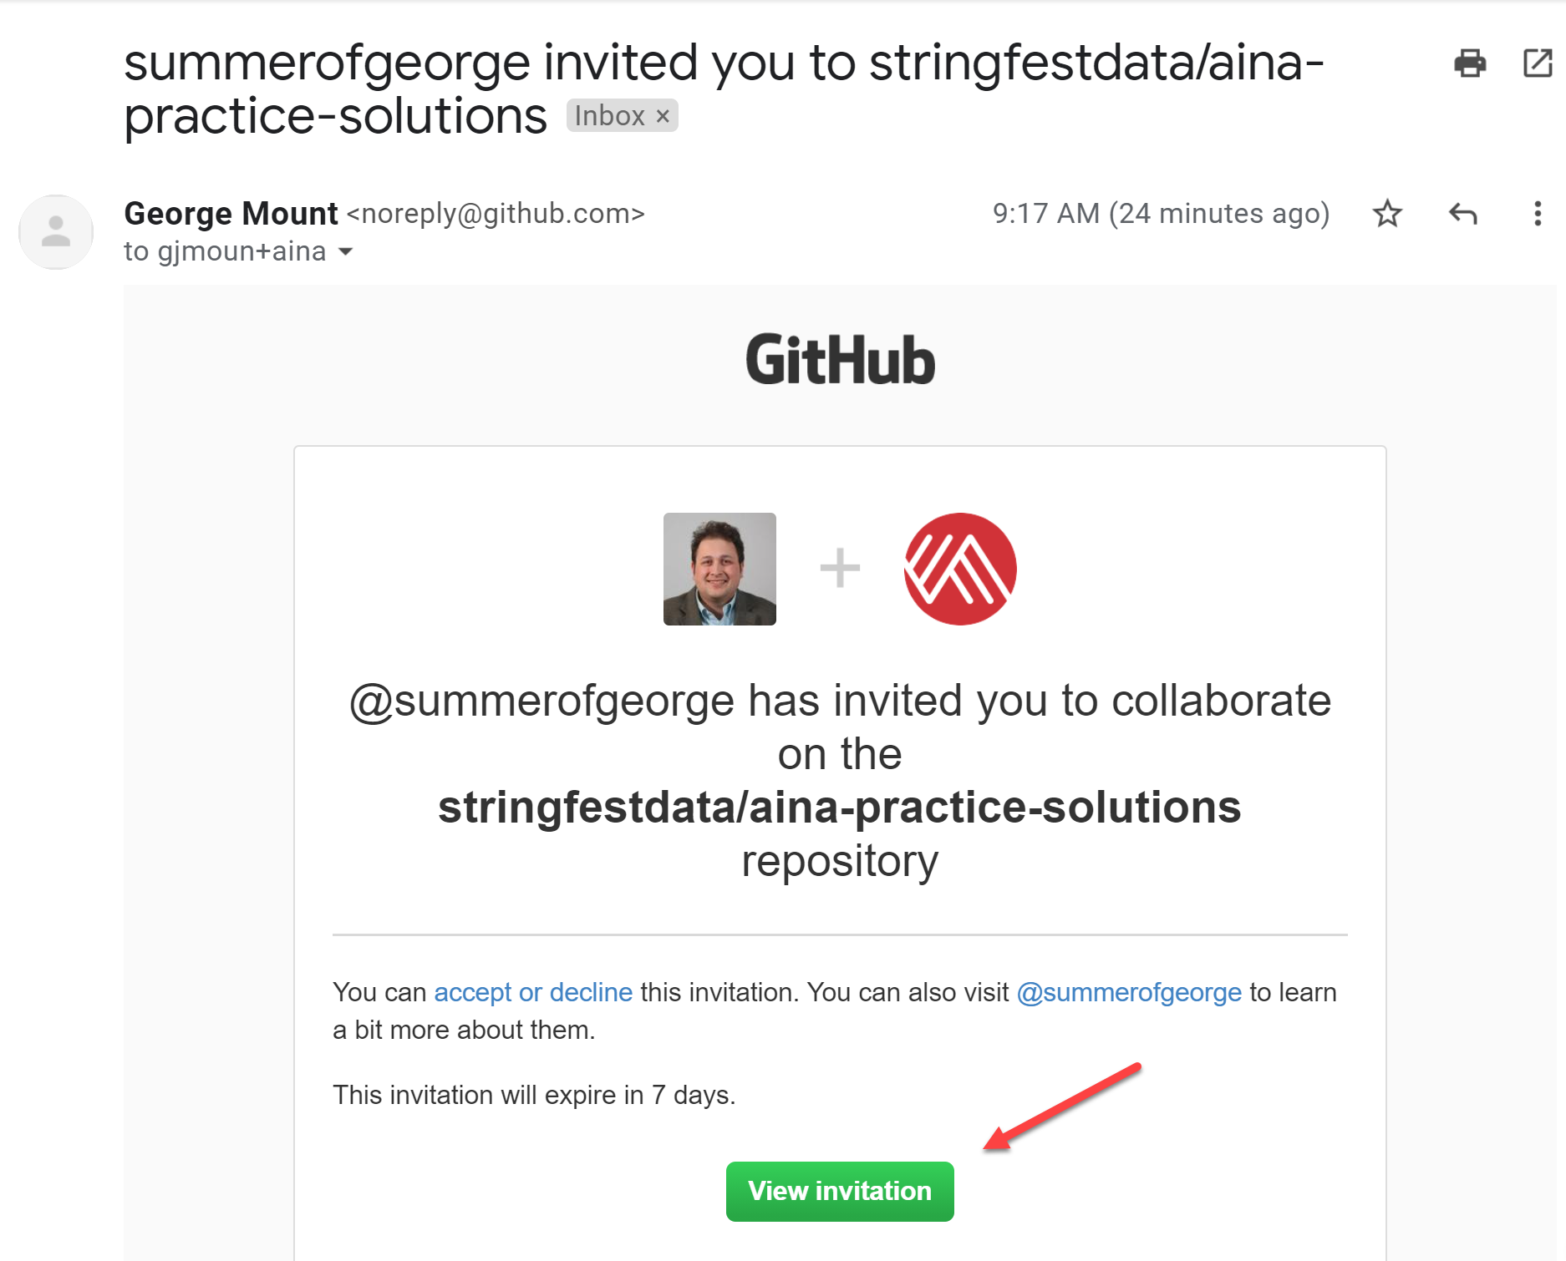
2. Accept invitation  
   
3. You are now in the repo! You will learn how to work with it in Analytics Systems

