**Demo: recoding and chi-square**

Open the diabetes.xlsx file to continue.

1. Go back to your queried dataset. There will be a menu to the right, Queries & Connections.
   1. Right-click diabetes and select Edit   
      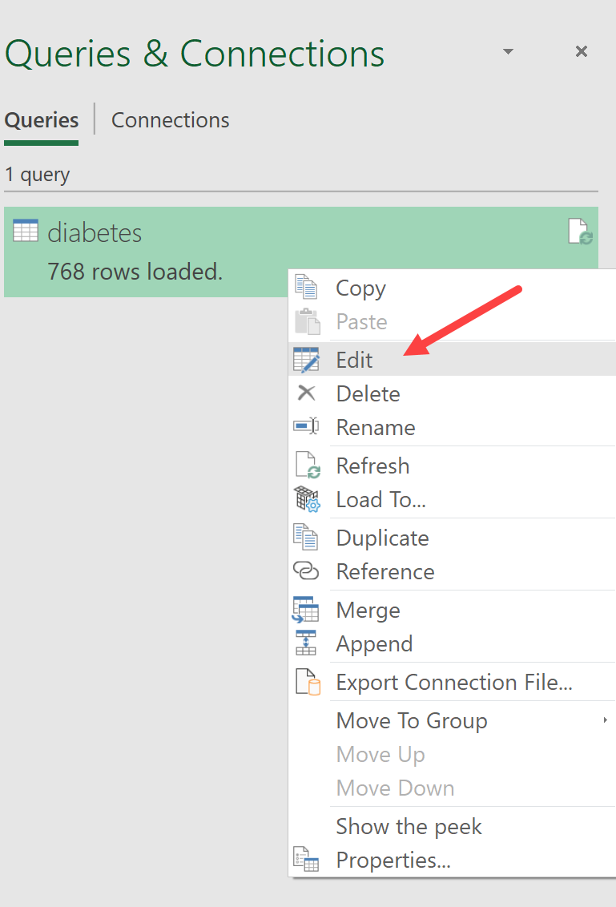
2. We will create a conditional column. Click Add Column > Conditional Column
   1. Use the menu to populate the following: If Pregnancies equals 0, set to 0; otherwise, set to 1. You can also name the column was_pregnant.   
      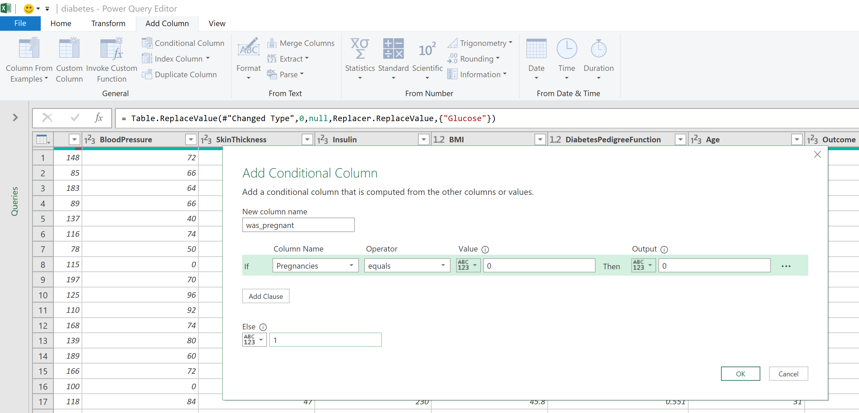
   2. Home > Close & Load
3. Insert the resulting Table into a PivotTable.
   1. We want to count how many records are in each quadrant: Outcome: 0, 1; was_pregnant: 0, 1. You may want to label the worksheet so it’s clear which is which on the PivotTable.   
      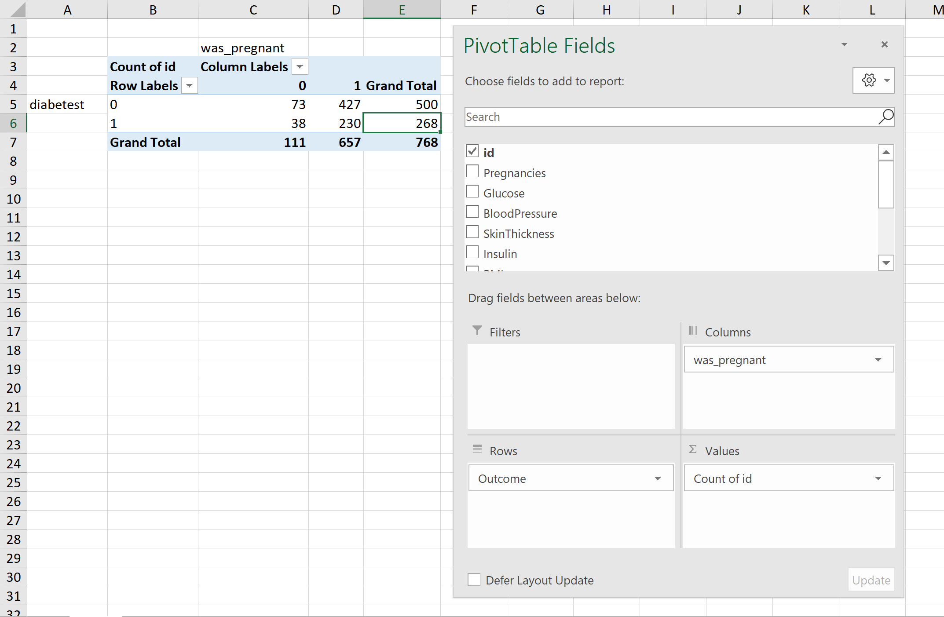
4. We want to know what we’d *expect* to find in each quadrant based on a straight proportion: create a new one below the actual values.