**Data profiling and visualization**

File: diabetes.xlsx

1. Select anywhere inside dataset, then Data > From Table/Range  
   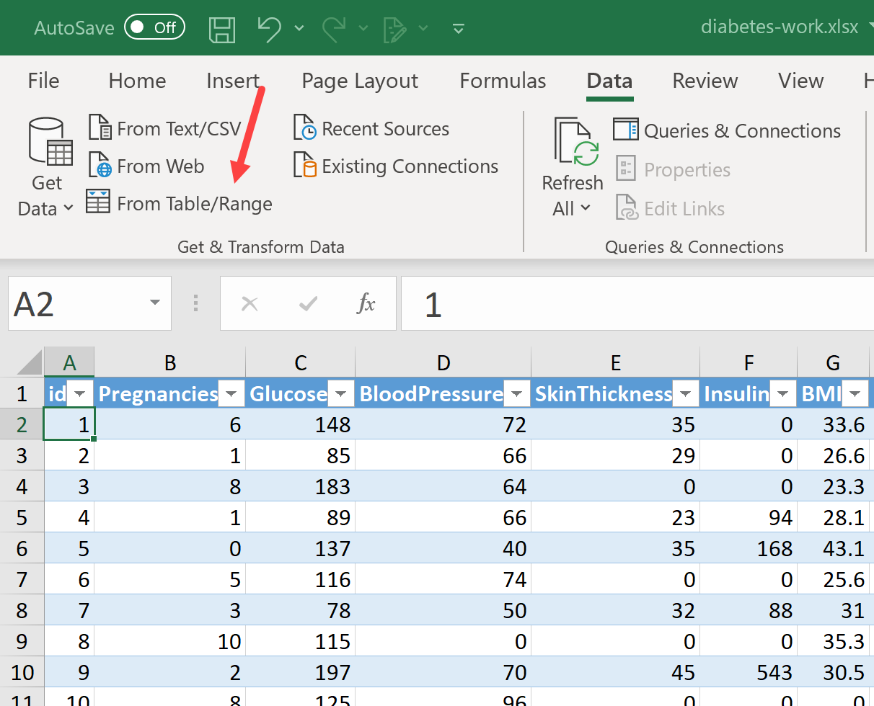
2. Go to View on the ribbon and check on “Column quality,” “Column distribution” and “Column profile”  
   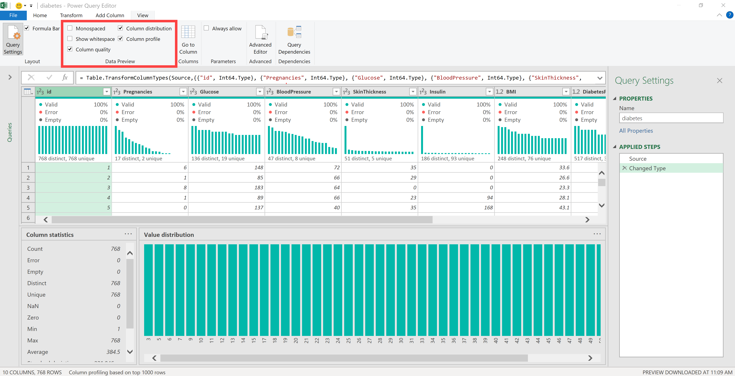
3. Click on the Glucose column This will provide some details about this variable, including the *number of zeros*. It really doesn’t make sense to have 0 glucose!   
   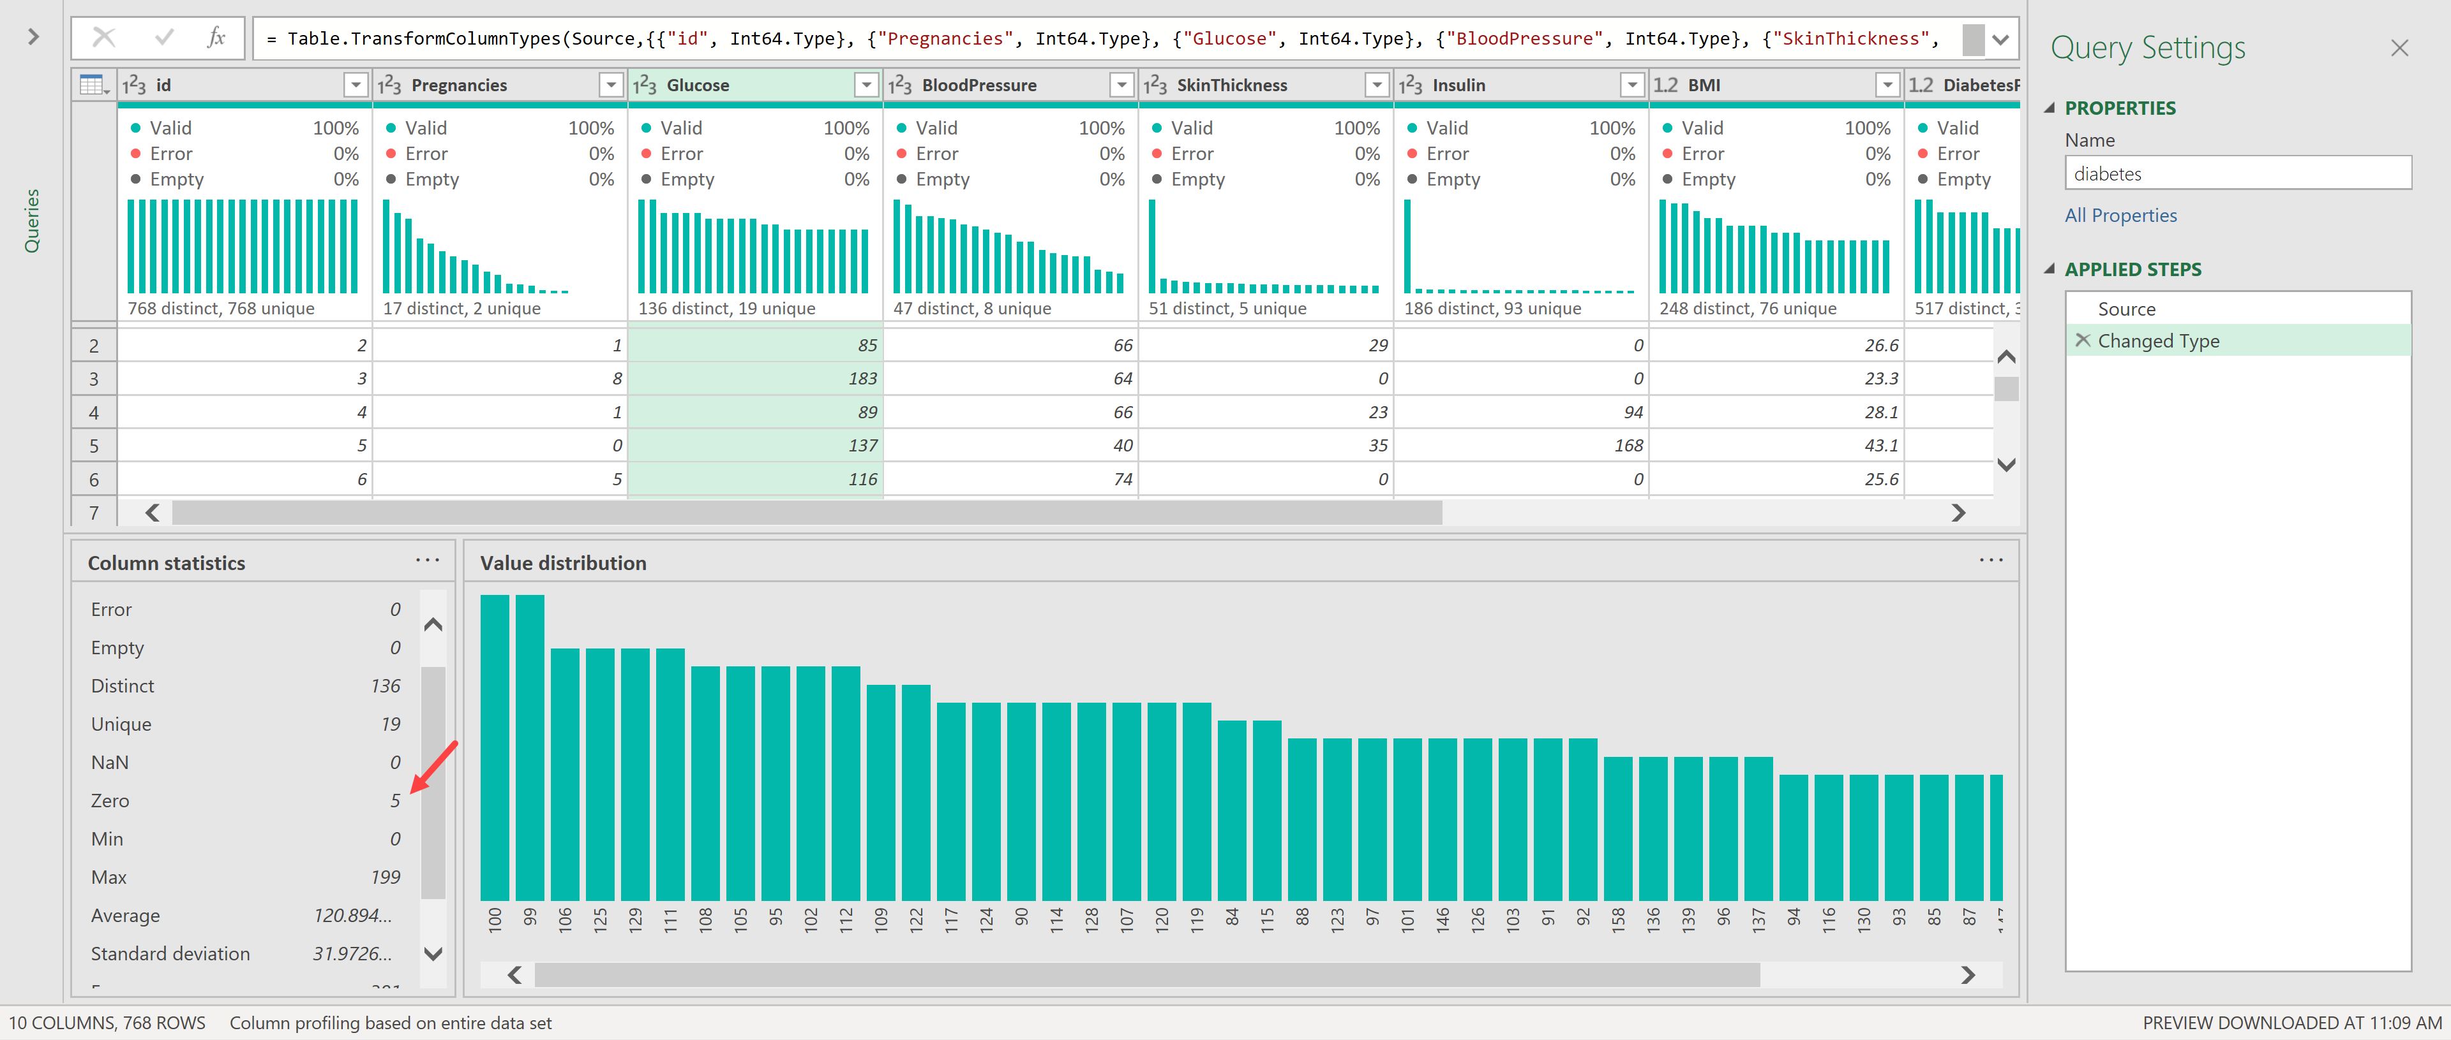
4. Let’s use PQ to fill in these zeros with nulls. You can turn off the profile features if you’d like.
   1. Select the Glucose column so it’s highlighted
   2. Go to Transform > Replace Values
      1. You will replace 0 with null:  
         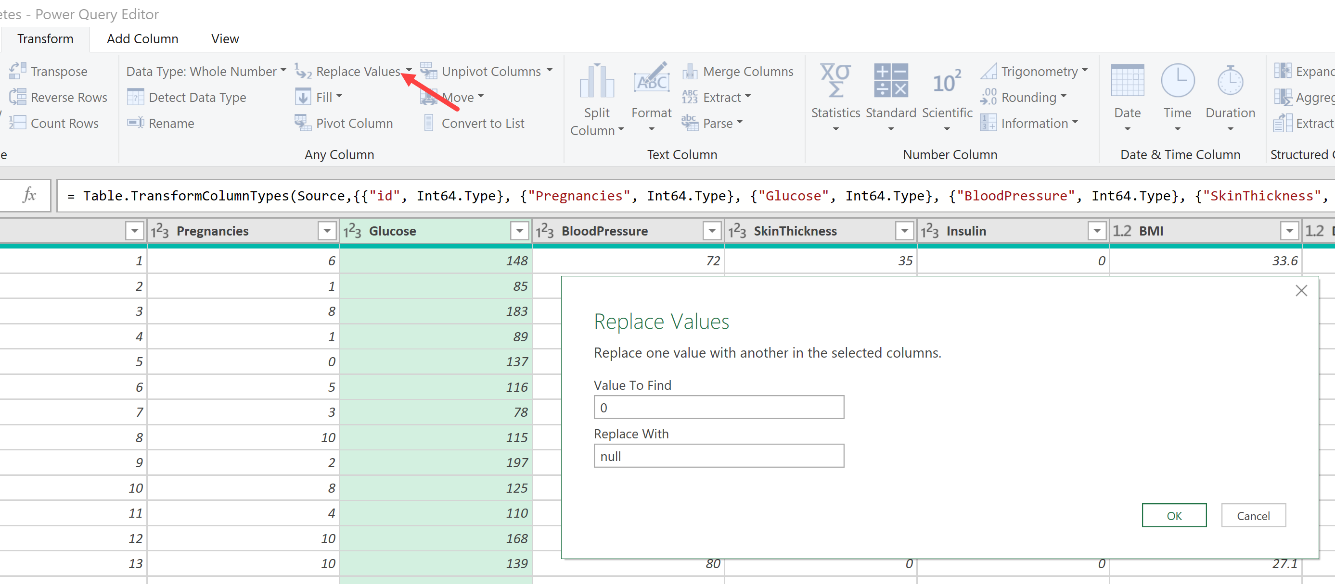
   3. If you’d like to confirm, you could filter on the null rows: there are five  
      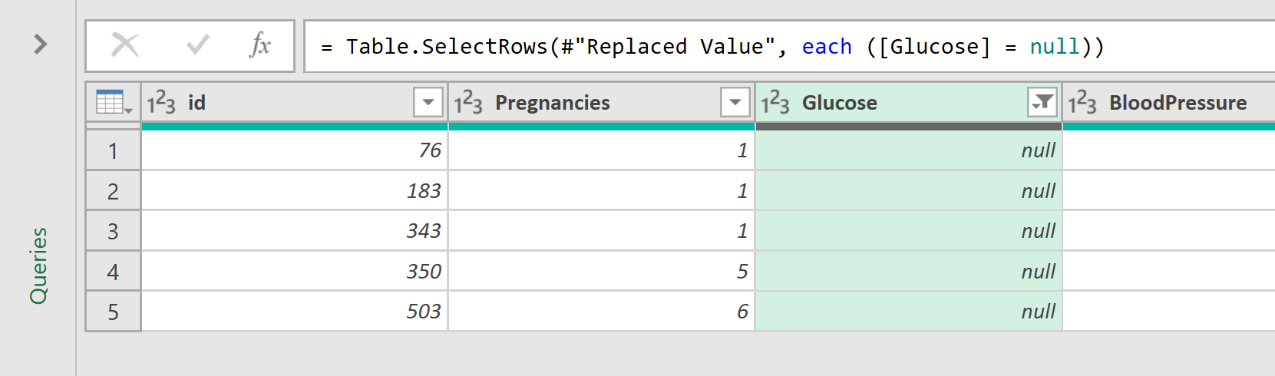
5. Every step that you take to the data is recorded over to the right on Applied Steps. To roll back this last one, click the X mark. You can revisit, reorder, roll back, etc. your steps here.  
   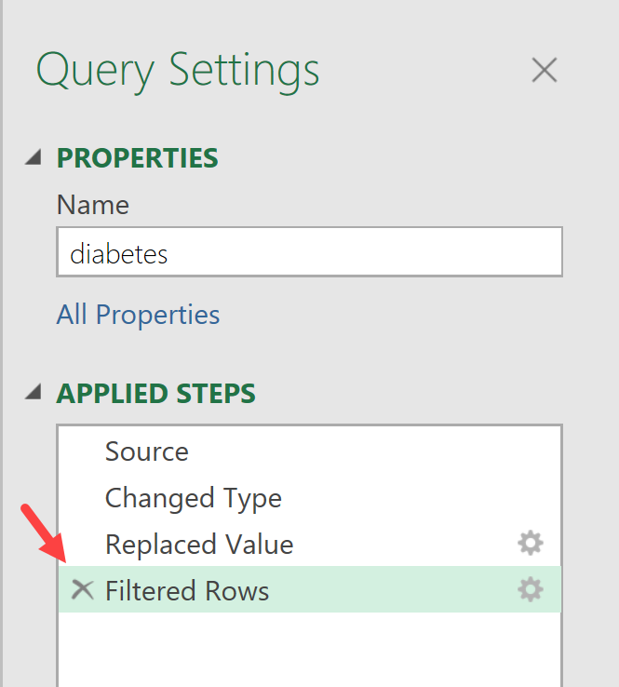
6. This data is ready to use for analysis. From the ribbon, select Home > Close & Load.
7. The transformed and loaded results are available in a new table.
   1. Rename your