**Logistic regression in Excel**

Raw data: datasets/diabetes.xlsx (It’s a good idea to make a copy of this file before operating on it)

Worked file: solutions/logistic-regression-solution.xlsx

1. The Analysis ToolPak does not include logistic regression, so you need to install XLMiner. Fortunately this is free and requires no external downloads: go to Insert > Get Add-Ins > XLMiner Analysis ToolPak.

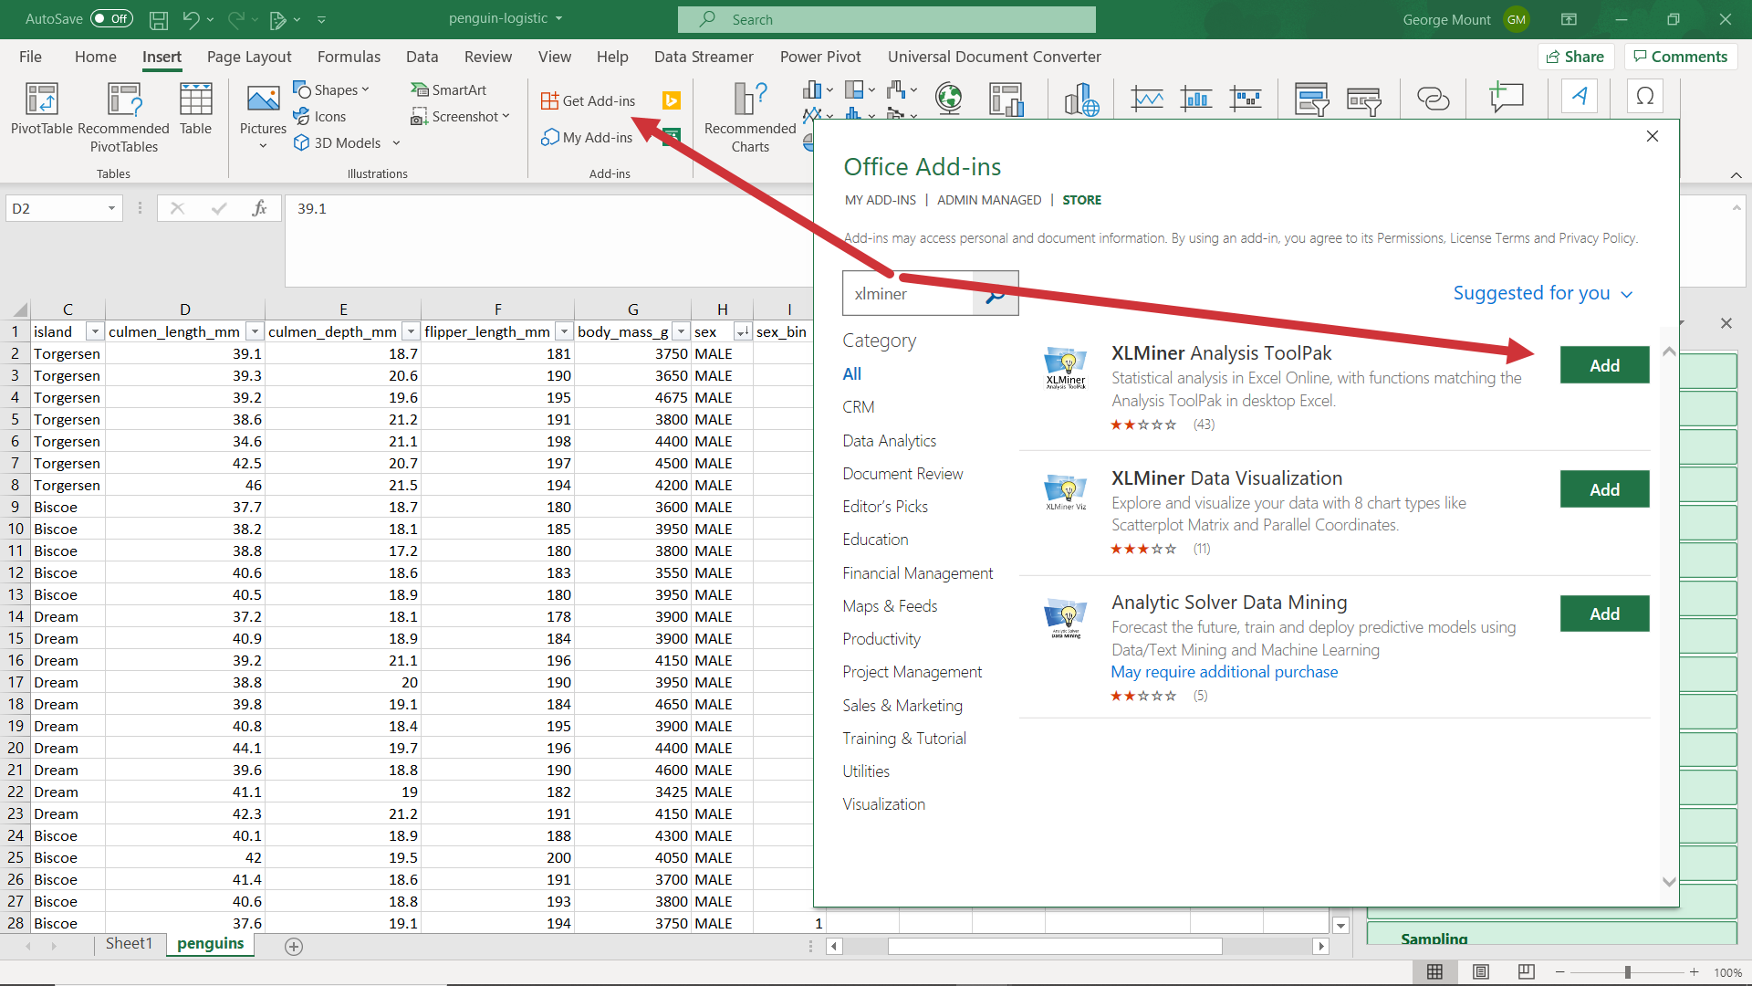

1. Select your Y range (Outcome) and X range (Pregnancies).
   1. The range selector tool in XLMiner is terribly user-unfriendly. It may be easier to grab a smaller range and fill it out by typing. You also need to specify where the output will go – it has to be on the same worksheet.   
      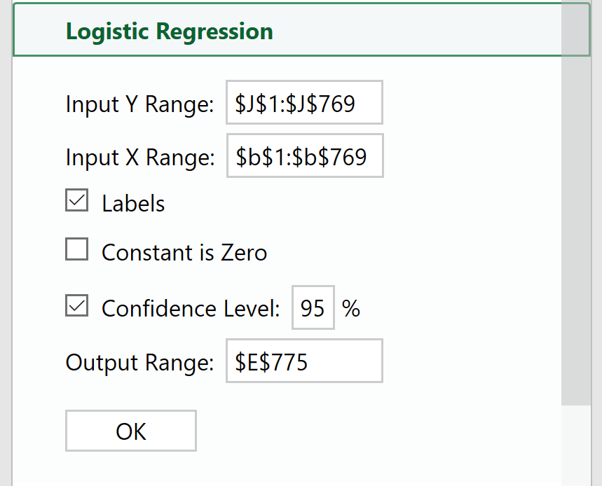
2. We can interpret this similarly to a linear regression with p-values and coefficients. As the number of pregnancies increase by one, the odds of becoming diabetic increase by about 15%.   
   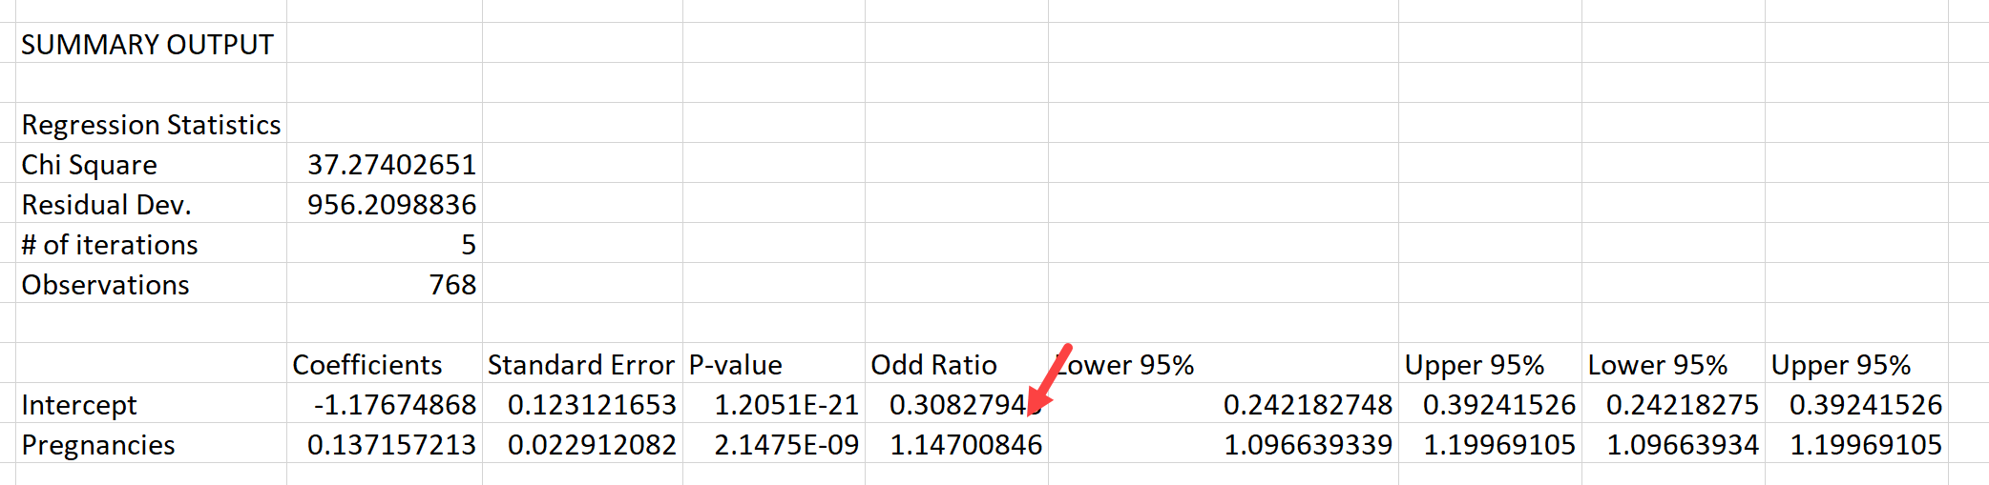

Does this *really* mean there’s a link between # of pregnancies and diabetes? Discuss