**Paired sample t-test**

Data: datasets/tomography.xlsx

Solutions: solutions/paired-t-test-solutions.xlsx

Is there a difference between measurements at Time 1 and Time 2?

Null hypothesis: There is no difference; Alternative: there is.

The paired t-test works by taking the difference between time points of all measurements, then finding whether this value in on average significantly different than 0.

It’s very similar to the independent samples t-test… except paired!

1. ToolPak > t-test: Paired Two Sample for Means option.

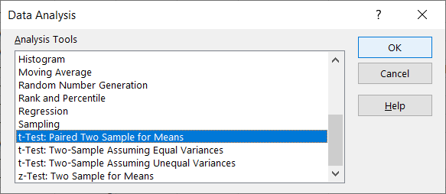

1. Select the measurements for Time 1 and Time 2. The Hypothesized Mean Difference will set to zero by default, which is what we want.

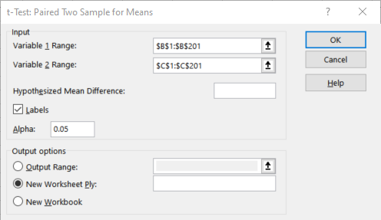

1. Based on the p-value for the two-tailed t-test, we fail to reject the null: the difference on average is not significantly different than zero.

**Bonus!** This figure foots with what’s stated in [Table 2 of the original paper](https://journals.plos.org/plosone/article?id=10.1371/journal.pone.0182849). Yay for reproducibility!

