**Demo: sentiment analysis in Excel**

File: sentiment.xlsx

1. Go to Insert > Get Add-ins
   1. Search for Azure Machine Learning
      1. Click “Add”  
         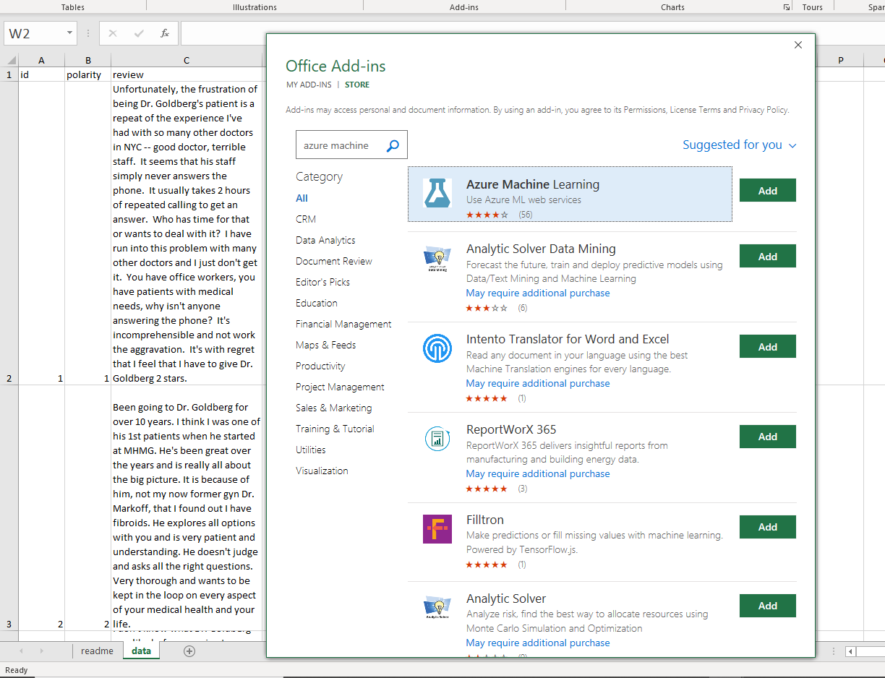
2. Select “Text Sentiment Analysis” (Excel Add-in Sample) from the menu to the right  
   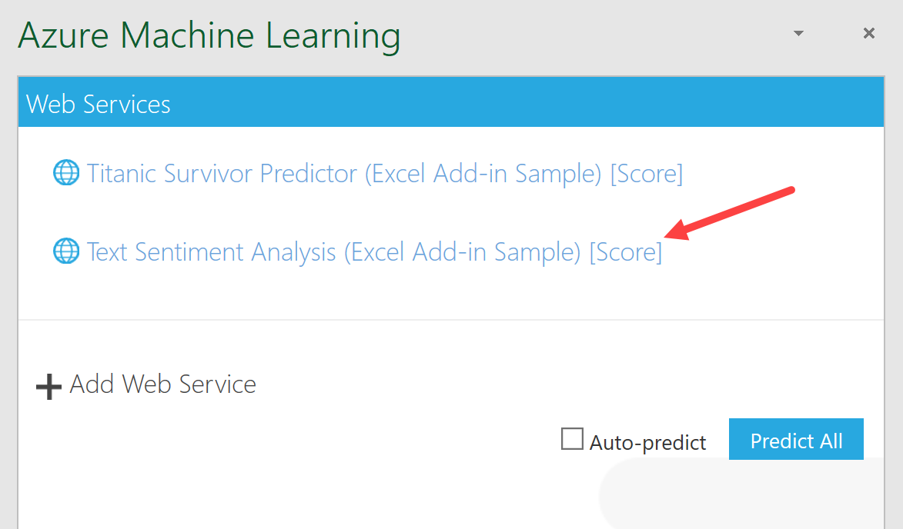
3. Due to the setup of “View Schema,” the input column must be labeled tweet_text. Change cell C1 to match that.
4. Select the Input and Output range  
   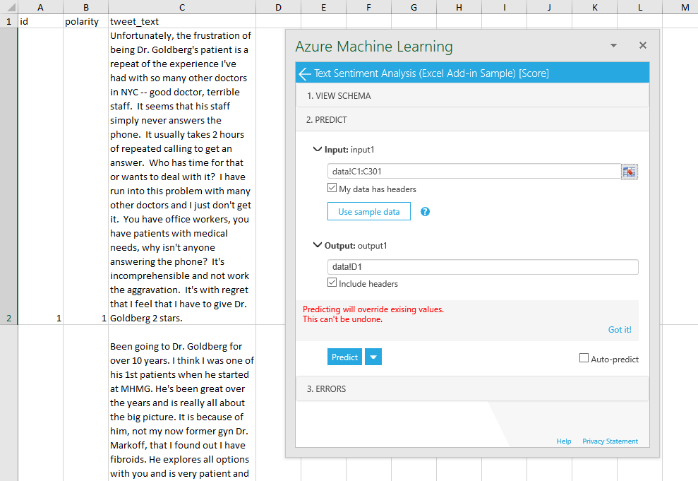
5. Select Predict.
6. You will receive a Sentiment and a Score column. Use the Score column to derive your own sentiment categories. If the Sentiment is greater than .5, it’s positive; otherwise, it’s negative: =IF(E2 > 0.5, "Positive", "Negative")
7. Is there a relationship between the classified sentiment and the stars column? If a review was given one or two stars, it’s classified a 1 here; otherwise, 2.
   1. What test will you use? Check the solutions file for the answer.