***Advancing into Analytics*: Getting Started in R**

1. **Download R and RStudio**

* Go to <https://www.r-project.org>
* Click on “download R”   
  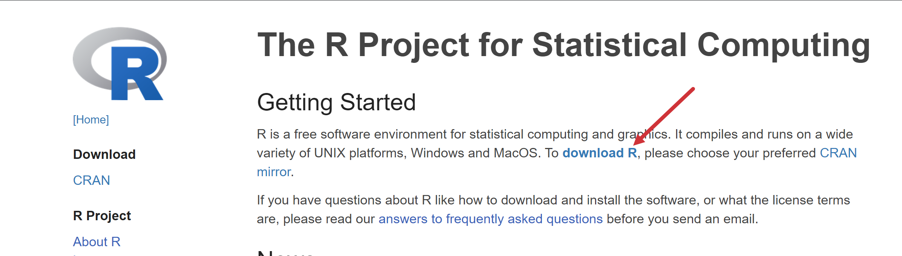
* Choose a location near you from the list of mirrors; I will choose [Case Western Reserve University](https://cran.case.edu).
* Click “Download R for Windows”   
  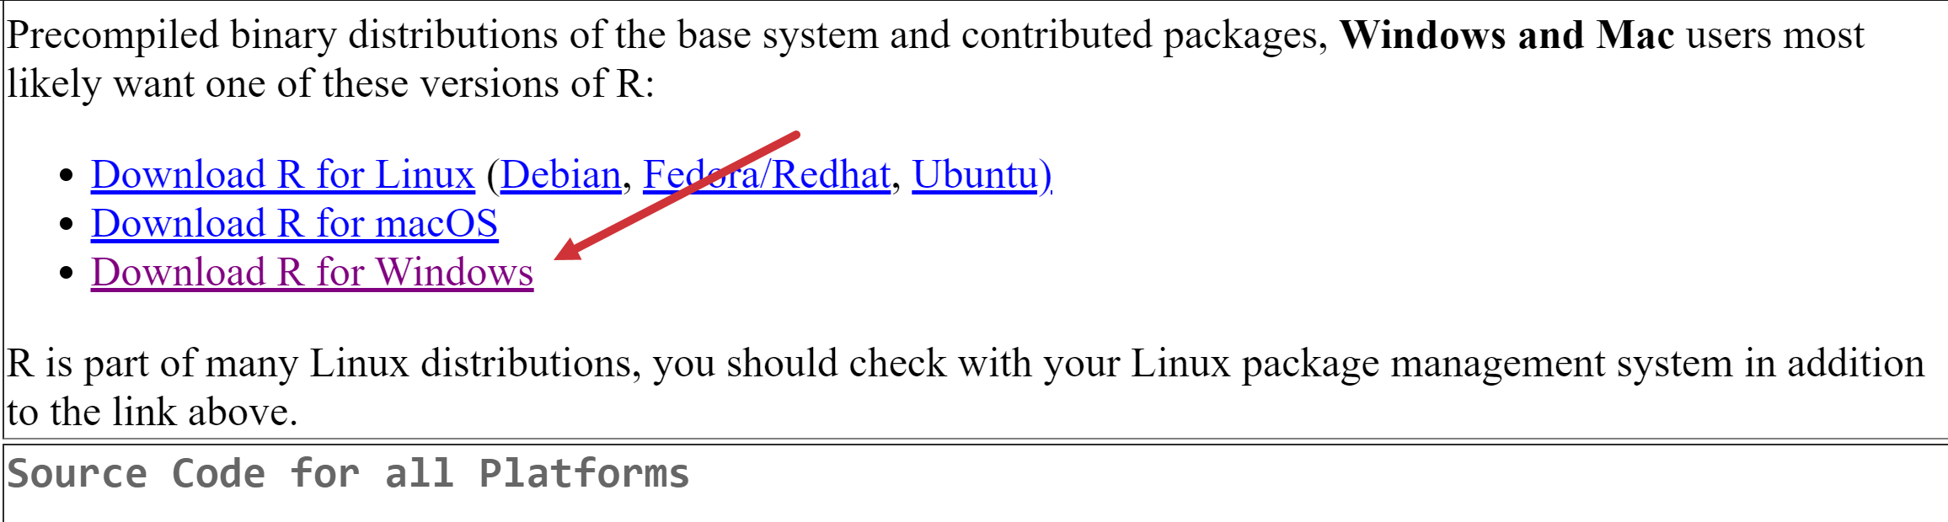
* Click “base” or “install R for the first time” (same link)  
  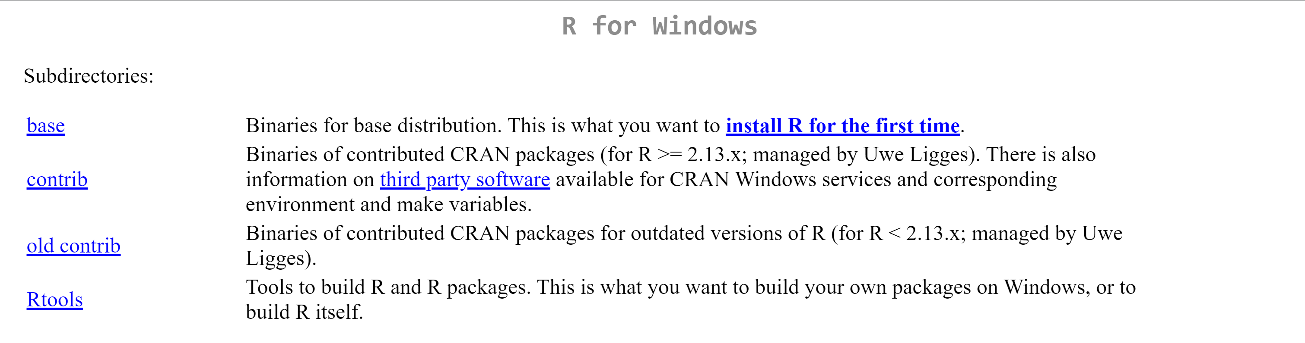
* Click “Download R for Windows” (version number will vary based on when you do this)
* Complete the installation

**R has been downloaded!** Now to RStudio…

* Go to <https://www.rstudio.com>
* Click “Download”  
  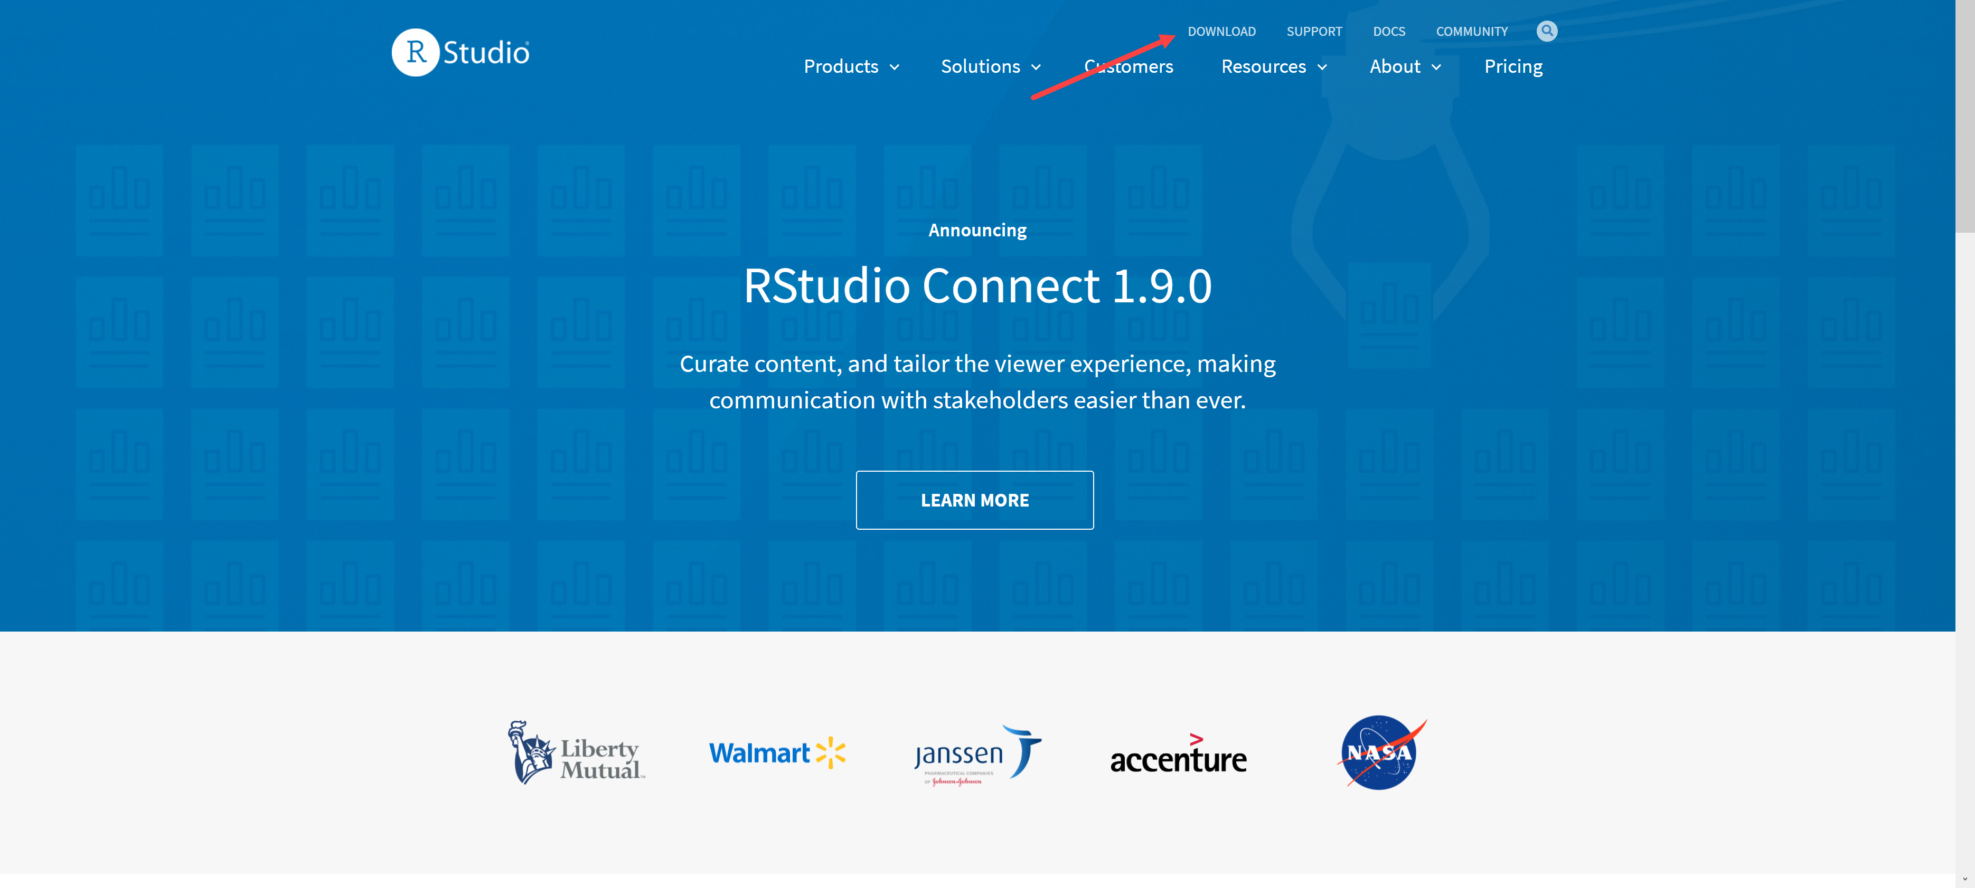
* Click “Download” on RStudio Desktop  
  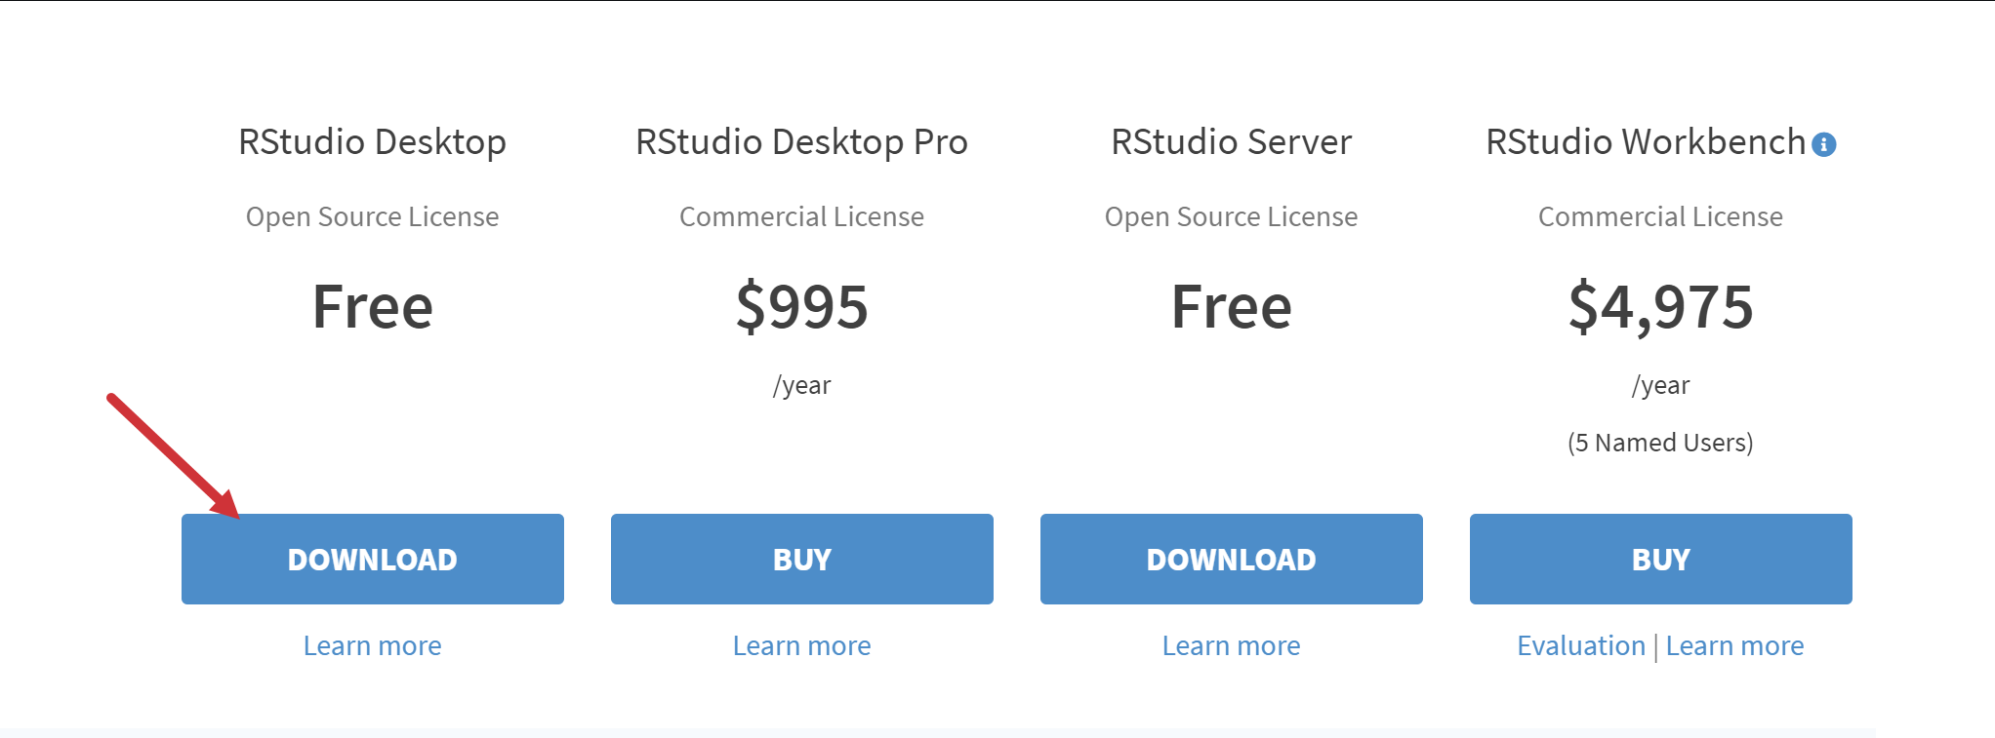
* Click “Download RStudio for Windows”
* Complete installation

1. **Run summary statistics**

* Hit Windows key, search for and open RStudio
* Go to File > Import Dataset > From Excel
* Select “Browse” and select loans.xlsx in the folder you downloaded it  
  Graphical user interface

  Description automatically generated
* Click Import.
  + Download the readxl package to import workbooks (RStudio will do this for you)
  + The dataset has now been uploaded into R as loans
* Type summary(loans) at the cursor into console (lower-left) and hit Enter  
  Graphical user interface, text

  Description automatically generated