***Advancing into Analytics*: Getting Started in Excel**

Open the ispy.xlsx file to continue.

1. **Download the Analysis ToolPak**

* From the ribbon, head to File > Options > Add-ins.
* Click “Go” at the bottom of the screen  
  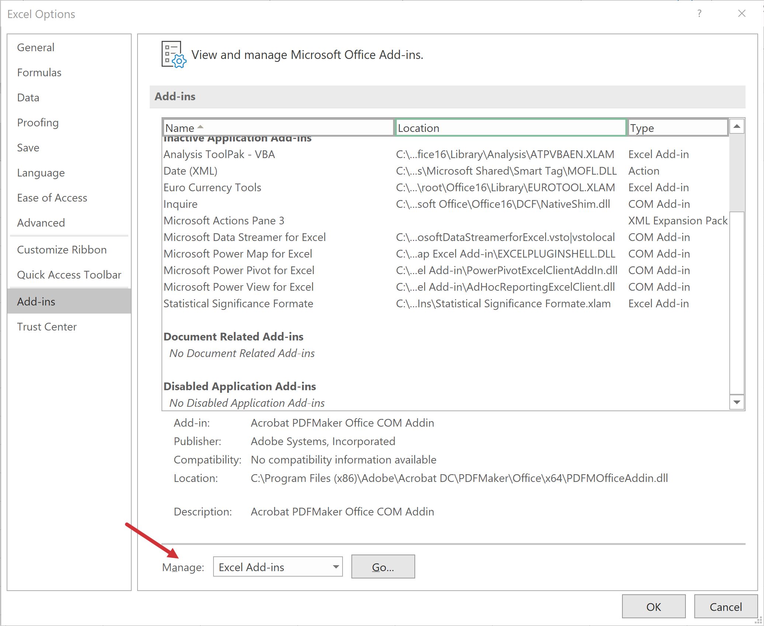
* Check on “Analysis ToolPak” (“Analysis ToolPak – VBA” is not necessary)  
  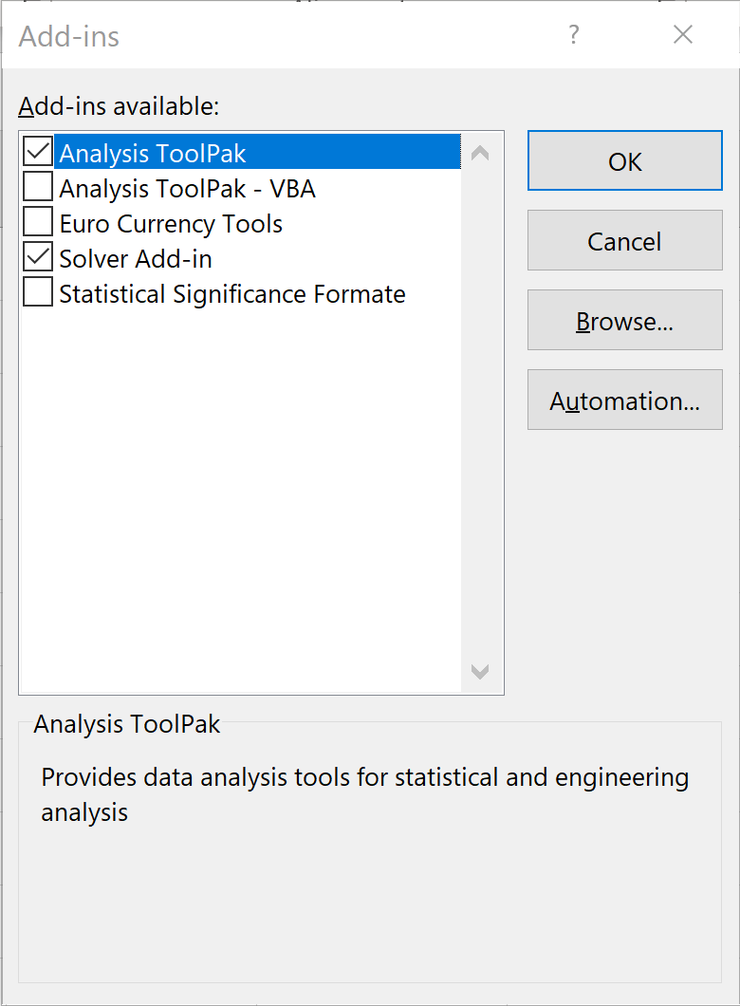
* You will find the ToolPak at the far-right of the Data tab under “Data Analysis” in the Analyze group  
  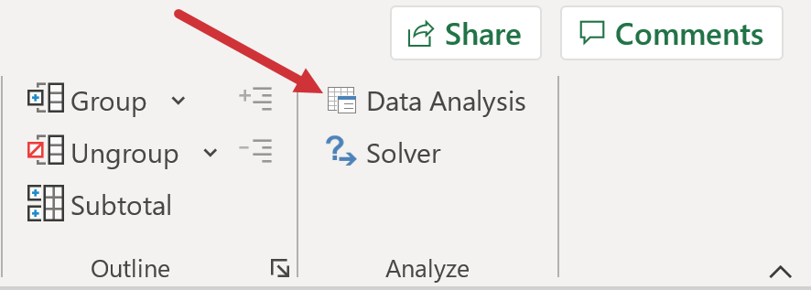

1. **Run descriptive statistics**

* Use the ToolPak: Data > Data Analysis > Descriptive Statistics
* The ToolPak can *only* summarize numeric data: select the values in Column B (age) for now
  + Make sure to turn summary statistics **on**
  + Make sure to check labels in first row **on.** I am going toput these into a new workbook because I do **not** want to modify my original dataset here:  
    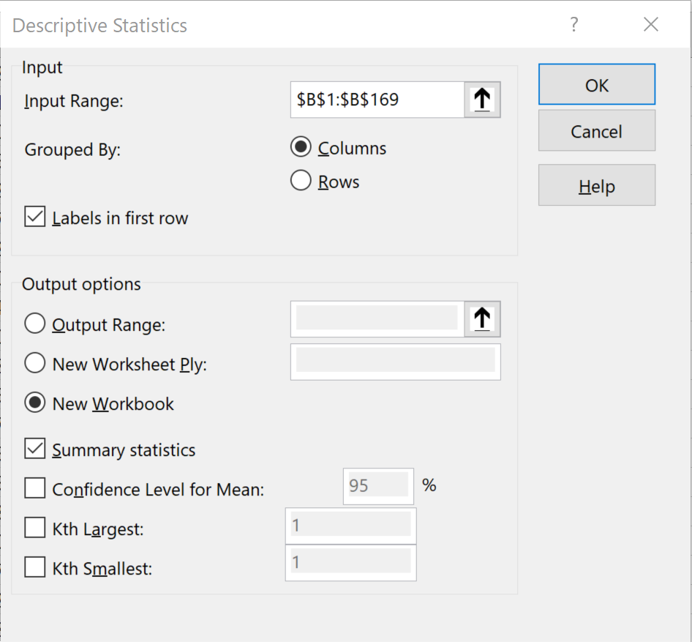
* You should see something like this:  
  