***Advancing into Analytics*: Getting Started in Python**

1. **Download Anaconda’s distribution of Python**

* Go to [anaconda.com](https://www.anaconda.com) > Products > Individual Edition  
  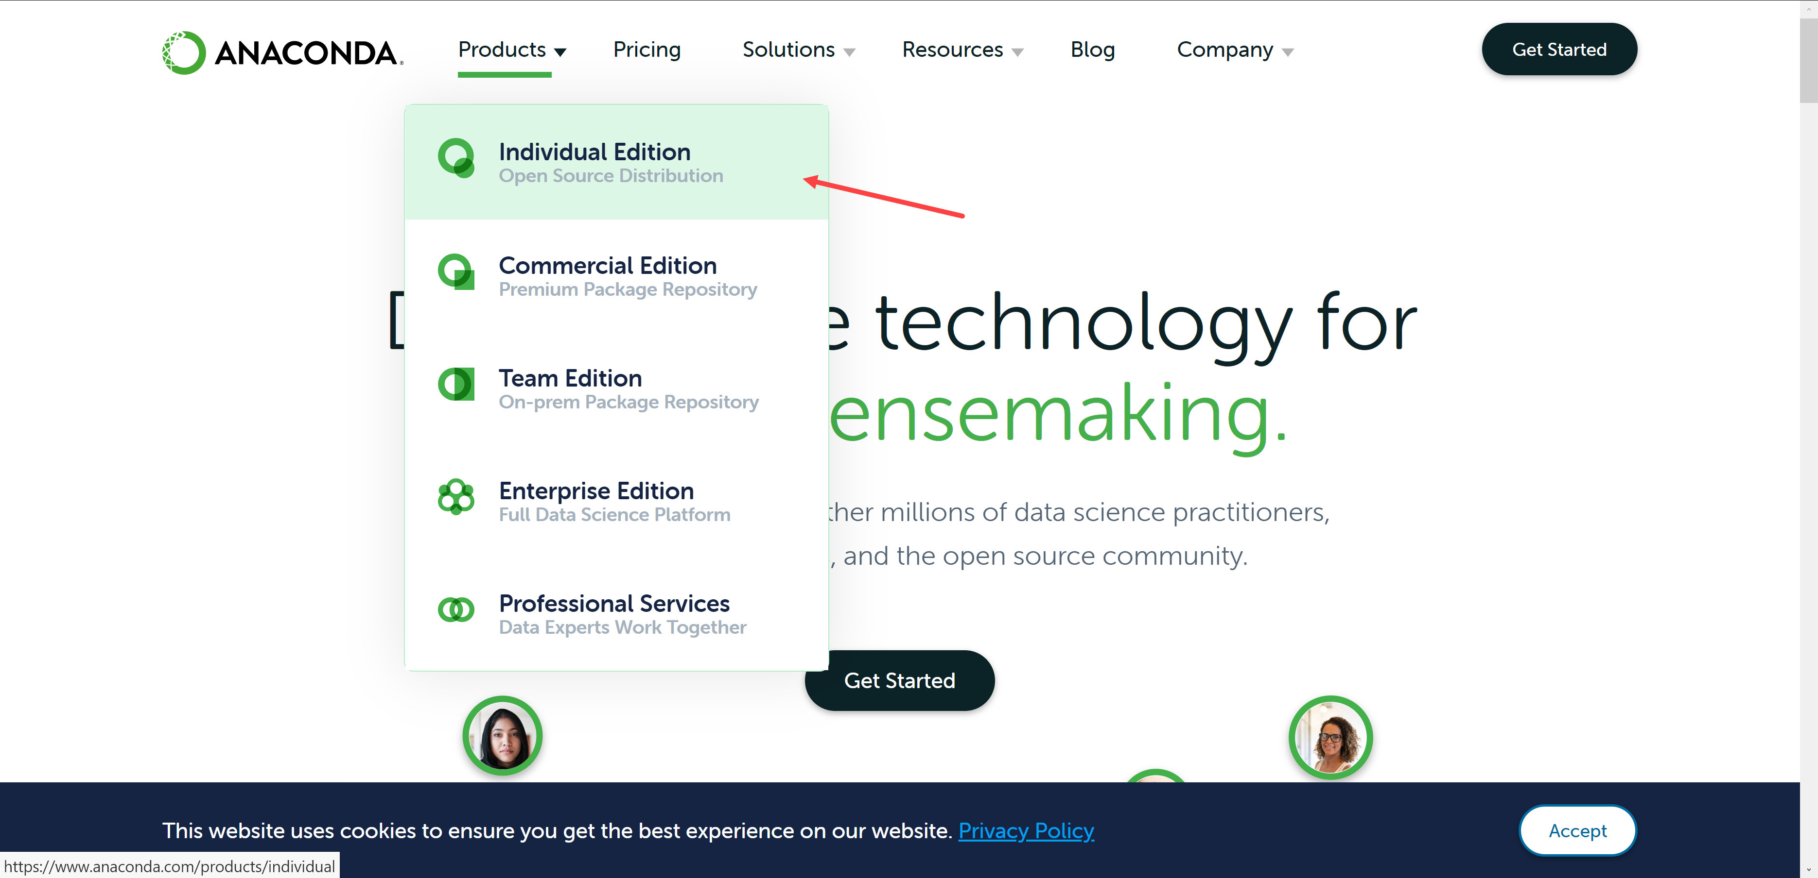
* Click on “Download”   
  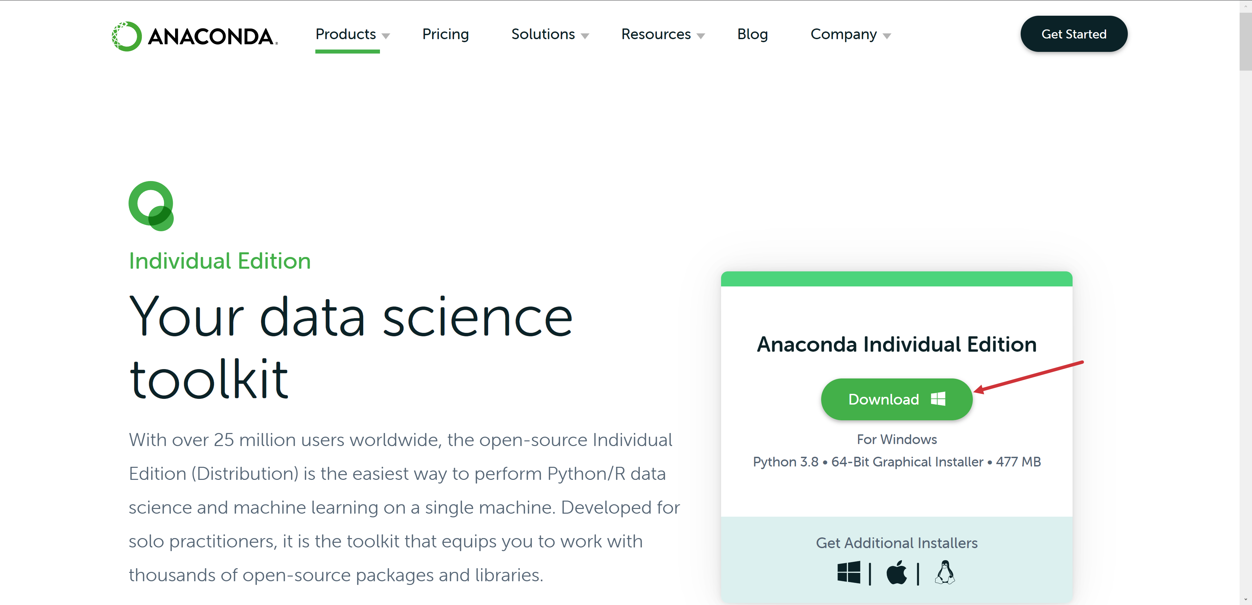
* Complete installation

1. **Run summary statistics**

* Hit Windows key, search for and open Jupyter Notebook (**don’t close the terminal window**)
  + Choose a browser to open with and click OK
* Navigate to where your ispy.xlsx file is
* Select New > Python 3

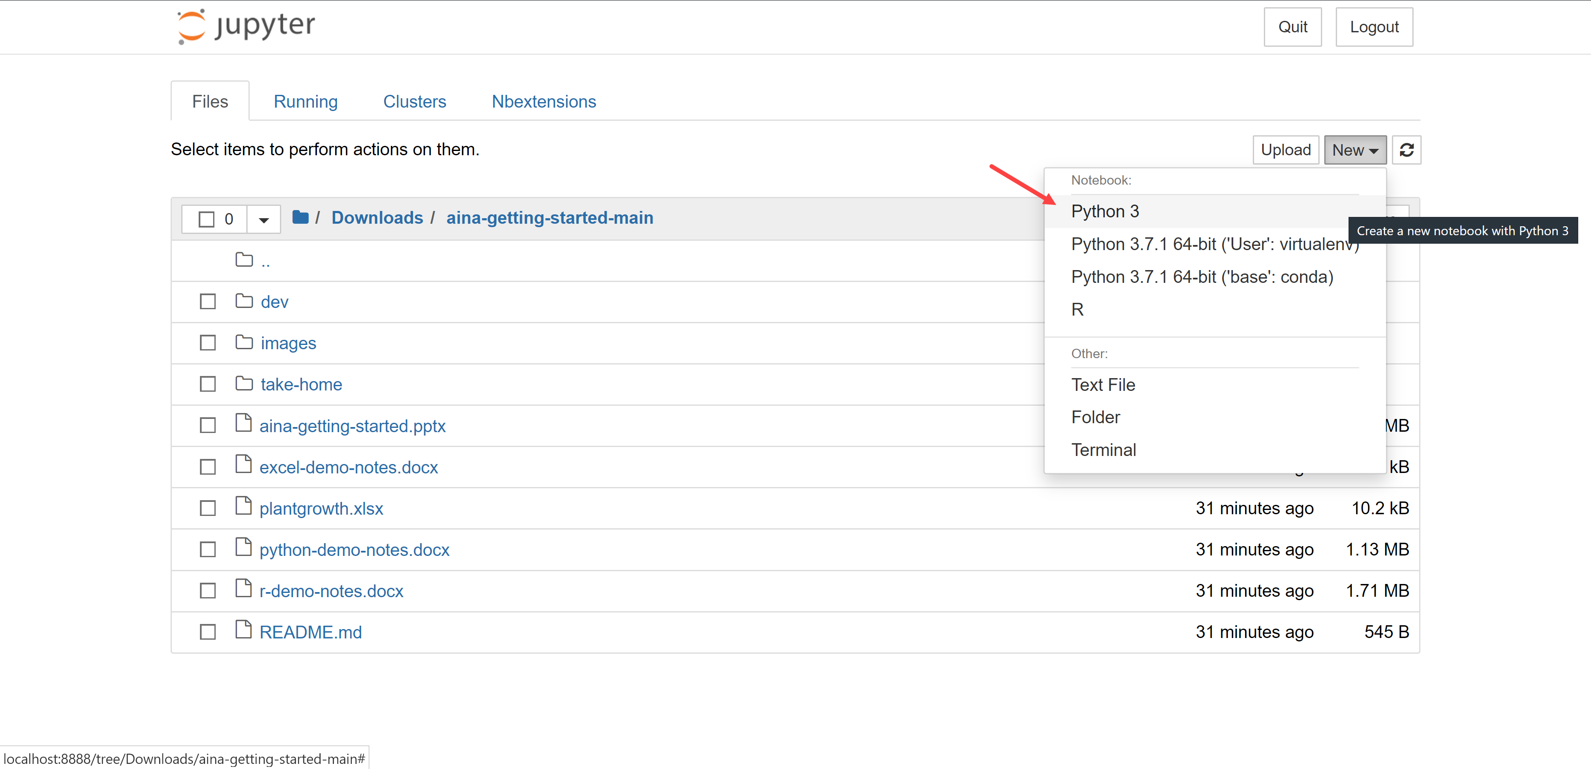

* Type import pandas in the first cell and hit Run
* Now enter and run ispy = pandas.read_excel('ispy.xlsx')
  + Alternatively you can read in the file from the web: ispy = pd.read_excel('https://github.com/stringfestdata/aina-getting-started-for-researchers/raw/main/loans.xlsx')
* Enter and run ispy.describe()  
  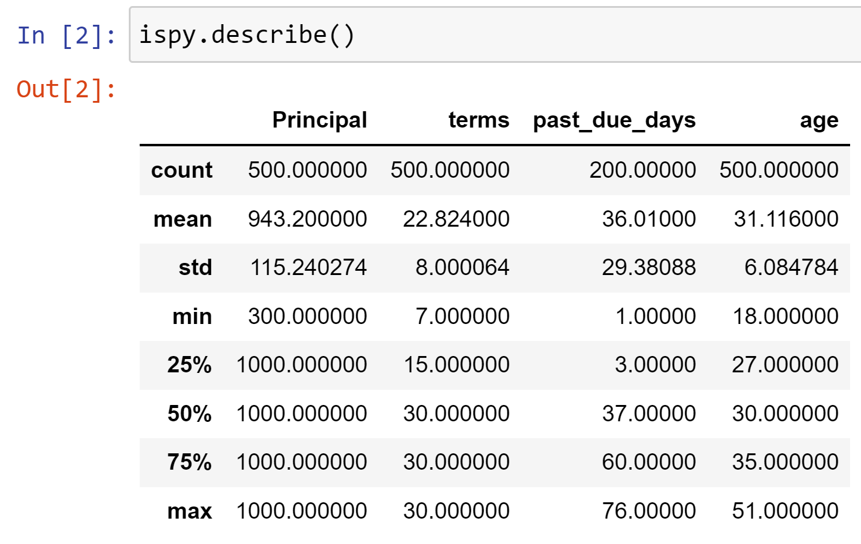
* To get descriptive statistics of all variables, run ispy.describe(include='all')  
  