***Advancing into Analytics*: Getting Started in Excel**

1. **Download the Analysis ToolPak**

* From the ribbon, head to File > Options > Add-ins.
* Click “Go” at the bottom of the screen  
  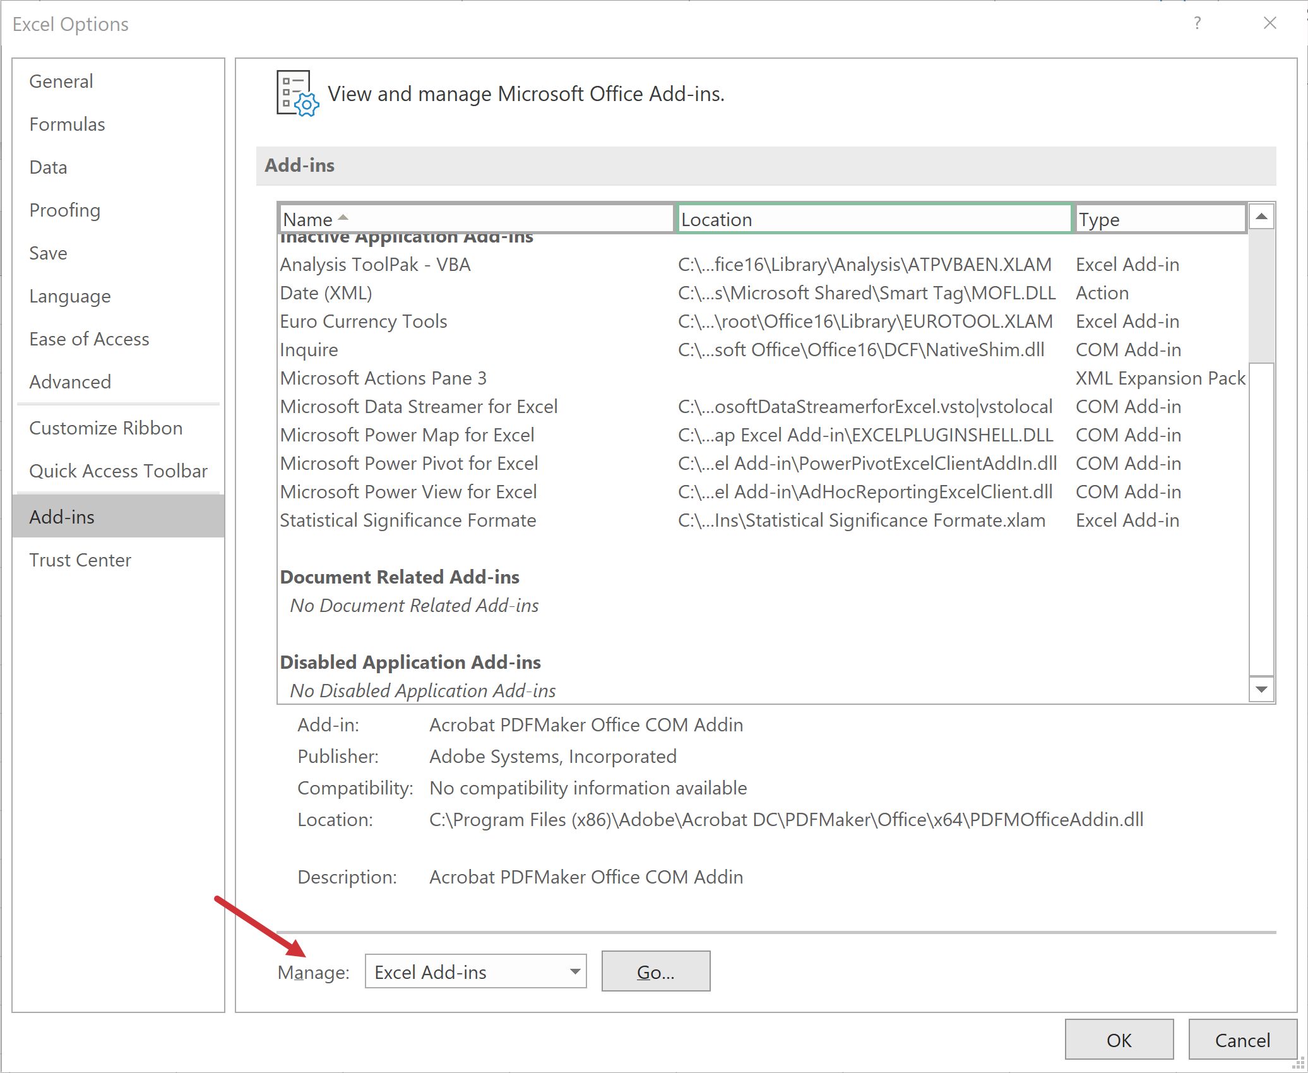
* Check on “Analysis ToolPak” (“Analysis ToolPak – VBA” is not necessary)  
  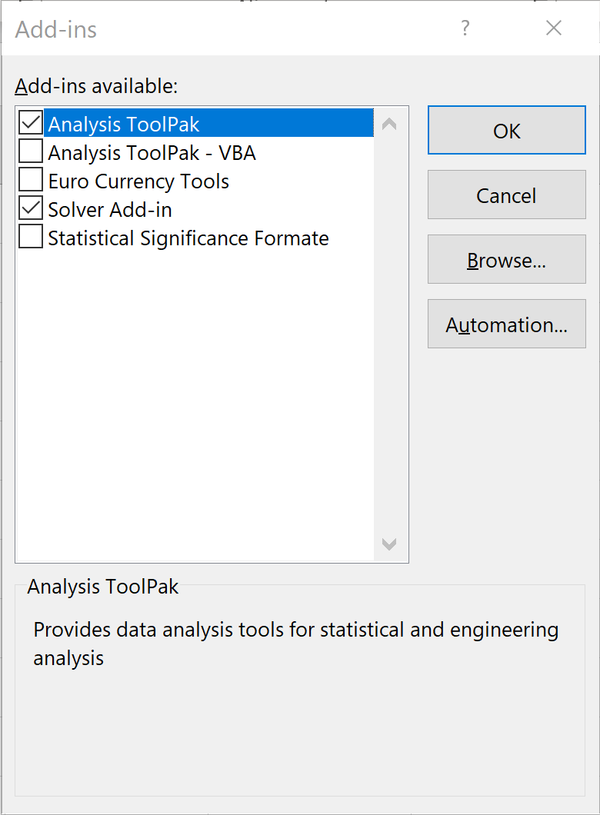
* You will find the ToolPak at the far-right of the Data tab under “Data Analysis” in the Analyze group  
  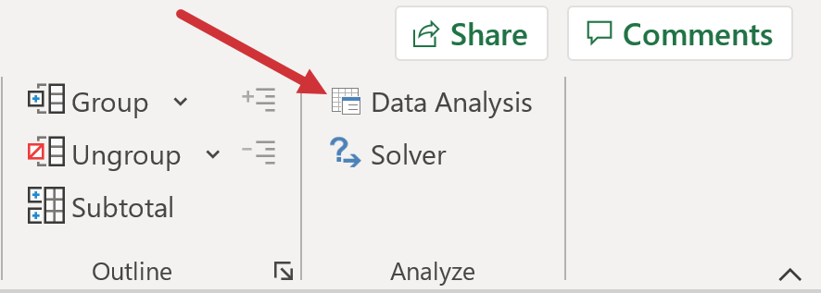

1. **Run descriptive statistics**

* Use the ToolPak: Data > Data Analysis > Descriptive Statistics
* The ToolPak can *only* summarize numeric data: select the values in Column A and make sure to turn summary statistics **on**:   
  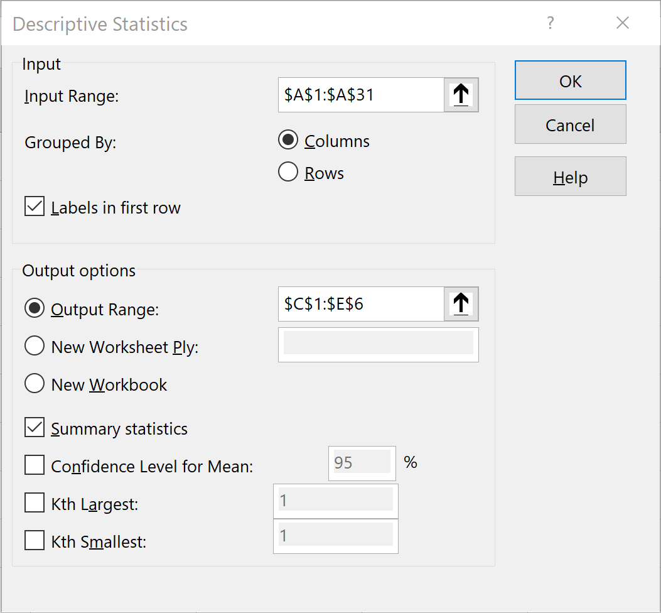
* You should see something like this:  
  