***Advancing into Analytics*: Getting Started in Python**

1. **Download Anaconda’s distribution of Python**

* Go to <https://www.anaconda.com/products/individual>
* Click on “Download”   
  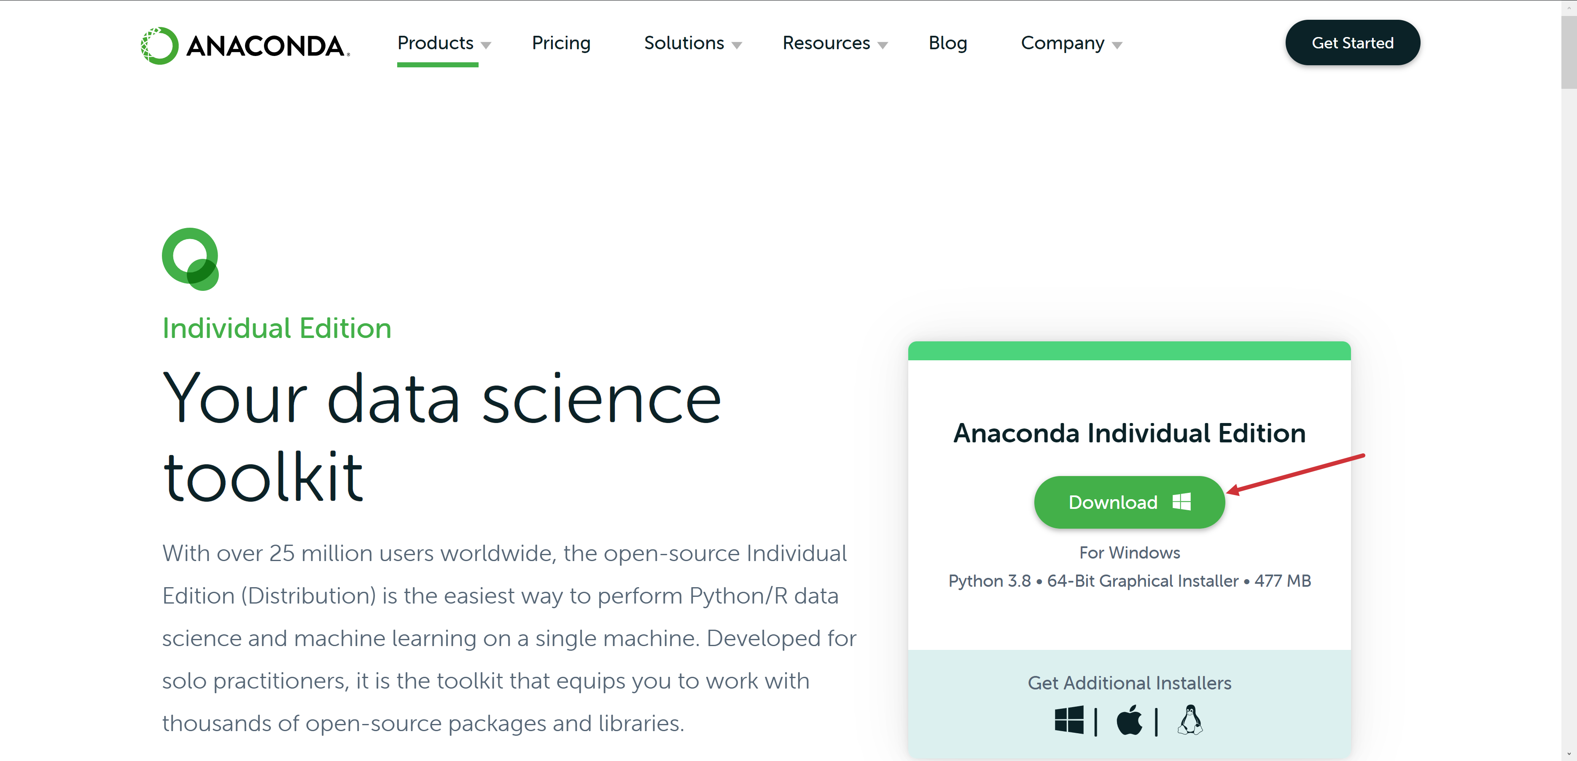

1. **Run summary statistics**

* Open Jupyter Notebook (**don’t close the terminal window**)
* Select New > Python 3   
  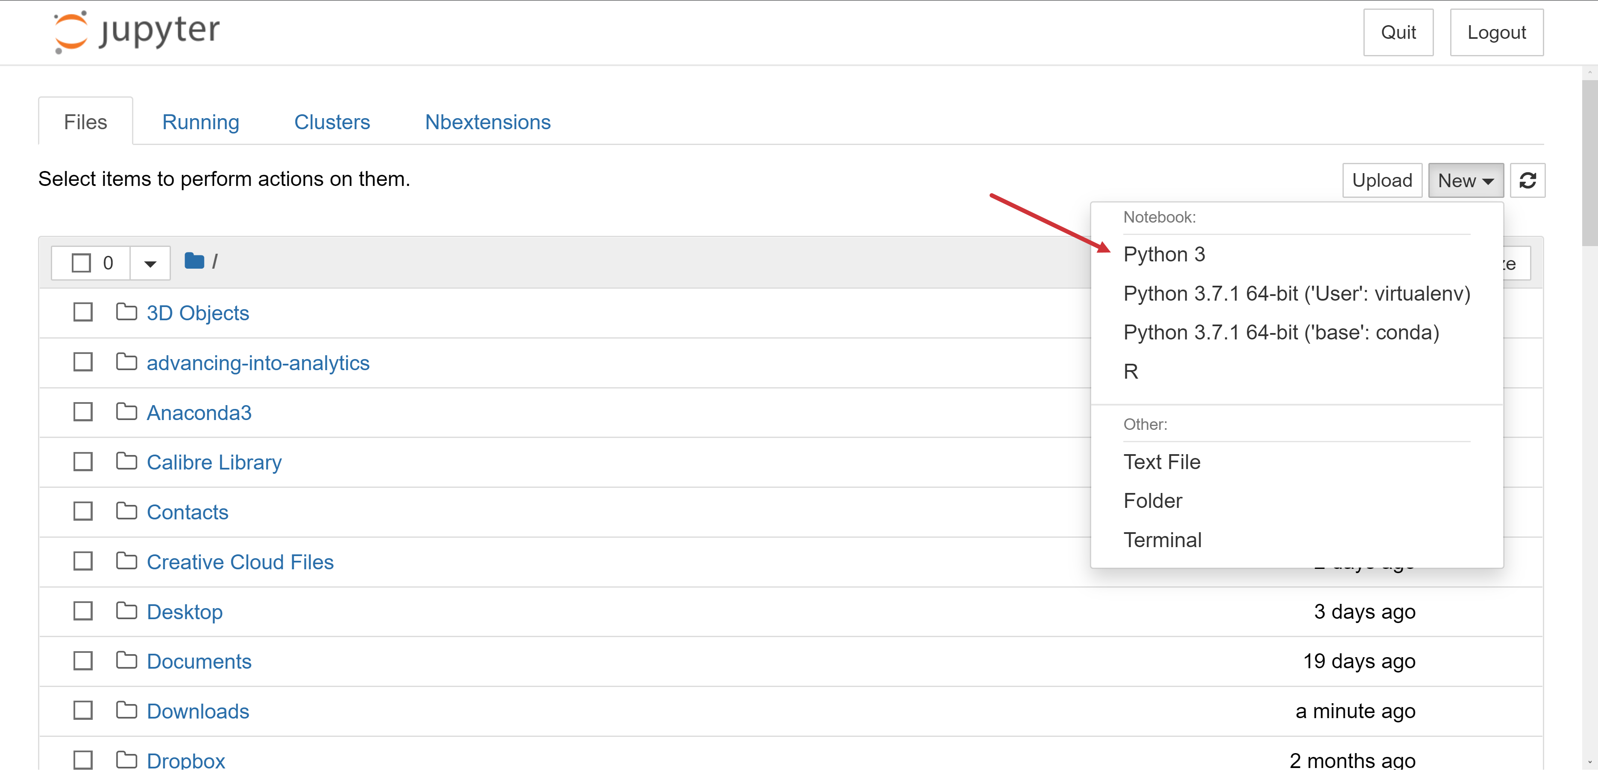
* Type import pandas in the bar and hit Run
* If you get an error, type !conda install pandas in the next cell and hit Run  
  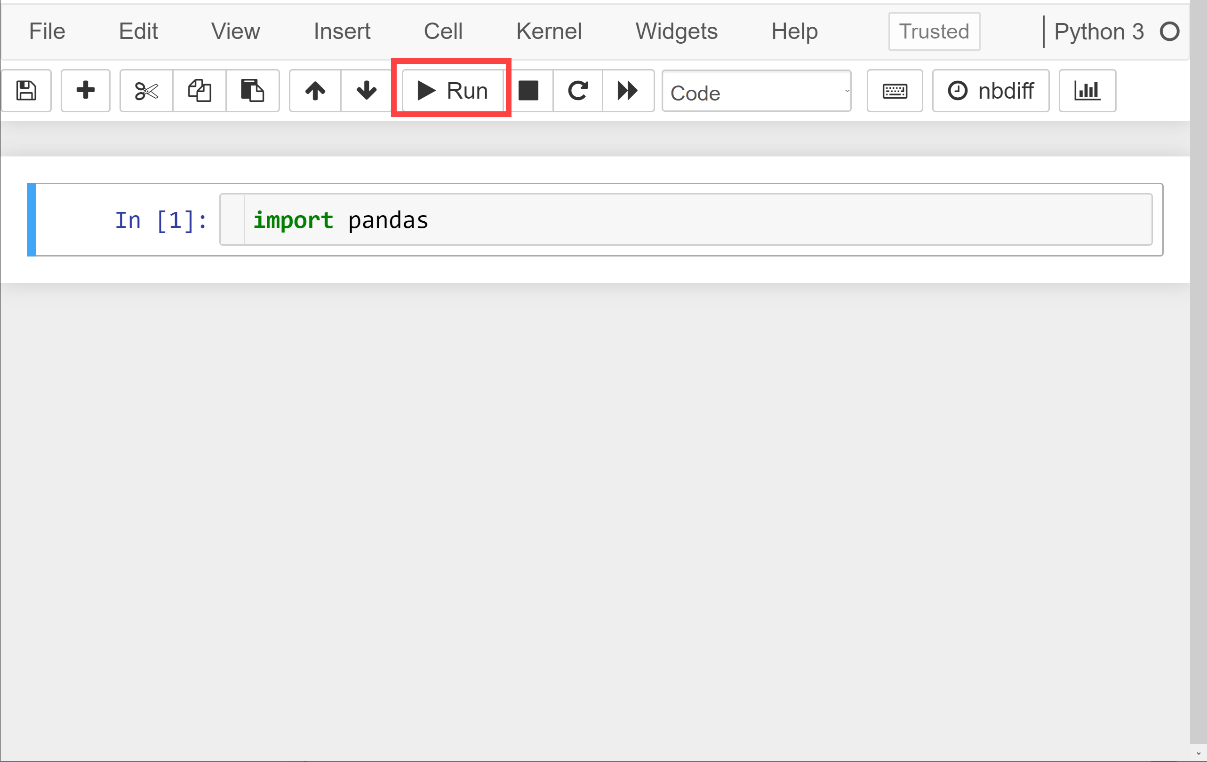
* Now enter and execute plantgrowth = pandas.read_excel(
* Enter and execute plantgrowth.summary()