***Advancing into Analytics*: Getting Started in Python**

1. **Download Anaconda’s distribution of Python**

* Go to [anaconda.com](https://www.anaconda.com) > Products > Individual Edition  
  
* Click on “Download”   
  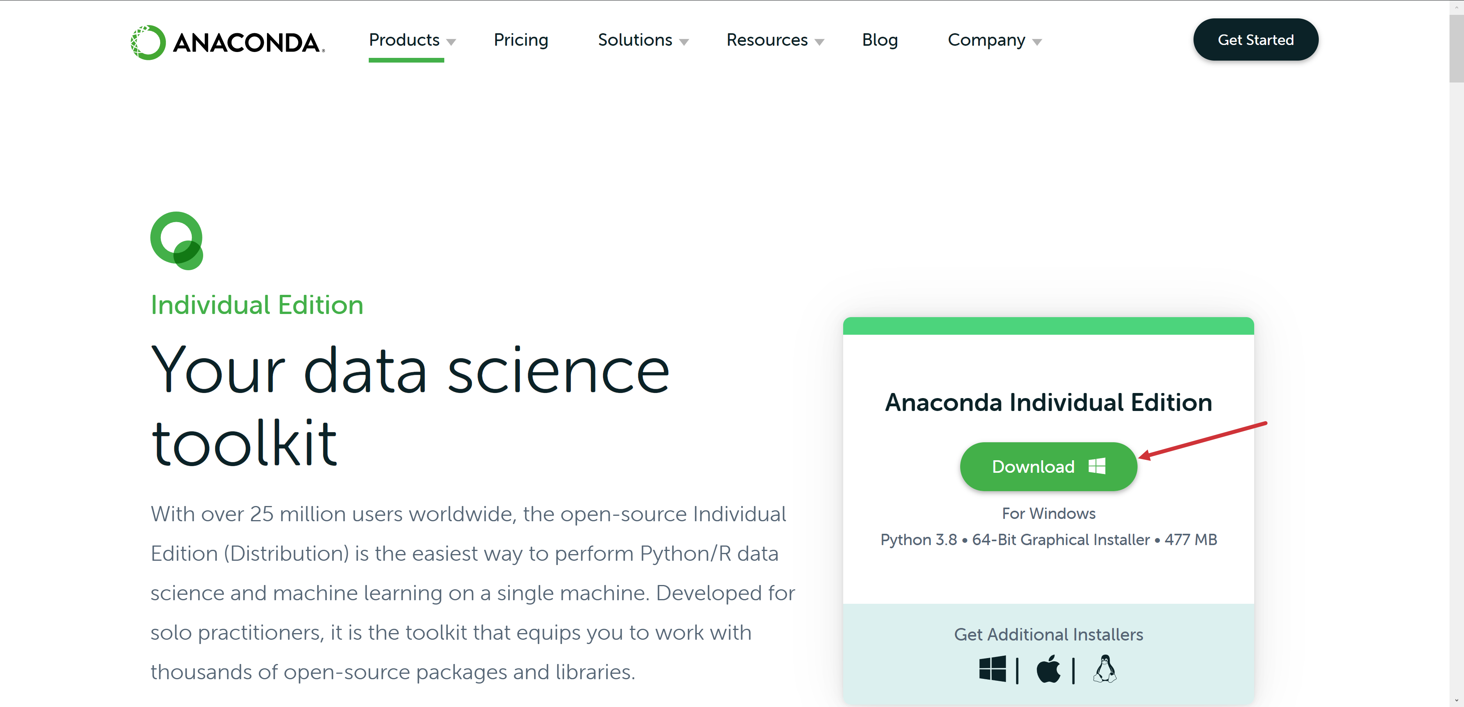
* Complete installation

1. **Run summary statistics**

* Hit Windows key, search for and open Jupyter Notebook (**don’t close the terminal window**)
  + Choose a browser to open with and click OK
* Navigate to where your plantgrowth.xlsx file is
* Select New > Python 3

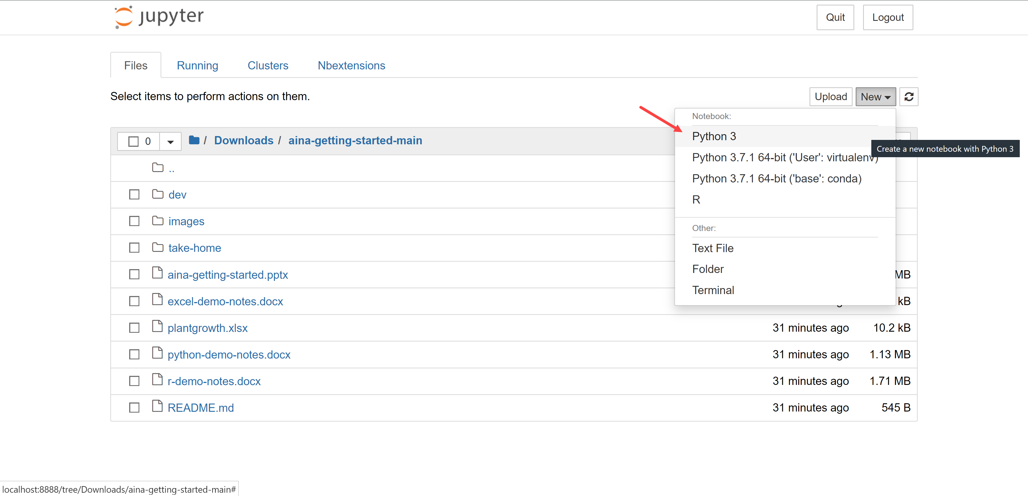

* Type import pandas in the first cell and hit Run
* If you get an error, type !conda install pandas in the next cell and hit Run

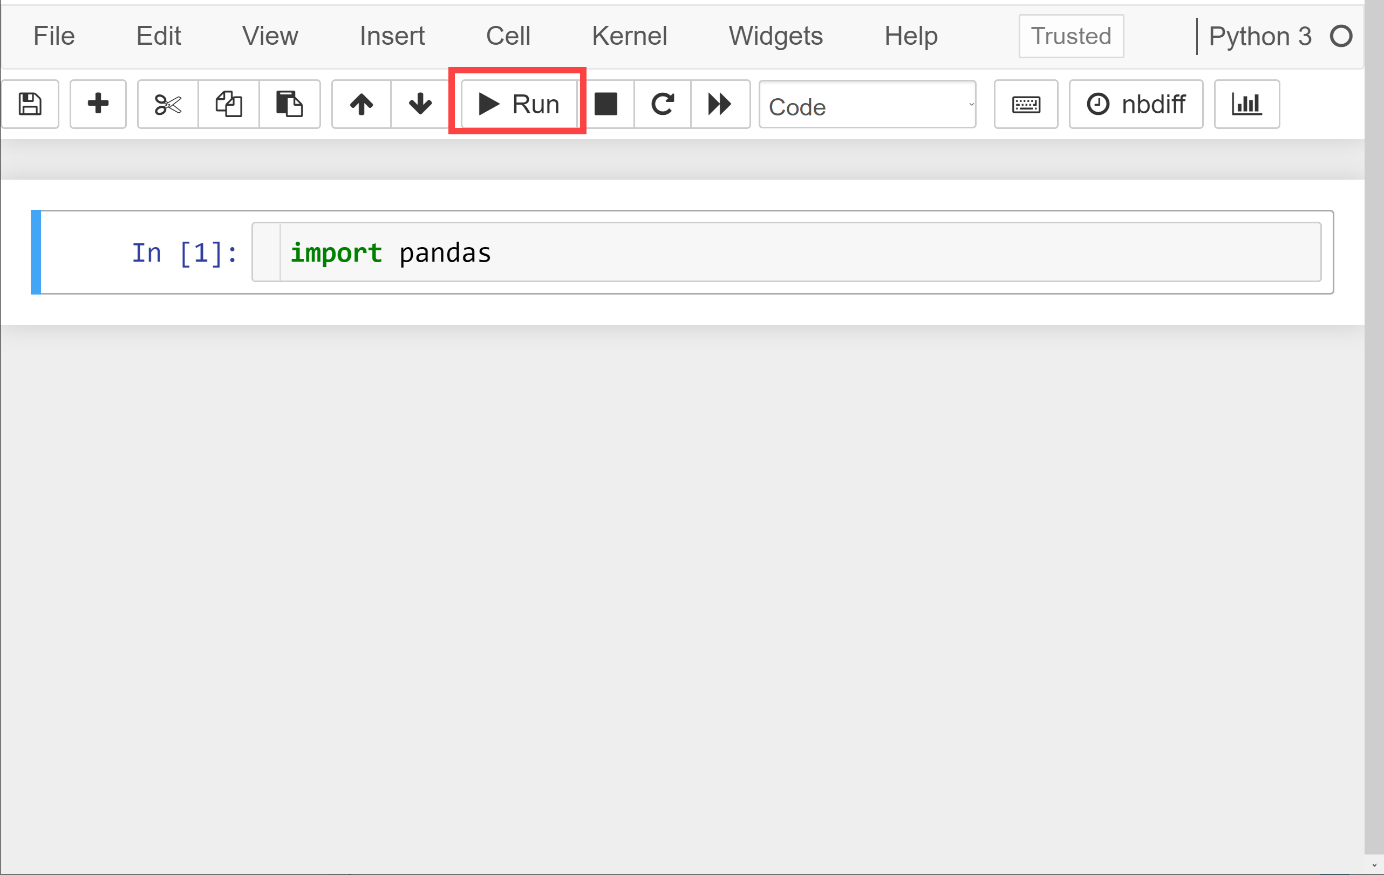

* Now enter and run plantgrowth = pandas.read_excel('https://github.com/stringfestdata/aina-getting-started/raw/main/plantgrowth.xlsx')
  + Alternatively you can read in the file from where you downloaded it; for best results have the notebook in same folder as the dataset
* Enter and run plantgrowth.describe()  
  