***Advancing into Analytics*: Getting Started in R**

1. **Download R and RStudio**

* Go to <https://www.r-project.org>
* Click on “download R”   
  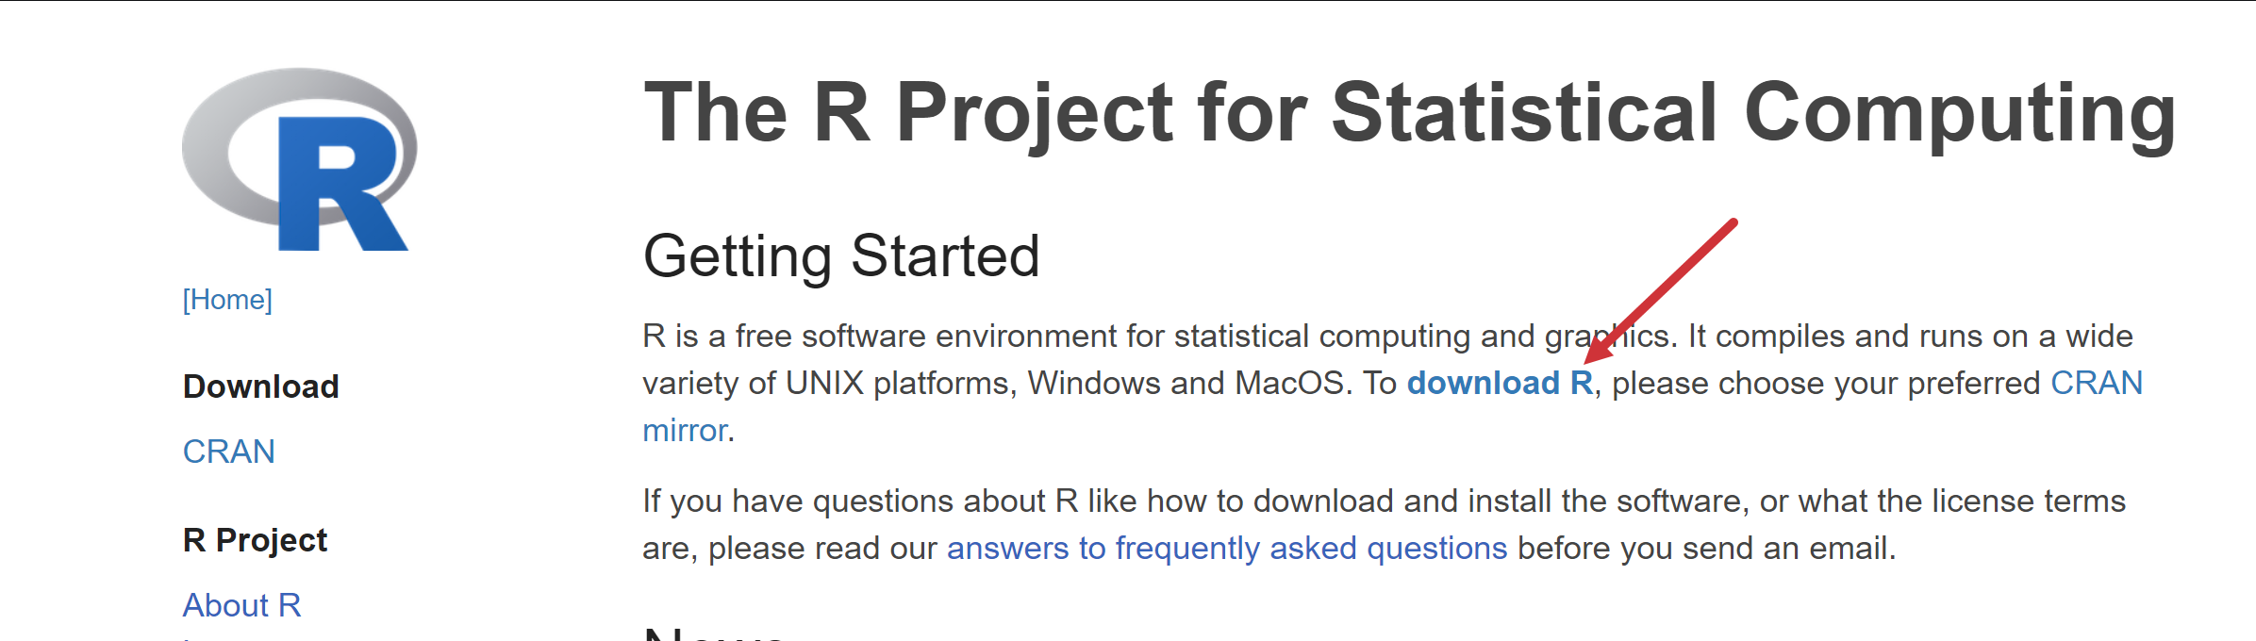
* Choose a location near you from the list of mirrors; I will choose [Case Western Reserve University](https://cran.case.edu).
* Click “Download R for Windows”   
  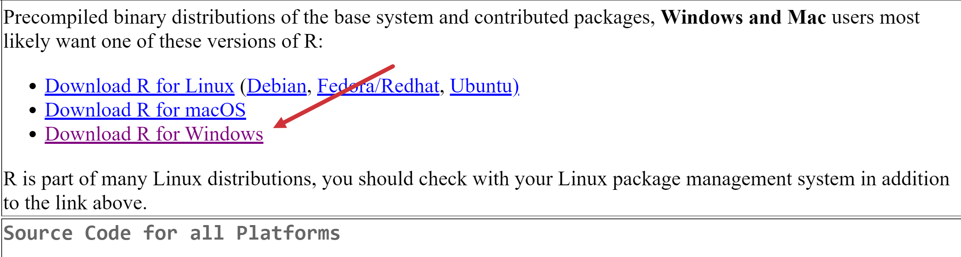
* Click “base”  
  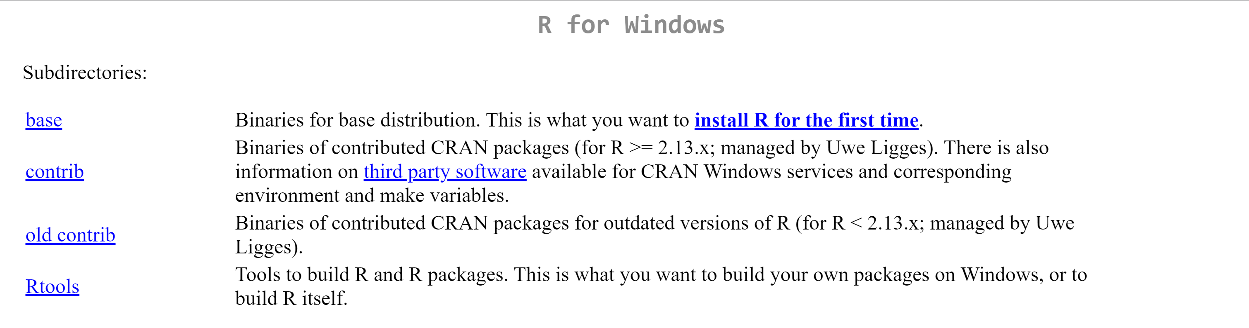
* Click “Download R for Windows” (version number will vary based on when you do this)
* Complete the installation

**R has been downloaded!** Now to RStudio…

* Go to <https://www.rstudio.com/products/rstudio/>
* Click RStudio Desktop > Download RStudio Desktop  
  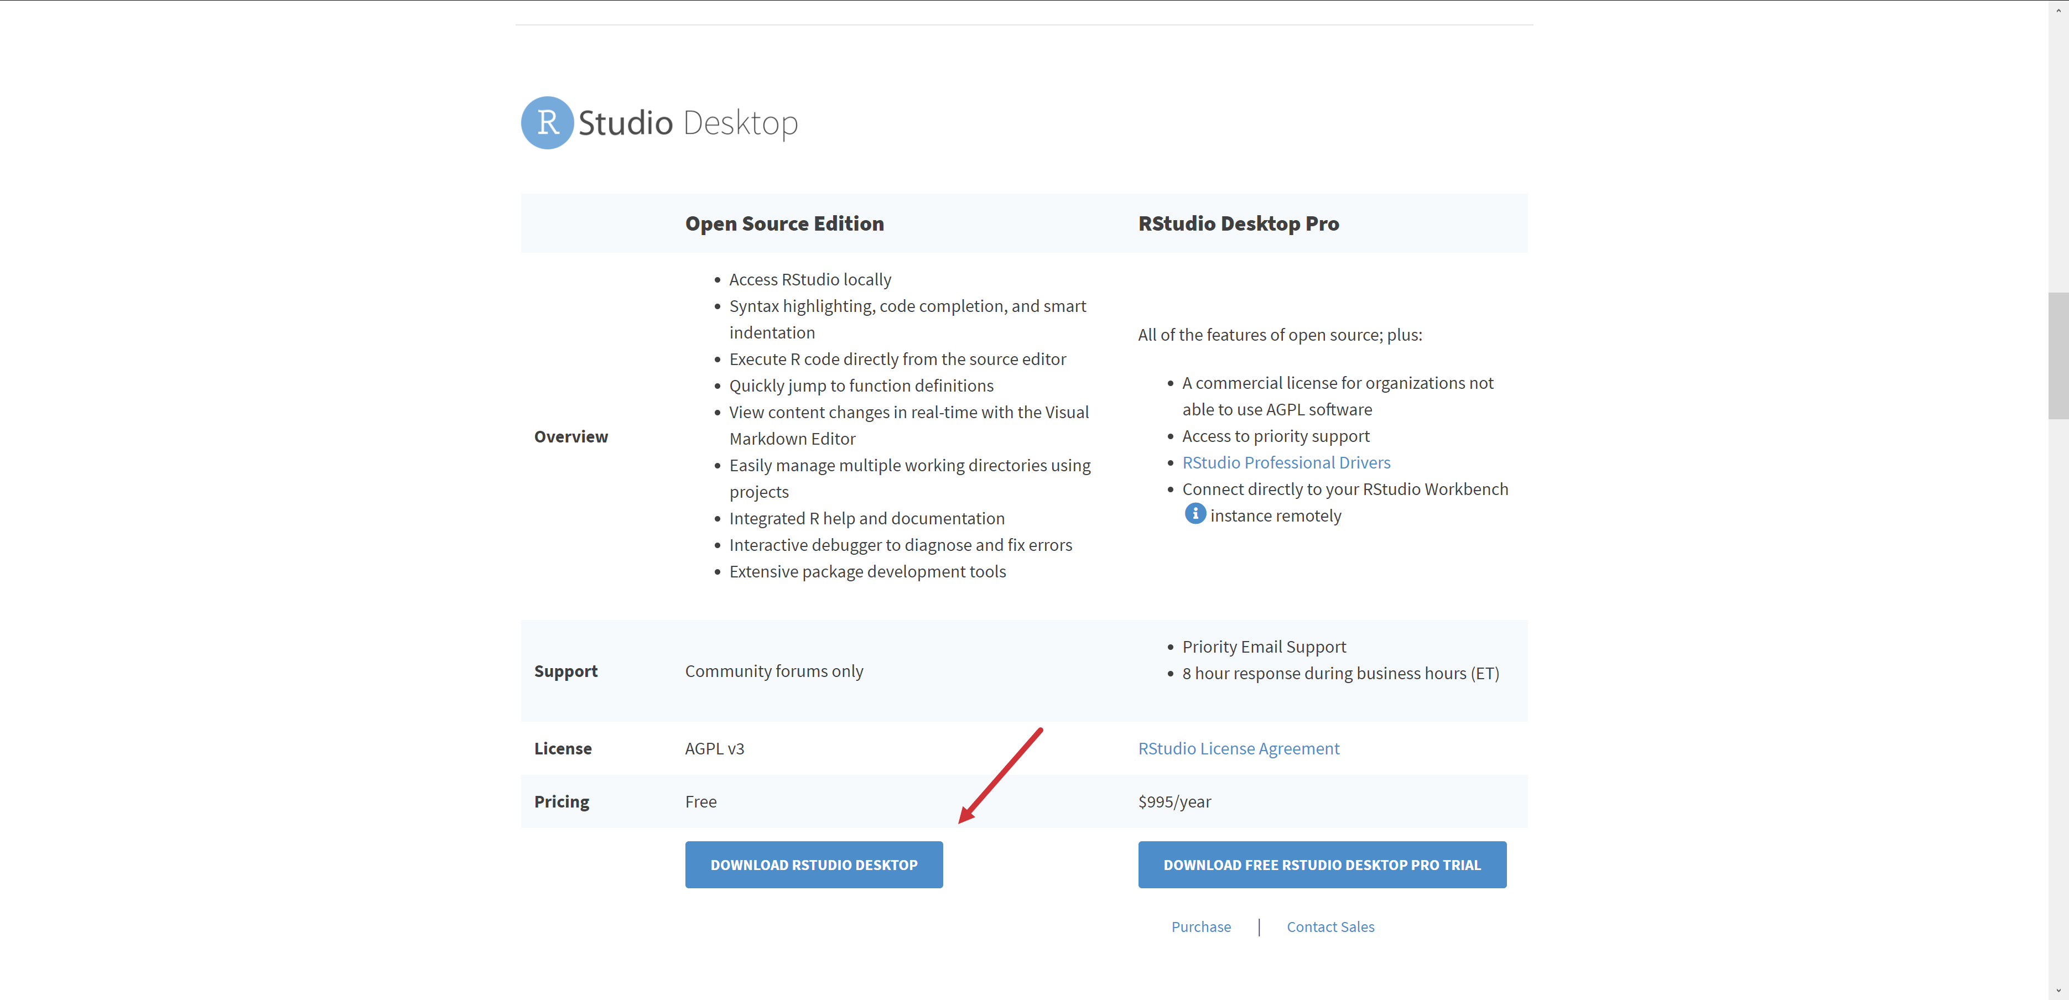
* Click “Download” on RStudio Desktop  
  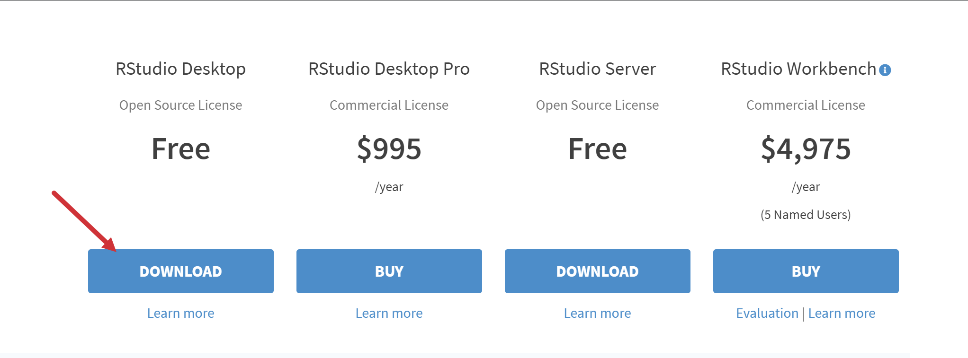
* Click “Download RStudio for Windows”
* Complete installation

1. **Run summary statistics**

* Hit Windows key, search for an open RStudio
* Go to File > Import Dataset > From Excel
* Select “Browse” and select plantgrowth.xlsx in the folder you downloaded it  
  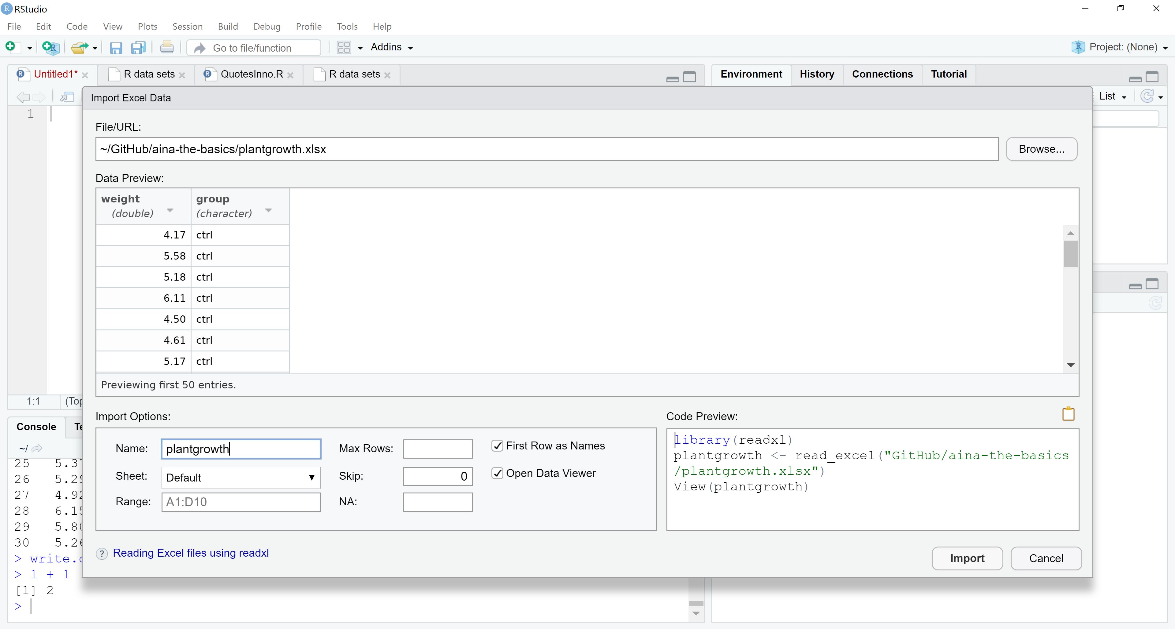
* Click Import. The dataset has been uploaded into R as plantgrowth
* Type summary(plantgrowth) into console (lower-left) and hit Enter  
  