**Python take-home demo**

1. Open Jupyter and navigate to where tips.xlsx is stored
2. New notebook: New > Python 3
3. To get the first few rows of data, use head():   
   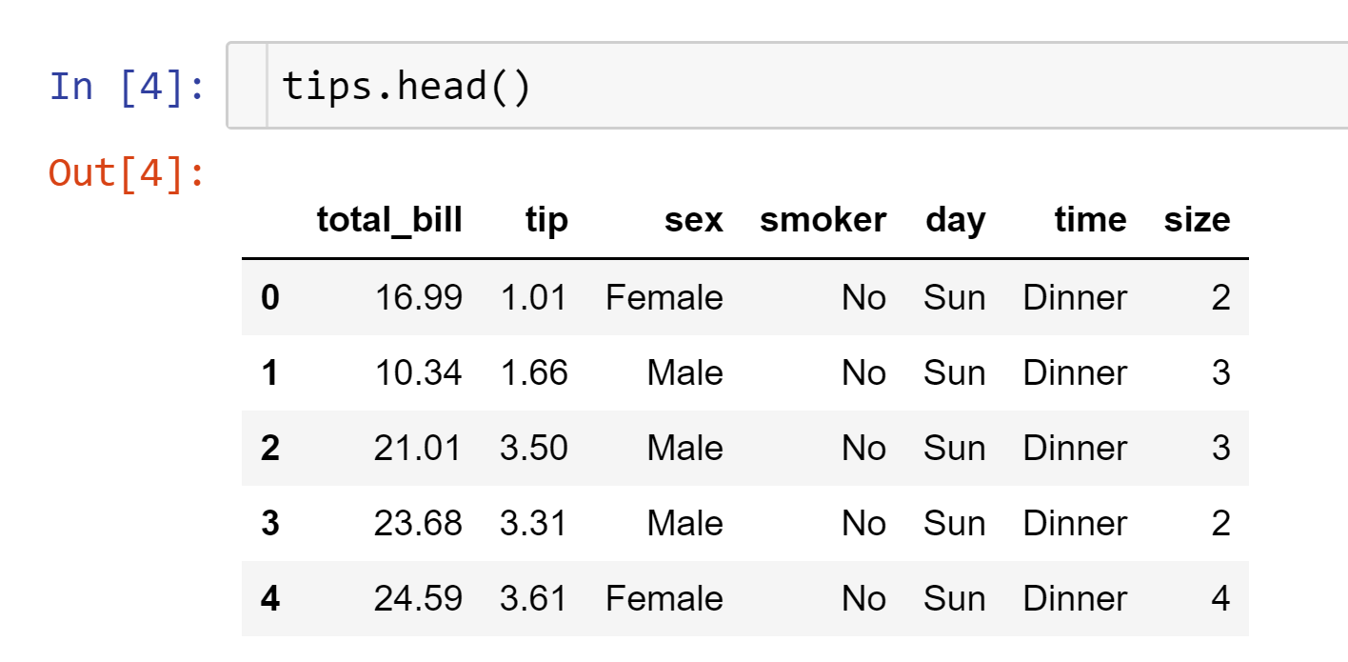
4. To rename the notebook, click on the current name (should be Untitled) and write over it:  
   