**R take-home demo**

1. Import the dataset: File > Import Dataset > From Excel
2. Browse to where you’ve downloaded tips.xlsx and select Import using the steps shown in course demo notes
3. You will see the import code has been generated in the console.
4. You want this code to be stored in a script: start by going to File > New File > R Script  
   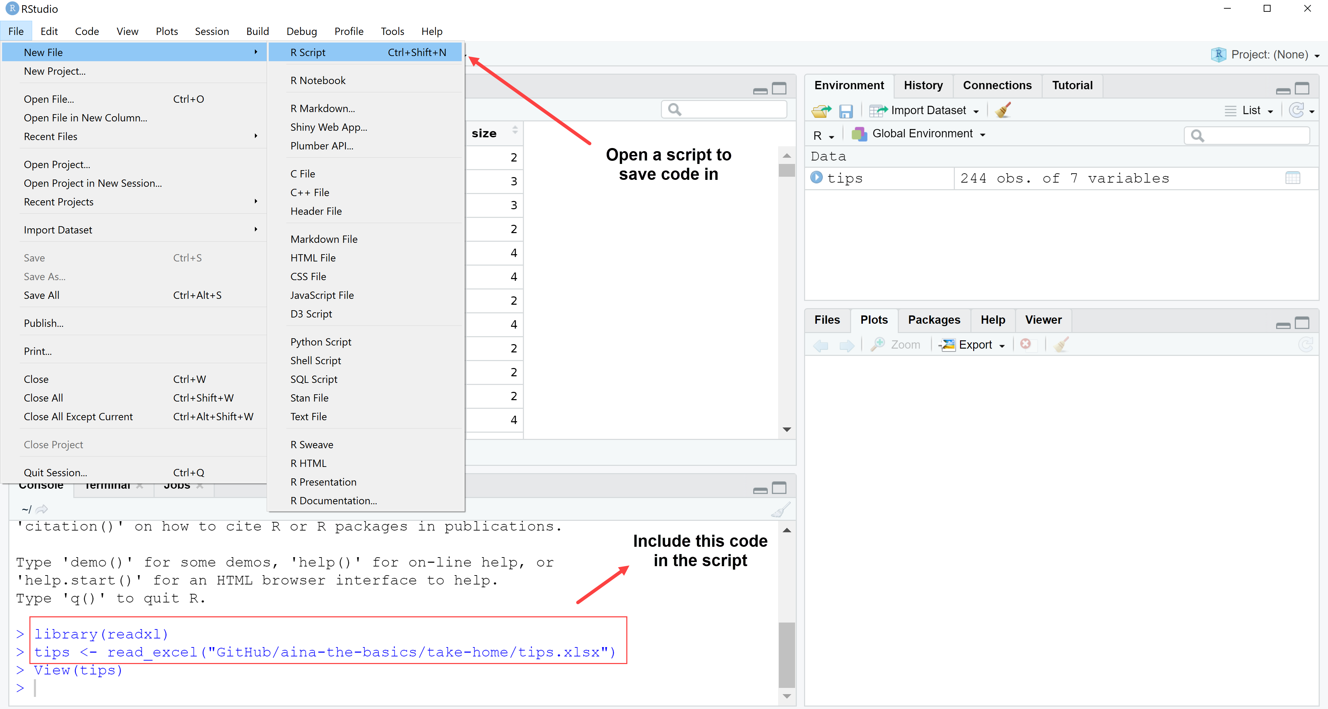
5. You can either type or copy-paste the code into the R script. The third line, View() is a function to view the data, not read it, so it’s not necessary to include.
   1. Only include the code, not the > characters preceding it.
6. In the script, type the code to run descriptive statistics: summary(tips)
7. Making sure your cursor is placed on the line where you typed summary(tips), click Run toward the upper-right of the script:  
   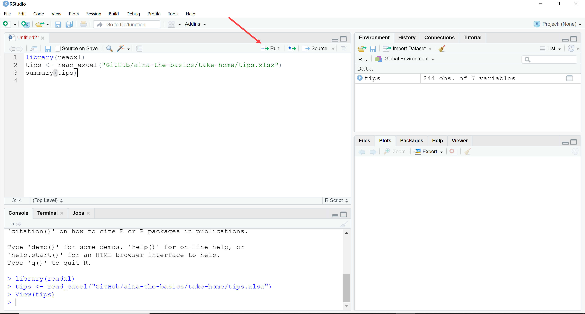
8. You will now see the summary statistics executed in the console:  
   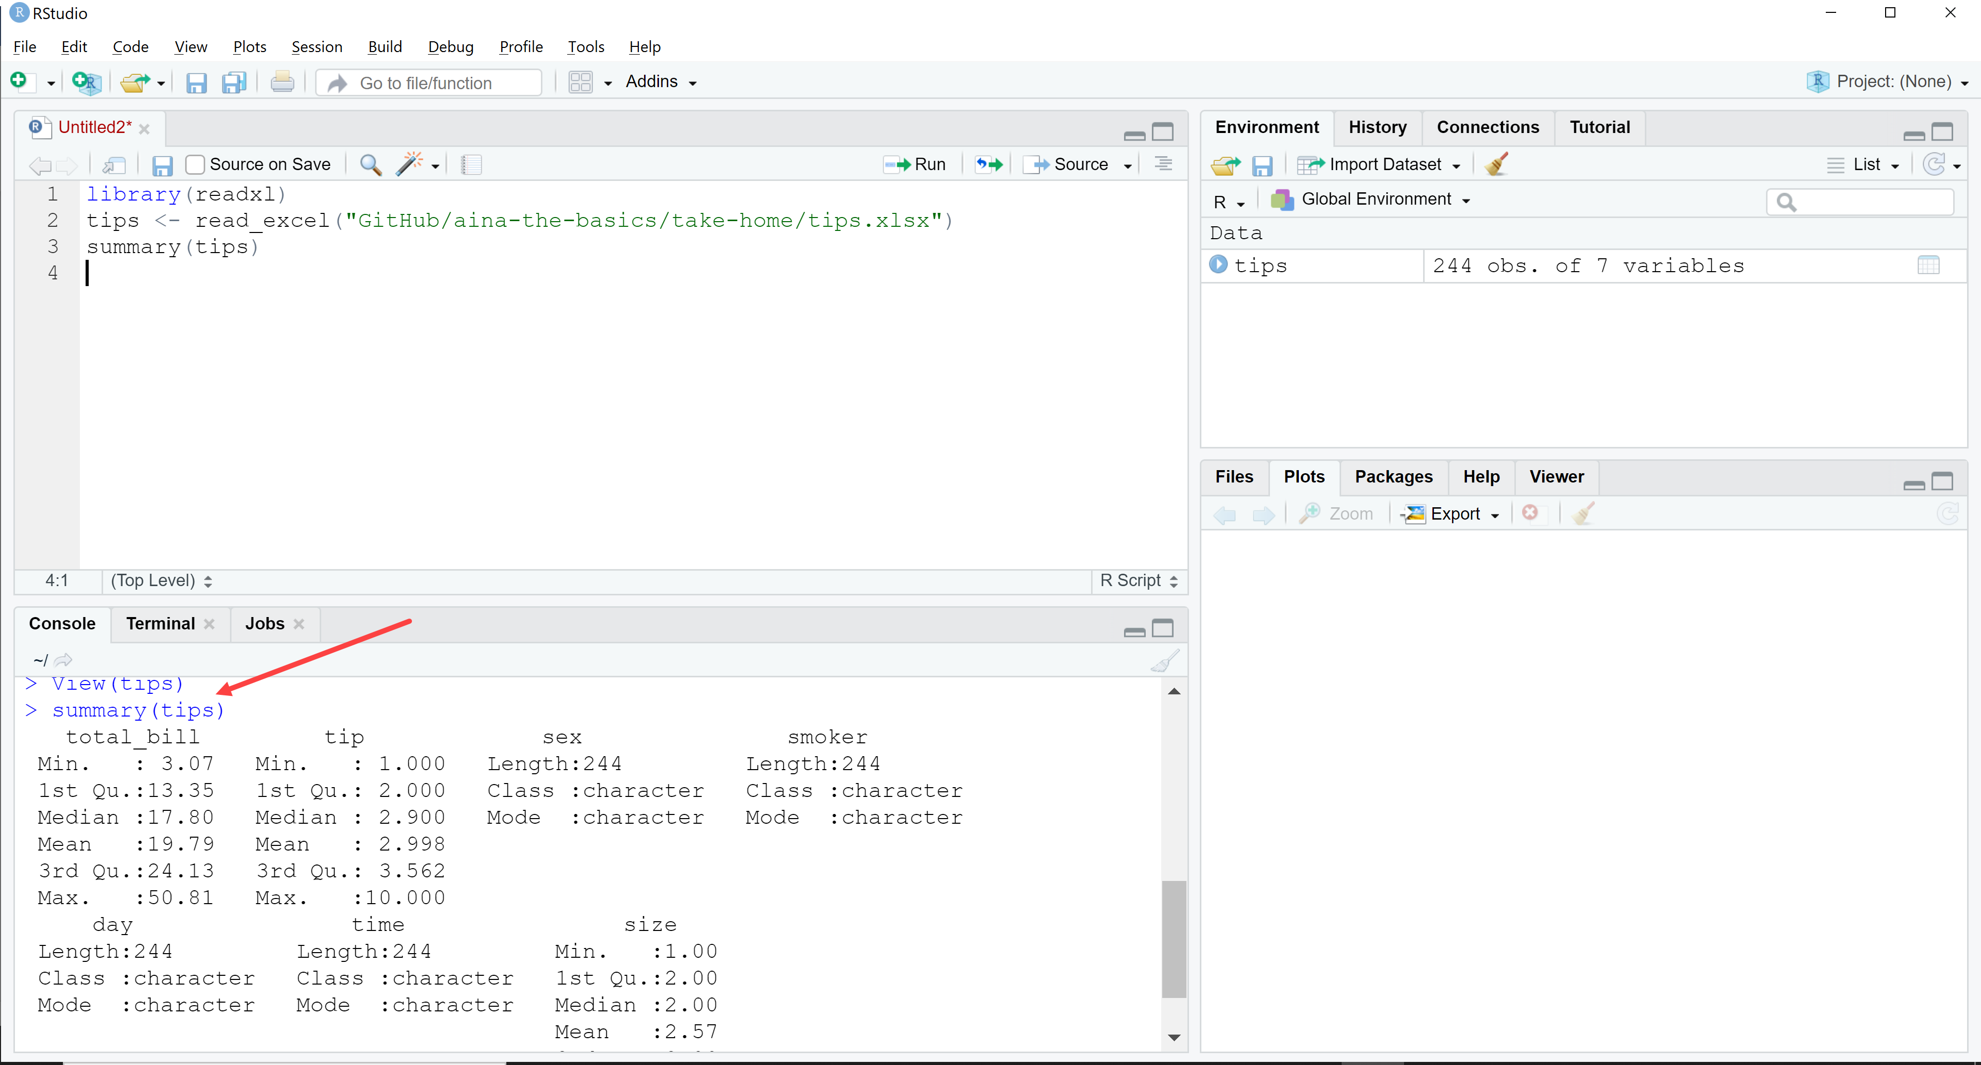
9. Save your script as a long-term record of what you did: File > Save As and save the script somewhere on your computer.